HOW TO REACH- THE ROYAL LIBERTY SCHOOL

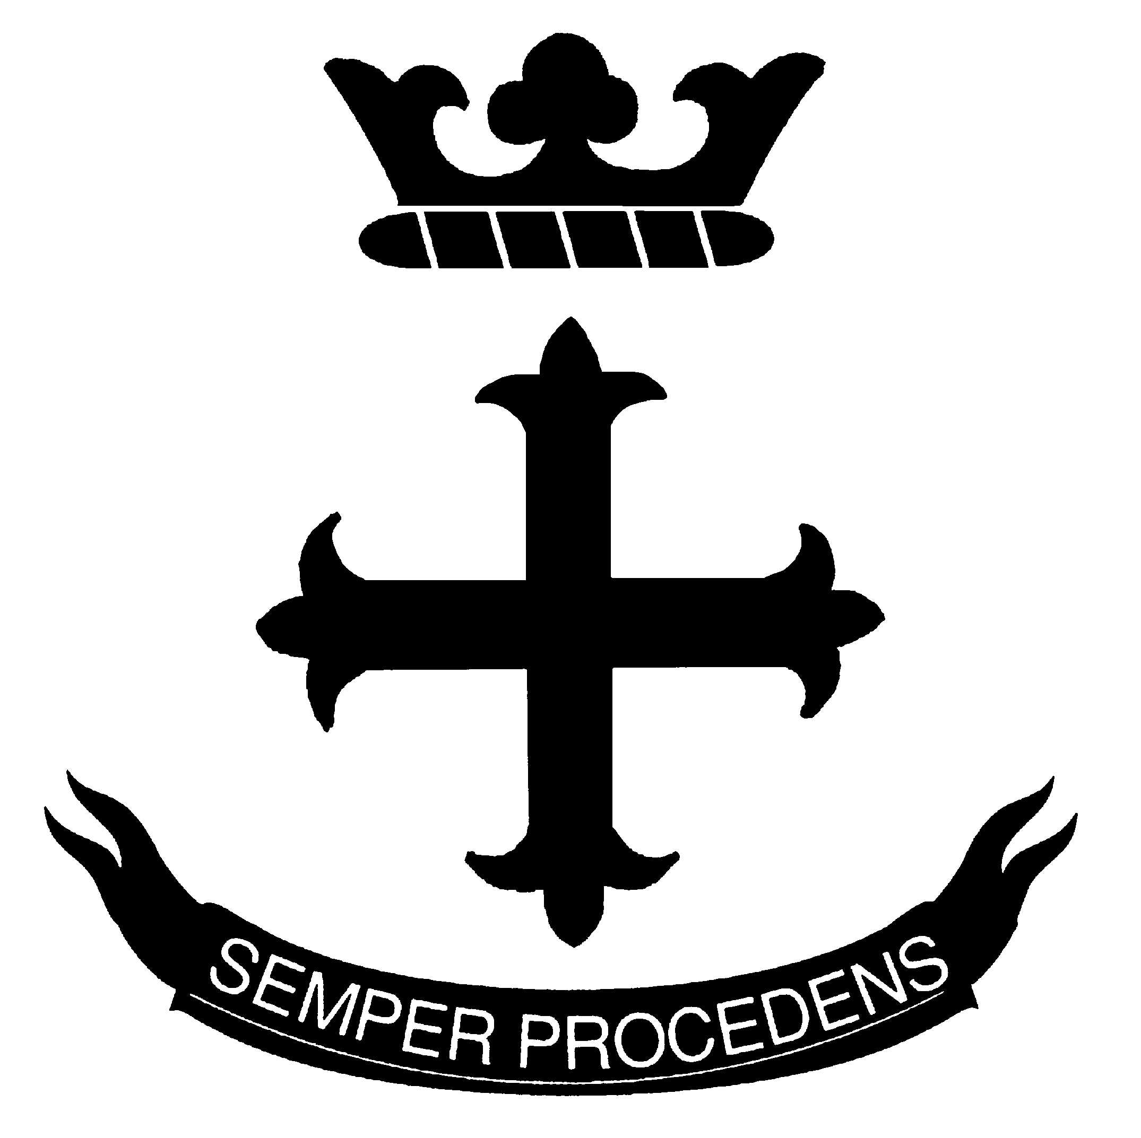
UPPER BRENTWOOD ROAD,

ROMFORD, ESSEX RM2 6HJ

TELEPHONE : 0708 730141
FAX : 0708 723950
E-MAIL : admin@royalliberty.org.uk
Web site : www.royalliberty.org.uk

BY RAIL: B.R. from Liverpool Street to Gidea Park Station.
Go up the steps from the platform, turn left over the line, turn left at the station entrance, fork left twenty yards later along a path at the top of the railway cutting, turn left at the end, which is Upper Brentwood Road. The School is on the left after less than a quarter of a mile.

BY CAR: Aim for Gallows Corner which is the junction of A127 and A12.
Do not go over the flyover but turn into the A118 towards Romford. You will find Upper Brentwood Road, the first turning on the left, at the traffic lights.

