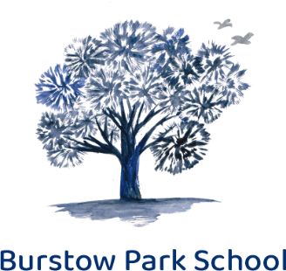

JOB DESCRIPTION

POST TITLE Blended Learning Tutor / Unqualified teacher

DEPARTMENT Burstow Park School

ACCOUNTABLE TO Head Teacher

Hours As per contact: as necessary to fulfil the requirements of the role

PPA Guide Not less than 10%

Key Responsibilities:

To make the safeguarding of all pupils a primary concern

At all times, to fully meet the DFE Teachers’ Standards (May, 2012) which can be found here: https://assets.publishing.service.gov.uk/government/uploads/system/uploads/attachment_data/file/665520/Teachers__Standards.pdf

To teach pupils in a way that ensures every pupil experiences a high quality inclusive school experience in line with Burstow Park School policies and protocols.

The writing of detailed and accurate Individual Educational Plans for pupils, based on their unique needs. Using CATS profile, EHCPs, their learning objectives and prescribed strategies to achieve best outcomes and progress for all pupils.

To co-ordinate and internally moderate any assessments with other teachers as required.

To act with honesty and integrity at all times

To impart a good level of subject knowledge through the use of high quality pedagogical practices, which are kept up to date through self-reflection and a commitment to continued professional development.

To play a principal role in teachers’ meetings, for the purpose of:
- Inducting students for our blended learning provision
- Delivering the optimum curriculum for all students, especially those on blended learning
- Making effective use of remote learning delivery and homework setting to accelerate pupils’ learning
- Co-ordinating and leading learning for all pupils
- Enabling continued development of the school

Additional specific key responsibilities:

- To deliver quality first teaching across a range of subjects, as directed by the subject leader
- To support the collation and recording of pupils’ attainment data

Essential Personal Qualities of a Tutor / Teacher at Burstow Park School:

- A strong and unrelenting commitment to the safeguarding and protection of all pupils at all times.
- A willingness to work with the policies, procedures and protocols of Burstow Park School at all times, demonstrating mutual respect and regard for students, colleagues, line management and the school leadership team
- Demonstration of a solution-orientated approach, striving for continual improvement
- Contributing to a high achieving staff team and taking ownership of own role in positively affecting staff morale
- Being open to new ideas and initiatives for the purpose of continually improving provision for pupils
- To participate and positively contribute to Team Meetings, for the purpose of whole-school development
- To demonstrate a high level of professional and personal integrity at all times, in order to be a strong role model
- A calm, inclusive and empathic nature, with a sound understanding of how internal and external factors can influence pupils’ behaviour, conduct and/or attainment
- To be reliable and hardworking – willing to ‘go the extra mile’ to ensure the highest quality of provision for pupils
- Good time-management skills
- A passion and belief in high-quality teaching, learning to ensure the best possible outcomes for all pupils
- A team player, wanting to make a personal impact on ongoing school development and develop own career
- Wanting and willing to learn/ be a lifelong learner
- Willing to undertake additional school duties as required, within the scope of the role, as directed by the Head Teacher or Deputy Head

