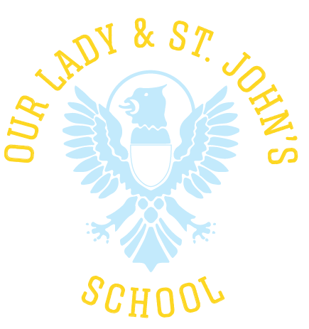
Our Lady & St John’s Catholic Primary School
Boston Park Road, Brentford, Middlesex TW8 9JF
Head Teacher
Closing Date: Please submit all applications by 10am, Monday 20th January 2025
Salary: Range L17-L21 (£77,773 - £84,550) - including outer London weighting
Contract Type: Full Time
Contract Term: Permanent
Pupil Roll: 210 + Nursery

The Governing Body are seeking to replace our Head Teacher who is retiring at the end of this academic year. The successful candidate will continue to build on our school’s current strengths and successes which can be summarised by our June 2024 OFSTED inspection which states: “This is a warm and nurturing school where pupils thrive”.

Governors are looking for a strong leader who will:
- Be able to demonstrate a strong practising Catholic faith
- Be committed to the ethos and vision of the school
- Provide clear and precise leadership, nurturing and inspiring others to achieve the highest of standards.
- Be committed to continuing the effective partnerships we have fostered with our parish, our parents, our governors, and our local community.
- Provide effective leadership through faith and prayer and show compassion and love for all pupils and staff by ensuring that Gospel values are at the centre of everything.
- Ensure that the needs of every child are met so that they are inspired to meet their true potential.

We can offer you:
- A friendly welcoming community, underpinned by our strong Catholic ethos, where all are valued.
- A dedicated, talented and professional staffing team actively living the school’s mission.
- A supportive and active governing body who will seek to build a strong working relationship with you.
- Happy, enthusiastic and confident children who enjoy learning.
- Strong parent/carer relationships where involvement is encouraged.
- On-going professional development with staff well-being / workload a priority.
- Good support from the Diocese and local authority.

The successful candidate will be required to sign the Catholic Education Service (CES) contract.
Our Lady & St John’s is committed to safeguarding and promoting the welfare of our children. This post will be subject to an enhanced disclosure from the DBS and receipt of satisfactory references.

We would urge all candidates to visit our school prior to application so that we can answer any questions you may have and that so you can experience first-hand the ethos of our school.

If you would like any further information then please do contact the school office on 020 8560 7477, option 2 or via email to admin@stjohnsrc.hounslow.sch.uk

Closing Date: 10am, Monday 20th January 2025
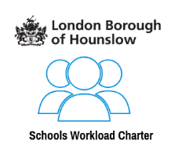




Interviews: week commencing Monday 27th January 2025

