



**Teacher of Mathematics MPS1-UPS3**

Job Description

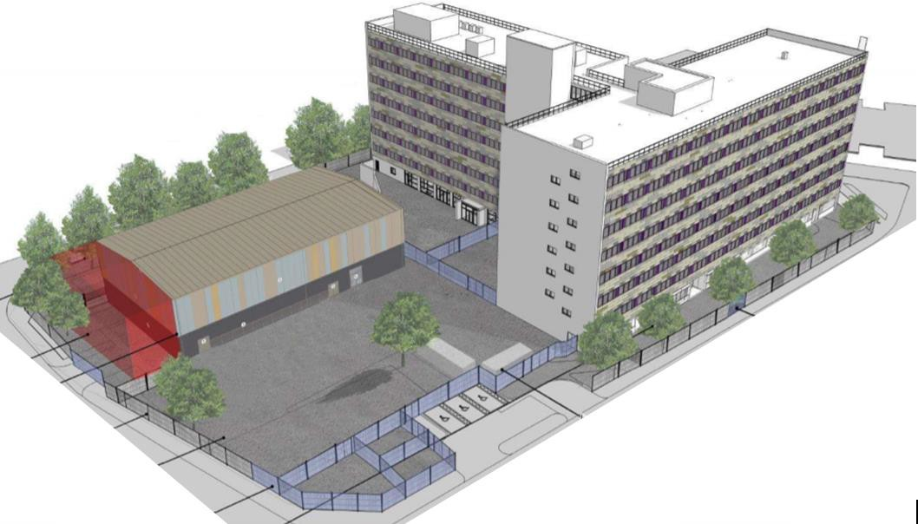

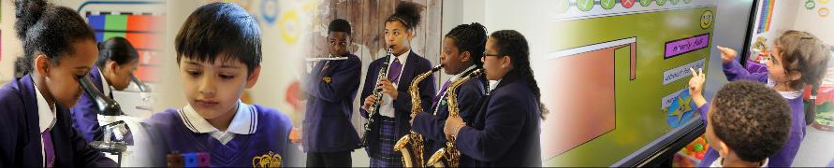

# Image result for king solomon international business schoolKing Solomon International Business School

**Education Excellence & Character Development**

**Lord Street, Birmingham, B7 4AA**

**T: 0121 357 1905**

**E:** [**hr@kingsolomonibs.com**](mailto:hr@kingsolomonibs.com) **W:** [**www.kingsolomonibs.com**](http://www.kingsolomonibs.com/)

Dear Applicant

Thank you for your interest in joining King Solomon International Business School.

Falcon Education Academies Trust is committed to providing high level, quality support and investment to the school, with the aim of ensuring that the best provision is developed for students, to ensure improved quality of education and outcomes for them in the future.

King Solomon is a Faith school, and we aim to inspire our students to seek out the best from what life has to offer. It is our aim to nurture students who are equipped and keen to make the most of the vast array of opportunities set out before them in school and beyond. Our vision is to achieve academic excellence and develop students with exemplary character.

The Christian ethos provides a framework for the character we want our pupils to develop, through which we seek to develop a student’s ability to recognise good advice, make sound judgements, wise decisions and to be honest, just, fair, and resourceful.

King Solomon is an all through school. Each September we welcome a new cohort of students in EYFS and Year 7.

From our school website [*www.kingsolomonibs.com*](http://www.kingsolomonibs.com/)*,* you will be able to find out more about the school. The job description and person specification will provide you with information of what candidates will need to demonstrate and what we are seeking in terms of suitability.

If you wish to work with us and our partners on this exciting opportunity to improve the school and student outcomes, please complete our application form, which can be found on our website[*www.kingsolomonibs.com/Vacancies/*](http://www.kingsolomonibs.com/Vacancies/) and send your completed application to [ckirk@kingsolomonibs.com](mailto:ckirk@kingsolomonibs.com)*.*  Please note we do not accept CVs for this post.

The closing date for this position is 22nd May 2024**, however, please note that we reserve the right to close applications once a suitable candidate is found.**

Yours sincerely



Executive Headteacher

**Job Description**

|  |  |
| --- | --- |
| **Post Title** | **Teacher of Mathematics** |
| **Job Summary** | All teachers make the education of their pupils their first concern and are accountable for achieving the highest possible standards in work and conduct. Teachers act with honesty and integrity; have strong subject knowledge, keep their knowledge and skills as teachers up-to-date and are reflective and self-critical; forge positive professional relationships; and work with parents/carers in the best interests of their pupils.  Upper Pay Scale teachers are highly competent in all elements of the Teachers’ Standards and their achievements and contribution are substantial and sustained. |
| **Reporting to:** | Head of Faculty |
| **Grade** | **MPS – UPS** |

**Primary Duties and Responsibilities**

|  |  |
| --- | --- |
| **Main Pay Scale (MPS)** | **Upper Pay Scale (in addition to MPS)** |
| **Sets high expectations which inspire, motivate and challenge pupils** | |
| * Establish a safe and stimulating environment for pupils, rooted in mutual respect. * Set goals that stretch and challenge pupils of all backgrounds, abilities, and dispositions. * Demonstrate consistently the positive attitudes, values and behaviour which are expected of pupils. | * Positively impact and influence colleagues in the setting and delivery of high expectations. * Provide supportive challenge to colleagues to create appropriate and stretching pupil goals. * Exemplify to others strong pupil interactions and high behaviour expectations of all pupils**.** |
| **Promote good progress and outcomes by pupils** | |
| * Be accountable for pupils’ attainment, progress, and outcomes. * Be aware of pupils’ capabilities and their prior knowledge, and plan teaching to build on these. * Guide pupils to reflect on the progress they have made and their emerging needs. * Demonstrate knowledge and understanding of how pupils learn and how these impacts on teaching. * Encourage pupils to take a responsible and conscientious attitude to their own work and study. | * Exceed pupil-based expectations. * Support colleagues in the development and implementation of strategies that lead to good progress and outcomes. |
| **Demonstrate good subject and curriculum knowledge** | |
| * Have a secure knowledge of the relevant subject(s) and curriculum areas, foster, and maintain pupils’ interest in the subject, and address misunderstandings. * Demonstrate a critical understanding of developments in the subject and curriculum areas and promote the value of scholarship. * Demonstrate an understanding of and take responsibility for promoting high standards of literacy, articulacy, and the correct use of standard English, whatever the teacher’s specialist subject. | * Achieve an excellent understanding of the curriculum and develop others in their knowledge. * Contribute positively towards development of the Federation’s curriculum and the associated high expectations for achievement of all students. * Model high standards in developing literacy through the curriculum. |
| **Plan and teach well-structured lessons** | |
| * Impart knowledge and develop understanding through effective use of lesson time. * Promote a love of learning and children’s intellectual curiosity. * Set homework and plan other out-of-class activities to consolidate and extend the knowledge and understanding pupils have acquired. * Reflect systematically on the effectiveness of lessons and approaches to teaching. * Contribute to the design and provision of an engaging curriculum within the relevant subject area(s). * Deliver lessons safely. | * Teaching consistently good and frequently outstanding lessons. * Support colleagues to ensure teaching is prioritised and is the key driver for delivering the curriculum. * Support the leadership of learning building on own consistently good practice. * Where there are barriers to pupil progress pro-actively support colleagues with the design and delivery of appropriate strategies. * Support other teachers to improve their practice. * Lead in creating a culture through which teachers enjoy teaching and thrive within the trust. |
| **Adapt teaching to respond to the strengths and needs of all pupils** | |
| * Know when and how to differentiate appropriately, using approaches which enable pupils to be taught effectively. * Have a secure understanding of how a range of factors can inhibit pupils’ ability to learn, and how best to overcome these. * Demonstrate an awareness of the physical, social, and intellectual development of children, and know how to adapt teaching to support pupils’ education at different stages of development. * Have a clear understanding of the needs of all pupils, including those with special educational needs; those of high ability; those with English as an additional language; those with disabilities; and be able to use and evaluate distinctive teaching approaches to engage and support them. | * Proactively support colleagues to understand their cohort and offer solutions to overcome barriers to learning. * Proactively identify higher attaining students and support the development of appropriate stretch and challenge. * Contribute within the wider team on how to successfully support students with varying needs to access the curriculum and achieve good progress. |
| **Make accurate and productive use of assessment** | |
| * Know and understand how to assess the relevant subject and curriculum areas, including statutory assessment requirements. * Make use of formative and summative assessment to secure pupils’ progress. * Use relevant data to monitor progress, set targets, and plan subsequent lessons. * Give pupils regular feedback, both orally and through accurate marking, and encourage pupils to respond to the feedback. | * Support colleagues in their understanding of how to use formative and summative assessment to achieve good progress. * Take a pro-active and curious approach to review of pupil-based data to support colleagues in their interpretation of data and application of appropriate interventions and strategies to achieve good progress. * Lead on intelligent use of assessment. |
| **Manage behaviour effectively to ensure a good and safe learning environment** | |
| * Have clear rules and routines for behaviour in classrooms and take responsibility for promoting good and courteous behaviour both in classrooms and around the school, in accordance with the school’s behaviour policy. * Have high expectations of behaviour and establish a framework for discipline with a range of strategies, using praise, sanctions, and rewards consistently and fairly. * Manage classes effectively, using approaches which are appropriate to pupils’ needs in order to involve and motivate them. * Maintain good relationships with pupils, exercise appropriate authority, and act decisively when necessary. * Escalate safeguarding concerns immediately to the Principal and/or Designated Safeguarding Lead. | * Take a leading role in ensuring behaviour management systems are implemented consistently, so that effective learning can take place. * Support colleagues experiencing challenging pupil behaviour towards a successful solution. |
| **Fulfil wider professional responsibilities** | |
| * Make a positive contribution to the wider life and ethos of the school. * Develop effective professional relationships with colleagues, knowing how and when to draw on advice and specialist support. * Deploy support staff effectively. * Take responsibility for improving own teaching through appropriate professional development (including attendance at off-site Federation wide CPD), responding to advice and feedback from colleagues. * Communicate effectively with parents with regard to pupils’ achievements and well-being. * Proactive and passionate about equality, diversity, and inclusion. * Communicate effectively with people from a variety of backgrounds. * This role involves working with children on a daily basis and is therefore in regulated activity. | * Support a culture of positivity and a solution focussed working environment. |
| **Additional expectations – Teachers will:** | |
| * Be aware of and comply with all school policies and procedures. * Be committed to safeguarding and promoting the welfare of children and young people. * Ensure that the equal opportunities policy is adhered to and promoted in all aspects of the post holder’s work. * Ensure effective quality control and continuous improvement in all aspects of the work and responsibilities attached to this post. * Demonstrate professionalism towards sensitive and confidential information and adhere to data protection legislation. * Comply with and promote Health and Safety policies and procedures and to undertake recommended Health and Safety training as and when necessary. * Comply with financial regulations and ensure effective management and appropriate use of resources to achieve value for money. * Commit to professional self-development, such as through participation in inset training and professional services network as necessary for the successful carrying out of the job. * Undertake such other duties as are commensurate with the grade of the post. * Secondary teachers will be primarily deployed to teach their specialist subject area, however, may on occasions be required to teach outside of the specialism.   **Note:** This job description is designed to outline a range of main duties that may be encountered.  It is not designed to be an exhaustive list of tasks and can be varied in consultation with the post holder in order to reflect changes in the job or the organisation.**– Teachers will:** | |

|  |  |
| --- | --- |
| **Terms of Employment** | All offers of employment are subject to the completion of the required statutory pre-employment checks which include proof of identity and Right to Work in the UK, two satisfactory references, an enhanced DBS disclosure and evidence of your relevant qualifications. You will also be required to read, understand and sign the  School’s Code of Conduct. |
| **Hours of Work** | Working hours are usually between 8:30am-3:45pm and you will normally be required to work between these hours as arranged with the executive headteacher. |
| **Special Arrangements** | The post holder may be required to work outside of normal working hours on occasion, with due notice. |

***Our School and all its personnel are committed to safeguarding and promoting the welfare of the children. This post is subject to an Enhanced Disclosure Application to the Disclosure and Barring Service.***

**Person Specification**

***This person specification acts as a selection criterion and gives an outline of the type of person and the characteristics and qualities required to carry out this role.***

| **ATTRIBUTES** | **ESSENTIAL CRITERIA** | **DESIRABLE CRITERIA** |
| --- | --- | --- |
| Qualifications / Knowledge | * GCSEs Grade C+ (Grade 4) including English, Mathematics and Science. * A Level Grade C+ within relevant subject(s). * Relevant Degree. * Qualified Teacher Status (QTS) (or QTLS). * Excellent subject knowledge. | * Postgraduate or Professional Graduate Certificate in Education (PGCE). |
| Skills | * Effective communicator. * Well organised. * Diligent. * Able to teach in an accessible manner that enables all pupils to understand and make good progress. * Works safely ensuring the well-being of children and young people. |  |
| Behaviours | * Establishes high expectations for all that we seek to achieve. * Creates equity of opportunity removing disadvantage. * Champions the success and life chances of all children. * Furnishes pupils and colleagues with the resilience to succeed as lifelong learners. * Promotes tolerance and respect. |  |