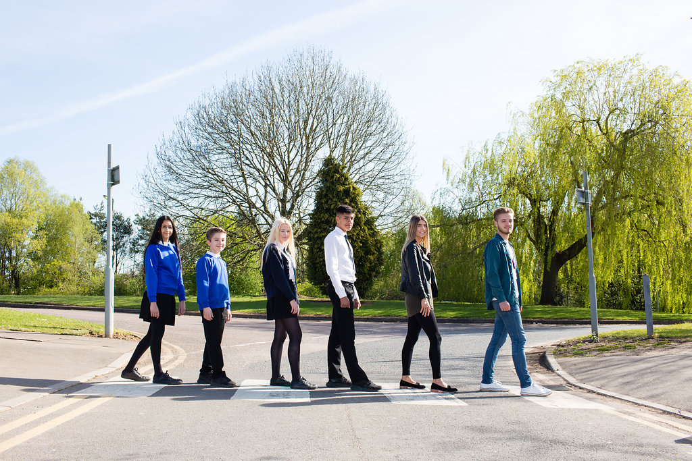

Teacher of Maths 11-19
Permanent, Full Time
Newly Qualified Teachers, Main pay Scale or Upper Pay Spine.
An additional recruitment allowance could be negotiated with the
successful candidate according to experience and ability.
Starting September 2018
Content

Vision, Values and Ethos |  | Page 3
Testimonials |  | Page 4
Faculty Information |  | Page 5
The Application Process |  | Page 6
Vacancy Advert |  | Page 7
Letter from the Headteachers |  | Page 8
Job Description |  | Page 9-10
Person Specification |  | Page 11-12

Vision, Values and Ethos
The shared vision and values of the Trust underpins all that we do, including the governance arrangements for the Trust.

Our Vision
Valuing Everyone, Achieving Excellence

Our Motto
Work Hard, Be Kind

Our goals
The goals of our trust:
- Outstanding levels of progress and achievement for all
- Outstanding levels of wellbeing for all
- Outstanding preparation for adult and working life
- Outstanding family and community engagement
- Outstanding levels of professional learning for all
Informed by “Schools of Tomorrow”

Testimonials
Extract taken from email correspondence, following a tour of the school by a prospective parent
(April 2016):
‘I would just like to say thank you for the time spent with me today on my tour of the campus, and state how impressed I was with the school. There seems to be a very calm, relaxed and organised approach to how the school operates, and I believe that obviously shows in the way your students behave’.
Written comments from parents following Year 9 Progress Evening (2017):
‘My child always talks positively about school to other children the same age, which I think is a good indicator that he is enjoying school’

‘Welcoming, approachable, friendly and knowledgeable staff’.
Written comments from parents following Year 11 Progress Evening (2017):
‘The teachers have pride in their teaching and in the pupils’ progress. They really care and are prepared to go the extra mile to support the students’.
‘My son seems to have progressed so well in most subjects. I feel this is due to good relationships he has been able to form with teachers and the standard of the lessons’.
Written comment from parent at the end of KS5 (2016):
‘This is my final parents evening after my youngest daughter is coming to the end of her years at GCE. Thank you for very happy years for my three daughters and for their excellent education!’
Thank you from parent of ex-student taking up a place at Cambridge University (2013):
‘To all the staff at Brookvale Groby Learning Campus.
My son has just started at Cambridge University studying Engineering. It was his ambition to go there and this summer, he achieved the grades he needed. We want to acknowledge the great teaching and support he received during his time with you. He progressed well academically, but also grew so much in maturity and confidence. With thanks to you all for your hard work and dedication.’
Extract of letter from staff member:
‘I have thoroughly enjoyed my time on campus. It has been a real pleasure working with staff who are always friendly, extremely supportive and willing to share ideas and knowledge. I have really appreciated having a senior leadership team which is so warm towards its staff and open to their comments and new ideas.
The children I have taught have made me smile, laugh and cry! I will miss my relationship with them and that buzz you get from seeing them progress. It does, however, give me great satisfaction to think that I have put into place schemes of work for pupils and created learning opportunities for them which should continue even after I have left.
I am sad to leave a post which I still love. Once more, thank you for all of your support and kindness.’

Comments from staff member leaving for promotion (June 2017):
It has been an honour to work at Groby and alongside such an amazing staff body. I have been supported at every turn and feel proud to have been a part of the change for the better that has taken place over the years. I wish the campus, staff and students continued success and recognition for their dedication.

Faculty Information

The Maths faculty comprises a hardworking and friendly group of staff who work well together at KS3, 4 and 5 in an atmosphere of mutual support. The faculty benefits from having experienced teachers who are able to offer help and support as well as staff who are relatively new in the profession, who contribute new thinking. Our ethos is to drive students to achieve their maximum potential in the subject. There is an unrelenting focus on teaching and learning. Our results at KS4 and 5 continue to improve with 71% of students achieving A* to C grades at GCSE and 60% achieving A*/B grades at A level.
Staffing
There are 15 members of staff in the faculty including 5 TA/HLTA’s supporting in lessons. The staff are strongly encouraged to develop and share their expertise in teaching and learning and are given support and encouragement with this process. A strong emphasis is placed on CPD. We are always looking at ways to improve the teaching and learning of mathematics in order to improve students’ experience in the classroom.

Accommodation
We have a suite of 10 classrooms, 1 of which is also a computer room and 2 staff offices. All rooms have ceiling mounted data projectors and interactive whiteboards. We have worked hard on displays over the last few years to improve the learning environment. We also have a bank of maths laptops that are available for class use.

Courses
KS3: Students follow a scheme of learning based on the kangaroo maths stages. We are currently developing our 11-19 schemes in order to encourage mastery and problem solving at all levels.
KS4: All students sit the Edexcel Linear exam. Students in set 1 also study the Level 2 Certificate in Further Mathematics and have the option to sit this exam in Year 11.
KS5: we offer AS and A2 courses in Maths and Further Maths following the MEI specifications through OCR. We also run GCSE Maths one year classes for AS students.
Students in KS3 and 4 have four maths lessons a week; Year 12 resit two; Year 12 and 13 four.
All A level groups are shared between 2 teachers.

Resources
The Maths faculty has an extensive bank of paper and electronic resources. We pride ourselves on the use of a variety of resources to engage learners and create a sense of wonderment. GCSE students have access to MyMaths, PiXL Maths and at KS5 the integral maths site, and are expected to make use of revision websites that contain video tutorials and worked solutions to exam questions.
We have sets of Key Maths and GCSE textbooks for Foundation, Middle and Higher ability students in each classroom. There are also Further Maths textbooks.

The Application Process

Complete application should be returned to efreeman@brookvalegroby.com

Or by post to

F.A.O. Elaine Freeman
Brookvale Groby Learning Campus
Ratby Road
Groby
Leicester
LE6 0FP

A letter will be sent to shortlisted candidates with details of the interview process.

Queries

If you have any queries on any aspect of the application or need additional information please contact Elaine Freeman, PA to Headteacher on the above email address.

Thank you.

The Role

Teacher of Maths
Full time from September 2018

Required from September 2018, we are seeking to appoint an enthusiastic, committed, inspiring and well qualified teacher of Maths across the 11-19 age range.

The Brookvale Groby Learning Campus is a highly successful collaboration of two schools sharing the same site. Brookvale High School is an ‘outstanding’ 11-14 high school and Groby Community College is 14-19 upper school graded as ‘good with outstanding features’ in its last Ofsted. Together, the campus meets the educational needs of 1600 students with nearly 400 at Post 16.

The Brookvale Groby Learning Campus is undergoing an exciting period of change following becoming a Multi Academy Trust in April 2017. The schools have a strong ethos of valuing everyone and achieving excellence for all including the professional development of our staff.

The Mathematics faculty forms a central place on our campus with all students studying Maths to GCSE. The department also offers popular A Levels in Maths and Further Maths.

Both newly qualified and experienced teachers are encouraged to apply.
An additional recruitment allowance could be negotiated with the successful candidate according to experience and ability.

Visits to the campus are very welcome.
Job Descriptions and further information is available on our website – www.brookvalegroby.com.

For further information or to arrange an informal discussion/tour of the campus please contact
Elaine Freeman on 0116 2879921 or efreeman@brookvalegroby.com

Closing date: Tuesday 20th February 2018
Interviews will be held within 2 weeks of the closing date.

The Brookvale Groby Learning Campus are committed to safeguarding and promoting the welfare of children and young people and expect all staff and volunteers to share this commitment. Applicants must be willing to undergo appropriate child protection screening, including checks with past employers and the Disclosure and Barring Service.

Dear Applicant

TEACHER OF MATHS

Thank you for your interest in the Teacher of Maths vacancy with the Brookvale Groby Learning Campus.

We hope the documents provided help you to gain a feel for the school and if you would like to visit us as well, we would be delighted to show you round. Please contact Elaine Freeman on 0116 2879921 or efreeman@brookvalegroby.com to make an appointment.

All the documents to support this application process are available on the website, www.brookvalegroby.com

To apply please complete the following:

- Application Form
- A letter of application, no more than two sides of A4, word processed using font size no smaller than 11

Your letter needs to be addressed to ourselves, and if you would like to e-mail your application then please send this to Elaine Freeman on the email address above.

The closing date for this post is Tuesday 20th February 2018. The interviews will be held within 2 weeks from that date. If you have not heard from us by then, please assume that your application has not been successful on this occasion. If this is the case, we would like to thank you for your interest and the time spent in applying.

This post will be subject to an enhanced level Disclosure & Barring Service check. All Brookvale Groby employees are expected to promote and safeguard the welfare of students at the school. Our Safeguarding Policy is made known to all and is designed to guide staff, students and parents/carers with regard to Safeguarding issues.

In line with best practice guidance re safeguarding we do not require an additional CV and any included with application forms sent to the school will not be taken forward to the short listing panel.

Yours sincerely

Katie Rush Robert Coles
Headteacher, Brookvale High School Headteacher, Groby Community College
Co-Director of BGLC Co-Director of BGLC

Job Profile
Post title | Teacher of Maths 11-19
Job purpose | - To provide the highest quality teaching and learning in order to raise standards of attainment and progress to meet campus targets.  - To implement and deliver an appropriately broad, balanced, relevant and differentiated curriculum for pupils and to support a designated curriculum area as appropriate.  - To facilitate learning experiences which provides pupils with the opportunity to achieve their individual potential.  - To enable each student to develop personally in line with the campus aims of Valuing Everyone, Achieving Excellence.
To whom the postholder reports | The postholder is accountable to:  - Brookvale Headteacher for KS3  GCC Headteacher for KS4 & 5  Responsible to:  Curriculum Leader for all subject teacher matters
Duties and responsibilities specific to the post | Responsibilities: Teacher  - To undertake teaching commitments in accordance with curriculum and timetable requirements across the campus.  - To teach other subjects as and when required by the needs of the timetable and as directed by the Headteachers. This will be negotiated in accordance with the skills of the teacher.  - Prepare students effectively for qualifications and external examinations.  - To fulfil the roles and responsibilities of tutor to a vertical group of students and support students on an individual basis through academic or personal difficulties. To act as a mentor to specific members of the tutor group in order to raise achievement.  - To take responsibility for personal CPD and to participate in campus and external CPD activities by negotiation.  - To undertake all of the requirements laid down by the campus Performance Management Policy.  - To participate in faculty/department and campus meetings.  - To participate in parental consultation/student progress afternoons and evenings as well as the annual target setting evening with Year 10 and 11.  - To participate in the duty rota as instructed.  - To fulfil the “Professional Standards 2012” as laid down by the DfE:  - Set high expectations which inspire, motivate and challenge students – safe and stimulating environment. Set goals and challenge students of all abilities and backgrounds. Demonstrate positive attitudes, values and behaviours.  - Promote progress and outcomes by students - accountable for attainment, progress and outcomes.  - Demonstrate good subject and curriculum knowledge – including literacy and numeracy.  - Plan and teach well structured and engaging lessons – including setting regular homework as per the campus policy. Selecting and using a range of different learning resources and equipment, including ICT and where possible the use of interactive whiteboards.  - Adapt teaching to respond to the strengths and needs of all students – including differentiation / needs of SEND students.  - Make accurate and productive use of assessment – using data/marking accurately/ giving feedback to students on how to improve/maintaining records of students' progress and development  - Manage behaviour effectively – establish rules/routines. Promote positive behaviour. Have high expectations.  - Fulfill wider professional responsibilities – make a positive contribution to the ethos of the campus. Take responsibility for own professional learning.
UPS/Expert Professional Responsibilities (if applicable) | - Ensure own standards of teaching and learning are at least good or outstanding in order to be a leading professional in the campus.  - Contribute to the professional development of colleagues through coaching and mentoring, demonstrating effective practice, and providing advice and feedback.  - Other responsibilities to be determined by the Headteacher and Line Manager or as part of TLR responsibilities.
Generic duties and responsibilities | To work within the framework of national legislation and in accordance with the provisions of the School Teachers Pay and Conditions Document. In addition the post is subject to compliance with:  - School policies and guidelines on the curriculum and school organisation  - LA policies adopted by the campus  - The Conditions of Service for School Teachers in England and Wales and with locally agreed conditions of employment  - Common core of skills and knowledge for the children’s workforce.  - All teachers have a responsibility for safeguarding the welfare of children and young people he/she is responsible for or comes into contact with.  The duties and responsibilities detailed within this job description should be supplemented by those accountabilities, roles and responsibilities common to all classroom teachers, as set out within the School Teachers Pay and Conditions Document.

Personnel Specification

ESSENTIAL | DESIRABLE | CRITERIA Assessed By
Qualifications  Degree in relevant subject.  Post Graduate Certificate of Education. |  | Application Form/CV  Application Form/CV
Training & Experience  Recent successful teaching experience at KS3 and KS4. For NQTs this includes teaching practice.  Proven commitment to own professional development. | Teaching experience at KS5. | Application Form/Letter/  Reference  Application Form/Letter/  Reference
Knowledge  Knowledge of Mathematics applicable to KS3, GCSE and A-level specifications.  Understanding the role of assessment within the subject area. | Knowledge of teaching pedagogies. | Interview/Reference  Letter/Interview
Skills  Ability to work with students and staff in a supportive and challenging way.  Ability to use ICT both in the curriculum and as an administrative aid.  Ability to motivate and enthuse students, including disaffected and reluctant learners.  Ability and enthusiasm to work with students in mixed ability groups.  Effective inter-personal skills.  Good written and oral communication skills.  Effective organisational and administrative skills.  Ability to contribute to the strategic management of relevant teams through discussion and debate. |  | Reference/Letter (Observation of teaching at interview).  Letter/Interview (Observation of teaching at interview.)  Letter/Interview (Observation of teaching at interview).  Letter/Interview (Observation of teaching at interview).  Interview/Reference  Letter/Interview  Reference  Interview/Reference

Attitudes and attributes  Open-mindedness and commitment to co-operate with both students and staff.  Willing to work in an inclusive way to support all students to achieve their potential.  Able to create a positive working environment through display of students' work and celebration of students' achievements.  Able and willing to work with leaders and all colleagues in relevant teams in a co-operative, supportive and enthusiastic way.  Flexible, resilient and reliable.  Resourceful and innovative thinker.  Must contribute to the shared resource system.  In possession of a good attendance and punctuality record.  Willingness to dress as a professional in line with the ethos of the campus. |  | Reference/Interview  Letter/Interview  Reference  Letter  Reference/Letter  Reference  Interview/Reference

