

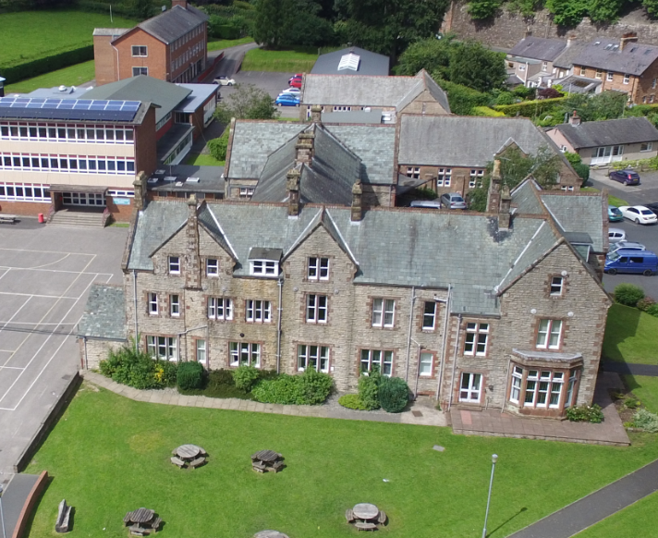

**Teacher of Maths**

**Recruitment Information Pack**



Recruitment Pack Contents

Page

Vision, Mission and Ethos 3

Introduction to the School 4

About the Department 6

Job Description 7

Person Specification 8

Copy of the Advert 9

Privacy Notice 10



**Vision, Mission and Ethos**

Vision: To be the Eden Valley’s premier secondary school by offering excellence in the classroom, on the sporting field, in the arts and beyond.

Mission: Enabling all students to achieve their full potential today and empowering them to become responsible citizens and leaders of tomorrow.

**What is our Ethos?**

* AGS is renowned for its moral purpose and its unshakeable belief that all can succeed, whatever their circumstances or background, when given a positive climate where support, encouragement and confidence building predominates, backed by high quality teaching and learning.
* AGS is committed to supporting the development of children, young adults and staff, at ease with themselves and each other, with the knowledge and skills to thrive in the midst of exponential change.
* AGS aims to achieve high level success through nurturing the adaptability of our staff and students, their passion and ability to work in partnership and sparking each other to be creative and innovative.

**Our Aims:**

* excellent leadership;
* high standards of professional effectiveness;
* a relentless focus on improvement;
* very high standards of behaviour;
* a constant focus on teaching, learning and innovation;
* risk taking and succession planning;

We follow Local Authority admissions criteria and believe that local children should attend local schools, we are not selective and we are fully inclusive. We provide outstanding personalised professional development and training combined with an extensive range of career development opportunities, every colleague feels valued and appreciated.



**Introduction to AGS**

Dear Candidate,

We are a small comprehensive school set in a stunning rural location. The school is an academy with high standards and great ambition for all our students. We pride ourselves on our strong family and community ethos. Our curriculum is strong and well balanced, with plenty of choice. We are committed to developing every student's particular strengths in an environment in which they can thrive. Appleby Grammar School is a member of the South Lakes Federation.

As an 11-18 comprehensive school serving families throughout the historic town of Appleby-in-Westmorland, we pride ourselves on the fact that all students thrive in a caring environment and are well motivated and co-operative. Our students are courteous and have a high degree of respect for others. They are proud of their school and enjoy learning.

We are delighted to be recruiting for a teacher of Mathematics to join our small but forward thinking and cohesive department. We are looking for an enthusiastic teacher with a passion for Mathematics to teach at all key stages and we can offer you an exciting opportunity to work in a welcoming and supportive environment for students and staff alike.

We teach with a clear focus on supporting all students to achieve positive outcomes. You will work with the Curriculum Leader of Mathematics and the Senior Leadership team to continually drive attainment and standards across the department.

We seek a teacher who is:

* an excellent classroom practitioner;
* a supportive member of the team;
* knowledgeable in their subject;
* well organised and motivated to support students of all abilities and needs.

We welcome committed, dynamic and creative applicants with a passion for Mathematics and the improvement of student attainment.

**This is an ideal opportunity for an NQT** to undertake their induction training in a school with a proven track record of providing excellent professional support for all staff, or for an experienced teacher looking for a new challenge and great CPD opportunities.

We have high expectations of our staff and we value them highly. Our school systems ensure you can focus on teaching high quality lessons in a sustainable manner – dealing with



poor behaviour quickly, and limiting the amount of ‘data’ we expect teaching staff to deal with.

What we offer:

* Students who are well motivated and co-operative
* Well-managed behaviour systems
* A school feedback policy that embraces constructive feedback methods helping to limit onerous marking
* No formally graded lesson observations and an emphasis on ‘coaching’

This is a very exciting time for the school and for the right candidate. If you would like to visit and meet with both myself and the Curriculum Leader, or if I can assist your application process in anyway then please do not hesitate to contact me. The right candidate is the most important outcome for us.

I look forward to meeting with you.

Yours sincerely



Andrew Lund

Headteacher



**The Department**

The Department is on an exciting journey of improving academic performance within an engaging and inclusive environment. You would become part of a small but dynamic team with a shared interest in encouraging the engagement and enjoyment of mathematics within all students.

**Staffing**

The Mathematics Department is a small department consisting of a Curriculum Leader, one full time maths teacher and a number of non-specialist teachers delivering across the full age range.

**Resources**

We have a dedicated Mathematics area consisting of 4 rooms. Each is equipped with whiteboards and other resources to assist in high quality teaching and learning.

**Curriculum**

At KS4 students are entered for Edexcel GCSE examinations. At KS5 we offer both A Level Mathematics and Core Mathematics. Students take part in a number of Mathematical competitions and challenges. Teachers are available to help students with their work, including after school revision classes which are timetabled for all Year 11 students in the spring and summer terms.



**Job Description & Person Specification**

**Job Description**

**Job Title:**  **Teacher of Maths**

**Salary:** MPS

**Hours of work:** Full-Time - Permanent

**Department:** Mathematics

**Responsible** **to:**  Curriculum Leader for Mathematics

**Job Purpose**

To teach students across the full age and ability range present in the school in order to ensure the highest possible standards of student achievement, personal development and well-being.

**Main Duties and Responsibilities:**

* To promote and be committed to the academy aims and objectives
* To maintain and contribute to the development of academy policies
* To promote and be committed to securing high expectations for learning and the raising of achievement
* Within academy and subject policies, to:
  + set appropriate homework;
  + mark work, assess, record and report student progress;
  + provide a stimulating learning environment;
  + have due regard for maintaining health and safety and security in the area s/he uses;
  + contribute to department and academy enrichment programmes.
* To be a form tutor carrying out the associated responsibilities
* To assist with the effective operation of the subject individually and with others:
  + Develop schemes of work, resources, teaching and learning strategies
  + Contribute to team review, monitoring and evaluation, and the development of working practices
  + Participate in working groups and projects
* Taking part in other professional development activities
* Ability and willingness to deliver some Key Stage 3 teaching outside of the department if required



**Other Specific Duties**

* To undertake any other duty as specified by the School’s Teachers’ Pay and Conditions Document not mentioned in the above
* To comply with any reasonable request from a manager to undertake work of a similar level that is not specified in the job description.

**Person Specification – Teacher of Maths**

|  |  |  |  |
| --- | --- | --- | --- |
|  | **Ess** | **Des** | **MOA** |
| **KNOWLEDGE/QUALIFICATIONS** | | | |
| Graduate with qualified teacher status | * |  | A/C |
| An Excellent classroom practitioner | * |  | A/I/R |
| An awareness of current issues in Maths education | * |  | A/I |
| Understanding of health and safety issues and good practice | * |  | A/I |
| **EXPERIENCE** | | | |
| Teaching of Key Stage 3 and 4 for Maths | * |  | A/I/R |
| Teaching of Key Stage 5 Maths |  | * | A/I/R |
| An excellent classroom practitioner that can model best practise | * |  | A/I/R |
| **SKILLS** | | | |
| Excellent classroom practitioner | * |  | A/I/R |
| Good organisational and personal management skills | * |  | AF/I |
| Effective planning and teaching | * |  | A/I/R |
| Effective behaviour/classroom management | * |  | A/I/R |
| An ability to demand high standards | * |  | A/I/R |
| Ability to lead effectively | * |  | A/I/R |
| Ability to work independently and be a team player | * |  | A/I/R |
| Ability to good working relationships with students and staff | * |  | A/I/R |
| Effective Time Management | * |  | A/I |
| The ability to meet deadlines | * |  | A/I |
| Good ICT skills | * |  | A |
| **BEHAVIOUR AND OTHER RELATED CHARACTERISTICS** | | | |
| Flexible and committed to work across our group of partnership schools | * |  | A/I |
| Takes the initiative | * |  | I/R |
| Is self-motivated | * |  | I/R |
| Work in ways that promote equality of opportunity, participation, diversity and responsibility | * |  | A/I |
| A commitment to abide by and promote the School’s Equal Opportunities, Health and Safety and Child Protection Policies | * |  | A/I |
| A commitment to the ethos and values of the School | * |  | A/I |
| To display a responsible and co-operative attitude to working towards the achievement of the School’s aims and objectives | * |  | A/I |
| An ability to respect sensitive and confidential work | * |  | I |
| Commitment to own personal development and learning | * |  | I |
| The post holder will require an enhanced DBS | * |  | C |

Key: ESS = Essential; Des = Desirable; MOA = Method of Application; A = Application; I = Interview and assessment; R = Reference; C = Certificate



**Teacher of Mathematics**

**Required for September 2019**

**11-18 Mixed Comprehensive Academy: NOR 386**

The governors are seeking to appoint an enthusiastic and innovative teacher to contribute fully to the future development of the department and the school.

**Teacher of Mathematics**

The successful candidate will:

* be an outstanding teacher of Maths at KS3, KS4 & KS5;
* have the capacity to motivate students and enable them to make sustained progress;
* contribute to the design and provision of an engaging curriculum;
* help foster a culture of high expectations and achievement within the department.

We can offer you:

* the opportunity to join a supportive staff and governing body and work with well-motivated students;
* good facilities and superb location in the Eden Valley with easy access to the Lake District and Yorkshire Dales National Parks;
* the opportunity to join an improving successful academy with good features.

Further details and a recruitment information pack can be downloaded from the school’s website. Informal discussions with the Headteacher about this post are welcome, as are visits and tours of the school.

**The school welcomes applications from newly qualified teachers.**

**/**

* **Application is by completed application form and by letter (no more than two sides), outlining the reasons for your application and why you consider yourself a suitable candidate for the role.**
* **The closing date for receipt of completed applications is 12.00noon on 21 March 2019.**
* **Shortlisting and invitations to interview will take place on 22 March 2019.**
* **Interviews will be held on Wednesday 27 March 2019.**

**Please note that if you have not been contacted then you must assume that you have not been shortlisted and your application has been unsuccessful.**

***Appleby Grammar School is committed to safeguarding and promoting the welfare of children***

***and young people and expects all staff and volunteers to share this commitment.*** ***The successful applicant will be subject to completion of satisfactory employment vetting checks in accordance with statutory guidance Keeping Children Safe in Education, September 2018.***

**Battlebarrow, Appleby-in-Westmorland, Cumbria, CA16 6XU**

T: **017683 51580** F: **017683 52412** E: **admin@appleby.cumbria.sch.uk**   
  
**www.appleby.cumbria.sch.uk**

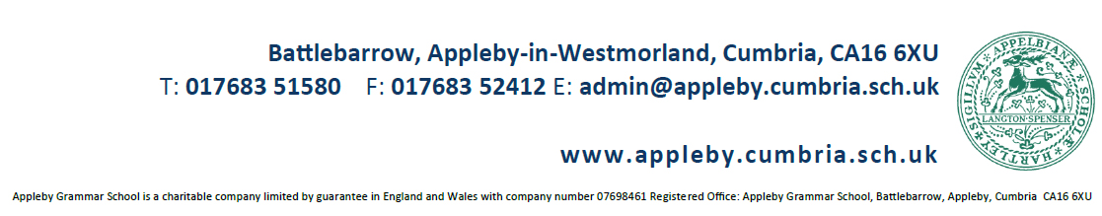



**Privacy Notice for Job Applicants**

Under data protection law, individuals have a right to be informed about how the school uses any personal data we hold about them. We comply with this right by providing ‘privacy notices’ (sometimes called ‘fair processing notices’) to individuals where we are processing their personal data.

This privacy notice explains how we collect, store and use personal data about individuals applying for jobs at our school.

We, Appleby Grammar School, Battlebarrow, Appleby-in-Westmorland, Cumbria, CA16 6XU are the ‘data controller’ for the purposes of data protection law.

Our data protection officer is Darren Hobson (see ‘Contact us’ below).

Successful candidates should refer to our privacy notice for the school workforce for information about how their personal data is collected, stored and used.

A copy of our School Data Protection Privacy Notice for school employees is available on our website.

**The personal data we hold**

We process data relating to those applying to work at our school. Personal data that we may collect, use, store and share (when appropriate) about you includes, but is not restricted to:

* Contact details
* Copies of right to work documentation
* References
* Evidence of qualifications
* Employment records, including work history, job titles, training records and professional memberships

We may also collect, store and use information about you that falls into “special categories” of more sensitive personal data. This includes information about (where applicable):

* Race, ethnicity, religious beliefs, sexual orientation and political opinions
* Disability and access requirements

**Why we use this data**

The purpose of processing this data is to aid the recruitment process by:

* Enabling us to establish relevant experience and qualifications
* Facilitating safe recruitment, as part of our safeguarding obligations towards pupils
* Enabling equalities monitoring
* Ensuring that appropriate access arrangements can be provided for candidates that require them

**Our lawful basis for using this data**

We only collect and use personal information about you when the law allows us to. Most commonly, we use it where we need to:

* Comply with a legal obligation
* Carry out a task in the public interest

Less commonly, we may also use personal information about you where:

* You have given us consent to use it in a certain way
* We need to protect your vital interests (or someone else’s interests)

Where you have provided us with consent to use your data, you may withdraw this consent at any time. We will make this clear when requesting your consent, and explain how you go about withdrawing consent if you wish to do so.

Some of the reasons listed above for collecting and using personal information about you overlap, and there may be several grounds which justify the school’s use of your data.

**Collecting this information**

While the majority of the information we collect from you is mandatory, there is some information that you can choose whether or not to provide to us.

Whenever we seek to collect information from you, we make it clear whether you must provide this information (and if so, what the possible consequences are of not complying), or whether you have a choice.

**How we store this data**

Personal data we collect as part of the job application process is stored in line with our Data Protection Policy and Record Keeping and Retention Policy.

When it is no longer required, we will delete your information in accordance with our Record Keeping and Retention Policy.

A copy of our Record Keeping and Retention Policy is available on our website.

**Data sharing**

We do not share information about you with any third party without your consent unless the law and our policies allow us to do so.

Where it is legally required, or necessary (and it complies with data protection law), we may share personal information about you with:

* *Our local authority – to meet our legal obligations to share certain information with it, such as shortlists of candidates for a head teacher position*
* *Suppliers and service providers – to enable them to provide the service we have contracted them for, such as HR and recruitment support*
* *Professional advisers and consultants*
* *Employment and recruitment agencies*

**Transferring data internationally**

Where we transfer personal data to a country or territory outside the European Economic Area, we will do so in accordance with data protection law.

**Your rights**

**How to access the personal information we hold about you**

Individuals have a right to make a ‘subject access request’ to gain access to personal information that the school holds about them.

If you make a subject access request, and if we do hold information about you, we will:

* Give you a description of it
* Tell you why we are holding and processing it, and how long we will keep it for
* Explain where we got it from, if not from you
* Tell you who it has been, or will be, shared with
* Let you know whether any automated decision-making is being applied to the data, and any consequences of this
* Give you a copy of the information in an intelligible form

You may also have a right for your personal information to be transmitted electronically to another organisation in certain circumstances.

If you would like to make a request, please contact our data protection officer.

**Your other rights regarding your data**

Under data protection law, individuals have certain rights regarding how their personal data is used and kept safe. You have the right to:

* Object to the use of your personal data if it would cause, or is causing, damage or distress
* Prevent your data being used to send direct marketing
* Object to the use of your personal data for decisions being taken by automated means (by a In certain circumstances, have inaccurate personal data corrected, deleted or destroyed, or restrict processing
* Claim compensation for damages caused by a breach of the data protection regulations

To exercise any of these rights, please contact our data protection officer.

**Complaints**

We take any complaints about our collection and use of personal information very seriously.

If you think that our collection or use of personal information is unfair, misleading or inappropriate, or have any other concern about our data processing, please raise this with us in the first instance.

To make a complaint, please contact our data protection officer.

Alternatively, you can make a complaint to the Information Commissioner’s Office:

* Report a concern online at <https://ico.org.uk/concerns/>
* Call 0303 123 1113
* Or write to: Information Commissioner’s Office, Wycliffe House, Water Lane, Wilmslow, Cheshire, SK9 5AF

**Contact us**

If you have any questions, concerns or would like more information about anything mentioned in this privacy notice, please contact our data protection officer:

Darren Hobson

Appleby Grammar School

Battlebarrow

Appleby-in-Westmorland

Cumbria

CA16 6XU