

Teacher of Science with Responsibility

From January/Easter 2019

Closing date for applications:

Tuesday 13 November 2018 at 12:00

Please note that this vacancy will close should a suitable candidate be appointed.

This school is committed to safeguarding and promoting the welfare of children and young people and expects all staff and volunteers to share this commitment. We will carry out a Disclosure Check by the Criminal Records Bureau before making an appointment.



Headteacher: Kerry Oakley

The Warwick School,

Noke Drive, Redhill, Surrey, RH1 4AD

Tel: 01737 378444 (HR)

Fax: 01737 770007

NOR: 920

Website: [www.warwick.surrey.sch.uk](http://www.warwick.surrey.sch.uk/)

# Teacher of Science with Responsibility

# From January/Easter 2019

**TMS, TLR2M + London Fringe Allowance**

This is an exciting opportunity for a skilled, enthusiastic and ambitious teacher to join our dynamic and committed Faculty of Science. The successful candidate will work within this supportive environment to contribute to the success of our students and the development of the curriculum area up to Key stage 4.

Applications from NQTs are welcome and will be supported through an induction programme, which we believe to be second to none.

The Warwick School is a vibrant 11 to 16 school, serving the Redhill area; judged by Ofsted to be

’Good’ with Outstanding Behaviour and Safeguarding.

The school is a member of the South East Surrey Schools Education Trust which is a partnership of The Ashcombe, Therfield and The Warwick Schools; each being successful, inclusive schools committed to work in collaboration for the benefit of their distinctive communities and those children and young people whom they serve. The school offers outstanding continuing professional development for its staff and the Trust will offer a range of opportunities for the right candidate to develop their practice and demonstrate their potential for promotion.

The Warwick School is committed to safeguarding and promoting the welfare of children and young people and expects all staff and volunteers to share this commitment. We will ensure that all our recruitment and selection practices reflect this commitment. All successful candidates will be subject to Disclosure and Barring checks along with other relevant employment checks.

For further information about the post and application form, please visit the vacancy page of the

school’s website [www.warwick.surrey.sch.uk](http://www.warwick.surrey.sch.uk/) or call 01737 378444 (HR)

**Please note that this vacancy will close should a suitable candidate be appointed.**

Therfield School, The Ashcombe School and The Warwick School have formed, and are part of, South East Surrey Schools Educational Trust (SESSET), a charitable company limited by guarantee and registered in England and Wales with company number 10479401. The registered address is The Ashcombe School, Ashcombe Road, Dorking Surrey, RH4 1LY

General Information for Applicants

The School

The Warwick School is a vibrant 11-16 school serving the Redhill area, judged Good with Outstanding Behaviour and Safety in its Ofsted inspection of February 2013. The school works in closely with the Ashcombe School, Dorking and Therfield School, Leatherhead; our partners in the South East Surrey Educations Trust (SESSET).

Currently we have approximately 900 students on roll. Some 98% of our students progress to Further Education or Training, in particular to Reigate College and East Surrey College in Redhill, with which we have very close links. We are proud of our school’s strong links with the local community and employers which assist us in fully serving the needs of all the young people who live in the Redhill area.

Continuing Professional Development lies at the heart of our people first values in relation to staff, and we are proud that many colleagues have been promoted as a consequence.

Location

The School is situated at the end of a quiet cul-de-sac on a green site within 4 minutes’ walk of Redhill town centre and rail and bus stations. The M25 and M23 are only a few minutes’ drive away and rail links to London, the South Coast and Gatwick Airport are excellent.

Accommodation

Our current facilities are very good and our buildings are well maintained. Each sector has its own dedicated suite of rooms and an office. The ICT network provides fast, school-wide access to the internet via broadband and a ratio of 1 computer to 3 students. All students and staff have their own e-mail address and area on the network accessible from home. All teachers are provided with a laptop and most departments have their own cluster of computers (desktops or laptops) and interactive whiteboards. We also have bookable ICT rooms for whole class teaching and a cluster of computers in the library. Our duty of care extends to a robust CCTV system that constantly monitors our site.

Our school grounds include playing fields, a floodlit all-weather sports pitch, tennis/netball courts and an ecology area. In keeping with Surrey County Council policy, the School is a no smoking site.

Over the next three years, we will be part of the Partial Schools Building Programme that will be building a new teaching block, which comprises of 8 science labs, Hall, dining space, drama studio, sports hall, textile and DT rooms and 8 classrooms.

Our students

The Warwick serves the main towns of Redhill, Merstham and Reigate and the surrounding villages as well as students who choose to travel from further afield. Close relationships with our main feeder primary schools are well established. We are a truly comprehensive school in terms of ability, social, additional and educational needs, as well as our religious and cultural mix.

The student voice is a key feature in the life of our school and we encourage our students to take responsibilities in school. Representatives are elected to vigorous Year and School Councils, which meet each half term to discuss issues based on a student-initiated agenda. Prefects, Head Boy and Head Girl are appointed towards the end of Year 10 to offer service to the School including supervision duties and mentoring Year 7 students. The student body runs its own Community Action team, which liaises with the local community and arranges events to benefit local, national and international Charities in association with our student run Rotary Interact Club. Other students help to maintain our ICT facilities, our library and serve as Captains to various subject departments and Clubs.

Curriculum and Organisation

At KS3 all students study the National Curriculum. Students are grouped for learning in most subjects.

At KS4 students study a core consisting of English Language, English Literature, Mathematics, Science, ICT, PE and Philosophy and Ethics. They are encouraged to take an English Baccalaureate subject as at least one of their four option choices. Our close relationships with local colleges enable us to offer a range of vocational qualifications. In addition, we run a small near to site programme for students for whom the traditional school or college route is not appropriate.

All subjects are expected to differentiate learning to meet the needs of the whole ability range and to provide extension activities for the gifted and talented. Additionally, the Learning Support Faculty provides excellent in-class support for students with a range of additional educational needs. Teachers are provided with detailed information on prior attainment, target grades, gifted and talented students, the Pupil Premium, English as an Additional Language and SEN requirements. We are rigorous in applying our Assessment for Learning policy to ensure that all students make progress, which is at least in line with expectation.

Students’ welfare and educational progress are supervised by Form Tutors who each have a mixed ability group of about 28 students. Tutors and the Head of Year remain with the students as they progress through the school. We have a dedicated Support Centre to support the development of identified and selected students.

Extra-Curricular Activities

We offer an extensive range of extra-curricular activities, including sports teams, drama productions, concerts, foreign exchanges, overseas trips, Duke of Edinburgh Awards Scheme and public speaking. Any teacher wishing to offer a new activity will be well supported.

The Staff

The School working environment is stimulating and very busy. We seek to appoint hard-working and self-motivated people, committed to high standards and inclusion, who show initiative and can work under pressure. Over 130 people are employed at The Warwick School. Successful applicants for posts at The Warwick School will join a friendly, cohesive and supportive team, dedicated to providing a quality education for the young people in our care.

The Warwick Partnership

Our School Direct programme is where we recruit trainees directly so that you can gain a PGCE. We work with a number of other local schools as well as University of Brighton and University of Sussex.

Safeguarding Statement

This school is committed to safeguarding and promoting the welfare of children and young people and expects all staff and volunteers to share this commitment. We will carry out a Disclosure Check by the Criminal Records Bureau before making an appointment.

cid:image003.jpg@01D45EF5.A68E9E70

Department Information

The Warwick has a vibrant, thriving and extremely successful Science department in the privileged position of providing many opportunities for the children in our community. Our friendly and supportive Science Team consists of nine teachers with a range of experience, and four technicians, who are also involved in Gardening club, Science club, Forest Schools and “Bike it”. One of our technicians John Everett, now retired from teaching, oversees the Duke of Edinburgh award scheme and is responsible for Outdoor education.

The Science department is situated along one corridor in the main building and consists of eight laboratories, two prep rooms, a paper store and a science hub/work area. All classrooms have interactive whiteboards with software networked to support schemes of work, interactive on-line textbooks and other ICT resources. The department also has thirty laptops available to book.

We have developed many links with both feeder and partnership schools as well as national and local external agencies to ensure that our students experience ‘real life’ applications in this broad subject. We are the only school to have received an award for WISE, we have also won a STEM club award, and work closely with our community link officer so that students have the opportunity to attend a range of WISE and STEM activities. These include careers events with STEM ambassadors and other local employers, competitions with local schools and trips to science lectures at The Royal institution, as well as our annual Warwick Christmas lecture. Primary schools regularly visit our department to take part in Space Days and Chemistry Days; we also visit them to deliver science activities and lend equipment.

The Science department is in the fortunate position of having an Ecology Area consisting of 1.2 Hectares of woodland with a lake and brook, enabling us to develop learning outside the classroom, for example, working with Surrey Wildlife Trust and Sutton and East Surrey Water on the Longitude Explorer Prize and Riversearch for schools project. Other extra-curricular opportunities include our Science Spectacular evening with Prof Hal from the University of Brighton, Science club, Gardening club (in its infancy), Lego Robots, Summer school and various trips, such as to the The Big Bang Fair and the Royal Society summer exhibition.

The range of opportunities the Science department provides has resulted in a significant number of students choosing Triple science as an option in Year 10 and continuing into A Level sciences at Reigate Sixth Form College. It is wonderful when we hear how some of these students progress to Russell group universities, including Cambridge. Additionally we have students who have achieved places on the STEM potential programme at Imperial College, London and two year nine students have made successful applications to the STEM summer school at the same institution.

The department is seeking to appoint an enthusiastic team player who is driven to inspire students in all three scientific disciplines by fostering a creative and investigative approach to learning. They will make a positive contribution to the future vision of the science department by bringing new ideas and regularly sharing good practice. The science department is committed to CPD and regular opportunities will be available to the successful candidate.

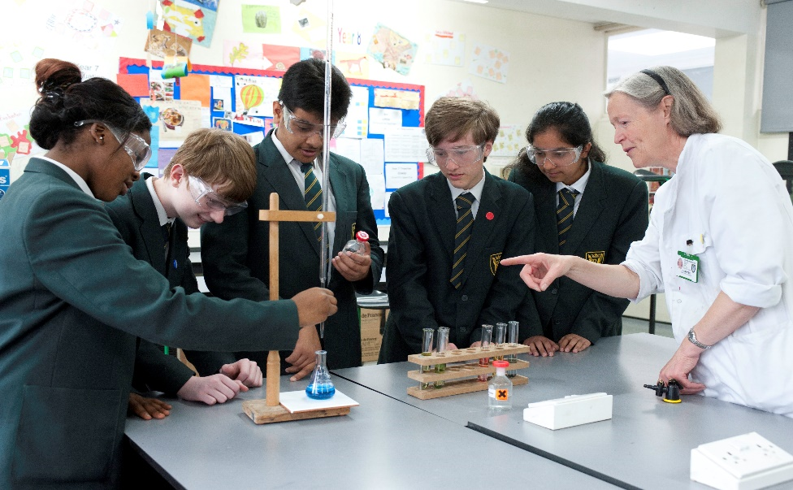

Job Profile

|  |  |  |  |
| --- | --- | --- | --- |
| Post Title: |  | Science KS3 Co-ordinator TLR 2 | |
|  |  |  | |
| Purpose: | Factors  a)  c)  b)  b)  c)  b)  d)  b) | * To optimise standards of student attainment and achievement within the subject and to monitor and support student progress. * To be accountable to the Faculty Learning Leader for quality assurance of student progress and development * To develop, enhance and monitor the teaching practice of others. * To ensure the provision of an appropriately broad, balanced, relevant and personalised curriculum for students in the Faculty in accordance with school aims and Governing Body policies * To be accountable for leading, managing and developing the curriculum area including staff, financial and physical resources * To lead in actively engendering a high level of professionalism, shared sense of purpose & positive emotional climate in the school and so create a vision, sense of purpose and pride in the faculty * To support the Faculty Learning Leader deputising when necessary * To promote STEM in years 7-9 through enrichment activities such as running STEM club, organising external visitors and/or trips | |
|  |  |  | |
| Direct Reporting: |  | Faculty Learning Leader | |
|  |  |  | |
| CORE DUTIES | | | |
| Operational & Strategic Planning | b)  b)  a)  c)  c)  a) b)  c) | * To lead the development of appropriate specifications, resources, schemes of work, assessment and marking policies, and teaching for learning strategies within the designated subject area * The day-to-day management, control and operation of subject service delivery * To systematically track, monitor and follow up student progress * To implement and monitor School Policies and Procedures * In liaison with faculty colleagues to take a leading role formulating aims, objectives and strategic plans for the Faculty which meet client need, have coherence and congruence with and contribute to the School Improvement Plan * To assist in ensuring that service delivery holistically reflects the School's distinctive ethos and mission. * To ensure that Health and Safety policies and practices are carried out in-line with specified requirements * To improve the engagement in science and future career aspirations through co-ordinating STEM enrichment activities |
| Curriculum Provision, Development & Service Delivery | a) b) c)  c)  c) | * To liaise with the Faculty Learning Leader in the development and delivery of an appropriate, comprehensive, high quality and cost-effective curriculum within the subject and wider Faculty * To lead curriculum development in the subject, keeping up to date with national developments and teaching practice and methodology | |
| Human Resources | b) c)  b) | * To contribute to Performance Management Review(s), ensuring that resultant staff development needs are met * To inspire Faculty members by personal example, promoting teamwork and intrinsic motivation * To participate in the school’s ITT programme. | |
| Management Information: | c) d)  a) c)  a) c)  c)  c) | * To maintain accurate and up-to-date information * To make use of analysis and evaluate performance data provided. * To help identify interventionist action on issues arising from data, systems and reports reviewing progress on the action taken * To help produce reports within the quality assurance cycle * To actively engage with information on examination performance   . | |
| Communications & Service Orientation: | b)  c)  c) | * To contribute to vision ownership & buy-in from staff * To ensure effective communication/consultation with parents * To communicate and co-operate with persons or bodies outside the school and to actively promote the school’s ethos when doing so. | |
| Marketing and Liaison: | c)  c)  c) | * To contribute to the School liaison and marketing activities * To lead the development of effective subject links with partner schools, external agencies the community, primary and FE partners * To actively promote the school & its corporate well being. | |
| Management of Resources: | c) | * To assist the F aculty Learning Leader in managing the available resources of space, staff, money and equipment efficiently in line with the principles of “Best Value” | |
| Pastoral Care & Welfare System: | a) c)  a) c)  a) c)  a) c)  a) b) c) | * To monitor and support the overall well being progress and development of students within the curriculum area * To help monitor student attendance, progress and performance in relation to targets ensuring that interventionist strategies are implemented * To contribute to PSHCE, CEG, WRL * To implement the Behaviour for Learning system in the curriculum area Faculty so that effective learning can take place * To contribute to the implementation of the school’s pastoral system and the 5 outcomes of Every Child Matters | |
| Additional Duties: | a) c) | * To play a full part in the life of the school community, to support its distinctive mission and ethos and to encourage staff and students to follow this example. | |
|  | | | |
| Other Specific Duties: | | | |
| To continue personal development as agreed.  To be generally responsible for safeguarding and promoting the welfare of students  To undertake any other duty as specified by STPCB not mentioned in the above.  To comply with any reasonable request from a manager to undertake work of a similar level that is not specified in this job description  To take the lead in courtesy to colleagues and in modelling the school ethos to visitors and callers.  The school will endeavour to make any necessary reasonable adjustments to the job and the working environment to enable access to employment opportunities for disabled job applicants or continued employment for any employee who develops a disabling condition.  This job description is current at the date shown, but, in consultation with you, may be changed by the Headteacher to reflect or anticipate changes in the job commensurate with the grade and job title. | | | |

Person Specification: Class Teacher

|  |  |  |
| --- | --- | --- |
|  | **Selection Criteria** | **Assessment Method** |
| **Qualifications** | Essential:   * Qualified Teacher Status * Evidence of further professional development * Desirable: * Post Graduate Qualification | Application form  Certificates |
| **Experience** | Essential:   * Successful teaching and curriculum experience * Recent experience of teaching within KS3 and KS4 | Written statement  Lesson observation  Interview |
| **Professional Knowledge and Understanding** | Essential:   * Sound understanding of science curriculum * Knowledge of best practice and procedures for safeguarding children and young people * Other key areas for the school/phase, early years, extended services etc. | Written statement  Lesson observation  Interview |
| **Professional Qualities** | Essential:   * Committed to the development and maintenance of good relationships with staff, parents, students, governors and the community. * Committed to the continuing professional development of self and others within the school. * Demonstrates flexibility appropriate to circumstances * Communicates enthusiasm and energy. | Interview  Group exercise  Presentation |
| **Skills and Aptitudes** | Essential:   * Able to plan and organise effectively * Well developed oral and written communication skills * Communicates at a level and in a manner appropriate to the situation | Application form  Written statement  Interview  In-tray exercise  Group exercise |

How to Apply

We hope that you would like to apply; please complete our application form for teaching posts on the vacancy page and send it to us with a supporting statement explaining what attracts you to the post and details the skills and experience you would bring to it.

Your completed application can be emailed to Karen Ehren HR Officer: [ehr@warwick.surrey.sch.uk](mailto:ehr@warwick.surrey.sch.uk)

or post to:

Mrs Karen Ehren

HR Officer

The Warwick School

Noke Drive

Redhill

Surrey

RH1 4AD

If you would like any further information please telephone Karen Ehren on 01737 378444 or email [ehr@warwick.surrey.sch.uk](mailto:ehr@warwick.surrey.sch.uk)

Please note that this vacancy will close should a suitable candidate be appointed.