HEAD OF NETBALL
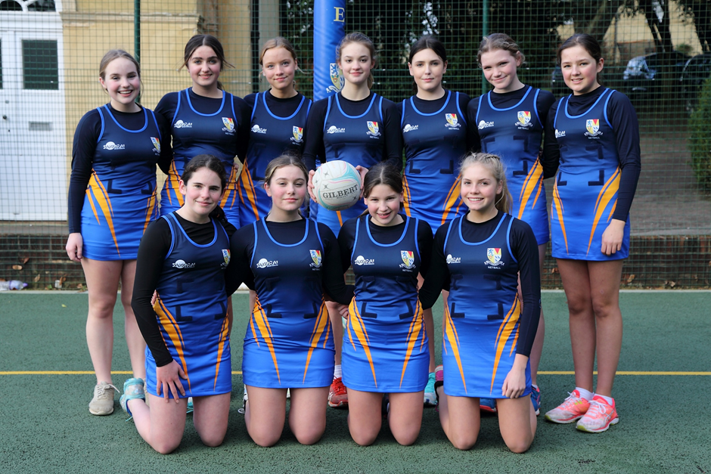
STOWE SCHOOL

Stowe School is a co-ed secondary independent boarding and day School of 880 pupils set in a sublime environment. We have an exciting opportunity for a dynamic and enthusiastic Head of Netball. The ideal candidate would possess ambition, drive and energy in order to lead the programme for teams and individuals in order to further build on the School’s rapid recent development in netball and to support the ambition of being a centre of excellence in the sport.
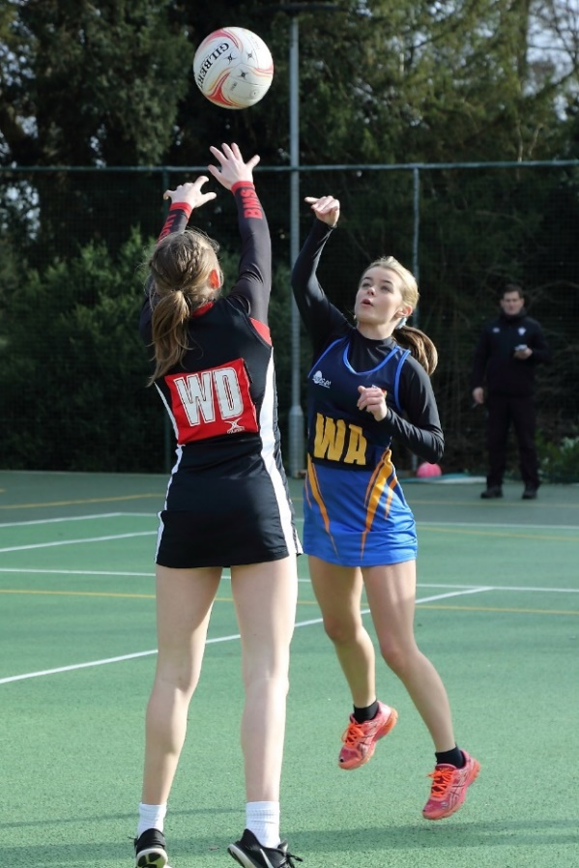
Stowe School runs 14 netball teams across five year groups with fixtures for all teams in the Lent term and pre-season training in the Michaelmas term. All our netball teams are part of the very strong Midlands Schools Sports League, we also enter teams to the National competitions. The post holder will be a qualified coach with experience of leading netball within either a School or club environment and a strong track record of increasing player participation and managing performance programmes for elite players.

Wasps have a performance hub at the School and strengthening this link as well as creating new partnerships will be central to this role. You will be required to assist with the development of the netball programmes in Winchester House and Swanbourne House Prep Schools which are part of The Stowe Group, as well as developing links with other prep Schools as part of the School’s outreach.

The ability to coach a summer sport to a high level will be an advantage. The post does not come with a teaching requirement, although teaching opportunities can be provided as part of the role.

The ideal start time would be September 2021, but candidates who cannot start until January 2022 will be considered.

Megan Thorne (Cheshire Upper Sixth) - England U19 and Wasps Senior squad

Head of Netball - Job Description
Job Title: Head of Netball
Department: Sports
Accountable to: Director of Sport
Purpose of the job:
To lead and manage the netball programme within the framework of an evolving Games Strategy Plan and to coach netball and at least one summer sport to support the delivery of a high quality and broad programme of sports and activities. To create an environment where students and staff enjoy taking part in sport and develop positive life-long habits and attitudes.

Context:
Stowe School occupies Stowe House and about 200 acres of the Stowe estate, and is located in Stowe’s world-famous landscape gardens set in 880 acres. Stowe School is an independent co-educational boarding School with approximately 850 pupils. There are around 500 full and part-time staff with 80 staff and their families living on site. The National Trust manages the landscape gardens and opens the grounds to over 200,000 visitors a year. Stowe House is open to the public during the School holidays and, for guided tours, during term time.
Stowe School is committed to safeguarding and promoting the welfare of children and expects all staff to share in this commitment.
Values and Behaviours:
The post-holder is expected to act professionally at all times and in accordance with the standards of behaviour and code of conduct outlined in the staff handbook and below.
The Stowe Community is committed to working together to achieve Stowe’s aims and objectives. It is a Christian community that aspires to excellence through working efficiently whilst being responsive to change, adding value where possible and using resources wisely. We collaborate to work both as individuals and as members of a team, communicating and consulting often and openly to the highest standards. We act with integrity and treat each other considerately, valuing diversity and rejecting discrimination. We operate within the appropriate laws and regulations. We are accountable to each other and to our pupils, parents, governors, trustees and visitors. The Stowe Community is both environmentally and socially responsible, recognising the importance of an appropriate work/life balance.
Key Responsibilities and Accountabilities:
- To manage the organisation of the netball programme and the delivery of the netball coaching.
- To promote the aims of the School at all times with colleagues, parents, pupils and the public.
- To play a full part in a seven day a week boarding School with commitment to teaching/coaching, pastoral care, extra-curricular activities and School duties.
- To assist in the recruitment of pupils and to promote the School and Department.
- To provide professional high-quality teaching/coaching, with the effective use of appropriate resources and the highest standards of learning and achievement of all pupils.
- To attend all appropriate Health & Safety (COSHH) and Child Protection training issues related to the pupils, School and Department.
Key Tasks:
1 Coaching
1.1 To enable pupils to acquire knowledge and make progress according to their ability so that they increase their understanding and develop their skills in the sport taught.
1.2 To foster in pupils the application of physical or creative effort, interest in their work, and the ability to think and learn for themselves.
1.3 To develop a progressive Netball programme to guide coaching throughout the School.
1.4 To show a good understanding of the aptitudes, needs and prior attainments of the pupils and ensure these are taken into account in activity-planning.
1.5 To utilise effective strategies for managing behaviour and encouraging pupils to act responsibly.
1.6 To organise, structure and lead pre-season training.
1.7 When required: Assess, record and report on pupils’ development, progress and attainment/achievement.
1.8 To contribute to the development of the sports programme.
1.9 To assist in the PE/Sports Science Dept with occasional lesson cover.
2.0 To manage the link with Wasps and develop further links with local clubs and satellite academies.

2 Management & Administration
2.1 To make fixtures in accordance with the School’s fixtures policy.
2.2 To ensure the registration of pupils for practices during afternoon activities.
2.3 To co-ordinate match results and match reports in a format suitable for School assembly and website.
2.4 To write/co-ordinate reports for the Stoic and End of Term assembly.
2.5 To update the risk assessment on an annual basis.
2.6 To attend INSET for continued professional development and recommend INSET training at the appropriate level for coaches under your charge.
2.7 To co-ordinate the programme for your sport through the Director of Sport.
2.8 To manage your sports budget.
2.9 To order equipment and kit on official order forms.
2.10 To check and maintain your sports equipment.
2.11 To organise transport to and from matches.
2.12 To organise catering requirements for matches through the Catering Department.
2.13 To manage your sports coaches on a day to day basis.
2.14 To send out weekly netball programme to the staff/departments who rely on this information.
2.15 To run weekly meetings for coaching staff.
2.16 To liaise with the Director of Sport and the Grounds Manager regarding the preparation of pitches/courts/facilities for practices and matches.
2.17 To liaise with the Director of Sport regarding the staffing of your sport.
2.18 To develop outreach programme with Prep Schools, local Schools and local clubs (in particular Wasps Academy and Milton Keynes Netters Club) to develop Stowe netball players and identify potential candidates for sports scholarship application.
2.19 To assist the Director of Sport in the delivery of the Sports Scholarship programme.
2.20 To put pupils of appropriate ability forward for representative honours.
2.21 To organise accommodation etc. when required for Regional/National competitions.
2.22 To organise pre-season training through the Director of Sport.
2.23 To organise sports tours through the Director of Sport.
2.24 To assist with Sports / Activities administration when required.
2.25 To manage video analysis process for your sport and assist where appropriate with others.
2.26 To monitor and develop advanced training programmes for pupils on sports scholarship and / or in the Sports Performance Programme linked with netball.
2.27 To contribute to the induction and support of new and probationary teachers.
2.28 To be committed to continuing career and professional development.
2.29 To ensure compliance with the current teaching staff handbook.
2.30 A willingness to be involved in other activities as directed by the Director of Sport.
3 Social and moral welfare of pupils
3.1 To take responsibility for the educational, social and moral welfare of pupils in the context of Stowe's boarding community.
4 Assessments and reports
4.1 To provide or contribute to oral and written assessments, reports and references relating to individual pupils and groups of pupils as required by the Director of Sport.
5 Review and Professional Development
5.1 To keep abreast of developments in his/her sport(s) and its coaching methods in order to maintain a high level of professional competence Staff should also participate in arrangements within the agreed framework for review and professional development, including INSET.
6 Discipline, Health and Safety
6.1 To maintain good order and discipline among pupils and safeguarding their health and safety both on the School premises and when they are engaged in School and other activities elsewhere, within the framework of the Health and Safety Policy documents.
6.2 To adhere to and manage all appropriate Health & Safety legislation, risk assessments and Child Protection training issues related to the Department.
7 Cover
7.1 To supervise pupils whose teacher is not available.
8 Meetings
8.1 To participate in all meetings which relate to the School curriculum, School organisation and School administration and to attend Chapel, assemblies and other School events as required by the Head.
9 Examinations
9.1 To assist with examination invigilation in line with other full-time staff.
10 School Duties
10.1 To undertake the supervision of pupils at meal times, in detention, on School journeys and on School premises as required by the duty rota.
10.2 To assist with the evening and weekend activities programme.
This job description reflects the present requirements of the post and as duties and responsibilities change/develop, the job description will be reviewed and be subject to amendment in consultation with the post holder.

Date agreed: March 2021

Person Specification
The selection of candidates for short-listing will be based on this specification and candidates should bear this in mind when preparing their application and completing the application form:
Attributes | Essential | Desirable
Qualifications | - England Netball Level 2 coaching award | - A good degree  - Netball umpiring qualifications
Specialist Skills & Experience | - Representative honours at County/Regional level or equivalent  - Previous experience of coaching  - Personally committed to continued professional development  - A willingness to coach other sports  - Good ICT skills | - Previous experience of coaching to a high level  - Experience of Independent and/or State boarding environment  - Driving licence  - Experience managing/supervising coaching staff  - Basics of financial management (departmental budgets).  - Previous experience of leading a hockey/sports programme
Personal Qualities | - Enthusiastic and energetic  - Good team player  - Patience and a sense of humour  - Good organisational skills  - Good professional manner and appearance  - Excellent practitioner able to inspire pupils in the love of (your) sport  - Ability to communicate effectively with pupils, staff and parents  - Willingness to contribute fully to the life of a busy boarding School

REMUNERATION AND OTHER BENEFITS
This is a full-time post and the salary will be commensurate with the qualifications and experience of the successful candidate, and will also reflect the importance of this post, which will be discussed at interview.

