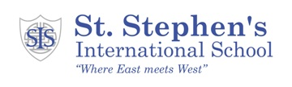
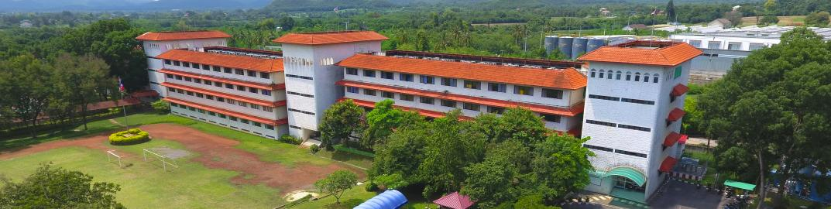Applicant Information Pack
PE Teacher
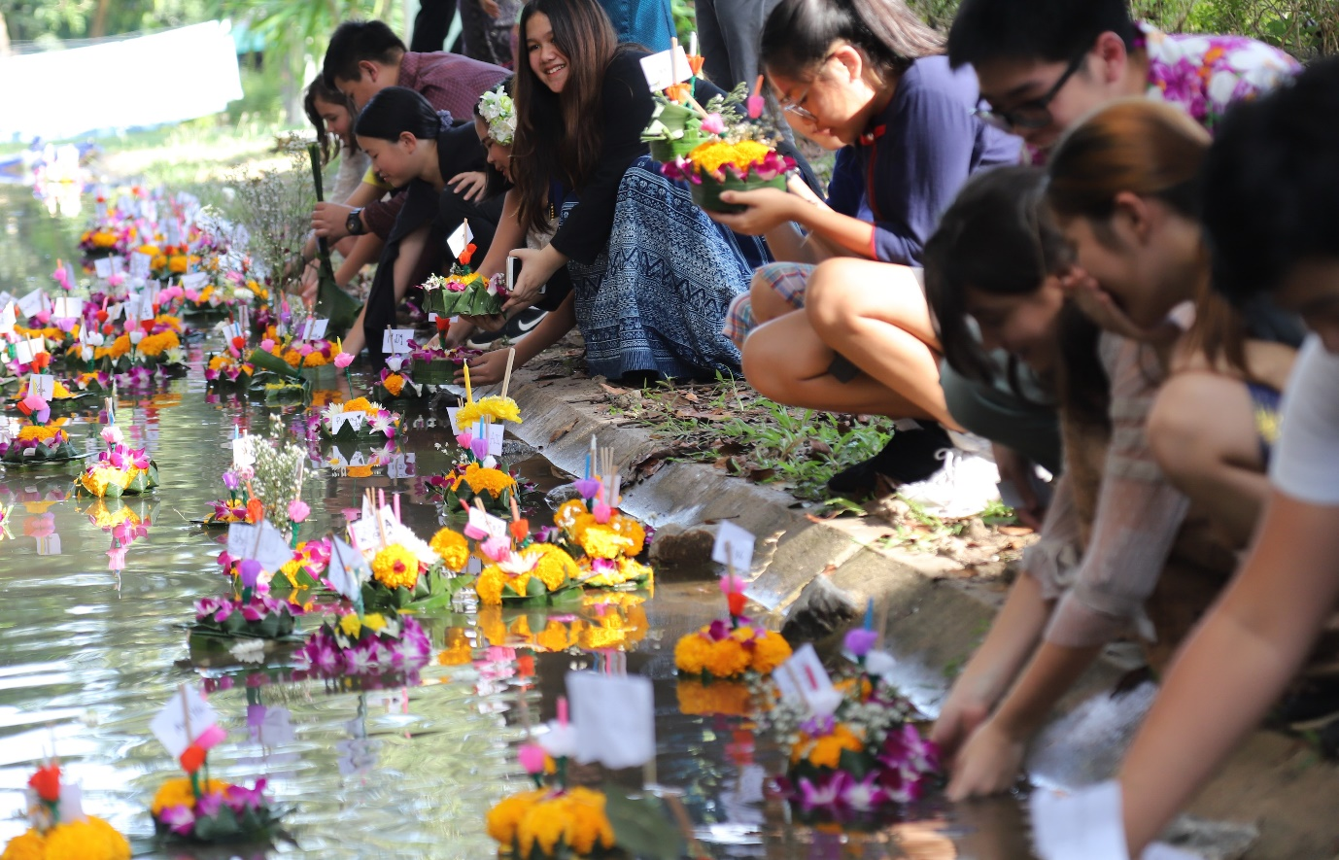
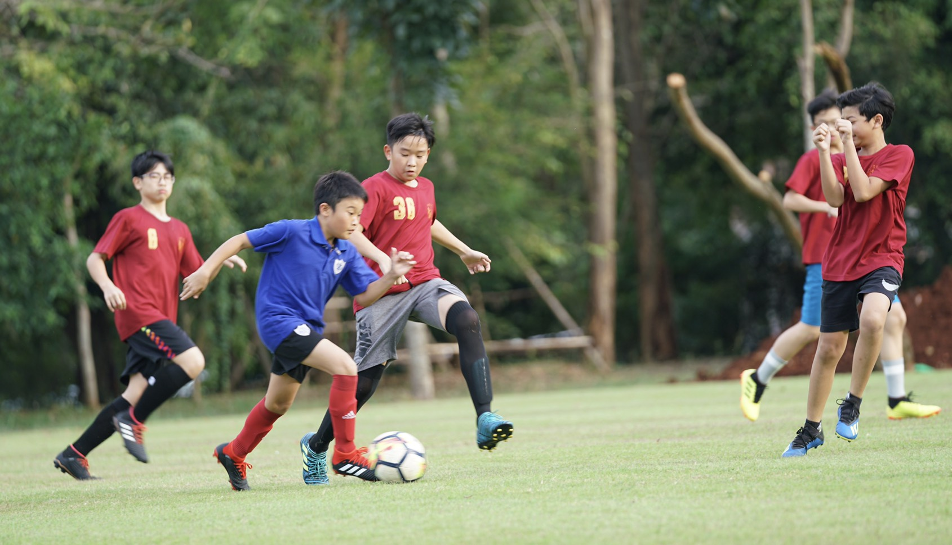
Dear applicant,
Thank you for expressing an interest in the role of PE Teacher at St. Stephen’s International School, Khao Yal. I hope you find the information in this application pack informative as we are keen to employ an outstanding candidate who will make a significant impact to the school. If you feel that you have the skills and dedication to make a difference, I strongly encourage you to make an application.

St. Stephen’s is an exceptional school in many ways. It was the first international boarding school in Thailand and remains one of only a handful of international boarding schools in Thailand offering the English curriculum. The school occupies one of the finest campuses in Thailand. Seated close to the World Heritage Site of the Khao Yai National Park there is access to a range of exceptional resources and attractions. We are unique in that we host the Howling Gibbon Adventure Centre. This is a specialist outdoor education centre that provides opportunities to students from around Thailand to experience learning in an outdoor environment. Our students are fortunate in being able to benefit throughout the year from this special resource.
With around 130 students from age 2 ½ to 18 everyone knows everyone. We offer a very personalised learning environment and students are supported exceptionally well. Class sizes are small and teachers often benefit from the support of a teaching assistant. All primary classes have their own dedicated teaching assistant and there are additional teaching assistants specialising in ESL, science, PE and design technology.
Our ‘East Meets West’ philosophy is very important to us. We take the best that education offers from the West and combine that with the culture and exemplary learning approaches from the East. Our students are a delight to teach and parents are incredibly supportive. As a school we have very high expectations of our students and staff, and provide an environment where everybody can thrive. We mark key Thai ceremonies within school, which celebrates the Eastern culture.
We are seeking an outstanding PE Teacher to work within our successful primary school. The exceptional candidate we wish to appoint will be able to build upon established success. The appropriate candidate will have high aspirations for every student and will be expecting students to make very significant progress during their time with us.
We have a single full-time PE teacher post, which is supported by a full-time PE teaching assistant. The successful applicant will need to teach both boys and girls from Nursery through to the Sixth Form. Some teaching groups will be mixed year groups. A wide range of sports are taught in the school and the successful candidate will require a good all round knowledge of different sports. Appropriate swimming qualifications are essential as all year groups swim for the majority of the year.
The school prides itself on its inclusive approach to PE and sport. We have a number of sports events during the year where every student participates, with significant staff and parent involvement as well. In addition to this students are keen to participate in competitive fixtures and there are regular competitions throughout the year, particularly in football and basketball. The school hosts residential tournaments each year and the successful candidate will be expected to organise these.
The school is highly committed to the professional development of all its staff and has a structure that enables all teaching staff and teaching assistants to benefit from a weekly CPDL slot. We encourage opportunities to share best practice in a culture of collaboration.
The school has excellent teaching facilities, both within the school building and outside. We are fortunate to be occupying a large site with a sports field, cross country course, outside swimming pool, three tennis courts and a large gym with two basketball courts. There is also a small fitness gym on site and a nine hole golf course adjacent to the school. The school is continually looking to improve, and we are currently building a dedicated STEAMER Centre within the school (Science Technology Engineering Art Mathematics Electronics Robotics) as well as expansion of the outdoor teaching facilities. We are also opening our sixth form in August 2020.
St. Stephen’s International School, Khao Yai has a sister school in Bangkok. The two schools work closely together and there are opportunities for collaboration between the two sites. This is very helpful in a school where there may be a single member of staff in a department.
All candidates must complete the standard application form, which is accessed via the TES website. In addition, applicants are asked to send their CV with a photo included to the Head of Campus at hoc_ky@sis.edu . Any additional enquiries should also be sent to this email address.

St. Stephen’s International School, Khao Yai is committed to safeguarding and promoting the welfare of children and young people and expects all its staff to share this commitment. The interview process will assess your ability to meet the essential requirements of the post including suitability to work with children. References will be requested as part of the interview process.

This is a very exciting time to join St. Stephen’s International School, Khao Yai. I look forward to receiving your application.

Yours sincerely
Dr. Kevin Hylands
Head of Campus
St. Stephen’s International School, Khao Yai
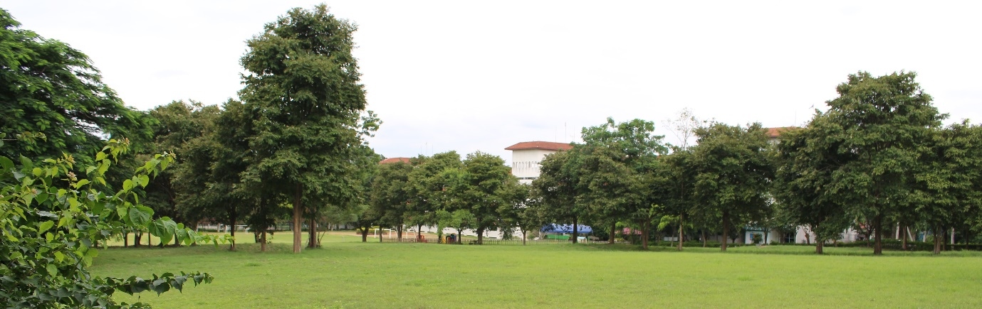
St. Stephen’s is a non-selective co-educational day and boarding school set in a beautiful 51 Rai site and located close to the unique and stunning World Heritage Site of the Khao Yai National Park. As the first boarding school in Thailand, the school is well established and has excellent facilities. The current intake is from 2 ½ years to 16 years old, with around 20% of students boarding. From August 2020 we are accepting applications for our sixth form.
Whilst we are non-selective with a high proportion of English as an Additional Language learners, our examinations results are excellent. In 2019 we achieved an overall A*-C pass rate at IGCSE of 100% with 53% of these at A*/A grades.
Around 70% of our students are Thai nationals who desire a high quality English curriculum. A further 20% have dual Thai nationality with a small number of expat students from countries such as the UK, USA, New Zealand, Australia, Switzerland and Korea.
The school occupies an idyllic site that includes many sporting facilities, outdoor education facilities, a cross country route and natural woodlands. Adjacent to the school and reached by the same entrance is a 550 Rai golf course. The school is easily accessible in under ten minutes from the main highway linking Bangkok to Northern Thailand. Bangkok itself is 150 km away, around a two hour drive. The nearest major town is Pak Chong, around ten minutes drive away.

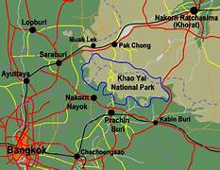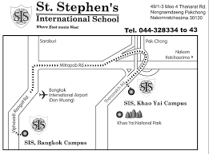

The School Curriculum
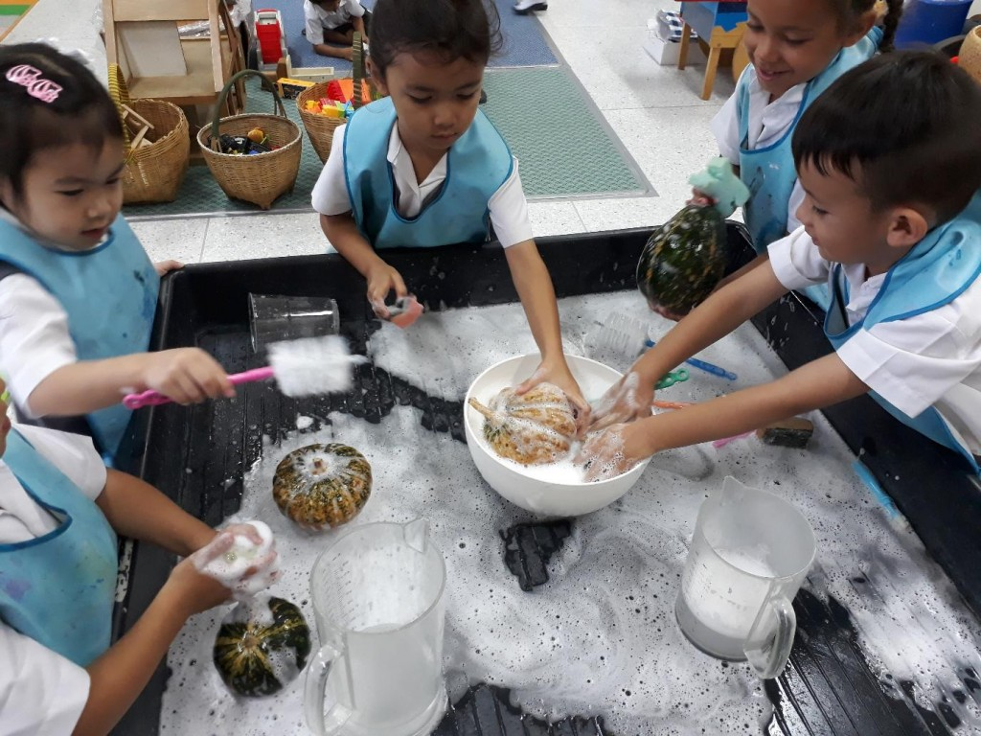
Early Years
The school has a discrete Nursery group and a combined KG1 and KG2 group. Each class has spacious accommodation with dedicated resources. The Nursery has a separate sleeping area, which some KG students continue to use. The school follows the English Framework for the Early Years Foundation Stage, which has seven areas for learning and development. These are communication and language, physical development, personal, social and emotional development, literacy, mathematics, understanding the world and expressive arts and design. Specialist lessons are provided for music, PE, Mandarin and Thai. Each class is supported by a dedicated teaching assistant and in addition a Nanny supports the nursery.
Primary
Primary covers Key Stage 1 and Key Stage 2. Year 1 and Year 2 are currently taught as a combined class. All other primary classes are taught as a single year group. Each primary class has its own dedicated teaching assistant. The school broadly follows the English National Curriculum, which is delivered through the International Primary Curriculum (IPC). This provides a highly engaging, cross-curricular and internationally minded curriculum. The IPC Curriculum is split into Mileposts:
Years 1 and 2 – Milepost 1 Years 3 and 4 – Milepost 2 Years 5 and 6 – Milepost 3
Within each Milepost learners engage in exciting, globally relevant thematic units of work that help pupils engage in learning from multiple perspectives. Themes are explored through independent yet integrated subjects and cover all key academic areas such as science, history, geography, art, design technology, society, international studies, ICT and computer science.
Academic learning goals are used to improve learning and to support pupils in being able to articulate and reflect upon their own learning experience.
Each IPC unit has a unique learning process that enables pupils to reflect on, consolidate, question and develop their learning. Each unit begins with an Entry Point to engage and excite, a Knowledge Harvest, to identify prior learning, Research and Recording Activities and an Exit Point, to reflect on and celebrate learning.
Personal and International Goals are also a key aspect of the IPC Curriculum and at St. Stephen’s they are taught, encouraged and promoted in all aspects of school life. We believe that these individual qualities and dispositions are essential for our pupils to become leaders of the future.
Mathematics is taught as a discrete subject. The ‘Busy Ants’ scheme provides an overall structure and many useful resources. Thai, Mandarin, music and PE are all taught as specific lessons by subject specialists.
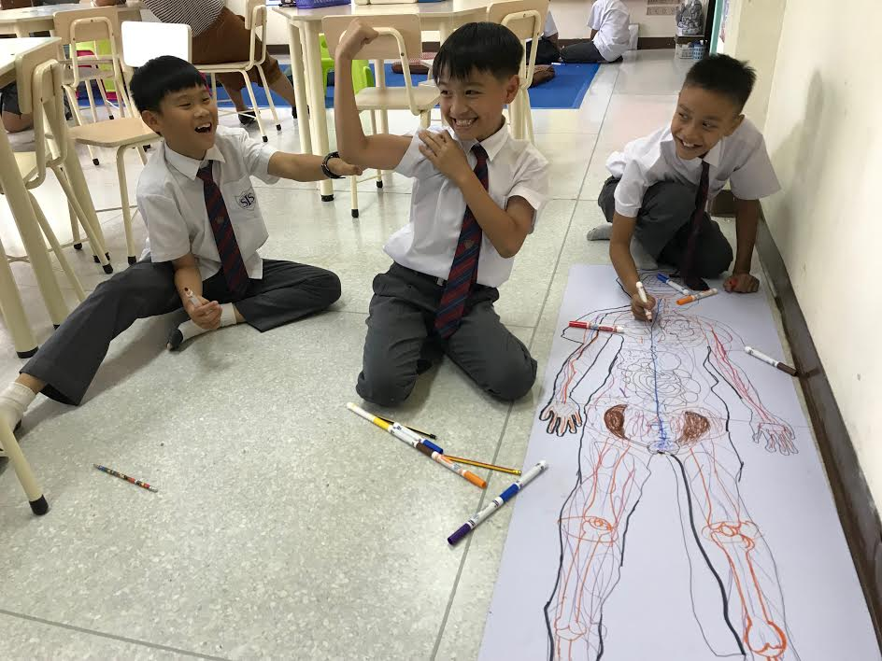
Key Stage 3
Students follow the English National Curriculum with all students taking the following subjects: art and design, computing, design technology, drama, English, geography, history, Mandarin (as the modern foreign language), mathematics, music, PE, PSHE and science. In addition, the requirements of the Thai government are met with students studying Thai language and culture, which includes certain geographical and historical content particularly relevant to Thailand, and Thai music. This provides a rigorous overall curriculum that challenges every student.
Both English and Thai are set with separate groups for first and second language learners. In both cases the school is very successful over time in enabling students to move from first to second language classes. Science is taught at Key Stage 3 by a single science teacher covering biology, chemistry and physics. Design and technology is currently taught as a rotation between all three year groups covering cooking / food and nutrition, product design and either wood work or electronics. Drama is taught to a combined Year 8 and Year 9 group and separately to Year 7. Each of these classes will perform a major production during the academic year. All other lessons are taught to year group classes.
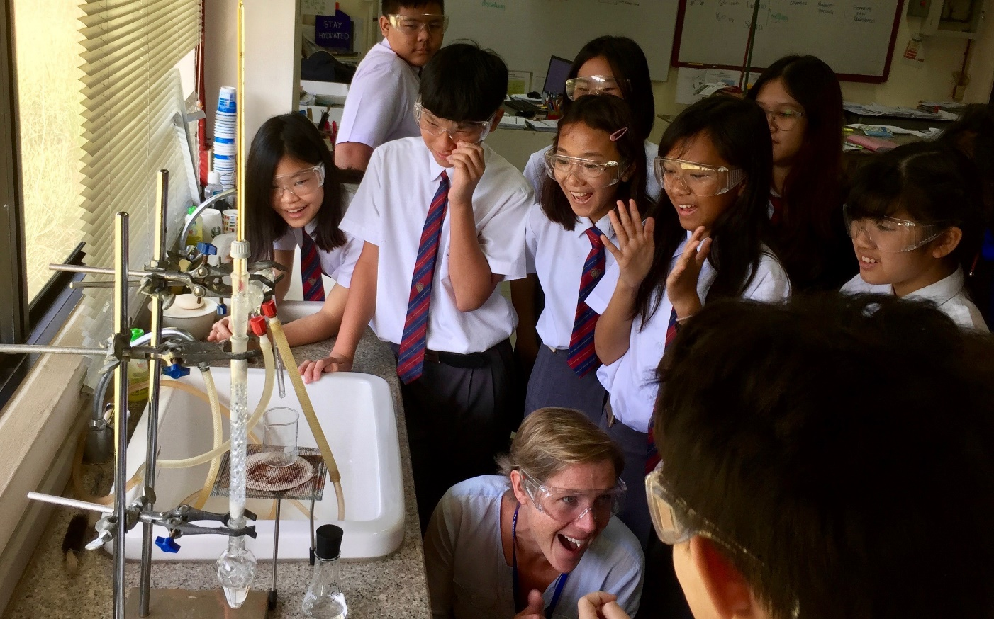
Key Stage 4
Students take their options in Year 9 and start their IGCSE studies in Year 10. All examinations are taken through CIE. All students study the following subjects: English, mathematics, PE, PSHE, Thai Language and Culture. Students in the English second language class will take the IGCSE English as a Second Language examination whilst the remaining students will take the English as a First Language examination. Nearly all the students who take the latter examination also successfully take the IGCSE World Literature examination. Only students in the First Language Thai class take the IGCSE examination as there is no equivalent examination for second language learners in Thai.
Students choose a further five subjects as part of the options process. One of these has to be a science. The recent options include art and design, biology, business studies, chemistry, design technology, geography, ICT, Mandarin and physics. The options offered, depend to some extent on the specialisms that staff are able to offer.

Key Stage 5
We are opening our sixth form to Year 12 in August 2020. Students will be offered a choice of a range of AS Levels including art and design, biology, chemistry, English Literature, ICT, Mandarin, mathematics and physics. All students will take part in a PSHE programme, which will include preparation for the IELTS examination, which is a requirement of many universities when accepting international students.
After School Activities (ASA) Programme
Extra-curricular activities are offered each day after normal lessons have finished. These are an important preparation for future life and enable students to broaden their experience beyond the core academic studies in normal lessons. The ASA programme is very popular, and many students attend four of the sessions each week. Activities are very varied, ranging from sports based activities, to STEM based clubs such as robotics to creative opportunities such as The Big Mural or dancing. In addition, some students take the opportunity to have additional tutorials and there is a vibrant individual music lesson programme covering around twenty instruments.
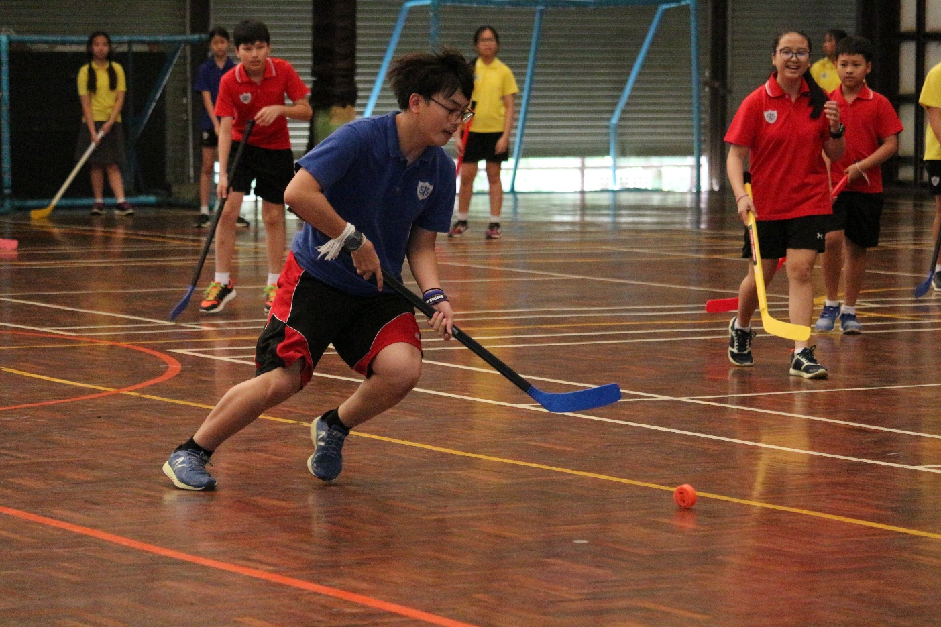

The School Site
The main building is made of three linked towers. The top two floors of Tower A and Tower B are used as boarding accommodation for dorm students and visiting groups. The bottom three floors provide teaching and administration accommodation for the school. The bottom floor of Tower C is currently being converted for use as the STEAMER Centre and will be used for the teaching of design technology and related subjects. The remainder of Tower C is used for accommodation and teaching purposes when we host large numbers of visiting students during our English and Adventure Camps.
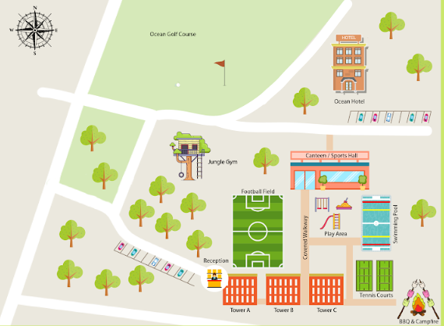
Major Facilities include:  - Large gym with two complete basket ball courts  - Large football field  - Three tennis courts  - 25 m swimming pool  - Cross country course  - Low ropes course for Jungle Gym  - Large dedicated music facility  - Two dedicated science laboratories  - Two ICT suites  - Food technology room  - Upgraded dormitory accommodation | Facilities planned or under development:  - STEAMER Centre  - Outdoor Classroom  - Outdoor obstacle course  - Bouldering wall

Living and Working in Khao Yai, Thailand
The School
Working at St. Stephen’s International School, Khao Yai is a delight. The students are positive, hard-working and focused on their learning. Behaviour issues are almost non-existent. Parents are respectful and appreciative of the teachers efforts. The school is a real community where everyone knows everyone and where everyone is mutually supportive. The idyllic location, excellent weather, good work-life balance and ability to use Thailand’s position as the travel hub of South East Asia means that as well as achieving a fulfilling professional role in school, staff can enjoy life too!
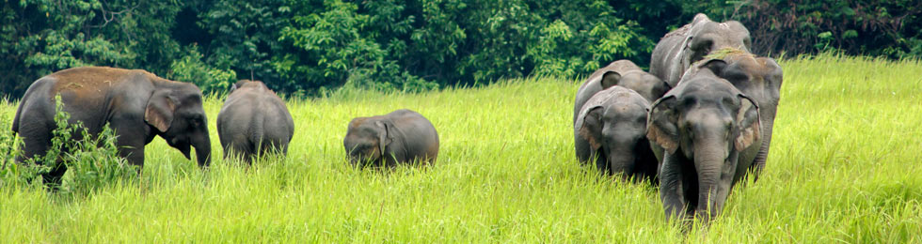
The Local Area
The Khao Yai National Park is just a short drive from the school. As part of the wider Dong Phayayen-Khao Yai Forest Complex it is renowned for its UNESCO World Heritage Site status. It is without doubt the best national park in Thailand for visitors, who are able to see a rich variety of natural wildlife and fauna. Animals such as wild elephants, macaques, barking deer, sambar deer, gibbons, porcupines, and civets can be seen relatively easily whilst bears, gaurs, otters, dholes and jackals are more rarely seen. There are over 300 species of birds in the park. The Khao Yai and neighbouring Pak Chong area is a very popular tourist destination and there are far too many tourist attractions to mention here. For staff at St. Stephen’s there is much to do and see in the close vicinity of the school.
The nearest town to the school is Pak Chong, about ten minutes drive away. It has all of the amenities that you might expect in a town with a population approaching 50,000, with the added advantage over Bangkok that you don’t get stuck in traffic to get there!
Weather / Climate
The Pak Chong / Khao Yai region sits on a plateau several hundred metres above sea level. The climate is considerably cooler and more comfortable throughout the year than other regions such as Bangkok or Pattaya. The hottest season is March and April when maximum temperatures may exceed 35 °C and minimum temperatures may not fall below 25 °C. This is followed by the rainy season from May to October which is cooler, with regular precipitation, often in the afternoon. The cold season is from November to February when maximum temperatures may be below 30 °C on some days and night time temperatures can fall as low as 10 °C.
Transport
There are no taxis in Pak Chong so it is essential that staff obtain their own transport. Many staff purchase or hire motorbikes, which are ideal for local transport needs. Families would need to consider leasing a car, which is significantly more expensive. An International or Thai driving license will be required to drive in Thailand. The school runs a weekly minibus service to the local Tesco superstore, which some staff choose to use for their main weekly shopping needs.
The school’s convenient location to Bangkok means that staff can easily travel to Bangkok within a couple of hours, either via the regular bus service or by train. There are improving train links in Bangkok via the BTS lines and if you are happy to sit in the famous traffic the taxis are very cheap. The coast to Pattaya and Rayong can also be reached by regular coach services. Bangkok has two airports and there are regular and inexpensive flights to many other Thai locations such as Chiang Mai in the north and Phuket to the south. In addition cheap international flights mean that locations such as Laos, Vietnam, Cambodia, Singapore, Hong Kong, China and Malaysia can all be weekend destinations.
Significant improvements to local infrastructure is well underway. A new motorway passing a couple of kilometres from school will link Bangkok to China. Similarly, a bullet train project is expected to be usable from Pak Chong in less than two years. It will be possible to travel direct from Pak Chong to the main Bangkok International Airport in 77 minutes and the journey to the nearest large cities of Saraburi and Korat will be less than half an hour. Within five years it will be possible to travel directly to China on this route.
Accommodation
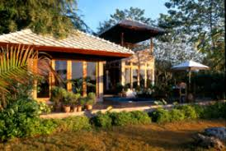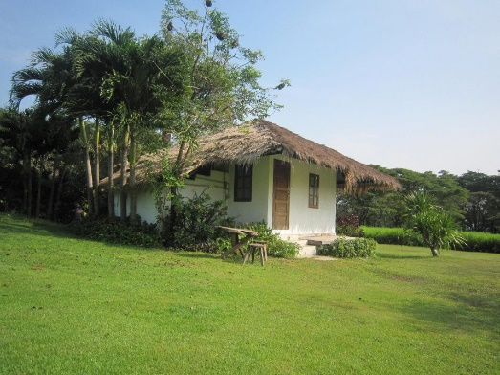 | Most staff find accommodation relatively close to the school.  The school admin team will help new staff upon arrival to find appropriate accommodation. In their first few days, new staff will stay in a hotel until their accommodation is organised.  The accommodation allowance provided by the school is sufficient to cover the costs of comfortable accommodation. As is standard in Thailand, those renting accommodation will be expected to pay a months deposit and two months rental up front and this will need to be budgeted for by staff.

Living Costs
Living costs in Thailand are far cheaper than in the UK and living costs in Khao Yai are cheaper than in Bangkok. Staff at Khao Yai are able to live a comfortable life and save money as well. There are a wide range of food options available and it is often cheaper to eat out than to buy food in and cook it yourself. Decent quality street food can be bought for the equivalent of around a pound per person.
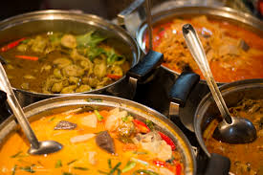 | 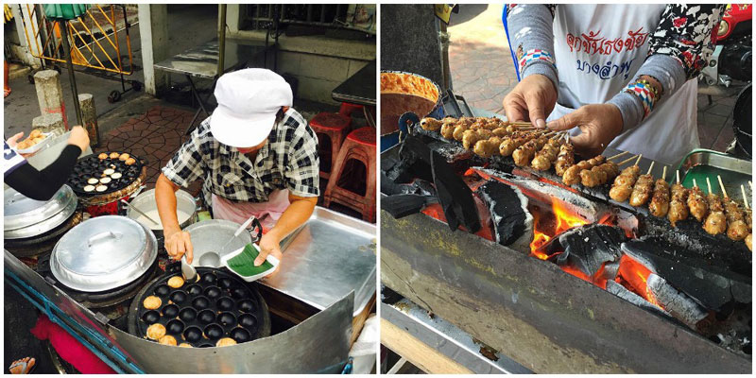

Housing bills will vary dependent upon size of the house and use, but a typical water bill will be less than £3 / month and the electricity bill will be less than £50 / month even when air conditioning is used. There are no council taxes or the equivalent. Internet and combined TV packages are available from around £10 / month up to £50 / month depending on the speed of the connection and additional services required. Pay as you go mobile services tend to be most widely used by staff and are very inexpensive.
Taxes
Thailand operates a PAYE system similar to that in the UK. There are no further deductions of national insurance or pensions. Tax bands for the current year are shown below:
Taxable Income (Baht) | Tax Rates (%) | Tax Amount | Accumulated Tax
0 – 150 000 | Exempt | - | -
150 001 – 300 000 | 5 | 7,500 | 7,500
300 001 – 500 000 | 10 | 20,000 | 27,500
500 001 – 750 000 | 15 | 37,500 | 65,000
750 001 – 1 000,000 | 20 | 50,000 | 115,000
1 000 001 – 2 000 000 | 25 | 250,000 | 365,000
2 000 001 – 5 000 000 | 30 | 600,000 | 965,000
Over 5 000 000 | 35
Please note that the Thai tax year runs from January until December. Consequentially, staff take home pay is a little higher from August to December in the first year as less tax is paid.

Medical Information
Thailand boasts many private hospitals with high quality medical care. Medical tourism is very healthy in Thailand. With well qualified health professionals and very short waiting times patients are well cared for. The school provides a good private health insurance package to all teaching staff. The nearest private hospital is Bangkok Hospital Pak Chong, which is about fifteen minutes from the school.
For minor ailments, or for advice, staff are very welcome to speak to one of the school nurses. As a boarding school, St. Stephen’s provides 24 hour medical cover during term time and has its own well equipped infirmary.
Additional Information for Families
One of the significant benefits of a teaching role at St. Stephen’s International School, Khao Yai, is the provision of up to two free student places for their child / children. This covers the main tuition costs and can be worth in excess of £10,000 / year. There are a number of additional costs that staff parents should be aware of:
- Termly meal costs for each child of around £200 / term (Staff lunches are free)
- Field Trip Account: All parents are asked to pay 10,000 baht (ca. £250) into a field trips account for their child at the start of each year. Any funds not used are reimbursed at the end of each year.
- Student uniform costs: Budget up to £200 / child.
- Specialist music lessons or other optional activities may have additional charges.

Working Hours and Duties
The student day starts at 07:50 with registration followed by the Flag ceremony. There are seven 50 minute teaching periods each day, with most staff having a contact ratio of about 80% (28/35 lessons). At the end of the school day after a short period for snack the majority of students remain in school and participate in the After School Activities for one hour. This is followed by a one hour study period for boarders before they have their evening meal at around 17:30.
Staff normally work from Monday to Friday, with the school day for teachers starting at 07:35. If teaching staff have no further duties they may finish at 16:00.
In addition to teaching lessons, all teaching staff are expected to participate in a range of supervisory duties either before, during or at the end of the day. A minimum of one after school activity per week is offered by teaching staff and teaching assistants throughout the year, usually on a Monday to Thursday.
All teaching staff apart from those in Early Years who have some additional duties during the day, are expected to participate in the Study Hall schedule for boarders and offer study support whilst the boarding students complete homework.
Teachers contribute a minimum of three activities to the boarders weekend programme over the year. These are usually local excursions that take place on a Saturday, although some staff take the boarding students away for weekend residential trips further afield. Many staff volunteer to do far more trips than is required as these provide organised opportunities to see Thailand, whilst supporting the students.
Remuneration Package and Job Application
As a long established, high quality international school, St. Stephen’s offers a competitive package that recognises the value that it places on its staff, who are essential to the school’s success. Successful overseas candidates for teaching posts will normally be offered:
• a two year contract, renewable by mutual agreement
• a competitive salary
• accommodation allowance
• medical insurance
• flights to and from home location
• free tuition for up to two dependent children
• relocation allowance
• free lunchtime meals
Applicants should complete the TES online application form accessed by the school’s online advert at www.tes.co.uk. Applicants should also separately email an up to date CV that includes a recent photograph to Dr. Kevin Hylands at hoc_ky@sis.edu. Any additional enquiries may also be sent to this email address. The deadline for applications is Thursday 16th January 2020.
There is a probationary period of three months for all new staff. New staff are also required to complete a medical questionnaire after they have accepted a post and undertake a medical when they arrive in Thailand as part of the visa application process.

