ERSKINE STEWART'S MELVILLE SCHOOLS’
GOVERNING COUNCIL

The Mary Erskine School

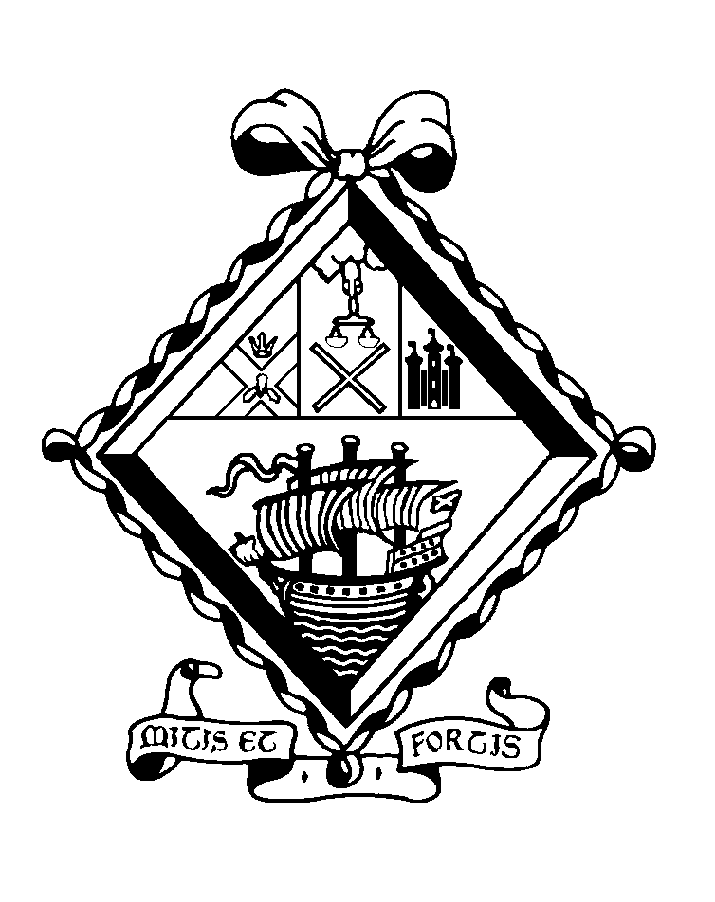

APPOINTMENT OF
TEACHER OF CLASSICS
(maternity cover)

THE SCHOOL

The Mary Erskine School comprises approximately 740 girls aged 12-18. Founded in 1694 by Mary Erskine and the Company of Merchants of the City of Edinburgh to educate and care for the daughters of city burgesses who found themselves in reduced circumstances, it is the oldest girls’ school in Scotland and one of the oldest in the whole of the United Kingdom. Throughout its history, the school has been administered by the Edinburgh Merchant Company.

Since 1978 the school has been twinned with Stewart's Melville College. Through this arrangement, the senior schools are separate and single-sex but are each led by the Principal, while all the girls and boys below the age of 12 are educated together in the ESMS Junior School. Senior school boys and girls come together in orchestras, choirs, drama and musicals, as well as in numerous Outdoor Education projects and in the Combined Cadet Force. Since August 1999, the Sixth Year has become a genuinely 'twinned' experience, with boys and girls jointly comprising a single academic, pastoral and social unit.
The Mary Erskine School was inspected by Her Majesty's Inspectors in 2017 and was highly commended in the subsequent report. It was named The Sunday Times Scottish Independent Secondary School of the Year 2012.

The Erskine Stewart's Melville Schools have a charitable foundation and today provide financial assistance to over 150 bursary holders, who attend Stewart's Melville College or The Mary Erskine School.

BUILDINGS

The school, named The Mary Erskine School in 1944 to mark the 250th anniversary of its foundation, has been housed on various sites in the city - the Cowgate, Bristo, Lauriston and Queen Street - and the buildings are depicted on the engraved glass panels in the entrance hall. In October 1966 the school moved to purpose-built accommodation on the magnificent 38 acre site adjoining Ravelston House. These new facilities have been enhanced by the building of a Sixth Form Centre in 1995 and by the more recent refurbishment of the Science Laboratories, Art Department, Home Economics Department, Careers Department, Library, ICT suite, the provision of two floodlit Astroturf hockey pitches, and the construction of six new tennis courts.

A new Sports Hall was completed in October 2000. It houses the National Cricket Academy and the Scottish Cricket Offices. A community sports facility is in operation seven days a week, outwith school hours and the project, which is linked to the sports facilities at Queensferry Road, are managed by the Community Sports Development Manager.

CURRICULUM

The Erskine Stewart's Melville Schools are committed to the all-round personal development of all children in their care. Their education is underpinned by nine values: appreciation, commitment, confidence, enthusiasm, grace, integrity, kindness, respect and responsibility.

The school follows its own curriculum prior to examination years. The Curriculum for Excellence is not followed. Girls generally sit the public examinations prescribed by the Scottish Qualifications Authority. It is normal for girls to sit a combination of eight subjects at National 5 and to proceed to Higher courses in S5. The majority will return for a final year in Sixth Form, with a high proportion taking Advanced Highers. ‘A’ Levels are offered in Art and in Music.

TEACHERS

There are approximately 80 teachers at the school. They rely on an excellent team of support staff, whose high standards contribute greatly to the quality of the school.

PROFESSIONAL REVIEW AND DEVELOPMENT

All teaching and support staff participate in a three-year cycle of professional review.

EXTRA CURRICULAR ACTIVITIES

Teachers are expected to play a full and active part in the extra-curricular life of the school. The ability to contribute to the Games programme (particularly hockey), the Combined Cadet Force (particularly the RAF Section) and the Duke of Edinburgh Award would be most welcome.

THE DEPARTMENT

The Classics Department at The Mary Erskine School is a small but increasingly popular one, achieving excellent results in SQA examinations. Latin is compulsory for all girls in S1 and is offered as an option in S2 and subsequently at National 5, Higher and Advanced Higher. The teaching of the Advanced Higher class, which is co-educational, is shared with the department at Stewart’s Melville College. Higher Classical Studies is offered as a “crash” Higher in Sixth Form and proves extremely popular. There is no Classical Greek in the school curriculum but some girls have opted to attend a lunch time club. A number of students each year go on to study Classics at top UK universities.

The Department consists of two members of staff. The text book currently in use from S1 to S5 is the Cambridge Latin Course and this is supplemented by a wide range of internally-produced resources, in particular to accompany the Literary Appreciation component of the SQA examinations. Girls in S3 are introduced to original Latin by means of a selection from Ovid and those in S4 and above study the works prescribed by SQA. There is no single text book appropriate for Higher Classical Studies but the Classics departments of The Mary Erskine School and Stewart’s Melville College have worked together to produce comprehensive resources.

The Mary Erskine School Classics Department works closely with the Stewart’s Melville College Classics Department, particularly in relation to Sixth Form teaching and learning.

There are two dedicated Classics teaching rooms with recently upgraded ICT. There is also a departmental staff base and a Teacher Assistant (shared with three other Departments) provides valuable administrative support for the Department. An ever-increasing library of historical film clips and recorded TV programmes is accessed via Clickview, enabling the Department to tailor media extracts to the requirements of a particular class. The Department also possesses a sizeable stock of books to supplement the Classics section in the school library, which provides an outstanding resource centre for all pupils and staff.

THE POST

This is a full-time, temporary post from Monday 7 January 2019 until at least Friday 11 October 2019. The successful candidate will be expected to teach at all levels from S1 to Sixth Form.

The generic job description for a teacher at The Mary Erskine School is appended.

REMUNERATION AND OTHER CONSIDERATIONS

Remuneration will be on the school’s own scale, which is above that paid in the State Sector, and is dependent on qualifications and experience. All teachers are entitled in term time to school lunch free of charge in return for supervisory duties.

Please note that the school operates a No Smoking Policy and smoking is not permitted on the school campus at any time.

FEE CONCESSION

Teachers with children at ESMS are entitled to discounts of 60% of fees for classes P4 to P7 and 75% for both senior schools.

APPOINTMENT PROCEDURES

Applications should be in the form of a letter, addressed to Ms Kirsty Nicholson, Head of The Mary Erskine School Senior School, and should be supported by a full Curriculum Vitae along with the names, addresses and contact details of two referees. They should be sent by email to recruitment@esms.org.uk or by post to the HR Administrator, Erskine Stewart's Melville Schools, Ravelston, Edinburgh EH4 3NT, from whom further particulars may be obtained. This information can also be found on our website.

The closing date is 12 noon on Friday 21 September 2018.

