



**Assistant Headteacher**

**Required for September 2022**

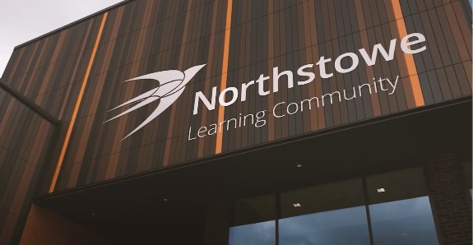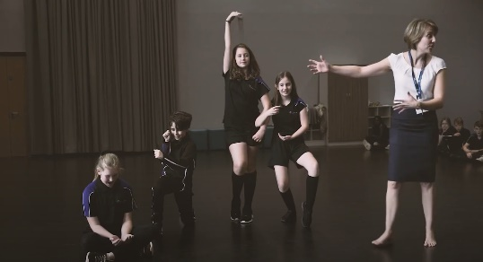

**Welcome Letter**

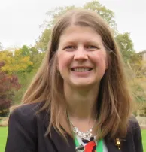Dear applicant,

Thank you for your interest in the position of Assistant Headteacher at Northstowe Secondary College, part of the Cambridge Meridian Academies Trust (CMAT).

Northstowe Secondary College is a brand-new secondary school at the heart of the Northstowe Education Campus, which opened to Year 7s in September 2019. The school currently has approximately 300 students in Years 7-9 and will grow year on year until it reaches its full capacity of 1,200 students aged 11-16. There will be a further 400 places available for sixth form students. It is an exciting time to join our team as we become the cornerstone of the Northstowe Learning Community, which will include a primary school, a special educational needs school and a sixth-form college.

Our brand-new site offers a range of impressive facilities, including two artificial pitches, hard courts, a dance studio, an activity studio, a 400-seat theatre, a café, a fitness gym, a community meeting room, and a four-court sports hall. You will be part of an experienced team that is creating an inclusive, innovative, and aspirational learning environment for our students and our local community.

To get an insight into daily life at the College, please watch our welcome video (<https://youtu.be/3EokN_apA0I>) and curriculum video (<https://youtu.be/g4tFeF9zWqI>) or visit our Facebook page (Northstowe Secondary College).

We are proud to be part of CMAT. Our Trust was first formed to lead a federation of schools in 2006 with a desire to provide high quality and dynamic education for everyone, right in the heart of our community. Through various government policies, our commitment to collaboration has remained consistent. We are a growing family of 25 academies, all within easy distance of Cambridge and Peterborough.

CMAT is one of the highest performing academy groups in the country and the largest in Cambridgeshire and Peterborough. We are committed to high quality professional development and career opportunities for all staff and strive to work at the heart of all the communities we work with. This role will inevitably involve a considerable amount of partnership working within the Trust to search out great practice to ensure wonderful opportunities for our young people. [https://www.cmatrust.co.uk/about-us/cmat-10-a-decade-of-achievement/cmat-timeline/#](https://eur02.safelinks.protection.outlook.com/?url=https%3A%2F%2Fwww.cmatrust.co.uk%2Fabout-us%2Fcmat-10-a-decade-of-achievement%2Fcmat-timeline%2F%23&data=04%7C01%7C%7C8affcc0695cf4ca7ed9a08d9d058cee5%7Ce1d9b82998164c549d9cade2d8e3aa6e%7C0%7C0%7C637769902102334064%7CUnknown%7CTWFpbGZsb3d8eyJWIjoiMC4wLjAwMDAiLCJQIjoiV2luMzIiLCJBTiI6Ik1haWwiLCJXVCI6Mn0%3D%7C3000&sdata=JqlC5ebNcpj%2FJALLaOJDs%2Fj5CUQmNg37e%2Fb9AyDLBSU%3D&reserved=0)

It is essential for the successful candidate to demonstrate our values which are *Kind, Curious* and *Hardworking*.

If you would like an informal discussion about working for Northstowe and CMAT or about this role, please contact: [recruitment@northstowesc.org](mailto:recruitment@northstowesc.org)

This will be an exciting and very rewarding role and we look forward to receiving your application.

Yours faithfully,

**Carole Moss**

**Headteacher**

**Vision and Values**

Cambridge Meridian Academies Trust (CMAT) exists to provide, support, and champion high-quality education at the heart of local communities.

As members of the CMAT family, trust academies aim to unite their pupils, families and other local stakeholders around this common purpose to share experience and resources, to improve standards and to maximise our contribution to their wider communities. Our vision, mission and values guide and bring together each of the trust’s academies.

**Our Vision:** High-quality educational provision for all at the heart of local communities

**Our Mission:**To deliver, promote and inspire high quality educational provision in schools at the heart of their local communities so that:

* Every child is a successful learner, confident individual and responsible and employable citizen
* Every school is a hub for community activities, a centre for extended services and a source of immense pride for students, their families and other local stakeholders

**Our Values:**

**Pursuit of Excellence**

* By expecting this of every person, every day
* Rejecting outright any sense of complacency
* Continually striving for the creation of a true meritocracy
* Promoting and celebrating elite performance inside school and in the wider world

**Value our People**

* Appreciating the incredible trust placed with us in educating young people and serving our community
* Valuing the diversity and qualities of our staff and students
* Ensuring that all students and staff feel known, appreciated and supported
* Committing whole-heartedly to collaboration within, between and beyond our academies

**Achievement for All**

* Ensuring that every student achieves their maximum potential
* Maintaining a relentless sense of optimism
* Removing barriers to learning
* Providing a whole education: academic excellence co-existing with an exceptional commitment to activity beyond

**High-Quality Learning Environment**

* Providing high quality buildings, engaging classrooms and excellent sporting facilities
* Delivering innovative learning resources and materials
* Ensuring a well-disciplined and caring environment
* Exploiting cutting edge technologies to expand the opportunities for students, staff and our community to benefit from learning in a digital age

**Extending The Boundaries of Learning**

* Providing positive memorable experiences inside and outside of the classroom
* Providing a diversity of experience to all
* Opening up the world to all students
* Securing the very best future educational and vocational experiences for our students

**Academies within the Trust**

[www.cmatrust.co.uk/our-schools](http://www.cmatrust.co.uk/our-schools/)

**NSC**

Northstowe Secondary College is in an enviable position, located at the heart of what will be a thriving new community. It is our aim to deliver excellent education for local young people; to ensure that every individual is a confident successful learner, independent and a responsible and employable citizen.

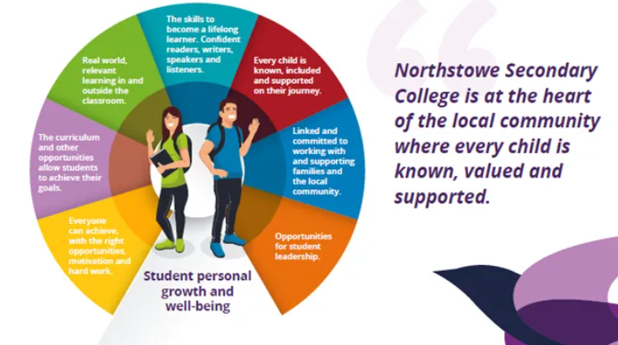

In our school we focus on the development of the whole child. We believe that every child can achieve, given the right opportunities and we do not believe in putting a ceiling on a child’s potential. We also understand that being successful at life means supporting students’ personal growth and well-being. That resilience, perseverance and coping skills are essential for students to be able to tackle all that life brings. We pride ourselves on knowing and valuing every child to support them to achieve their dreams and ambitions.

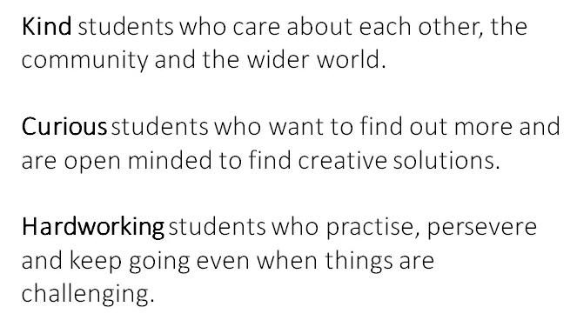

Our values are central to all that we do, we believe that if students are kind, curious and hardworking they can achieve anything. We expect all members of the NSC family to live these values every day.

**About Northstowe**

Northstowe Secondary College is at the heart of the new town of Northstowe. This unique town will have up to 10,000 homes, making it the largest new town in the UK since Milton Keynes.

Northstowe was designed to encourage active lifestyles, independence and happiness, providing excellent facilities for people to play, relax and enjoy sport.

Nature is never far away from Northstowe as the area is dedicated to sustainability and protecting and enhancing the local biodiversity. The landscape in and around Northstowe has been crafted with health and wellbeing in mind and features acres of green space, parks, countryside and heritage sites.

The town is ideally located for weekend and evening trips to Cambridge and London and provides you with great transport links that can get you to other parts of the UK quickly and easily. Northstowe also includes a network of cycling and walking routes, electric vehicle charging points, plus a new link road connecting the town centre to the A14.

To find out more about Northstowe, visit: [www.northstowe.com](https://www.northstowe.com/).

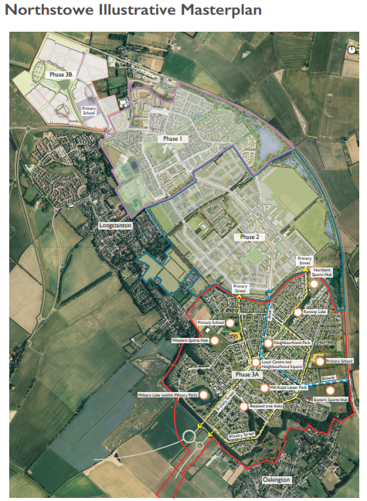

Northstowe Learning Community

**Job Description**

Start Date: 1st September 2022

Scale: Leadership scale, points 11-15 (£54,091 - £59,583)

Hours: This is a full-time post

*Applicants must be able to teach Maths, DT, History, or Computing due to the teaching requirements in a small school. We cannot accept applicants who teach English, Geography or PE as their main subject.*

## Purpose of the job:

The Assistant Headteacher will have responsibility for the day-to-day running of their roles and responsibilities within the Senior Leadership Team and as a senior member of staff, will contribute to the overall leadership and management of the College and be active in promoting its aims, and supporting an ethos that promotes achievement and high standards.

The Assistant Headteacher will report to the Headteacher and join a team of 3 full time Assistant Headteachers that make up the College Leadership Team.

Specific areas of responsibility and accountability:

* SEND provision – Line Management of the SENCO, Interventions, ensuring we are an inclusive school that meets the needs of those students with EHCPs and those with emerging needs.
* Whole school fluency strategy and its implementation: [Key Stage 3 – Northstowe Secondary College (northstowesc.org)](https://www.northstowesc.org/learning/curriculum/keystage-3/)
* CEIAG – Leading the CEIAG advisor, ensuring we are meeting the GATSBY benchmarks, achieve the Careers Mark and meet the needs of our young people.
* Glennie House – Line Management of a Senior Tutor and supporting children to overcome barriers and achieve their full potential.

## Main Duties and Responsibilities:

**Kindness**

* To be a role model, to believe in and embody the schools core values of Kindness, Curiosity and Hard Work.
* Ensuring that the school is a safe and happy working environment for both staff and students, where high expectations are maintained and all members of the NSC family feel able to achieve their best.
* Promote a culture of teamwork, in which views of all members of the College community are valued, supported and considered.
* To be a key member of the Leadership Team, contributing to the leadership, management and development of the College.
* To attend all Leadership Team meetings, supporting the work of the Headteacher and other Senior Leaders in the leadership, management and development of the College.
* To undertake a share of daily Leadership Team duties including lunchtime and after school.
* To take part in the annual College cycle of performance management, appraising staff as required and using the process to develop the personal and professional effectiveness of the appraisee.
* To plan, monitor, support, challenge and evaluate the work of the College to ensure that NSC stays true to its vision and achieves excellence.

**Curious**

* Contribute to the identification of key areas of strength and weakness in the College.
* Contribute to strategic planning and the creation and maintenance of the School Development Plan.
* To communicate high expectations to students during assemblies by contributing to the termly assembly rota.
* To line manage specified curriculum teams, ensuring that their teams of subject teachers and associate staff are well managed, and focused upon high quality provision and outcomes.
* To line manage a specified Senior Tutor, ensuring that their team of tutors and associate staff are well managed, effectively led and focused upon high quality provision and outcomes.
* To line manage specified Cross Curricular Coordinators, ensuring that their areas of responsibility are well managed, effectively led and focused upon high quality provision and outcomes.

**Hardworking**

* Support the Senior Leadership Team and Governors in achieving and embedding the vision for the future of the school and community, demonstrating inspirational leadership and creativity.
* Play a leading role in the College improvement planning process, taking account of the agreed priorities of the College and how these link with national and local initiatives.
* Work to a high standard in implementing agreed policies, priorities and expectations, so as to set a good example to other colleagues.
* To deputise for the Headteacher and take responsibility for the everyday running of the College in her absence.
* To adopt a visible presence around the College site, ensuring high standards of uniform and behaviour are maintained by all students both in and out of lessons.
* To engage with all stakeholders to support and maintain the high standards and challenge where necessary when these expectations are not met.
* To attend relevant Governing Body Meetings.
* Ensure adherence to all Trust and school’s policies but particularly regarding safeguarding, health and safety and GDPR.

## Additional Responsibilities:

* To undertake any other tasks as reasonably required by the Headteacher.

***The post holder will have a shared responsibility for the safeguarding of all children and young people. The post holder also has an implicit duty to promote the welfare of all children and young people.***

***The College is committed to safeguarding and promoting the welfare of children and young people and expects all staff and volunteers to share in this commitment. All staff will be subject to an enhanced check with the DBS***

***Where the post holder has a budgetary responsibility, it is a requirement of the role to work within the school’s financial regulations. This will involve complete monthly monitoring reports and where necessary liaison with the Business & Resources Manager.***

***As well as an understanding that all our funds are ‘the children’s money’, it is your responsibility not to waste it.***

**Person Specification**

|  |  |  |
| --- | --- | --- |
| **Skills, attributes and experience** | **Essential or Desirable** | **Assessed through** |
| **Qualifications and experience** | | |
| Qualified teacher with the relevant qualifications | E | A |
| SENCO qualification | D | A |
| Master’s degree or equivalent | D | A |
| Ability to teach your subject in key stages 3, 4 and 5 | E | A |
| **Kindness** | | |
| Experience of Line Management of SEND department | D | A/I |
| Willingness to go above and beyond | E | A/I |
| Commitment to work hard but can manage their own workload and is mindful of others’ workload | E | I |
| Experience of inclusion and working with students and families to remove barriers | E | A/I |
| Can sustain and grow positive relationships with Parents, Students and all Staff | E | I |
| **Curiosity** | | |
| Is passionate about inclusion and creative to find solutions to meet student need | E | O/I |
| Is an excellent practitioner who is open to change and personal improvement | E | O/I |
| Has undertaken recent CPD in areas relevant to this post and can elucidate how this has changed their practice | D | A/I |
| Is up to date on current educational research in the area of SEND, inclusion and best practice for literacy and numeracy interventions | E | A/I |
| Is committed to inclusion – understands that differentiation is not dumbing down but about scaffolding up | E | O/I |
| Has experience of leadership or involvement in CEIAG programmes | D | O / I |
| Is open to working with leads across the Trust | E | I |
| **Hard work** | | |
| Can plan and teach excellent lessons | E | I |
| Proven record of implementing intervention programmes and improving outcomes | E | A / I |
| Understands assessments for identification of SEND needs and evidence of work with external agencies | D | A / I |
| Excellent track record as a Senior or Middle leader | E | A / I |
| **Other personal characteristics** | | |
| Suitability to work with children and young people | E | A/I/O |
| Personable and well presented. | E | I/O |
| Remains call under pressure, can diffuse stressful situations and is good humoured, honest and consistent | E | A/I/O |

|  |  |  |
| --- | --- | --- |
| D = desirable | E = essential |  |
| A = application | I = interview | O = observation |

**How to Apply**

Please submit an application form via TES - [www.tes.com/jobs/employer/northstowe-secondary-college-1218811](http://www.tes.com/jobs/employer/northstowe-secondary-college-1218811) or mynewterm - <https://www.mynewterm.com/school/Northstowe-Secondary-School/135739> **Please note, we cannot accept CVs.**

**Closing Date:** Thursday, 24th February 2022 (by 9am). We cannot accept applications after this time.

**Interviews:** Wednesday 2nd and Thursday 3rd March 2022.

**Applying:** For any questions about the process of applying, for further information regarding the role or to arrange a school visit please contact: Sarah Wakerley, HR Officer on [recruitment@northstowesc.org](mailto:recruitment@northstowesc.org) or telephone 01223 343800.

NSC is committed to safeguarding and promoting the welfare of children and young people and expects all staff and volunteers to share this commitment. This means that the post holder will have a shared responsibility for the safeguarding of all children and young people.  The post holder also has an implicit duty to promote the welfare of all children and young people.

All staff will be subject to an enhanced check with the Disclosure & Barring Service (DBS).