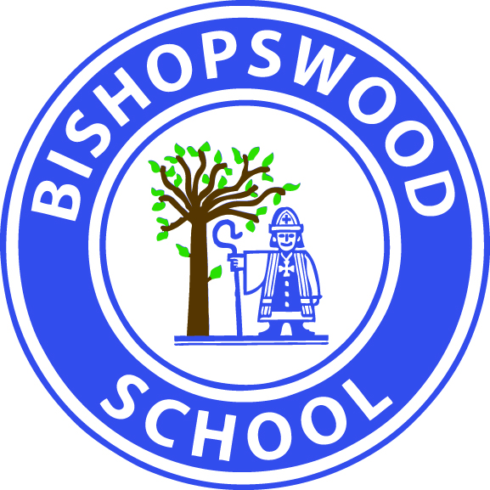

Bishopswood School Aims:
- To develop and enhance the ability of each pupil to have dignity and personal choice, both at school and in their future lives.
- To offer an environment which is safe, stimulating, creative, challenging and fun.
- Through our ability to embrace change, to ensure that we apply approaches to teaching and learning that are proven to be effective.
- To provide pupils with the means of mobility, communication and self expression.
- To encourage pupils to develop independent living skills to equip them with the knowledge and skills they need in the future.

Bishopswood School Values:
- We appreciate the unique contribution made by each pupil to the life of the school.
- We believe the understanding and mutual respect that follows the development of closer links between Bishopswood, our partner schools and the wider community benefits all involved.
- We recognise the positive support that parents and carers provide in helping us to deliver our stated aims for each child.
- We celebrate the achievements, no matter how big or small, made by individual pupils.
- We recognise the importance of teamwork and the different roles and skills contributed by individual staff or groups of staff.

