Bishopswood School
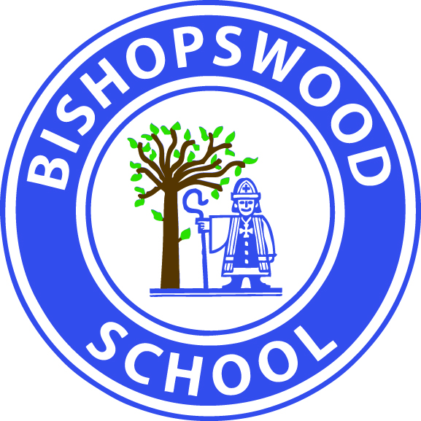

PERSON SPECIFICATION: ASSISTANT HEADTEACHER
ESSENTIAL | DESIRABLE
Qualifications/Training:
Qualified teacher status | Additional post qualified training related to special education needs
 | SLD/ PMLD/ASD training
 | Evidence of recent relevant Continuing Professional Development including evidence of attendance on leadership courses.
Experience:
Successful teaching experience working with pupils with severe learning difficulties and complex needs | Experience of working with colleagues in mainstream schools
Teaching experience in an inclusive setting | Recent TEAM TEACH training
Experience of developing a specific area of curriculum and monitoring its implementation. | Experience of managing site health and safety including identifying hazards and ensuring risk assessments are made and implemented.
Training and experience of promoting amongst pupils high standards of behaviour and respect for others | Familiar with assessments for pupils with SEND.
EYFS/primary experience
Professional Knowledge/ Attitude/ Skills:
Knowledge and experience of SEN teaching and learning strategies and approaches | Knowledge of the developmental nature of learning in an SLD/PMLD school
A commitment to inclusion
An understanding of and commitment to equality of opportunity for people with disabilities
An understanding of and commitment to working in partnership with parents | A clean driving licence
Up to date and effective ICT skills | Knowledge of the National Curriculum
Ability to deliver training courses
Experience of coaching and mentoring
Evidence of the ability to communicate clearly and concisely both orally and in writing.
Personal Qualities:
Strong qualities of leadership
Personal qualities that allow effective work as a member of the school’s senior management team.
Ability to be flexible and to use own initiative | Adaptable, positive and resilient
Good communication skills with adults and young people | Committed to continuing own professional development
Able to demonstrate good organisational skills
Evidence of good interpersonal skills and the ability to work effectively as a member as a team and develop and maintain good relations with all members of the school community.
Creative approach in problem solving situations and self motivated
A flexible approach to tasks
A sense of humour
Physical Requirements:
Willingness to take an active role in the total care of the students in the class | Relevant moving and handling training

The Governing Body will actively offer long term support to the successful candidate to help prepare and develop him/her towards headship.

