September 2023

Dear Applicant

Re: Cover Supervisor – Permanent – Part Time

Thank you for your interest in the above position. I have pleasure in enclosing an application pack
as requested.

Please note that closing date is Noon, Monday 16 October 2023. However, we reserve the right to close
the advert for this role as soon as suitable applications are received.

Interviews will take place on Wednesday 1 November 2023.

Completed applications can be downloaded from the following websites:

www.blackfenschoolforgirls.co.uk

www.tes.com

Returned by email to:
vacancies@blackfen.bexley.sch.uk

Your completed application form will be used to decide whether or not you are selected for interview.

If you are shortlisted, you will be contacted within one week of the closing date. If you do not hear from
us within this time, please assume that you have been unsuccessful.

Yours faithfully
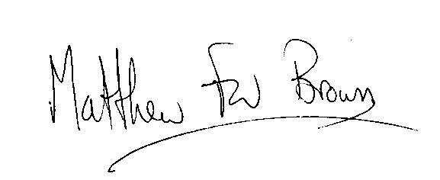
Matthew Brown
HEAD TEACHER

Enc

