September 2023

Dear Applicant

Thank you for your interest in the vacant position here at Blackfen School for Girls.

As part of the recruitment process, we hope you will research the school, reading the Ofsted reports, our website and Twitter feed, all of which will give you a flavour of the school.

However, as useful and informative as these sources are, it is unlikely you will have a ‘feel’ for the school. Clearly only by working (or studying!) at Blackfen will you come to understand and be part of the community. We would encourage you to visit the school. We are very proud of our students and we believe that they are our best ambassadors and our student guides take visitors around the school. Their opinion of, and pride in the school, is often one of the factors that convinces parents, children and prospective staff of how good Blackfen School for Girls is.

Governors and the Leadership Team share students’ pride in the school and so are determined to provide the students with the best staff possible to support and encourage their learning. Therefore, the recruitment process is rigorous but fair and may well include presentations, discussions with students, teaching and tests as well as an interview. We hope that these activities will give us a clearer idea of your talents and skills but also your qualities.

The school motto is ‘Raising aspirations-releasing potential’ and governors want every student to feel that there are few, if any, limits to what they can achieve. We do this through our growth mindset culture and this underpins our aspirational ethos.

We also want staff to feel the same way. With that in mind, the school has an extensive CPD programme and an active wellbeing strand that is designed to make the school a rich and rewarding experience for everyone who works within it.

We would like to wish you good luck in your job search and hope that you will be able to contribute to the continuing success of Blackfen School for Girls. We look forward to receiving your application.

Yours faithfully
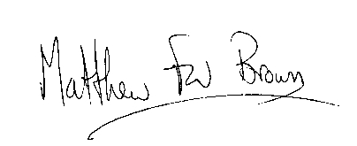

For Chair of Governors

