January 2019

Dear Colleague

Thank you for your interest in the Headship of Waterside Primary Academy.

Waterside Primary Academy is a member of White Hill Schools Trust (WHST), a Multi Academy Trust established in September 2015 (please be aware that the Trust is in the process of changing its name to Red Kite Schools Trust). There are currently three schools in the MAT, the others being Chesham Grammar School, an outstanding secondary school which converted to Academy status in 2011 and Ivingswood Academy, a sponsored academy which joined WHST in September 2015.

This is an exciting time to join the Trust. Waterside Primary Academy joined on 1st May 2018 but over the next year, the Trust is expected to further expand, realising our vision of providing an excellent educational experience for local children.

Waterside Primary Academy is a single-form entry primary school. It has faced several challenges in the past couple of years and so we are looking for someone with the necessary passion, drive and enthusiasm to lead the Academy to good as quickly as possible. Working under the Executive Headteacher, the Headteacher will lead the school on a daily basis, with a core focus on teaching and learning and pupil outcomes.

WHST employs a Primary Consultant to advise and support the primary schools within the Trust. This is tailored to the experience of each school’s leaders and is designed to be truly supportive whilst building leaders’ autonomy and expertise. In the case of an experienced headteacher taking up post at Waterside, the Consultant’s role would be light-touch and similar to that of a Local Authority School Improvement Partner. However, if the headteacher is new to the role the Consultant will provide intensive induction and on-going support. This is a unique opportunity to successfully move into a first headship with excellent professional development whilst maintaining your position as the school’s leader and decision-maker.

If you believe that you have the expertise, skills and commitment to lead Waterside Primary Academy at this important and exciting time, we look forward to hearing from you.

If you wish to apply, please complete an application form and also explain in no more than two sides of A4 how your experience to date has prepared you for this role and what action you would take as the Headteacher to lead Waterside Primary Academy to good.

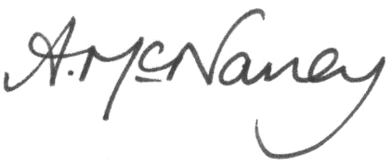
With warm wishes

Annmarie McNaney Sue Walton
Executive Headteacher Chair of Trustees

