[](https://www.google.co.uk/search?q=todmorden+high+school&safe=strict&tbm=isch&source=iu&ictx=1&fir=nfkQNFrjHhfIOM,AAAAAAAAAAABAM,_&usg=__fcTCH3Pfd0cC15rnj_j0rWc0Pk4%3D&sa=X&ved=0ahUKEwjgpJeqz8PaAhXEJMAKHaFxAK4QuqIBCH0wDQ#imgrc=_7gS7HMao5Q82M)

**Todmorden High School**

Come join us! We champion our whole school values which are

**AMBITION, RESPECT, CARE AND HONESTY**

*We are a recently inspected GOOD school engaged in a period of significant growth. We are located in the beautiful Todmorden valley. We’re a thriving comprehensive school for 11 to 16-year-olds, with approximately 800 pupils and just over one hundred staff.* ***Workload and Wellbeing*** *is at the forefront of all we do. We are looking for several new colleagues who may be fulltime, part time, or come to us with flexible requests. We encourage working in every formation possible, we know one size does not fit all. We endlessly support working families and champion worklife balance, we’re so much more than ‘just another school’…*

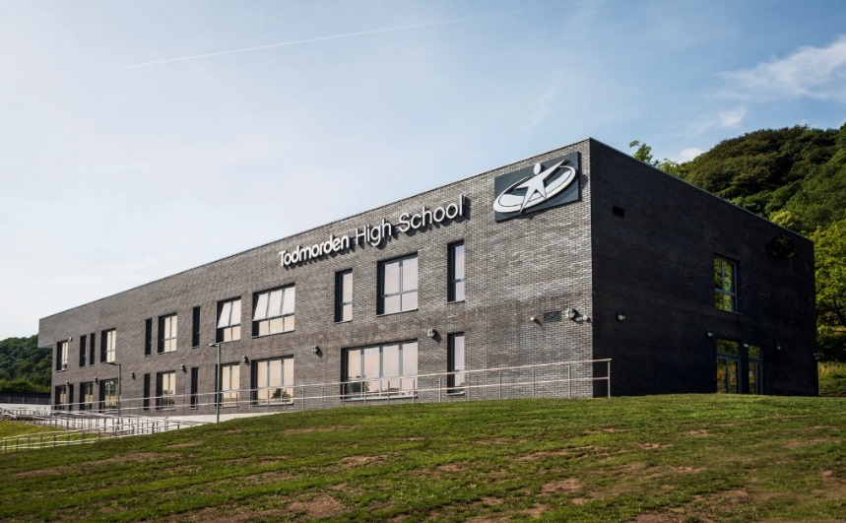

**Learning Support Assistant**

***SCP11 - SCP13***

***Fixed term position, 12 months***

**Closing Date: 4 July 2018 (9.00am)**

**Date: Required for September 2019**

Todmorden High School is a popular and oversubscribed school. The core value of our school is to appoint the best professionals possible to inspire our young people in an environment that is supportive but aspirational. The successful candidate will work alongside an ambitious and talented team in a successful school, providing the vision and strategy within a forward looking environment, where wellbeing is championed and staff voice is strong. We are a good school, an oversubscribed school, set in the beautiful Calderdale valley, financially we are sound, and we are embracing a period of both change and growth. This is an excellent time to join our community.

This is an exciting opportunity for a candidate who champions our values of Ambition, Respect, Care and Honesty to come with us as we progress. There has never been a more exciting time to join a school which is open, innovative and has high expectations for all.  You can have a real impact on the lives of the young people as well as developing your skills to be the best that you can be. Together, we unlock potential.

|  |
| --- |
|  |

Look at our recruitment page on our website, find out more about joining our team, click WORK FOR US on the link below, openings close 16 July 2019 at 9.00am [www.todhigh.co.uk](http://www.todhigh.co.uk)

**OfSTED, October 2018**

*‘The Headteacher and other Leaders, including Governors, are determined to provide the best possible education for pupils’.*

*‘Leaders seek out best practice from other schools and Advisers, and are keen to provide the best care possible’*

Our Vision

Our school will provide a safe and happy environment   
where everyone aspires to make remarkable rates of progress,   
both personally and academically.We will inspire all to develop our core values of respect,   
care and honesty. We will support each other and celebrate   
our talents. Our students will be supported to grow into remarkable   
individuals, ready to thrive in the modern world.We hope to give Todmorden an Aspirational, Inspirational   
and Remarkable school.

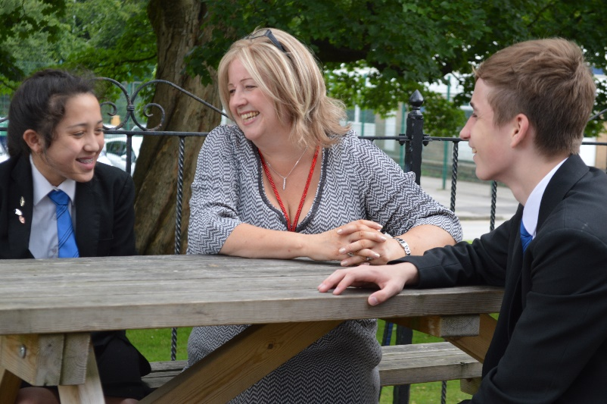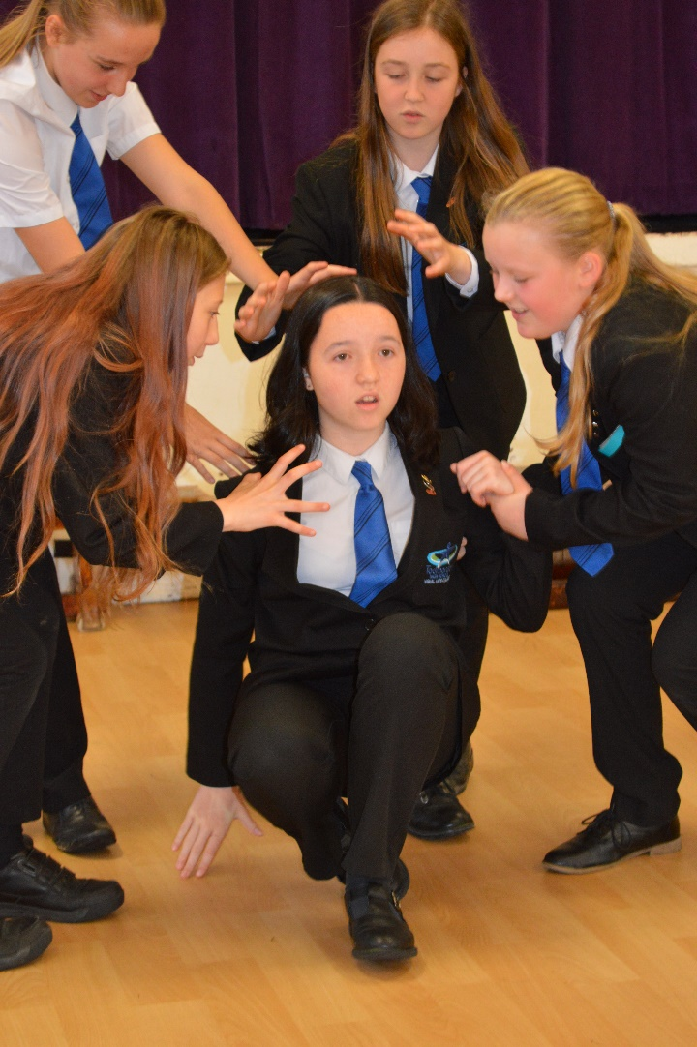

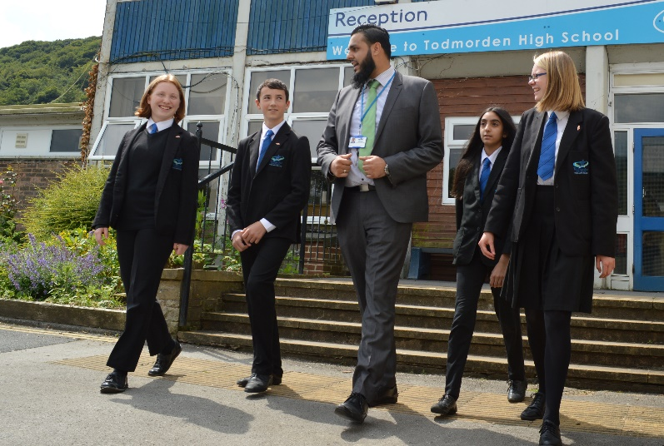

**Learning Support Assistant (SEN)**

|  |  |
| --- | --- |
| Start Date | September 2019 |
| Salary | SCP11-SCP13 (pro rata for term time only) |
| Closing Date | 16 July 2019, 9:00am |
| Start Date | 1 September 2019 |
| Interview Date | Interviews - 17/18 July 2019 |

**Teaching Assistant - £18,065-£18,426 FTE (pro-rata, 30 hours TTO + 5 training days)**

**Fixed Term Contract until 31 August 2020. September 2019 start**

We are seeking to appoint an enthusiastic, dynamic and inspirational Teaching Assistant to join our student learning and progress team at Todmorden High School, fulfilling a key role within the SEN Department, providing support to a student with complex medical needs. In this role you will form part of a wider team. We are looking for a high performing professional who can bring passion and enthusiasm to the team. We seek to appoint an para-professional to this post, a colleague who is committed to supporting the development and securing progress for all students.

Todmorden High School has been through an exciting and transformational journey; you will join us at an exciting time. You will find yourself working in a friendly and supportive environment with a tremendous group of students and staff.

We welcome applications from our wider community. We are looking for someone who can hit the ground running on the first day of the new school year. We are a supportive and friendly environment. You will play a significant part in our journey to becoming a truly ‘outstanding’ school.

Please send all completed applications to [d.todd@todhigh.co.uk](mailto:d.todd@todhigh.co.uk).

Todmorden High School is an aware employer is committed to safeguarding and protecting the welfare of children and vulnerable adults as its number one priority. This commitment to robust recruitment, selection and induction procedures extends to organisations and services linked to the School on its behalf. This post is subject to an enhanced DBS check. We value variety and individual differences, and aim to create a culture, environment and practices at all levels which encompass acceptance, respect and inclusion.

***July 2019***

Dear Applicant

Many thanks for your interest in working at Todmorden High School. This covering letter conveys everything we are.

We remain passionate, and ensure our students have access to the very best educational experiences possible. In order to achieve this, it is vital that we attract and retain the right calibre of professional to work alongside our dedicated team. We are seeking colleagues who share the vision that our students are at the very heart of everything we do. A colleague who is able to enjoy positive, professional relationships with young people, and more importantly, a colleague who can demonstrate high levels of emotional intelligence and resilience when dealing with complex and sensitive situations. A colleague who models our core values of ambition, respect, care and honesty.

We aim not only to foster a thriving climate for learning, but to provide the very best career opportunities for everyone in an environement where wellbeing for all is respected. It is an environment where aspirations can be met and opportunities for personal development and growth remain a constant priority. We are committed to creating a culture where all staff, at all levels, can feel proud of who we are, of our achievements and feel a sense of pride when they reflect on their individual contribution to our School development. All this in an environment where generosity and kindness can thrive. In keeping with our values, we strive to create a workplace that celebrates difference. Somewhere we all feel responsible, valued, empowered and trusted to do the right thing for each other, our students and our community.

We offer a variety of great benefits (in a stunning countryside location) including the benefits you would expect to see such as a Teacher’s Pension, we add to this with childcare vouchers, Cycle to Work Scheme, discounted gym membership, Wellbeing Support, a Wellbeing Committee and a Wellbeing Day (in November), we are incredibly family friendly and flexible, we trust in our team, we have an open culture, share as much news as possible in a weekly newsletter. Control the amount of email and the impact this has on our working life, we close early every Friday, we have an On-Site Honesty Shop, birthday card and present store, tea and coffee for all, offer complimentary toast and juice every breakfast time, champion Buttie Friday and encourage bespoke CPD and developmental opportunities, we believe in ‘growing our own’. Financially we are strong and we are growing, investing and developing. Many of our counterparts, are sadly being forced to go the other way.

With very best wishes



**Gill Shirt**

**Headteacher**

**Job Description**

*Learning Support Assistant*

Todmorden High School is an aware employer is committed to safeguarding and protecting the welfare of children and vulnerable adults as its number one priority. This commitment to robust recruitment, selection and induction procedures extends to organisations and services linked to the School on its behalf. This post is subject to an enhanced DBS check. We value variety and individual differences, and aim to create a culture, environment and practices at all levels which encompass acceptance, respect and inclusion.

**Purpose and objectives of the role**

To work alongside the class teacher and other adults in school to support the social and learning needs of one student throughout the school day.

To encourage and support interaction with others for the young person.

To support the removal of potential barriers to learning so that the young person achieves their potential.

**Responsibilities** **(responsible to, SENCO)**

Meet and greet the student each day and check they are ready to learn.

Support the student whilst moving around the building in between lessons.

Support students to meet and manage the school’s expectations regarding behaviour, attendance, attitude to learning and progress.

To encourage and support interaction with other students with the peer group and other adults.

To negotiate, establish and maintain effective working partnerships with staff across the School in order to assess students’ needs and work to remove barriers to learning and maximise progress.

Work with staff in school and external agencies to plan programmes of support for students with Autism.

Support students during extra-curricular activities to ensure accessibility to all opportunities in school.

Working in collaboration with the SENCo, parents, students and external agencies, contribute to the implementation of Education, Health, Care Plans (EHC Plans).

Work alongside the class teacher to support learning and progress for all young people whilst promoting independent learning.

Contribute to the maintenance of student records through observing and reporting on pupil progress.

Support and maintain pupil safety by following school policies and procedures.

Take the role of keyworker for your student caseload.

Maintain effective working relationships with parents and carers to ensure all potential barriers to learning are removed.

**People Responsibilities:**

Liaising with

SENCO

Teachers

Parents/Carers

Student Learning and Progress Team

**This post could involve intimate care at some point in the future**

*This job profile is not a restrictive outline, but indicates a range of duties. The post holder will be expected to be flexible in the range of tasks undertaken as appropriate to the post.*

**Person Specification LSA**

**A = Application form C = Certificates I = Interview R = References**

|  |  |  |  |
| --- | --- | --- | --- |
| Qualifications | | | |
|  | Essential | Desirable | Source |
| Excellent level of education | E |  | A,C |
| Previous work experience |  | D | A,C |
| Willingness to engage in further study, inc First Aid | E |  | A, C |
| Skills and Knowledge | | | |
| Professional and confident manner | E |  | A, I |
| Strong customer care skills | E |  | A, I |
| Able to resolve problems and think creatively | E |  | A, C |
| Able to meet strict deadlines | E |  | A |
| Ability | | | |
| Able to work within a team and alone and with initiative | E |  | A, I |
| Previous experience of working with young people |  | D | A,I |

|  |  |  |  |
| --- | --- | --- | --- |
| Professional attributes | | | |
| To be able to demonstrate an understanding, awareness and empathy for the needs of the pupils at this school. | E |  | I |
| To be able to support our behaviour management strategies | E |  | A, I |
| To have excellent written and oral communication skills (which will be assessed at all stages of the process) | E |  | A, I |
| Show a good commitment to sustained attendance at work. | E |  | R |
| Personal qualities | | | |
| Continue to promote the school’s strong educational philosophy and values | E |  | A, I |
| Inspire, challenge, motivate and empower teams and individuals to achieve high goals |  | D | A, I |
| Inspire trust in the school community |  | D | I |
| Demonstrate personal enthusiasm and commitment aimed at making a positive difference to children and young people | E |  | A, I |
| Build and maintain quality relationships through interpersonal skills and effective communication | E |  | A, I |
| Demonstrate personal and professional integrity, including values and vision | E |  | A, I, R |
| Prioritise, plan and organise yourself | E |  | A, I |
| Think analytically and creatively and demonstrate initiative in solving problems | E |  | A, I |
| Be aware of own strengths and areas for development and listen to, and reflect constructively and act upon as appropriate feedback from others | E |  | A, I |
| Demonstrate a capacity for sustained hard work with energy and vigour | E |  | I |
| Confidential references and reports | | | |
| A positive recommendation from all referees, including current employer | E |  | R |
| Application form and supporting statement | | | |
| ***The form must be fully completed and legible. The supporting statement should be clear, concise and related to the specific post.*** | | | |