Application Pack

Headteacher

Letter from the Chair of Governors
Dear Potential Colleague,
I am delighted that you have shown an interest in the position of Headteacher at Westhoughton High School. I hope that the information in the application pack provides you with enough insight into our school to make an informed decision to apply.
Our school is a genuine inclusive community school, with the vast majority of our students living within a mile radius of the school site. Generations of families have attended the school, which enables deep and connected relationships to be formed when supporting our students. It is a school with a strong sense of belonging and identity where our students take pride in the school and their environment. Visitors to school regularly comment on the positive relationship between staff and students and amongst students themselves.
At Westhoughton High School our dedicated staff are led by an experienced, vibrant and ambitious Senior Leadership Team who help our students achieve their potential. The Governing Body of Westhoughton High School firmly believes that our students, regardless of ability, aptitude, background or faith, take pride in themselves and leave us well qualified and possessing the confidence to take on the competitive and ever changing world in which they will live. These shared values permeate daily life at our school through our LEARN ethos, from our students’ positive attitude to learning and behaviour, to the work carried out by our Form Tutors and strong Pastoral and Curriculum Teams in order to get to know our students as individuals and inspire them to achieve in a safe and caring environment. The Governing Body is committed and supportive and provides challenge as a critical friend, encouraging strong partnerships with other schools and external agencies.
Our school is a great place to work. We have high expectations of our staff but they are strongly supported; we place a large emphasis on CPD and also have a whole school focus on staff wellbeing. Our learning environment has been transformed over recent years and we recently undertook a significant building and improvements programme which accommodated an increased capacity to 1350 students, reflecting the increasing popularity and oversubscribed position of our school within the local and wider communities.
As our new Headteacher, you will have the passion, confidence and ambition to take us on this exciting journey together. You will share our values and aspirations, you will be able to balance professional leadership with compassion and understanding, you will inspire our school community with your enthusiasm, creativity and imagination and demonstrate the leadership required to lead us forward on our journey to ‘Good’.
As a Governing Body, we will expect a lot from you and will ask for openness, dedication and honesty with a resilient and consistent approach. In return, you will be part of a supportive school community as we work together to ensure that every student receives the best possible experience during their time at Westhoughton High School.
If you believe you have the qualities we are looking for, we would be delighted to receive your application. If you are the successful candidate, I know that you will be joining a strong team who will deliver great things for our school, students, staff and community.
Yours sincerely,
Mrs Joanne Murphy
Chair of Governors
On behalf of the Governing Body of Westhoughton High School
Welcome to our School
Westhoughton High School is a successful and expanding 11-16, mixed community comprehensive school situated close to the centre of the growing town of Westhoughton, within Bolton Council’s boundaries.
We are proud to be Westhoughton’s only secondary school; we have strong links with all primary schools and provide many opportunities to work together, including cultural activities and specialist subject support. We believe strongly in serving our community by providing challenging educational opportunities and developing the next generation to be ambitious, successful and worthwhile citizens for our town and beyond. The student population is largely made up of young people from Westhoughton itself, but students also attend from the neighbouring communities of West Bolton, Blackrod, Bolton, Atherton and Hindley.
The school has undergone a transformation in recent years; we have made significant investment in our learning environment and considerably improved the facilities available to our students; GCSE examination results have improved, so that all Westhoughton students can progress successfully to the next stage of their education.
We are proud of our students, our staff and our community and are always keen to welcome visitors. So whether you think you know the school or whether you’re just discovering us for the first time, you will see a school that is ambitious for its students, proud of its past and very confident about its future. The school was visited by a team of Ofsted Inspectors on October 20th - 21st 2015 and they awarded the school an overall grading of ‘Good’ with some outstanding features.
Effectiveness of leadership and management; the quality of teaching, learning and assessment; outcomes for pupils were individually graded ‘Good’ but we are very proud that personal development, behaviour and welfare was graded as ‘Outstanding.’
A high number of parents responded to the Ofsted questionnaire, demonstrating their support for the school; 91% of parents would recommend the school to another parent. It is also really pleasing to report that the Inspectors took away with them a very positive view of our students, whether in class, in form, on interview panels or just around the site at break and lunch time.
The quotations below will give you the flavour of a very positive Ofsted report that accurately reflects our school.

Ofsted said:
- Leaders at all levels are passionate about ensuring that every student can achieve his or her best and are diligent in their pursuit of this aim.
- All staff share the Headteacher’s determination to make the school the best it can be.
- The behaviour of students is outstanding. It is outstanding because of the very positive attitude students have to their work and the respect they have towards teachers and others. Students are hardworking, committed to learning and ambitious.
- Students’ positive attitudes are a key reason why outcomes are rapidly improving.
- The school has a strong culture of high aspirations and expectations for success. This is summed up in a notice in one of the classrooms which reads, ‘if it isn’t excellent, it isn’t finished.’
- The attainment of students has risen every year for the last four years and is above average.
- High-ability students are being given more opportunities to reach their potential.
- The interesting curriculum effectively prepares students for modern Britain.
- The Governing Body is skilled and rigorous in holding the school to account.
- Pastoral support is excellent. The school does not give up on any student.
- Students are confident that bullying is rare and that the school deals with it instantly and effectively. Promoting students’ personal development and well-being has a high priority on the school’s agenda.
- Students say that they feel their school is highly inclusive; everyone can take part in any activity.
- The school’s work to promote pupils’ personal development and welfare is outstanding.
- During the inspection many students commented on their pride in their school. This was reflected in their neat uniform, clean, litter-free environment and their appreciation of the work done to improve the buildings and outdoor grounds.
LEARNing

We value academic achievement highly and are ambitious for all our learners to make good or better progress and achieve their full potential. Students have access to the full national curriculum including opportunities to learn a new language, to develop their musical, creative and sporting talents and to develop their literacy and numeracy skills to a high level. Progress is carefully tracked and, in addition to Parents’ Evenings, parents receive a report three times in the academic year. Students are given the opportunity to test themselves against others both locally and nationally through a variety of subject focussed competitions. Every student is encouraged to develop and achieve according to their abilities, aptitudes and interests and our job is to challenge and support them.

Learning beyond the classroom is also very important to the development of the well-rounded individual, whether that be through the Duke of Edinburgh scheme, through representative sport, musical instrument tuition, enterprise activities or one of the many educational visits organised by our hard working staff. These include visits to the theatre, to the Peak and Lake Districts to study the impact of tourism, to the Tate Gallery or further afield with residential trips to London, Prague, Belgium and France. We have a number of enrichment days during the year when the normal timetable is suspended and students engage in a range of different activities to develop their personal and social skills. At Westhoughton, we believe we are ALL learners and every opportunity should be taken to LEARN.

Standards
As a school, we strive for the best outcomes for all our students, regardless of individual circumstances. To do this we require each and every lesson to be the highest quality with an appropriate impact on student progress. We have high expectations as to what the ‘daily diet’ of our students should be but have strong and robust systems in place to support us all in delivering our ambitions. To develop staff throughout their careers, we invest heavily in professional development focussing on teaching, learning and assessment to improve classroom impact and in addition, leadership development for both experienced and aspirant leaders. We are pleased that staff retention for both teaching and associate staff is strong, as we believe that this reflects the culture and ethos of the school.
Whilst we are proud of the progress that we have made in improving the GCSE outcomes and life chances of our students, we are clear where further improvements can be made to ensure that more students realise their full potential. Whilst performance measures change continually, we have retained a curriculum designed to meet student needs and not secure league table position. This remains one of our core values.
The school seeks verification of its high expectations and delivery whenever possible and as such, we are proud to hold a number of quality standards. Others are planned for the future but below are those secured to date:

Students
We are very proud of our reputation as a school that cares for each individual in the organisation and we do everything we can to ensure all our students are safe, happy and making good progress. The pastoral structure ensures our students meet with their form tutors every day so they have a familiar face to talk through any problems or ask for advice. We know our students well and do our very best to ensure they learn in a safe environment so that they will develop into self-reliant and resilient future citizens. When problems do occur, our students know they will be listened to and that we will work together in partnership to resolve them quickly and fairly.

The teenage years provide many challenges, for the young people themselves, for us as a school and for parents, and our experience tells us that working together to the same aim is the best way to resolve them.

We have a range of services available to support young people including:
- Non-teaching Student Support Leaders (SSLs) who look after pastoral needs
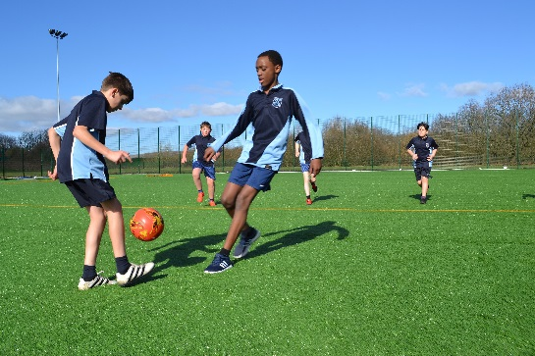
- Student Progress Leaders (SPLs) who track and ensure academic progress
- Independent Careers Advice and guidance
- School nurse drop-ins
- Nurture groups
- Peer mentoring
- Buddying system
- Homework support clubs
- Enrichment programmes
- Learning Support Centre with specialist staff

Parents

We have high ambitions for our students and we are sure they are matched by parents’ high aspirations for their children. We fully acknowledge that students are more successful at school if they are supported by their parents, with parents and school working together in partnership. Just as we need every child to fully engage with the school and everything it has to offer, we expect parents to play an active role in their child’s career at our school.
All parents sign a home-school agreement before their child starts at the school which clearly outlines the support they can expect from us and what we expect from our parent group. In addition, we run several parent focus groups where parents can discuss with staff issues such as reporting and assessment and can help drive change.

Every year group has a Parents’ Evening to discuss progress with teachers and there are additional events at key stages in your child’s education. At times parents may need our support and we may need theirs – and in any active partnership, people support each other. This is because we both have the best interests of every child at heart.

Investing in Our Staff

Wellbeing is a central drive to many of our initiatives here at Westhoughton. You have an SLT that truly believe in developing and investing in our staff and the wellbeing of all who come through our doors. We have multiple activities that develop our staff wellbeing including a Wednesday wellbeing-focused briefing whereby we celebrate our staff, best practice and recognise staff who have supported other colleagues. We have staff activities such as a staff choir, staff yoga and workout sessions and a secret buddy system of supportive comments and gifts that our staff sign up to. We believe in continually reviewing our systems and protocols to ensure that we reduce workload in as many aspects as we can.

As of September 2020, our school week altered in order to have all students leave our school site at 2:10pm every Wednesday. We deliver our personalised CPD programme from 2:30pm each week which ties together our whole school priorities, personalised CPD opportunities and talent development programmes alongside our pastoral CPD programmes to ensure we build this into our school day and value the time together.

Community

We are a successful community school and strongly believe our young people should develop a good appreciation of their heritage and pride in their town and country. We have strong links with local primary schools who are regular visitors to the school; we are supported in the curriculum by local people, including members of the Rotary Club and local businesses, our MP, support agencies and voluntary groups, and our students reciprocate through participation in competitions such as Youth Speaks. Our young people regularly go out into the community to support others, raising awareness or funds for charities or just doing good deeds during focussed charitable projects.

Parents and friends of the school actively support the many school events running in the year, from Parents’ Evenings to Careers Conventions via music and drama productions. It is also important that our young people develop a sense of the wider community and they have opportunities to work alongside students from other Bolton schools, for example in joint visits to Oxford and Cambridge Universities. Our students also have opportunities to communicate with their peers further afield through visiting other countries. The world has become a much smaller place in the 21st century and developing their ideas about community, both local and global, will ensure our students are best placed to take advantage of the many opportunities available to them as they grow into adulthood.

Visit us by Car
Leave the M61 at Junction 5, and take the A58 Snydale Way. At the roundabout take the 4th exit and follow Manchester Road (the A6) until the first set of traffic lights. Then turn left onto Bolton Road. Follow the road for around half a mile and Westhoughton High School is situated on the left.

Visit us via Public Transport
Our school is close to both Westhoughton and Daisy Hill train stations and bus services run regularly here from Bolton town centre. To find out more, please visit the Transport for Greater Manchester website to plan your journey.
Contact us
Westhoughton High School
Bolton Road, Westhoughton, Bolton BL5 3DN
Tel - 01942 814 122
Email - WHSOffice@westhoughton-high.org
Job Description - Headteacher
Grade: L31 – L35
This job description reflects the National Standards of Excellence for Headteachers (2015). These standards are built upon The Teaching Standards (2011) which apply to all teachers, including Headteachers.
The appointment is subject to the current conditions of employment of Headteachers, contained in the School Teachers’ Pay and Conditions document, and other current educational and employment legislation, including that of the Department for Education. In carrying out his/her duties, the Headteacher shall consult, where appropriate, with the Local Authority, the Governing Body, the staff of the school, its students and the parents of its students.

A. The Core Purpose of the Headteacher

The core purpose of the Headteacher is to provide professional leadership and management for the school. This will promote a secure foundation from which to achieve high standards in all areas of the school’s work. To gain this success the Headteacher must establish high quality education by effectively managing teaching and learning and using personalised learning to realise the potential of all students. The Headteacher should establish a culture that promotes excellence, equality and high expectations of all students.

The Headteacher is the leading professional in the school. Accountable to the Governing Board, the Headteacher provides vision, leadership and direction for the school and ensures that it is managed and organised to meet its aims and targets. The Headteacher, working with others, is responsible for evaluating the school’s performance to identify the priorities for continuous improvement and raising standards; ensuring equality of opportunity for all; developing policies and practices; ensuring that resources are efficiently and effectively used to achieve the school’s aims and objectives and for the day-to-day management, organisation and administration of the school.

The Headteacher, working with and through others, secures the commitment of the wider community to the school by developing and maintaining effective partnerships with, for example, schools, other services and agencies for children, the Local Authority, higher education institutions and employers. Through such partnerships and other activities, Headteachers play a key role in contributing to the development of the education system as a whole and collaborate with others to raise standards locally.

Drawing on the support provided by members of the school community, the Headteacher is responsible for creating a productive learning environment which is engaging and fulfilling for all students.
B. The Four Domains of Headship
Domain One: Qualities and Knowledge
1. Hold and articulate clear values and moral purpose, focused on providing a world class education for the students they serve.
2. Demonstrate optimistic personal behaviour, positive relationships and attitudes towards their students and staff, and towards parents, Governors and members of the local community.
3. Lead by example - with integrity, creativity, resilience, and clarity - drawing on their own scholarship, expertise and skills, and that of those around them.
4. Sustain wide, current knowledge and understanding of education and school systems locally, nationally and globally, and pursue continuous professional development.
5. Work with tenacity and financial astuteness, within a clear set of principles centred on the school’s vision, ably translating local and national policy into the school’s context.
6. Communicate consistently the school’s vision and drive the strategic leadership, empowering all students and staff to excel.
Domain Two: Students and Staff
1. Demand ambitious standards for all students, overcoming disadvantage and advancing equality, instilling a strong sense of accountability in staff for the impact of their work on students’ outcomes.
2. Secure excellent teaching through an analytical understanding of how students learn and of the core features of successful classroom practice and curriculum design, leading to rich curriculum opportunities and students’ well-being.
3. Establish an educational culture of ‘open classrooms’ as a basis for sharing best practice within and between schools, drawing on and conducting relevant research and robust data analysis.
4. Create an ethos within which all staff are motivated and supported to develop their own skills and subject knowledge, and to support each other.
5. Identify emerging talents, coaching current and aspiring leaders in a climate where excellence is the standard, leading to clear succession planning.
6. Hold all staff to account for their professional conduct and practice.
Domain Three: Systems and Processes
1. Ensure that the school’s systems, organisation and processes are well considered, efficient and fit for purpose, upholding the principles of transparency, integrity and probity.
2. Provide a safe, calm and well-ordered environment for all students and staff, focused on safeguarding students and developing their exemplary behaviour through shared respect in school and in the wider society.
3. Establish rigorous, fair and transparent systems and measures for managing the performance of all staff, addressing any under-performance, supporting staff to improve and valuing excellent practice.
4. Welcome strong governance and actively support the Governing Board to understand its role and deliver its functions effectively – in particular its functions to set school strategy and hold the Headteacher to account for student, staff and financial performance.
5. Exercise strategic, curriculum-led financial planning to ensure the equitable deployment of budgets and resources, in the best interests of students’ achievements and the school’s sustainability.
6. Distribute leadership throughout the organisation, forging teams of colleagues who have distinct roles and responsibilities and hold each other to account for their decision making.
Domain Four: The Self-Improving School System
1. Create outward-facing schools which work with other schools and organisations - in a climate of mutual challenge - to champion best practice and secure excellent achievements for all students.
2. Develop effective relationships with fellow professionals and colleagues in other public services to improve academic and social outcomes for all students.
3. Challenge educational orthodoxies in the best interests of achieving excellence, harnessing the findings of well evidenced research to frame self-regulating and self-improving schools.
4. Shape the current and future quality of the teaching profession through high quality training and sustained professional development for all staff.
5. Model entrepreneurial and innovative approaches to school improvement, leadership and governance, confident of the vital contribution of internal and external accountability.
6. Inspire and influence others - within and beyond schools - to believe in the fundamental importance of
Safeguarding - Responsible for promoting the welfare of all children and young people and be faithful to the trust deed. Create an organisational culture which is vigilant to, monitors and prioritises the safeguarding of children and young people above all considerations.
Customer Care - To continually review, develop and improve systems, processes and services in support of the School’s pursuit of excellence in service delivery. To recognise the value of its people as a resource and to be perceptive of their needs
Promoting Equality and Diversity - To accept everyone has a right to his or her distinct identity. To treat everyone with dignity and respect and to ensure that what our customers tell us is valued by reporting it back into the organisation. To promote and participate in the council’s work to eliminate discrimination; advance equality of opportunity; and foster good relations between our diverse communities.
Developing Self and Others - To use processes and put processes in place to generate a learning environment. To focus on the strengths and requirements of all individuals and enable them to further their skills and knowledge. To actively pursue your own development. To be self-aware and role model continuous self-development.
Safer Recruitment – The school is committed to safeguarding and promoting the welfare of children and young people and expects all staff and volunteers to share this commitment.
"Bolton Council has a statutory duty under the Civil Contingencies Act to respond in the event of an emergency. If Bolton Council's Emergency Management Plan is activated, you could be required to assist, or assist others, in the continued maintenance or delivery of key Council services and of support to the community. This could require working outside of routine working hours and could entail working from places other than your normal place of work.
N.B. Emergencies requiring activation of the Bolton Council Emergency Management Plan only occur very infrequently. If you are asked to respond to an emergency, your personal circumstances at the time will be taken into account.
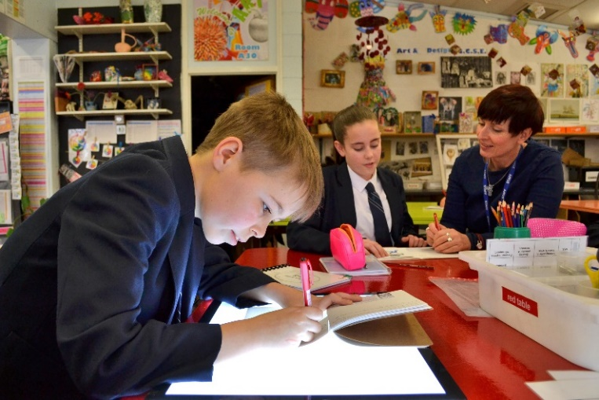

Person Specification
The applicant will be required to safeguard and promote the welfare of children and young people

Note: Candidates failing to meet any of the essential criteria will automatically be excluded
(Source key: A = Application, I = Interview, R = Reference, AC = Assessment Centre)

[A] Qualifications

Qualification Requirements | Essential | Desirable | Source
Qualified teacher status | E |  | A
Degree or equivalent | E |  | A
NPQH |  | D | A

[B] Professional Development

Evidence of regular, recent and appropriate professional development for the role of Headteacher | E |  | A
Has successfully undertaken the Secretary of State's (NCSL, CWDC or local authority) approved "Safer Recruitment" training or has a commitment to do so within 12 months of taking up post | E |  | A
Has successfully undertaken appropriate Child Protection training/ Designated Senior Person training | E |  | A

[C] School Leadership and Management Experience

Successful leadership as a Headteacher |  | D | AIR
Recent successful leadership as a Deputy Headteacher | E |  | AIR
Demonstrate an understanding of the role of the Governing Board | E |  | AIR
To have taken an active involvement in school self-evaluation and development planning | E |  | AIR
To have implemented and developed a whole school initiative | E |  | AIR
An active involvement in financial management of a secondary school |  | D | AIR
Knowledge and understanding of strategic financial planning and budgetary management in relation to their contribution to school improvement and student achievement | E |  | AIR
To have had responsibility for policy development and implementation | E |  | AIR
To have had experience of and ability to contribute to staff development across the secondary range. (E.g. coaching, mentoring, INSET for staff) | E |  | AIR

[D] Experience and Knowledge of Teaching

Experience of teaching in more than one school |  | D | AIR
Significant, successful teaching experience within the secondary phase | E |  | AIR
To have a working and current knowledge and understanding of all Key Stages in the secondary phase | E |  | AIR
To be able to effectively use data, assessment and target setting to raise standards/address weaknesses | E |  | AIR/AC
To be able to exemplify how the needs of all students have been met through the highest quality teaching and learning | E |  | AIR

[E] Professional Attributes

Demonstrate an understanding, awareness and empathy for the needs of the students at Westhoughton High School and how these could be met | E |  | AIR
Able to demonstrate a clear rationale for behaviour management and a proven track record of the effective implementation of a range of behaviour management strategies | E |  | AIR
Excellent written and verbal communication skills (which will be assessed at all stages of the process) | E |  | AIR/AC
To be an inspiring leader of learning demonstrating, promoting and encouraging outstanding classroom practice | E |  | AIR
Show a good commitment to sustained attendance at work | E |  | AIR
Show a commitment to advancing equality and inclusion within the school and wider community | E |  | AIR

[F] Professional Skills

(Based on the National Standards of Excellence for Headteachers 2015).

The Headteacher is expected to address the National Standards of Excellence for Headteachers (2015). Candidates are therefore asked to structure their Supporting Statement under the following Excellence Domain headings:
- Qualities and Knowledge
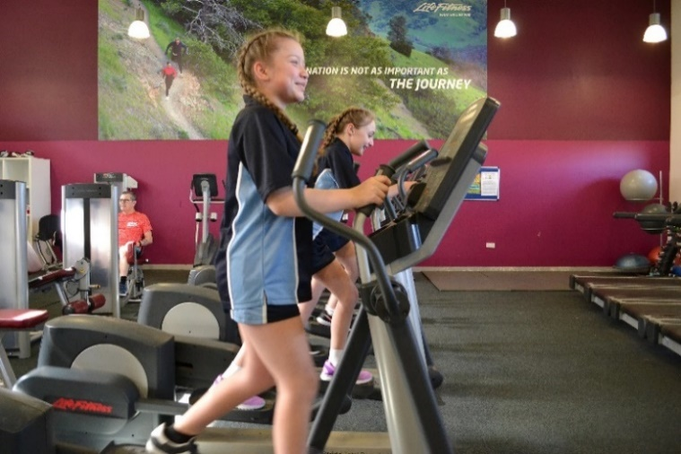
- Students and Staff
- Systems and Processes
- The Self-Improving School System

[G] Personal Qualities

All of the following personal qualities are considered to be essential for this post and will be assessed through interview/reference and assessment centre tasks

Continue to promote strong educational philosophy and values at Westhoughton High School
Inspire, challenge, motivate and empower teams and individuals to achieve high goals
Be a positive role model at all times, a highly effective and respected representative of Westhoughton High School
Be approachable, person centred
Demonstrate personal enthusiasm and commitment to leadership aimed at making a positive difference to children, young people and staff
Build and maintain quality relationships through interpersonal skills and effective communication with parents and carers and the whole school community
Demonstrate personal and professional integrity, including modelling values and vision
Inspire trust and confidence across the school and community
Prioritise, plan and organise themselves and others
Be aware of their own strengths and areas for development and listen to, and reflect constructively and act upon as appropriate, feedback from others
Demonstrate a capacity to work with energy and vigour

[H] Confidential References and Reports

Positive recommendation from all referees, including current employer | E
A supportive reference from the Local Authority, if possible, or a further supportive professional reference | E

[I] Application Form and Supporting Statement

The form must be fully completed and legible. The supporting statement should be clear, concise and related to the specific post, following the guidance outlined in section F above and no more than 3 sides of A4.

Safeguarding  Displays a commitment to the protection and safeguarding of children and young people.  Has up-to-date knowledge and understanding of relevant legislation and guidance in relation to working with, and the protection of, children and young people. | AIR
Promoting Equality and Diversity  Understand how knowledge of our diverse communities can help us to deliver effective services and reduce disadvantage in the borough. Listen to contributions made to service development without prejudice. Challenge behaviours and processes which do not support the council’s work to eliminate discrimination; advance equality of opportunity; and foster good relations, while being prepared to accept feedback about own behaviour.  Customer Care  Listen and respond to children/young people needs, seek out innovative ways of consulting and engaging them. Network with others to develop services for the benefit of the children/young people.  Developing Self and Others  Coach and mentor others. Be willing to share learning and encourage others to do the same. Listen to others and respond to their needs. Apply a range of development activities to develop and train staff. Endorse the principles of Investors in People. Strives for improvement and take responsibility for own development. Be self-confident and lead by example. | AIR  AIR  AIR

Application Process
Please download, complete and return the application form by the closing date specified, Monday 25th January 2021 at 12:00 noon. Candidates are asked to complete all the relevant sections of the application form and to submit a supporting statement, addressing the criteria listed on the person specification. This should be no longer than 3 sides of A4 paper.

The completed application form should be emailed to Miss A Hodson, ahodson@westhoughton-high.org or posted to: Miss A Hodson, PA to the Headteacher, Westhoughton High School, Bolton Road, Westhoughton, Bolton BL5 3DN.

For further details, please contact the school office on 01942 814122 or for additional information about the school please visit the website www.westhoughton-high.org.

If you would like to arrange a visit to Westhoughton High School prior to submitting your application, please contact Miss A Hodson on 01942 814122 or email ahodson@westhoughton-high.org

Whilst every effort has been made to explain the main duties and responsibilities of the post, you will be expected to comply with any reasonable request from a line manager to undertake work of a similar level that is not specified in this job description. Depending on the needs of the school, these may be altered from time to time in accordance with the conditions set out in the currently operating School Teachers’ Pay and Conditions Document and relevant Governors’ Policy Documents.

This post is subject to the current conditions of employment contained in the School Teachers’ Pay and Conditions Document, the 1998 School Standards and Framework Act, the required

Background Checks and Safeguarding Students

Westhoughton High School is committed to safer recruitment practice and pre-employment checks will be undertaken before any appointment is confirmed. This post is subject to an Enhanced Disclosure and Barring Service check, medical clearance, satisfactory references, qualification checks and eligibility to work checks under the Asylum and Immigration Act.
The school is committed to safeguarding and promoting the welfare of children and young people and it expects staff and volunteers to share this commitment.

Thank you for considering Westhoughton High School
&
We look forward to receiving your application.

