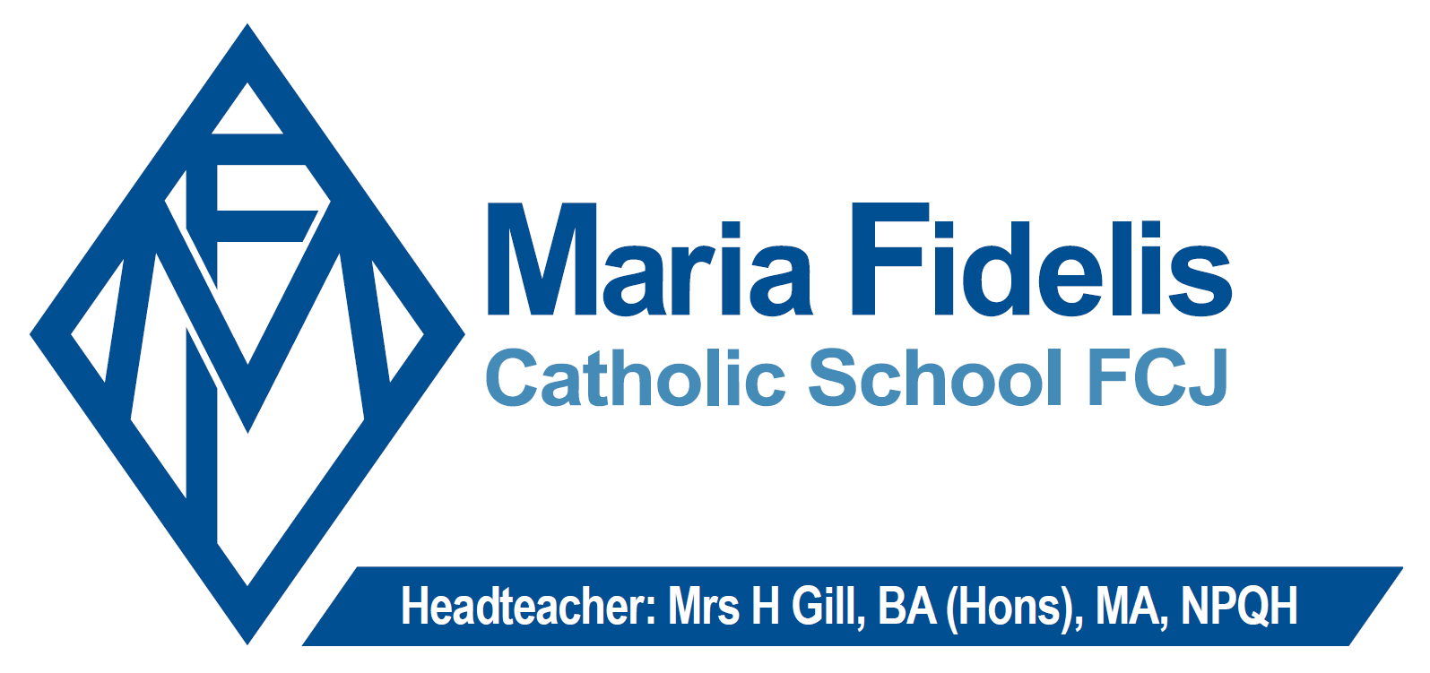

Teacher of History

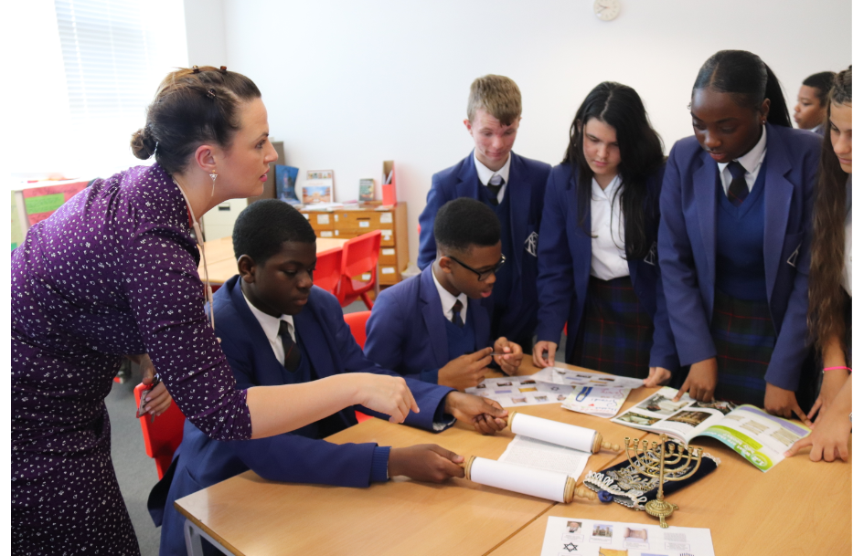
Contents

Welcome from Helen Gill, Headteacher
About the role
About the department
About the location and benefits
Job Description
Person Specification
Applying for the role

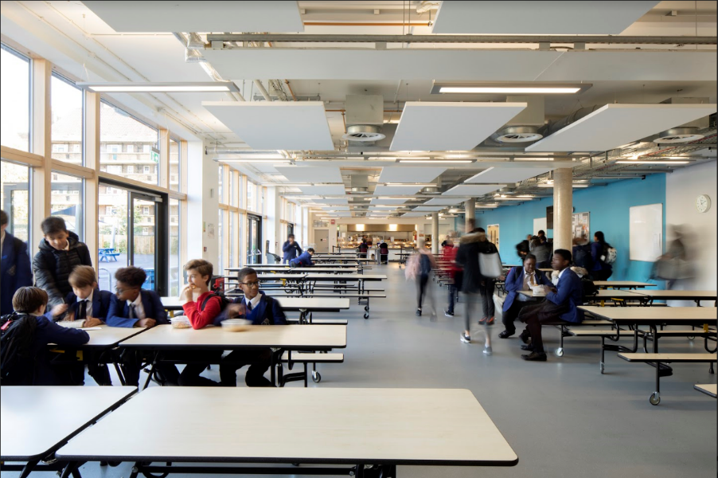
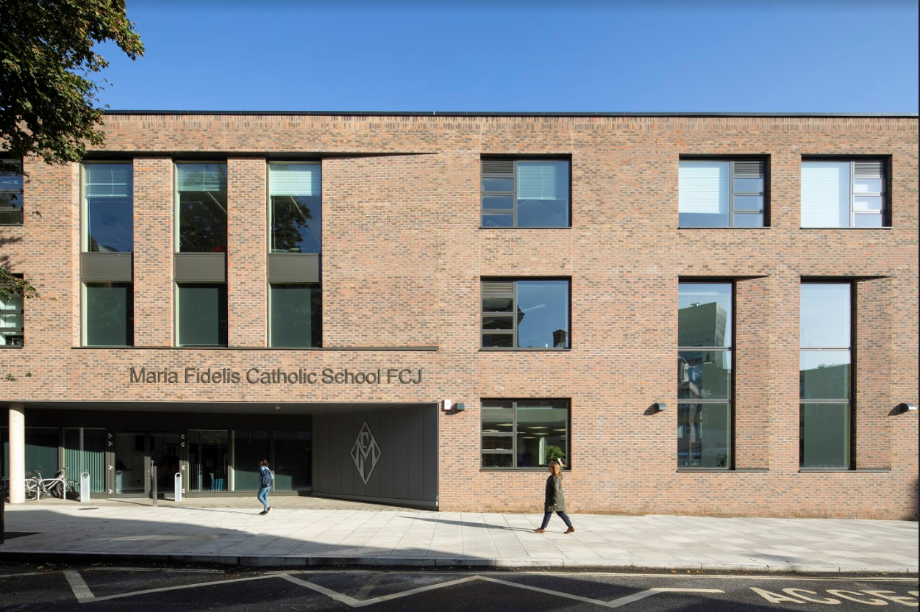

Welcome from Maria Fidelis Catholic School
Dear Colleague,
Thank you for your interest in the role of Teacher of History at Maria Fidelis Catholic School. We hope this pack will give you a great insight into our school and the role.
Our school began serving the local community in 1830 under the direction of Marie Madeleine D'Houet, founder of the religious order, the Faithful Companions of Jesus (FCJ).
Our vision is that FCJ schools are communities of personal academic excellence. Strong in companionship, the unique giftedness of every person is recognised, nourished and celebrated. Our hope and expectation is that each young person grows into their best self, with zest for life and the generosity and confidence to use their talents and gifts in the service of others.
We believe we provide a truly special experience for our students and staff – not only of academic excellence, but also an environment that is caring, supportive and focused on the uniqueness of every person.
In 2018-19 we merged our separate lower and upper schools into a brand new state of the art school on a single site between Euston and Kings Cross Stations. Our new building is fantastic – with fully equipped spaces for teaching and learning, new technology and systems to support 21st century learning.
The successful candidate will be fully supported by the Head of Department and will be provided with opportunities to develop and grow within the school. We are looking for someone who can help lead a well-established department, in particular - raising standards at KS4 and KS5.
For a confidential and informal conversation to discuss this opportunity, please contact Ms C Bagnall (Assistant Headteacher) at cbagnall3.202@lgflmail.org or Ms L. Morris (Executive PA to the Head) recruitment@mariafidelis.camden.sch.uk on 0207 387 3856.
If you think you are the person we are looking for, I would be delighted to receive your application and I look forward to meeting you.

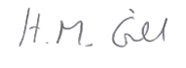
Helen Gill
Headteacher
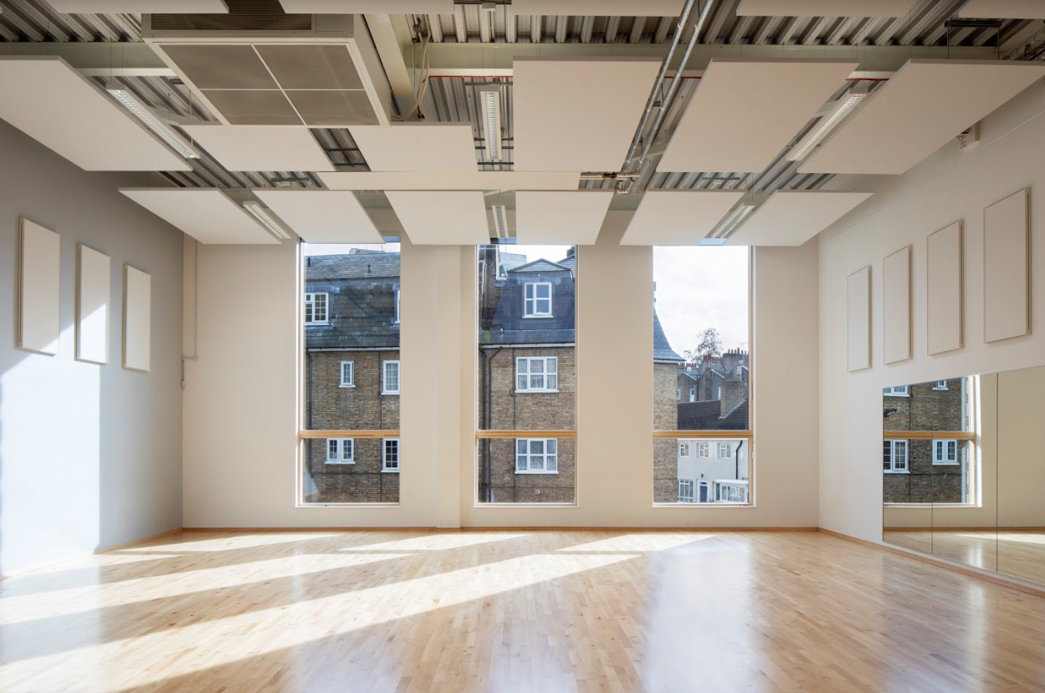

Role of Teacher of History
The key purpose of the Teacher of History is to support the progress and attainment of pupils through high quality teaching and learning with close monitoring and swift intervention to ensure maximum pupil progress.
We believe the following qualities are essential in the successful applicant:
- An excellent classroom teacher;
- The ability to gain the trust and respect of school staff, pupils and parents;
- Experience of delivering GCSE and A Level History;
- Outstanding subject knowledge with an ability to share this with pupils in an exciting and academically rigorous way;
- Evidence of successful intervention in various areas, e.g. improving exam skills and/or examination results;
- Evidence of relevant professional development;
- An interest in pedagogy and current issues relating to teaching and learning;
- Knowledge of meeting the needs of pupils with SEND;
- Organised, flexible, able to work under pressure;
- A commitment to our pupils, with the belief that education has the capacity to transform their journey.

The Department
Joining the Humanities faculty means that you will be joining a faculty that is dynamic with enthusiastic teaching professionals who are collectively committed to the progress their pupils make. The History Department currently consists of three department members with one having responsibility for leading the department. The History Department works very closely with the Humanities faculty and teachers often teach across subjects within the faculty to further develop their expertise and skills.

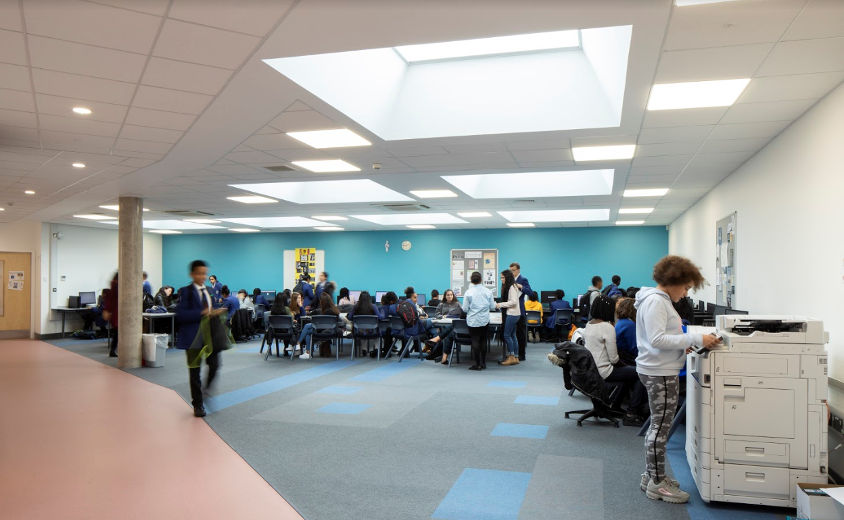

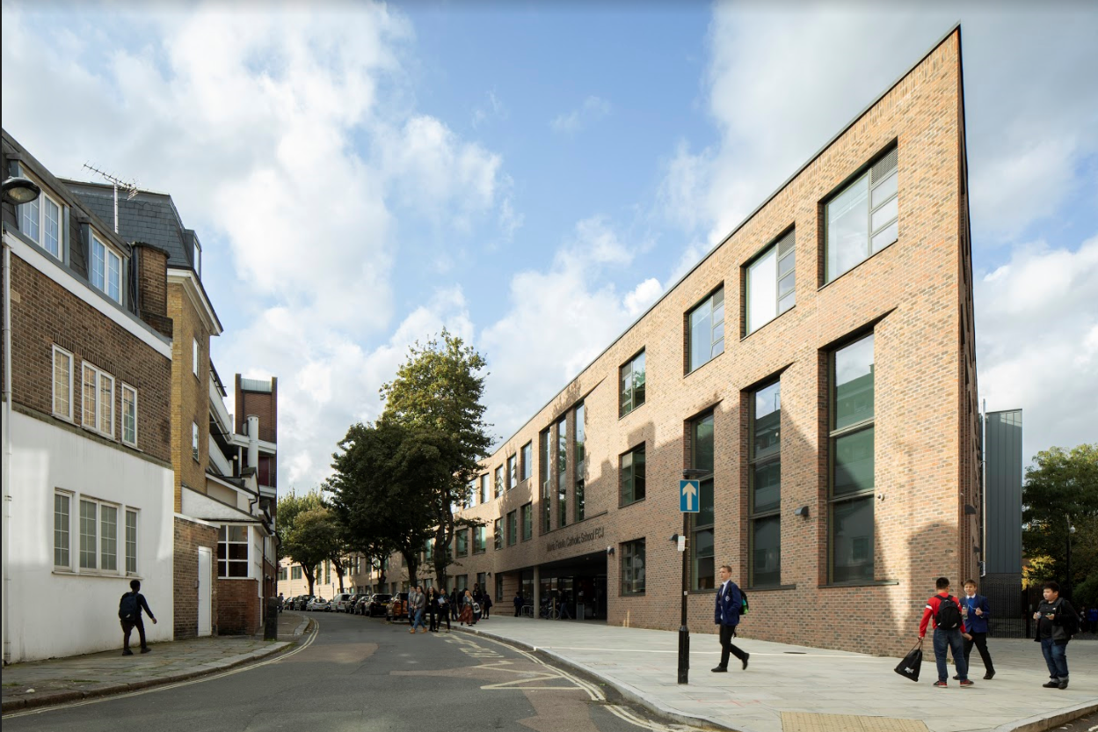
Location and Benefits
Maria Fidelis is situated in a fantastic location between Euston and Kings Cross Station, which makes it very easy to reach. The British Library, Francis Crick Institute, Wellcome Trust, UCL, SOAS, LSE and Central St. Martin’s School of Art are all within a five-minute walk of the school site; the school therefore enjoys extracurricular links with several institutions, many of which offer exciting opportunities not only for our pupils, but also professional development activities for our teachers. Partnerships with City firms such as Deloitte enrich the curriculum and also allow our staff to keep ’in touch’ with the world outside of education.

Maria Fidelis is a welcoming and supportive community. We value the professional autonomy of high-performing staff and understand the different approaches different departments may need to take. We make managing workload a high priority.

We are forward-looking and progressive with many opportunities for professional development and sharing practice. Maria Fidelis belongs to networks within Camden, but also in other boroughs including Westminster, Kensington and Chelsea and with other high performing Catholic Schools in the Westminster Diocese.

We are a diverse school community in terms of both staff and students and therefore welcome applications from anyone who supports our ethos.

Key Benefits – health and wellbeing
• A commitment to managing workload.
• Cycle to work Scheme, with savings of between 32% and 42% on the standard retail price of a new bike;
• Corporate rates for membership of a gym - GLL – Better Leisure. Camden’s award-winning leisure centre is just 5 minutes away and boasts a gym, swimming pool, library and cafes;
• Free hearing tests, eye tests and health checks

Key Benefits – financial
• An interest-free season ticket/travel-card loan scheme;
• A Childcare Voucher scheme which can be used to pay for registered childcare for children up to 16 years old;
• A collection of staff discount and cash-back deals available every day of the year, on shops and health clubs, travel and insuranc
MARIA FIDELIS CATHOLIC SCHOOL

JOB DESCRIPTION

To work as a team member to maintain and develop Maria Fidelis Catholic School as a learning community “growing together through Christ with courage, confidence and dignity.”

Post Title: | TEACHER of History
Post Purpose: | To be a team member, playing a full part in the life of the community of Maria Fidelis.  To support our distinctive Catholic mission and ethos and encourage staff and students to follow this example.  Under the reasonable direction of the Headteacher, carry out the professional duties of a school teacher as set out in the current School Teachers' Pay and Conditions Document (STPCD).  To implement and deliver an appropriately broad, balanced, relevant and differentiated curriculum for students and to support a designated curriculum area as appropriate.  To monitor and support the overall progress and development of students as a teacher/ Form Tutor.  To facilitate and encourage a learning experience which provides students with the opportunity to achieve their individual potential.  To contribute to raising standards of student attainment.  To share and support the school’s responsibility to provide and monitor opportunities for personal and academic growth.
Reporting to: | Head of Department and assistant Headteacher
Responsible for: | The provision of a full learning experience and support for students.
Liaising with: | Headteacher, Leadership Team, Middle Leaders, teachers and support staff, LA representatives, external agencies and parents.
Working Time: | Full time as specified within the STPCD
Salary/Grade: | Classroom Teachers' Pay Scale
Disclosure level | Enhanced

TEACHING
To teach students according to their educational needs, including the setting and marking of work to be carried out by the student in school and elsewhere.

To assess, record and report on the attendance, progress, development and attainment of students and to keep such records as are required.

To provide, or contribute to, oral and written assessments, reports and references relating to individual students and groups of students.

To ensure that ICT, Literacy and Numeracy are reflected in the teaching/learning experience of students.

To undertake a designated programme of teaching.

To ensure a high quality learning experience for students which meets internal and external quality standards.

To prepare and update subject materials.

To use a variety of delivery methods which will stimulate learning appropriate to student needs and demands of the syllabus.

To maintain discipline in accordance with the school’s procedures, and to encourage good practice with regard to punctuality, behaviour, standards of work and homework.

To undertake assessment of students as requested by external examination bodies, Faculty and school procedures.

To mark, grade and give written/verbal and diagnostic feedback as required in line with the School’s assessment policy.

OPERATIONAL/ STRATEGIC PLANNING:
To assist in the development of appropriate syllabuses, resources, schemes of work, marking policies and teaching strategies in the Curriculum Area and Faculty.

To contribute to the Curriculum Area and Faculty’s development plan and its implementation.

To plan and prepare courses and lessons.

To contribute to the whole school’s planning activities.

CURRICULUM PROVISION:
To assist the Head of Department and the Assistant Head (Teaching & Learning) to ensure that the curriculum area provides a range of teaching which complements the School’s strategic objectives.

CURRICULUM DEVELOPMENT:
To assist in the process of curriculum development and change so as to ensure the continued relevance to the needs of students, examining and awarding bodies and the school’s Mission and Strategic Objectives.

STAFFING:
To take part in the school’s staff development programme by participating in arrangements for further training and professional development.

To continue personal development in the relevant areas including subject knowledge and teaching methods.

To engage actively in the Performance Management Review process.

To ensure the effective/efficient deployment of classroom support.

To work as a member of a designated team and to contribute positively to effective working relations within the school.
QUALITY ASSURANCE:
To help to implement school quality procedures and to adhere to those.

To contribute to the process of monitoring and evaluation of the curriculum area/faculty in line with agreed school procedures, including evaluation against quality standards and performance criteria. To seek/implement modification and improvement where required.

To review from time to time methods of teaching and programmes of work.

To take part, as may be required, in the review, development and management of activities relating to the curriculum, organisation and pastoral functions of the school.
MANAGEMENT INFORMATION:
To maintain appropriate records and to provide relevant accurate and up-to date information for management information systems, registers, etc.

To complete the relevant documentation to assist in the tracking of students.

To track student progress and use information to inform teaching and learning.
COMMUNICATIONS & LIAISON:
To communicate effectively with the parents of students as appropriate.

Where appropriate, to communicate and co-operate with persons or bodies outside the school.

To follow agreed policies for communications in the school.

To take part in liaison activities such as parents’ evenings, review days and liaison events with partner schools.

To contribute to the development of effective subject links with external agencies.

MANAGEMENT OF RESOURCES:
To contribute to the process of the ordering and allocation of equipment and materials.

To assist the Director of Learning to identify resource needs and to contribute to the efficient/effective use of physical resources.

To co-operate with other staff to ensure a sharing and effective usage of resources to the benefit of the School, Faculty and the students.
PASTORAL SYSTEM:
To mentor assigned groups of students.

To promote the general progress and well-being of individual students.

To liaise with Student Support Officers/ Heads of Year to ensure the implementation of the school’s Pastoral System.

To register students, accompany them to assemblies, encourage their full attendance at all lessons and their participation in other aspects of school life.

To evaluate and monitor the progress of students and keep up-to-date student records as may be required.

To contribute to the preparation of action plans and progress files and other reports.

To alert the appropriate staff to problems experienced by students and to make recommendations as to how these may be resolved.

To communicate as appropriate, with the parents of students and with persons or bodies outside the school concerned with the welfare of individual students, after consultation with the appropriate staff

To contribute to PSHE and citizenship and enterprise according to school policy.

To apply the Behaviour Management systems so that effective learning can take place.

To ensure an up-to-date understanding of all safeguarding issues and report any concerns to the Designated Teacher.

Whilst every effort has been made to explain the main duties and responsibilities of the post, each individual task undertaken may not be identified.

Person Specification
Teacher of History

ATTRIBUTES | ESSENTIAL | DESIRABLE | STAGE IDENTIFIED
ETHOS
Willing to support the school’s inclusive approach to education | X |  | A,I,R
Willing to establish open, positive, supporting relationships across the community, where children and young people will feel that they're listened to | X |  | I
Ability to model behaviour which promotes health and wellbeing and encouraging it in others | X |  | I
EDUCATION
Qualified Teacher status | X |  | A,R
Good Honours Degree or equivalent in relevant subject | X |  | A,R
Evidence of continuing professional development | X |  | A,R
Post graduate qualification |  | X | A,R
A Relevant higher degree or professional qualification |  | X | A,R
EXPERIENCE
Experience of teaching in the UK in a mainstream secondary school | X |  | A,I,R
Evidence of successful and innovative teaching in all Key stages | X |  | A,I,R
Awareness of developments in History and their likely impact on teaching and learning | X |  | A,I
Proven track record of raising attainment in History at GCSE and A level | X |  | R
Evidence of leadership experience |  | X | A,I,R
Evidence of commitment to extended learning for students beyond the classroom | X |  | A,R
Experience of implementing systems and processes to monitor and evaluate learning and teaching | X |  | A,I,R
Active involvement in the promotion of equal opportunities | X |  | A,I,R
Experience of being a form teacher |  | X | A,I,R
Experience of mixed ability teaching |  | X | A,I,R
Experience of working with parents and external agencies |  | X | A,I,R
PROFESSIONAL KNOWLEDGE AND SKILLS
A passion for the subject and knowledge and skills to inspire students | X |  | A,I,R
Ability to lead, manage and motivate staff and students | X |  | A,I,R
Excellent communicator – sensitive and effective | X |  | I,R
An ability to establish good working relationships with a wide range of people including students, parents, governors and colleagues | X |  | A,I,R
Knowledge, skill and intelligent use of data to inform intervention strategies to improve outcomes for students | X |  | A,I,R
Ability to plan, monitor, evaluate, review, be accountable and lead by example | X |  | A,I,R
A keen interest in how students learn and experience of putting this knowledge into practice | X |  | A,I,R
Knowledge, skills and desire to support the school’s programme for care, welfare and guidance | X |  | I,R
Knowledge and understanding of current educational issues |  | X | A,I,R
Knowledge and understanding of Safeguarding | X |  | I
A commitment to Equal Opportunities | X |  | A,I
PERSONAL QUALITIES
Be committed to supporting the Catholic ethos of the school | X |  | A,I,R
Ambition and vision | X |  | A,I,R
A commitment to sustaining and raising achievement, attainment and aspirations of all students | X |  | A,I,R
Have the ability to work in and lead a team | X |  | A,I,R
A sense of humour and perspective | X |  | A,I,R
Ability to work under pressure and remain positive, enthusiastic and resilient | X |  | A,I,R
Reflective and analytical | X |  | A,I,R
Sound judgment | X |  | A,I,R
An optimist who brings out the best in people | X |  | A,I,R
Energy, imagination and personal commitment | X |  | A,I,R
Personal and professional commitment to the philosophies of school improvement and effectiveness | X |  | A,I,R
Have high standards of personal presentation, commitment and dedication | X |  | A,I
Excellent attendance and punctuality | X |  | R

KEY: A = Application; I = Interview; R = Reference

Applying for the Role

We look forward to receiving your application by 09:00am on Thursday 20th May 2021.
This should include
- A completed application form
- A letter of application outlining your readiness for the role of Teacher of History at our school. We are particularly interested to hear about any initiatives you have been involved in, assessing your contribution and its impact.
We shall hold interviews on Thursday 27th May 2021 and the successful candidate will start in September 2021.
Maria Fidelis Catholic School is committed to safeguarding and promoting the welfare of children and young people and expects all staff and volunteers to share this commitment. Any successful applicant will be required to undertake an Enhanced Disclosure check by the Disclosure Barring Service.
If you have any questions about the role or would like a confidential and informal chat please don’t hesitate to contact Ms. C Bagnall (Assistant Headteacher) cbagnall3.202@lgflmail.org or Ms L. Morris (Executive PA to the Head) recruitment@mariafidelis.camden.sch.uk on 0207 387 3856.
We would also be happy to welcome you to come and look around the school. To do this you can contact Leanna as above.

To receive the necessary application form to apply please contact Ms. L. Morris,
Executive PA to the Headteacher
Tel.: 0207 387 3856
Email: recruitment@mariafidelis.camden.sch.uk

COMPLETED APPLICATION FORMS SHOULD BE RETURNED BY EMAIL TO:
recruitment@mariafidelis.camden.sch.uk

