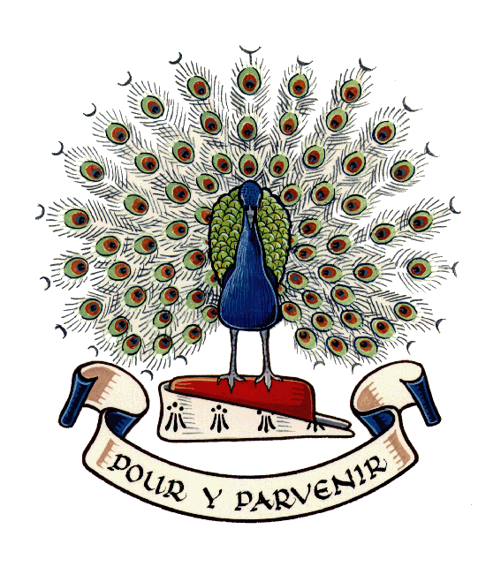Lady Manners School 

**About Lady Manners School**

Lady Manners School has a history going back nearly 400 years, and we're very proud of it. We are a thriving comprehensive school in which we build on our traditional values to help our students to create the best possible future for themselves.

We offer our staff the opportunities to:

* work in the beautiful surroundings of Bakewell, in the heart of the Peak District
* work with over 1300 students (around 260 of whom are in our Sixth Form) representing the diversity of a wide catchment, which includes both rural and suburban areas
* thrive from the energy and challenge associated with a student group with very varied backgrounds
* be part of our staff of nearly 240 dedicated and professional teachers and support staff
* input to the enviable range of extra-curricular activities that we provide for students, inspired by students and staff interests
* be part of a school at the heart of the community - not just our strong local community but, having achieved the full International School Award in 2009, 2012, 2015 and 2018, our students are encouraged to be responsible members of the global community

Successful applicants would be joining a school that has ambitions to improve and develop. Our facilities constantly evolve, with new performance and sporting spaces currently being developed.

Our long-term ratings and exam results are good - but we want to become even better. We look to new staff to bring with them their new ideas and enthusiasm. We look forward to welcoming you.

**Values and vision**

Lady Manners School helps students to strive to attain the highest standards in their work, have respect for others and develop their individual talents. It makes the most of strengths that are shaped by traditional values and it is active in preparing for the future. The school strives to establish processes, outcomes and facilities that make its aims possible. Lady Manners School is an excellent place for the development of academic, personal and social potential.

**School Organisation**

The school is organised into:

* Lower School (Years 7-9) Key Stage 3
* Upper School (Years 10-11) Key Stage 4
* Sixth Form (Years 12-13)

Each student has a Head of School, Heads of Year, and Form Tutor.

We have a strong team of support staff, including specialist finance, premises, catering and technical staff, all of whom are employed directly by the school.

**Curriculum**

Teaching is organised through subject specific departments, each with a Curriculum Leader.

The Lower School curriculum provides a broad and interesting education for all students. In Upper School the core curriculum contains English, Mathematics, Science, Religious Studies, PE and PSHE. Choice is introduced through four subject options but students are encouraged to ensure that their curriculum remains broad and balanced by considering creative, humanities and language subjects.

We currently offer 29 subjects for study at Key Stage 4 and 28 in the Sixth Form, including academic and vocational subjects.

**Further Information**

* We maintain lots of information about the school on our website, [www.ladymanners.net](http://www.ladymanners.net/)
* For a feel for daily life here, and the achievements of our students you can also visit our Facebook page, [www.facebook.com/LadyMannersSchool](http://www.facebook.com/LadyMannersSchool)
* For our latest Ofsted report, visit [www.ladymanners.net/performance](http://www.ladymanners.net/performance)