Teacher of Creative Digital Media Production
Job start: January 2022
Salary: MPS/UPS

Unique opportunity for a candidate who has expert subject knowledge and industry experience in Creative Digital Media Production.

Aldridge UTC MediaCity
Established in 2015 and based in the heart of MediaCityUK, The UTC is a 14-18 mainstream University Technical College, specialising in creative digital media. Our facilities are truly cutting edge and industry standard in every area of the curriculum. We thrive on creating a ‘competitive advantage’ for our 350 students through unrivalled experiences linked to the media industry.

We are seeking a Teacher of Creative Digital Media Production who can share their subject knowledge and prepare our KS4 and KS5 students for their first step into the Creative industry. The ideal candidate will have TV studio experience, a knowledge of a wide range of cameras and have experience teaching EDUQAS Film Studies at A-level.

The Benefits:
- Ongoing professional development within an exciting Multi Academy Trust
- Working closely with senior staff and cluster leads across 2 sites
- Development and demonstration of strategic work
- Excellent and genuine opportunities for career progression
- Opportunities within a cluster of schools who are supportive and collaborate
- Make a real difference in the engagement with education of the young people

Download our application pack now and submit an Application Form (which includes a section for a supporting statement) to Victoria.Brown@aldridgeeducation.org by 5pm on Wednesday 22nd September 2021.

Please note that we do not accept any supporting documents, all information relevant to your application should be included in the Application Form. To gain more information about the schools please visit www.utcmediacityuk.org.uk For questions about the position, please contact Victoria.Brown@aldridgeeducation.org
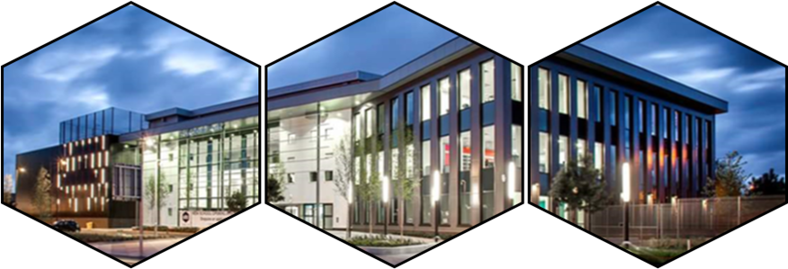
UTC@MediaCityUK is committed to safeguarding children; successful candidates will be subject to an enhanced Disclosure and Barring Service check.

