Norwich School

Norwich School is a co-educational, independent day school for pupils aged seven to eighteen. Its origins can be traced back to the early life of Norwich Cathedral, which was founded in 1096. It was incorporated by Royal Charter in 1547 by King Edward VI. Set in the Cathedral Close, Norwich School is a traditional yet lively place where boys and girls enjoy a rounded and stimulating education. The School is characterised by strong, warm relationships and a profound appreciation of scholarship.

Norwich School is divided into two sections: the Lower School and the Senior School. The Lower School is the base for our 4-11 year old pupils (Reception-Year 6), while the Senior School caters for the 11-18 age range (Years 7-13).

Norwich School appointment procedures conform to guidelines to ensure compliance with safer recruitment guidelines.

We look forward to receiving your application.

S.D.A. Griffiths
Head Master

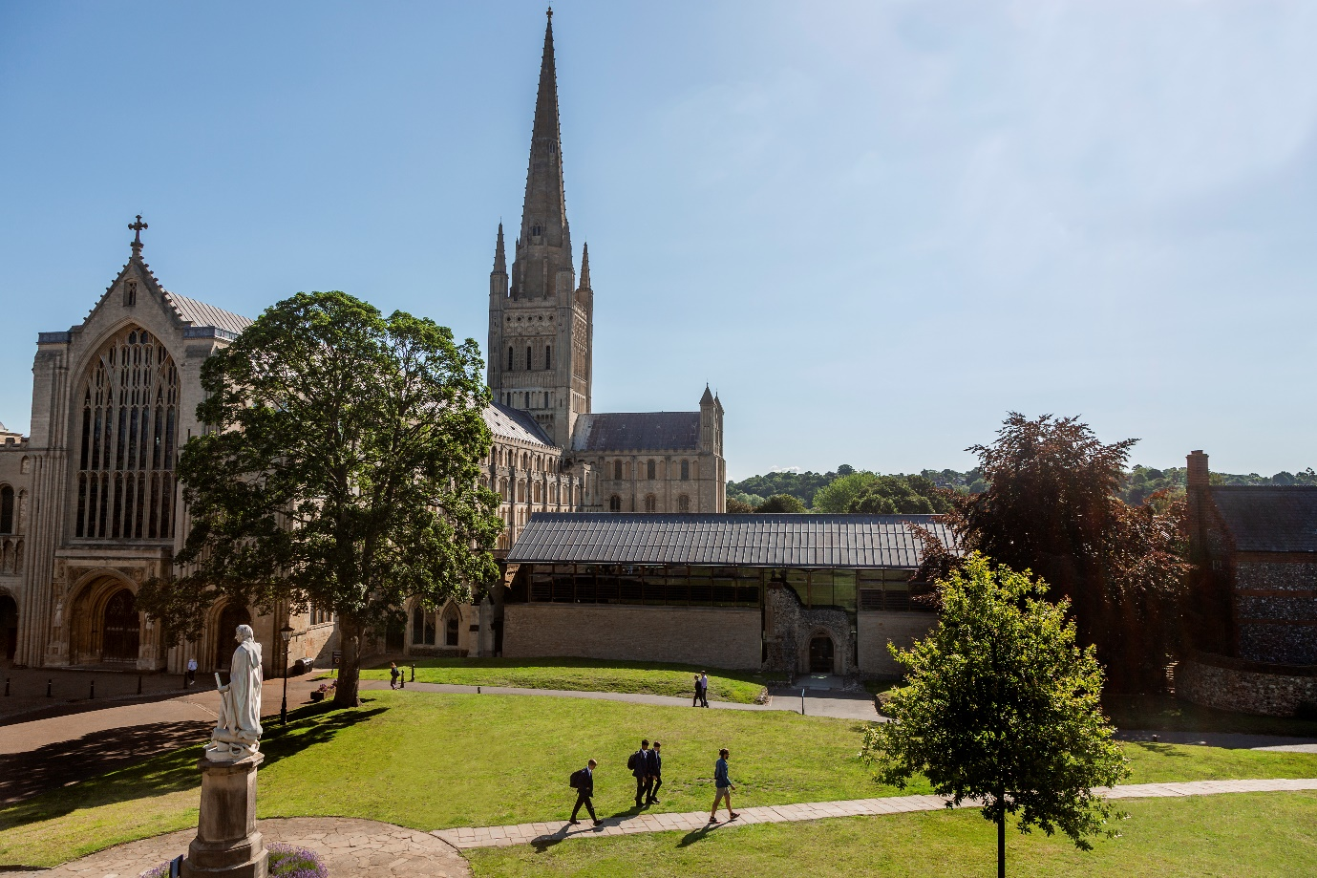

Application Form

Preliminary Details

Norwich School post applied for:
Current notice period:
Available start date:
Current or most recent salary:
NIC
COL

Personal Information

Surname: |  | Forenames:
Title: | Preferred name: | Former name/s (including maiden name):
Address: |  | Contact number:  Mobile number:  Work number:  E-mail address: :
Postcode:
National Insurance number: |  | Teacher registration number (if applicable):

General

Are there any special arrangements/reasonable adjustments you may require to attend an interview?  If so, please state: | Yes ☐ No ☐
Where did you see our advert?
Are you related to or do you maintain a close relationship with an existing employee, volunteer or Governor of the School?  If so, please give name: | Yes ☐ No ☐
Do you have children that attend the Norwich School? | Yes ☐ No ☐
Outside interests

Right to work in the UK

Do you have the right to live and work in the UK? | Yes ☐ No ☐
Are there any restrictions to your right to live and work in the UK which might affect your right to take up employment with us?  If YES please provide details: | Yes ☐ No ☐

EDUCATION, QUALIFICATIONS AND EMPLOYMENT
This section is designed to give a full history of education and employment in chronological order, progressing from the latest date to the earliest. Please ensure that all education and employment is listed and provide an explanation for any periods not in education or employment, and in each case of employment give the reasons for leaving that employment.

Please use continuation sheet (page 10) if necessary.

Please include secondary, further and higher education

All Universities/Colleges/Schools attended: (name, Address) | Months/years attended: | Subjects and qualification/s achieved or qualifications pending:
 |  | Subject: | Result: | Date: | Awarding body:
 | Start date:
 | End date:
 | Start date:
 | End date:
 | Start date:
 | End date:
Employment

Current / most recent employer and address:

Job Title:

Responsibilities:

Date started (Month & Year): | Date employment ended (Month & Year):
Reason for leaving to find new employment:

Membership/s of Professional Bodies

Date: | Professional Body: | Membership number: (if applicable)

Previous employment

Dates of employment: | Employer name and address: | Job Title: | Reason for leaving:
Start Date, Month & Year:

End Date, Month & Year:

Start date, Month & Year:

End Date, Month & Year:

Start date, Month & Year:

End date, Month & Year:

Gaps in employment (please provide details and dates)

REFEREES

Please give details of three referees. One should be your current or most recent employer.

Where you are not currently working with children but have done so in the past, one referee must be from the employer by whom you were most recently employed in work with children.

The school is unable to accept references from relatives or referees writing solely in the capacity of friends.

Reference 1
Name:

Company Name & Address:

Relationship to you:

Email address:

Telephone Number:

May we contact prior to interview? Yes ☐ No ☐
Reference 2
Name:

Company Name & Address:

Relationship to you:

Email address:

Telephone Number:

May we contact prior to interview? Yes ☐ No ☐
Reference 3
Name:

Company Name & Address:

Relationship to you:

Email address:

Telephone Number:

May we contact prior to interview? Yes ☐ No ☐

PERSONAL STATEMENT

Please set out in detail below a statement in support of your application, which addresses the criteria in the persons specification for this post.

Declaration

I am aware that Norwich School applies for an enhanced certificate from the Disclosure and Barring Service (DBS) as well as requesting other statutory pre-employment checks on its employees. My signature below indicates that I give my permission for the School to proceed accordingly. I also commit to providing sight of my DBS certificate to Norwich School within 14 days of receiving the documentation and prior to starting employment with Norwich School. |  | Yes ☐
I declare that the information I give in this application is accurate, complete and true. I understand that providing misleading, inaccurate or incomplete information will disqualify me from the appointment or, if appointed, may result in my immediate dismissal without notice. |  | Yes ☐
I understand the information may be seen by the Governors, Senior Leadership Team, HR Department and the Bursar’s PA, at Norwich School for the purposes of processing and ensuring compliance with safe recruitment best practice. |  | Yes ☐
I understand that it is a requirement of the post to register with the DBS Updating Service. I do this at my own cost and give permission for Norwich School to check my status at any time. |  | Yes ☐
Data Protection Statement

By signing the application form you are agreeing to the use and processing of personal data in accordance with the School’s registration with the office of the Information Commissioner under the Data Protection Act. | Yes ☐

Signature & Date

Signature:
Date:

NORWICH SCHOOL | 70 THE CLOSE | NORWICH NR1 4DD
Tel: 01603 728430

Continuation Sheet

