Fairley House School
…………and all of a sudden nothing is impossible
Candidate Information Pack
English [with ability to teach maths and RE] Teacher KS3/4

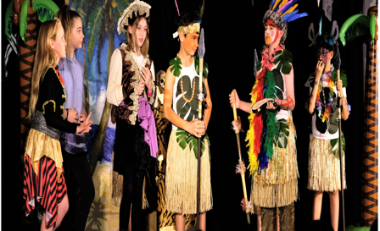

London’s leading day school for specific learning difficulties

Dear Candidate

We are so pleased that you are interested in applying for the post of English Teacher at Fairley House School. We hope that our application pack gives you all the information you need but if you do have any further questions please do not hesitate to contact us.

Fairley House is an outstanding specialist Independent School meeting the needs of pupils aged 5-16 with dyslexia, dyspraxia and dyscalculia. We are based in central London with our junior department in SE1 and our senior department and offices in SW1 – approx. twelve minutes’ walk between the two. We currently have approx. 180 pupils on roll. We also have an external assessment centre based in SW1.

We would like to appoint an imaginative and creative English Teacher who would be happy to teach some maths and RE, based at the senior school with a passion to engage students of all abilities. We have small classes that will give you the opportunity to get to know the students, to support them and enable them to thrive. Please see the job description and person specification in the pack and address all key areas when submitting your application form and personal statement. This is an opportunity to be involved in a school that really does change pupil’s lives.

We are a supportive organisation and pride ourselves on our commitment to staff wellbeing, professional development, induction and our whole school ethos.

Our incentive package includes

- Fairley House operates its own competitive pay scale, and salaries are enhanced to reflect our status as a leading Central London SEN Independent School.
- Free school lunch during term time
- Buffet lunches during INSET
- End of Year staff event
- Complimentary tea/coffee and fruit
- Cycle to work scheme
- Employee assistance line which includes online counselling
- Comprehensive Induction programme
- Mentoring with members of staff from our Leadership Team
- Opportunity for those who teach English to undertake our Diploma in SpLD
- A range of in house CPD
- Excellent transport links [close to mainline Victoria and Vauxhall, 3 minutes from Pimlico tube and numerous central London bus routes]
- The opportunity to work in the centre of London with attractions such as Tate Britain, Westminster Abbey, Lambeth Palace and the London Eye on our doorstep

We are keen to attract a diverse range of professionals who will support the ethos of the school, if you would like a chat about the roles and ambitions of the school then please do feel free to contact us hr@fairleyhouse.org.uk enquires to Sally Fenton, HR Manager sf@fairleyhouse.org.uk. We hope to be able to offer a tour of the school but this will be subject to Covid guidance.

Fairley House is committed to the safeguarding and welfare of children and successful applicants must be willing to undergo an enhanced DBS check, personal and professional reference check and a medical.

I look forward to receiving your application.

Yours sincerely
Michael Taylor
Headmasterr

FAIRLEY HOUSE SCHOOL

MISSION STATEMENT

Our charity aims to transform the lives of children with specific learning difficulties [SpLD] and to provide encouragement to their families:
We do this by:

- Providing a first class education for children with SpLD
- Giving children with SpLD the skills and confidence to maximise their potential after 2-3 years at FHS in mainstream education and throughout their lives
- Ensuring that children’s needs are met by offering a unique tans-disciplinary assessment and whole school approach
- Seeking to influence the lives of SpLD families outside our school community through research, teaching, training and advocacy
- Maintaining dialogues with government agencies, children’s services and the voluntary sector organisations and though partnerships with research bodies and higher education institutes

In the pursuit of our goals we are committed to:

- Advise and work in partnership with parents to provide hope and to achieve the best possible long term outcomes for their children
- Reward the professionalism and dedication of our staff by ensuring that our workplace is safe, enjoyable, stimulating and supportive of their individual career ambitions
- Our belief that Fairley House is a dynamic and innovative environment where our children thrive and are happy

Job Description English Teacher

Teaching and Learning

- To teach English, Maths and RE across a range of abilities from year 7 to year 11
- Contributing to providing a first class education for students with specific learning difficulties through a whole school approach
- Writing and reviewing IEPs in co-operation with parents, pupils and the Special Provision department
- Contributing to implementing the IEP so that each child has the chance to develop his or her potential to the full
- Work as a member of a transdisciplinary team.
- Maintain an up to date knowledge of the National Curriculum

- Following school policy on planning and assessment
- To follow the school policies on classroom management
- Contribute to maintaining FHS as a safe and healthy environment
- Develop close liaisons with parents, particularly in relation to homework, organisation and management strategies
- Fostering and developing areas of interest which can be shared with colleagues, for example courses and in service training days

Monitoring and Reporting
- To carry out the assessment, recording and reporting of pupils work as outlined in school policies.
- To set appropriate assignments as required by school policy and to ensure that marks are recorded on pupil database and MIS
- To provide information on pupil progress when required and to ensure that parents are informed of successes or concerns.

Pastoral Duties
From time to time teaching staff could be allocated the role of Form Tutor and will need to ensure that the registration process is completed each day
- Provide pupils with a positive role model
- Ensure that individual children in the class are encouraged during the unstructured periods of the school day, such as break and meal times , to develop self-discipline and to foster responsible and considerate behaviour
- To support members of their form group on a day to day basis
- To support other staff in relation to pastoral care and welfare of pupils

Whole School ethos
- To attend parent’s meetings as required.
- To operate in accordance with school policies and procedures
- Staff are encouraged to contribute to extra-curricular activities such as lunch time and after school clubs, and competitions.
- Organise RE related field trips
- All staff are required to be on the duty rotas for lunch and break supervision

Person Specification: Teacher

Qualifications | Essential  Good honours degree and teaching qualification such as PGCE and QTS |  | Desirable  Specific learning difficulties qualification or willingness to undertake level 5 diploma or in house certificate  Evidence of, and commitment to, further professional development
Experience | The teacher should have experience of:  Teaching at Key Stage 3 and 4  Teaching children with specific learning difficulties |  | Teaching further national curriculum subjects
Knowledge and understanding | Teachers should have knowledge and understanding of:  Specific learning difficulties including dyslexia, dyspraxia and specific language impairment  Effective teaching and learning styles.  Theory and practice of providing effectively for the individual needs of all children (e.g. classroom organisation, planning, teaching strategies and removing barriers to learning);  National Curriculum requirements at the appropriate key stage;  Monitoring, assessment, recording and reporting of pupils’ progress;  Legislation concerning Equal Opportunities, Health & Safety, SEN and Child Protection |  | In addition, teachers might also have knowledge and understanding of:  Assessment for Learning  Administration and scoring of standardised tests  Planning programmes based on test results to accelerate pupils’ learning  Expectations for pupils without SEN in private schools and/or the maintained sector  Working with occupational therapists, speech and language therapists, educational psychologists and teaching assistants  Trans disciplinary working
Skills | Teachers will be able to:  Promote the school’s aims, ethos and whole school approach to specific learning difficulties  Teach interesting, multi-sensory lessons  Manage behaviour positively |  | In addition, the teacher might also be able to:  Develop initiatives which improve the school

Background of Fairley House

The school is located in central London on two sites, the Senior Department (Years 7 to 11) in Causton Street in Westminster and the Junior Department (Years 3 to 6) in Lambeth (15 minutes’ walk between the two sites)

The school was established in 1982 by Daphne Hamilton-Fairley whose husband was killed by an IRA bomb in 1975. Mrs Hamilton-Fairley was a speech and language therapist who had been providing therapy for dyslexic children at home. As a parent with four children of whom two were dyslexic, she knew how poor provision was for dyslexia in London and in the UK generally. She resolved to set up a school for dyslexic children as a memorial to her husband, hence the name Fairley House. She aimed to combine a medical focus: speech and language therapy and occupational therapy, then mainly delivered in hospital clinics, with education. In this respect she was a pioneer and although provision of therapy within school is now common place we stay true to her vision by pushing forward the boundaries of integrating therapy and education.

Currently the school is thriving with 180 -200 pupils. In response to demand and to enable our 10-year Strategy Plan we aim to provide help for more children and families affected by specific learning difficulties, through offering Assessment, Training and Research into effective teaching methods. The school is a charity and is run by a Board of Governors.
Distinctive features of the school and its governing structure.

We are registered with the DCSF as an independent special school for specific learning difficulties. We have children from a range of socio-economic backgrounds and from a wide geographical area (central and greater London but children have come from as far away as Cambridge or the Isle of Wight, remarkable for a school that offers no boarding). The majority of pupils are private placements and parents manage to afford the fees which are high due to the favourable staff: pupil ratio and expertise available. 37% of children are statemented, the vast majority paid for by local authorities (LAs) with some coming from the poorest London boroughs. It is a tribute to our children that this diversity is embraced and friendships are forged by children from very different backgrounds and circumstances. Children do not arrive in Year 1 and stay until Year 9 because the aim is to provide intensive help for their difficulties and return them to mainstream schooling as and when is appropriate.

Why work at Fairley House School ……………

Comments from current staff

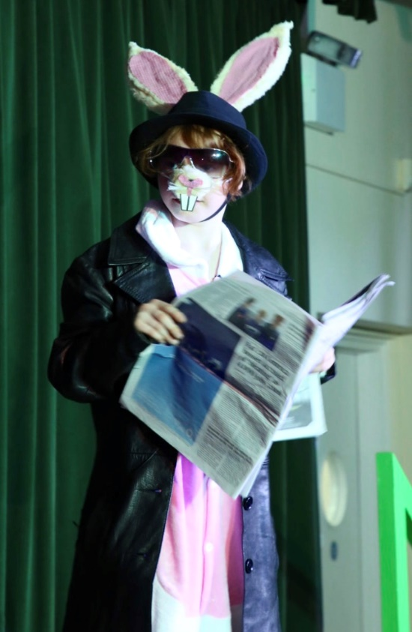
“Why I love teaching drama: we are a small drama department looking to grow and develop, we have relaxed and supportive learning environment for both students and teachers, by having small class sizes we are able to provide opportunities for students to engage in performance on stage or musically and host several productions each year. Creativity is strongly supported and as a department head you will be given creative control to be able to create bespoke content, writing and adapting new schemes. After school and lunch time drama clubs are encouraged.”

“What I love most about working at FHS is the team approach to helping our pupils. I believe that this holistic approach of looking at the whole child is what makes us so successful at achieving our ultimate aim, which is to get them back into mainstream schooling, equipped with all the strategies they need to flourish. I find it very insightful to work with a child across different contexts (such as within a speech and language therapy session, a Writing lesson, a Reading lesson or within lunchtime clubs) and this is what enables me, as a speech and language therapist, to be able to ensure that the skills that I am working on are functional to the child within all of their lessons, throughout the school day. I love working collaboratively with the very talented and creative teachers here to plan and co-teach lessons together, where we are both working towards the same common goals.

The children here are also inspirational. Often they have had very difficult experiences of education prior to coming here, where learning has been such a challenge and they sometimes have a very low opinion of themselves. However, they are very brave and resilient and willing to give learning another go, and it is amazing to see them succeed and recognise their achievements for themselves. We quickly see their self-esteem soar as they realise what they are capable of and this gives them the confidence to take more risks with their learning”.

“I was on my way home from a parents evening and was yet again reminded how fortunate I am to be working at Fairley House. After a particularly emotional meeting, I left close to tears when a mother described how much her daughter had flourished since being at the school. On a daily basis I know that I am contributing to unlocking the potential of children who previously have seen themselves as a failure. I work alongside a fantastic team and together I know we make such a difference to our students and their families, giving them a safe haven in which they can achieve their potential”.

FAIRLEY HOUSE SCHOOL - TRAINING OPPORTUNITIES

Level 5 Diploma in Teaching Learners with Specific Learning Difficulties (Dyslexia)

Fairley House School (FHS) and CPD have offered a Certificate in teaching learners with specific learning difficulties since January 2006 to those that teach English. The next course will start in January 2022.

This well-recognised qualification provides Continuing Professional Development for teachers working with specific learning difficulties affecting the acquisition of literacy and numeracy. It is suitable for SENCOs, learning support teachers, therapists and classroom teachers wishing to develop specialist skills in this area.
Candidates will attend lectures and seminars after the end of the school day on a Wednesday (from 4:30 to 7:00) due to the recent pandemic much of this is accomplished on line. Jacqueline Murray, our Principal Educational Psychologist will contribute to the course, as will members of the school’s speech and language and occupational therapy teams with tutors presenting the majority of lectures, group seminars and individual tutorials.
Candidates are required to teach a student with literacy difficulties for 12 hours and a student with literacy and numeracy difficulties for 6 hours.
Candidates will be assessed teaching both their students and this will usually be done by tutors submitting a videoed lesson. Candidates must gather a portfolio of evidence which demonstrates knowledge of SEN legislation and the roles of Specialist Teachers, Educational Psychologists and Speech and Language Therapists. The portfolio must also demonstrate skills in identifying and assessing students with specific learning difficulties, planning teaching programmes, delivering and evaluating lessons, as well as reflection on the candidate’s own performance. There are formal guidelines to follow in order to achieve the qualification. The expectation is that those taking OCR will need to allow at least 10 hours of study per week on top of attending the course.
The course runs for a year. (Fairley House staff are funded in house, and are required to work in the school for at least 2 years following the course. If not, they would be liable for the course costs or part, thereof, depending upon circumstances). It covers CPD fees, lectures and seminars, plus tutorial support and assessment of the candidate’s work over 3 terms. If for any reason this extends over and above the three terms, staff could be liable for additional marking costs.
Fairley House School is now the only Central London venue offering the course. The course draws upon the expertise of FHS and working with dyslexic and dyspraxic students. It combines theory and practice and will give candidates practical skills they can use.
The course is offered to candidates from many other schools and offers additional networking opportunities.
For staff who are not teaching English we offer a short course on teaching pupils with specific learning difficulties, leading to a Fairley House Certificate.
For all other enquires relating to professional development please contact HR

How to apply

Having looked at all the documentation please return to our website www.fairleyhouse.org.uk or the TES to download an application form or apply online.
Please remember that your supporting statement should address the criteria set out in the job description and person specification. We follow safer recruitment guidelines so please give explanation for any gaps in employment.
Alternatively please contact our HR office at hr@fairleyhouse.org.uk
Or telephone on 0207 976 5456 for further information about this vacancy or an application form.

Job Role
Full time
Permanent Contract with 3 terms probation period
Salary range: £31700 - £41003 [we have our own pay scales ] depending upon experience
Start date: as soon as possible or January 2022 for the right candidate

Closing date
Friday 17th September 2021

Interviews:
The interviews are schedules for the w/c 27th September 2021
Candidates will be notified after shortlisting has been completed.

Fairley House School is committed the safeguarding of children and young people. All applicants must be willing to undertake an enhanced DBS check. CVs not accepted – application forms only

…………..and all of a sudden nothing is impossible….

Fairley House School

30 Causton Street
London
SW1P 4AU

Headmaster:
Michael Taylor

www.fairleyhouse.org.uk

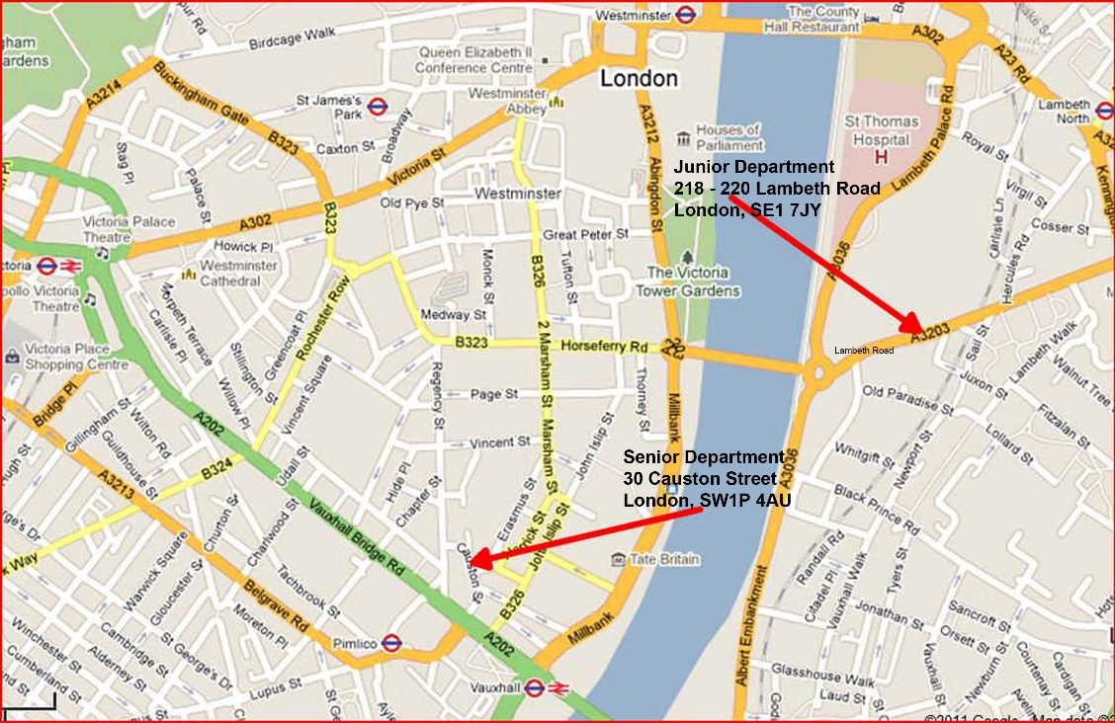

HR Manager
Sally Fenton
02079765456
hr@fairleyhouse.org.uk

