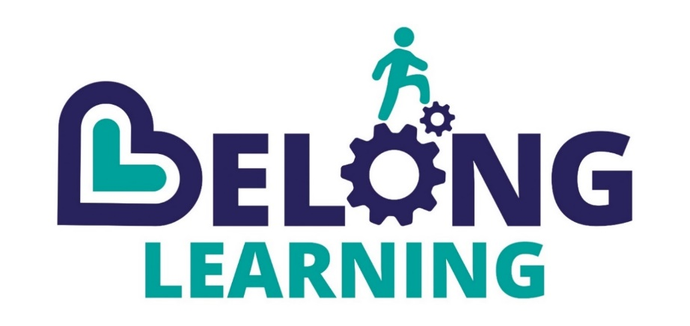

An Introduction to BELONG LEARNING

We are a not-for-profit company that exists to meet the unmet needs of children.

BELONG LEARNING CiC (formally CMAS) is a rapidly growing and highly successful Community Interest Company (CIC) that provides education, outreach and intervention services across the South West of England.

Our vision is to be the learning provider of choice, meeting the unmet needs of children and their families. We currently have approximately 100 dedicated employees and a board of 5 directors.

BELONG LEARNING operates two Ofsted registered schools: one in Gloucestershire across 2 sites with a learning hub between Gloucester and Stroud and in Devon, where we are spread across the county over 3 sites. Our teams of teachers and learning coaches deliver small group learning activities with a focus on empowering students to develop their capacity for learning and build and foster their emotional wellbeing.

BELONG LEARNING focuses on individual needs within the group and creates learning tasks that are personalized to engage each child and ensure they can reach their own learning potential.

BELONG LEARNING schools are informal by design. We deliver safe, calm and orderly groups where learning is often project based with a consistent thread of literacy and numeracy intervention and a personalized curriculum that develops key-skills such as problem solving and collaborative working. We are registered with the QCA and exam boards and deliver qualifications from Unit Awards to GCSE’s.

Our curriculum emphasises emotional wellbeing, including personal social education and healthy living and eating and is delivered within a context of high support, nurture, care and positive peer influence.

These small step-changes to build into positive transformations in individual young peoples’ lives and to enable them to leave us equipped to be able to continue to learn, grow and become independent adults who positively contribute to their communities and society.

