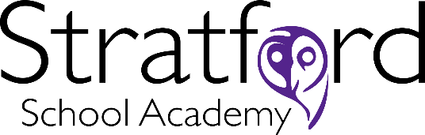

Stratford School Academy’s Cultural Fit

Working in a school where you are not aligned with the culture is a miserable experience. So …we both need to have alignment if you come to work here!
- We believe that students come first (and staff a very close second).
- We believe that we all have a professional obligation to improve as teachers and staff.
- We believe in a culture of the possible, where we can all make progress beyond what anyone, including ourselves, could have imagined.
- We believe that truly great teaching is that which improves students’ progress.
- We believe an evidence-informed approach to teaching and learning helps us identify what works best in the classroom.
- We believe that hard work is the key to success for all staff and students.
- We believe that you cannot just wish teachers and students to be better – you have to create the conditions for them to grow.
- We believe basic literacy and numeracy are essential to students making good progress.
- We welcome diverse ideas to solve problems.
- We believe in forming positive and collaborative relationships with all members of the school community
- We believe that feedback should be timely and respond to the needs of the individual student so that they can actively engage with the feedback.
- We value generosity of spirit.
- We acknowledge that we all make mistakes.

We live by the values of Respect, Excellence and Responsibility.

