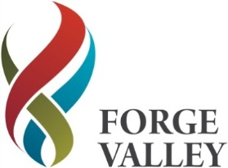

FORGE VALLEY SCHOOL
PERSON SPECIFICATION - TEACHING ASSISTANT LEVEL 3 I.R
SPECIFICATION | REQUIRMENT
Qualifications and training | - GCSE Grade C or equivalent in English and Maths  - NVQ Level 3 for Teaching Assistants or equivalent qualification/experience
Skills and knowledge | - Knowledge and understanding of subjects taught within the National Curriculum.  - Ha sound speaking and listening skills to develop language in discussion.  - Effective use of ICT to support learning. Be proficient in the use of Microsoft Office packages, email and the internet.  - Experience of working with young people within an educational setting.  - Understands the needs of young people with an autism diagnosis  - Can plan, implement and evaluate interventions.  - Understanding of the principles of child development and learning.  - Ability to relate well to pupils and adults.  - Work constructively as part of a team, understanding classroom roles and responsibilities  - Can maintain trust and confidentiality where appropriate.  - Understanding of relevant policies, codes of practice and awareness of relevant legislation.
Experience | - Experience of working with young people, including those with SEND, primarily Autism  - Can manage pupil’s behaviour in a effective manner.  - Has sufficient practical and organisational skills to contribute to the preparation and management of resources.  - Can complete and maintain pupil records.
Personal | - Flexible  - Resilient and positive  - Honest and reliable  - Excellent communicator  - Calm under pressure  - Sense of humour, commitment and energy  - Patient  - Empathetic with young people  - Team playing, able to work collaboratively  - High personal and professional standards
Work Related Circumstances
FVS is committed to the safeguarding and promoting the welfare of children and young people and expects all staff to share this commitment.

