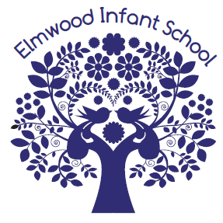

October 2017

Dear Applicant,

Reception Class Teacher Required from January 2018

Thank you for expressing an interest in joining our school.

We are a four form entry Infant school with a 52 place nursery on site. If successful, you will join a strong and supportive team within a school that prides itself on being a rights respecting school with high expectations for all children at the heart of the curriculum.

As our advert says, we are looking for someone to work in Reception but who has with the skills and flexibility to work in Key Stage 1 in the future. The successful candidate will be innovative in their approach, creative in their thinking and passionate about outdoor learning.

We would urge you to come along and visit so that you can see us in action, get a feel for our values and meet the children. Please also take a look at our website where you will be able to find out a bit more about us – www.elmwood-inf.croydon.sch.uk Applications from both NQTS and experienced teachers are welcome.

I look forward to receiving your completed application form by 12pm on Friday 13th October 2017.

Thank you for your interest.

Yours sincerely,

Zoe Harris
Head teacher

