The Aldenham Foundation – The Vision that Maintains Excellence
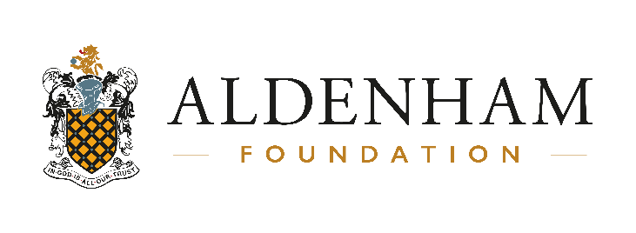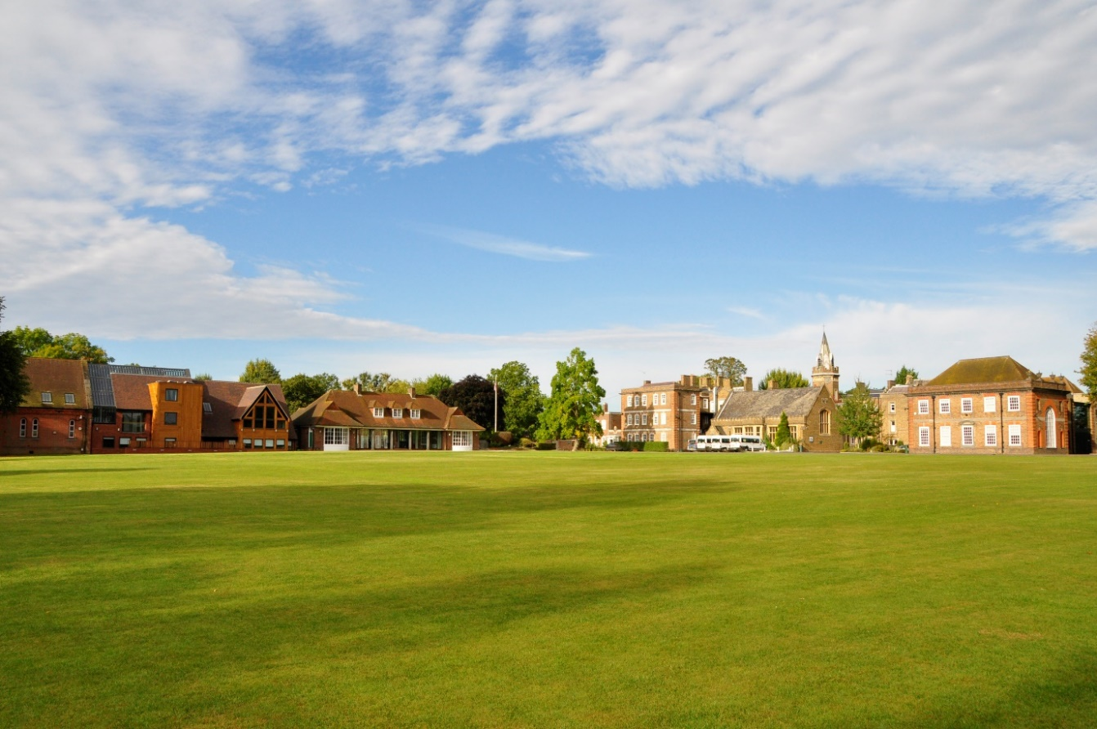
Aldenham School, Hertfordshire UK
The Aldenham Foundation provides a holistic vision of education in all its schools for which the following are essential features:
- Attentive and committed learning and teaching
- Wide opportunities for participation and experience beyond the academic curriculum
- The highest standards of pastoral care
- The development of every individual child to realise and exceed their potential
- The development of personal qualities in its pupils which will enable them to be widely admired beyond the school itself
- A sense of community in which pupils, staff, parents and governors can take pride and be valued.

In establishing new Aldenham schools we look for high quality leaders and teachers who share this vision and who will be able to work with us to see it applied for families around the globe.
In the UK, The Aldenham Foundation consists of three schools across two sites in Hertfordshire just 15 miles from Central London.

Aldenham School (founded in 1597) was a boys’ only full boarding school for around 380 years until the 1980s, but it is now a mixed school for boys and girls, boarders and day pupils and educates children throughout their years of secondary education from 11 to 18. Around one third of the pupils currently board on either a full time basis or as “flexi boarders” for up to five nights each week. The remainder of pupils are day pupils. (www.aldenham.com)
Aldenham Prep School is a one form entry coeducational junior school on the Aldenham site. It provides an ideal foundation for those who wish to transfer to Aldenham School at 11+, although it also sees pupils transfer to other leading schools in the independent and state sectors at the age of 11. (www.aldenhamprep.com)
St Hilda’s School was founded as a girls’ school in Bushey (some four miles from the main Aldenham campus) in 1918 and operated independently for many years until it became part of the Aldenham Foundation. The school continues to offer girls only preparatory education. The Bluebird Nursery which runs on the same site provides 40 week a year nursery care for girls and also boys. (www.sthildasbushey.com)
In the UK, the Aldenham Foundation therefore educates children from the start of education at age 3 to the end of Advanced Level at age 18. It employs around 270 staff in teaching and administrative roles.
All schools in the Aldenham Education Group follow this core vision, wherever they are in the world. Aldenham Prep Riyadh is our first school in Saudi Arabia, and we are pleased to bring this vision for education to this country for both expatriates and for Saudi children.


The Aldenham Education Group – Supporting Growth and Leadership
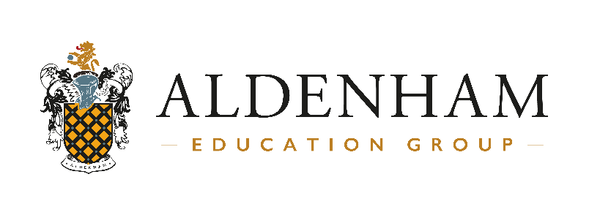
The Aldenham Education Group is the international arm of The Aldenham Foundation. It consists of educational expertise directed from the Aldenham Foundation HQ in Hertfordshire UK, and investment and business expertise directed from our International HQ in Dubai. Together, this perfect partnership enables the Aldenham Education Group to support its international schools from their start-up phase to their continued growth and established success. It is to this Group that the Head of Aldenham Prep Riyadh will report.
Each Head is autonomous in the running of their school. The Aldenham Education Group is careful to appoint leaders who are able to understand and buy in to the vision and ethos of the Aldenham Foundation and deliver it successfully. Nevertheless, any Head in an Aldenham Education Group School is supported by being able to draw on help from others and their expertise and experience.

The Aldenham Education Group is committed to providing its School Leadership teams with the resources and guidance they need to deliver an excellent Aldenham product, but doing so in a manner which enables each School to stand on its own and have its own local character.

