

Army Section Commander

Candidate Pack - March 2022



Life at Worksop College and Ranby House

A broad ability school educating children aged 2-18, the focus at Worksop College and Ranby House is firmly on progress, recognising that every child has his or her own set of skills and abilities - whether academic, sporting, musical or otherwise.

A confident and welcoming community of over 400 pupils on the Senior Site (Years 7-13), with a further 179 pupils at our Prep School (2-11), much has been done in recent years to invest in the infrastructure - developing existing strengths and positioning ourselves as a school of choice for parents in the region, nationally and internationally.

Thus, through the full, weekly, flexi and occasional boarding offer, some 85% of the school undertake some kind of boarding; cared for by an increasing number of staff who live on site in a variety of accommodation: detached houses, staff who are resident in boarding Houses or who live in other accommodation within the main buildings.

These are mostly majestic, Victorian buildings, a legacy of this being the final school created by the visionary Canon Nathaniel Woodard, whose mission was to educate the children of the growing middle classes at the end of the 19th Century. At Worksop, he did so on a fine estate of some 300 acres that now also house an 18 hole golf course, an indoor swimming pool, a sports hall, tennis courts, netball courts, two Astroturf hockey pitches, an athletics track, four cricket pitches, six rugby pitches and two football pitches, a recently extended and refurbished fitness suite and sixth form centre.

The school has a strong Christian ethos, but welcomes pupils from all faiths or those who have no faith at all; and of all the things the pupils take away from their time at the school, Chapel is one of the ones they recall most fondly. Staff are expected to attend services in the beautiful Chapel: an opportunity to reflect in what are otherwise busy lives. We have also recently undertaken work to define more sharply our Mission, our Motto, our Values and our Learner Profile, and candidates for interview should expect to demonstrate the inclusion of some aspect of these in the lesson they are asked to teach and other aspects of the recruitment and selection process. Upon appointment, staff are expected to uphold, support and develop these as they contribute to the life our community.

Our Value System

A golden thread that links from our school motto, right through to our pupil charter - our value system is a way of life. From the way we recruit, to the business decisions we make, teaching styles to personal development reviews, our value system is a blueprint for the way we behave and the vision we have for our pupils.
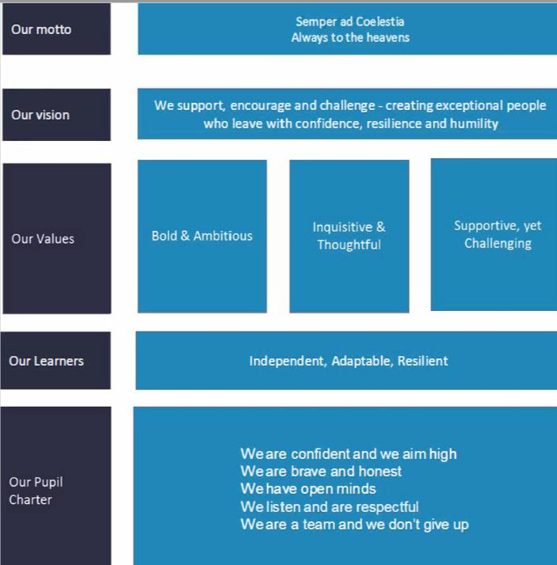

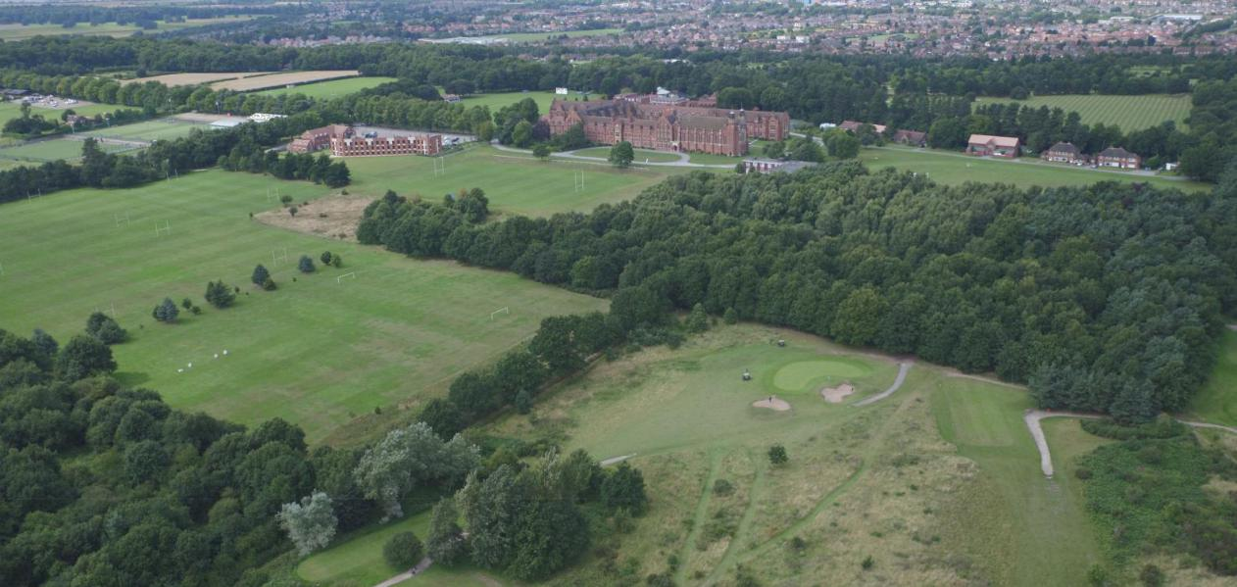

Where we are

Set in 400 acres of stunning North Nottinghamshire woodland, Worksop College and Ranby House has the benefit of a sprawling campus, with some of the best facilities in the county. The major cities of Sheffield, Doncaster and Nottingham are an easily commutable distance and give the school a secure and rural feel, whilst enjoying a comfort-able proximity to city life.

In addition, Worksop’s location on the edge of Clumber Park and with ease of access to the A1, M1 and East Coast mainline make it an ideal place to live and work. Major university cities Leeds and York are easily accessed by road or rail, as are Newcastle, Edinburgh or London, allowing for academic visits or personal enjoyment in the generous holidays. The Peaks, the Dales, even the Borders are also within easy reach.

Teaching at Worksop College

Worksop College is a non-academically selective school, priding itself on ‘value-added’ and the progress that children make – regardless of the level at which a pupil enters the school.

• A friendly community with excellent relationships between teachers and pupils
• Charming and well-mannered pupils who are willing to engage in and respond enthusiastically to a range of
learning activities
• Small classes
• Autonomy for teachers and, significantly, for Heads of Departments
• Support for further personal and professional development
• Confident, forward-looking management and Governors

Pastoral care

In addition to the academic role, every teacher at Worksop is expected to contribute fully to the wider aspects of education. Worksop College is renowned for the quality of its pastoral care and all teachers are attached to one of the eight boarding or day houses.

Extra-curricular

All members of staff at Worksop are expected to play a full part in extra-curricular activities. These embrace a full range of sports, music, societies, expeditions, drama, many forms of art and technology, CCF, voluntary service, and a wide range of hobbies.



The Role

To lead a high quality and vibrant Army Section within the School’s successful CCF Contingent. You are the key leader within the Army CCF team and are responsible for the planning and delivery of high quality training to the cadets within the section.

Key Areas of Responsibility

- Manage all correspondence (both ingoing and outgoing).
- Maintain an up-to-date filing system.
- Maintain the database and the Westminster account.
- Production of all necessary paper work such as 5010C, CASPs and Med Plans.
- Ensure that officers and instructors are kept abreast of the latest directives from MOD and outside agencies.
- To collate all returns to RPOC in conjunction with the SSI.
- To co-ordinate and organise attendance on military and adventure training courses for CFAVs and Cadets in conjunction with the Contingent Commander/SSI.
- Maintain standards of discipline and dress within the CCF.
- Follow the Colleges policies and procedures when carrying out your duties.

Training, field days and Summer Camps

- Ensure that all necessary equipment is available for Parade Afternoon CCF training, field days, overnight exercises, courses and camps.
- To liaise with Training Team Sgts and Bde Training Officer re visits and training.
- In conjunction with the SSI complete all associated administration for the training programme as directed by the Contingent Commander. This will include bids for training facilities, stores, ordering equipment, transport, food and accommodation and attendance at camp and training area conferences as necessary.
- Instruct and supervise CFAVs and Cadets as required to increase their knowledge of military matters. They will be encouraged to use their own skills and qualifications with special interest groups.
- In conjunction with the Contingent Commander and SSI Prepare Risk Assessments and Exercise Action Safety Plans needed for contingent training and take an active role in safety arrangements for all CCF activities in conjunction with the Contingent Commander.
- To update standing orders, regulations and training manuals etc.
- Liaise with local units in order to create and develop good relationships allowing greater training opportunities and use of facilities and equipment.
Syllabus & CPD

- To maintain an up-to-date but enjoyable and challenging training programme at all levels.
- To update 5010C in conjunction with the training package delivered.
- Have a sound working knowledge of Army Cadet Safety Management System (ACSMS).
- Have the desire to increase the cadet experience at all levels within the contingent.
- Establish an individual Development plan for the position within the Contingent and encourage officers within the section to develop their qualifications.
Logistics and Quartering

- Liaise with the appropriate Army authorities and the SSI in respect of ordering, updating, writing-off equipment and other stores matters.
- In conjunction with the SSI record and control all clothing and equipment issues to all cadets and staff, including control and maintenance of clothing and equipment accounts, and billing for lost/damaged equipment as necessary.
- To purchase (with the Contingent Commander) and maintain items required for training.
Civil and Military Relations

- Take a key role in planning for the Contingent’s Biennial Inspection in conjunction with the Contingent Commander.
- Promote the school to HM Armed Forces locally and nationally.
- To undertake visits and journeys deemed appropriate by the Contingent Commander/Headmaster on contingent/school business.
- To assist with the marketing of the CCF and DofE.

General

- Responsibilities carried out by all staff in the Colleges comply with the contract of employment.
- To follow the colleges Safeguarding and Child Protection policies.

Additional Responsibilities

Successful candidates will be expected to undertake such additional responsibilities as may, from time to time, be considered to be reasonable and required by the Headmaster.



The Benefits Package

Working at Worksop is as much about a lifestyle choice as it is about pursuing a satisfying career path. The College has high expectations of its staff and therefore looks to reward them with an attractive benefits package, which includes:

- Fee concessions for your children

- Work place pension scheme

- Resident Church of England Chaplain

- Free lunch is provided when on duty; the College is known for its high quality catering
- Free tea and coffee are available throughout the working day

- Free on-site parking


Statutory requirements & equal opportunities

Safeguarding & Child Protection

For this post must be willing to undergo child protection screening, including, but not limited to, reference checks with previous employers, prohibition checks and a criminal record check via the Applicants Disclosure and Barring Service (including Barred List Check). All offers of employment are conditional upon the satisfactory outcome of child protection screening checks.

Disclosures

We will appoint, train, develop and promote on the basis of merit and ability alone. It is a stipulation of the Governors and a statutory requirement that members of staff appointed to Worksop College should be shown not to have any criminal record which might prevent them accepting a post at the College. Accordingly, the College requires permission from all members of staff to make an appropriate investigation. Offers of employment are subject to a satisfactory outcome of this enquiry.

The post is exempt from the Rehabilitations of Offenders Act 1974 and the School is therefore permitted to ask job applicants to declare all convictions and cautions (including those which are “spent” unless they are “protected” under the DBS filtering rules) in order to assess their suitability to work with children.

Equal Opportunities

Worksop College is an equal opportunities employer and is committed to a policy of treating all our employees and job applicants equally. It is our policy to take all reasonable steps to employ and promote employees on the basis of their abilities and qualifications without regard to age, disability, sex, gender reassignment, pregnancy, maternity, marital or civil partnership status, race (which includes colour, nationality and ethnic or national origins), sexual orientation, trade union membership, religion or belief.

References

Safer Recruitment: Please provide details of two referees to provide information regarding suitability for this role prior to appointment (requirement of KCSIE for all candidates).

If you are not currently working with children, at least one of these references should be from a recent employer by whom you were employed to work with children.

Please note that neither reference should be from a relative or someone writing in the capacity as your friend

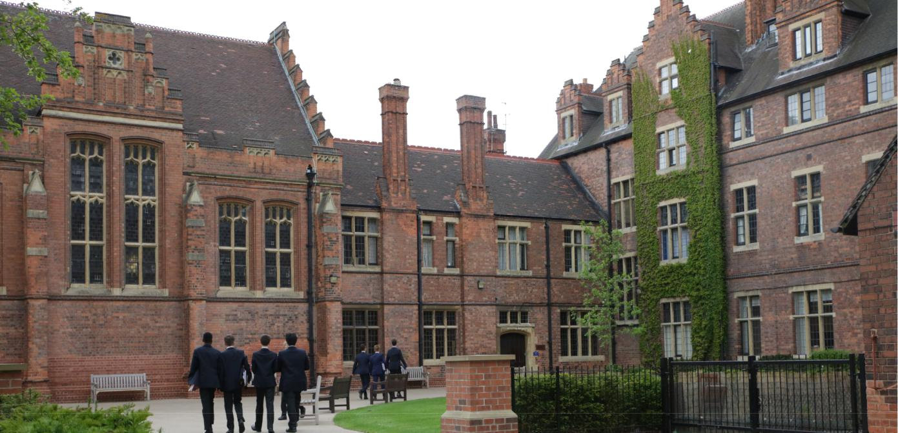

The Vacancy

Working hours: Casual employee you will work such hours as agreed with the Contingent Commander/DofE Manager

Salary: £13:06 per hour plus holiday pay.

Commencement: Mutually agreeable start date, subject to satisfactory safeguarding checks being in place

Closing Date: 29 April 2022

Applications should be made by application form and include a covering letter through https://www.tes.com/jobs outlining the reasons why you are interested in the role and to demonstrate how you meet the role and responsibilities outlined within the job description. CVs may be sent in addition to, but not instead of the completed application form and covering letter.

We reserve the right to close this advertisement early if we receive a high volume of suitable applications.

T: 01909 537100

Further information about the school is available at: www.wsnl.co.uk

What to expect at interview (example interview schedule):

Interview with the Headmaster

Interview with the Head of Worksop College

Interview with the Head of Department

Teach an observed lesson, demonstrating our Values and Learner Profile

Tour of the campus

Meet the Department

Meeting with a member of the HR team



Getting to Worksop College

By road

Worksop College is easily accessible by all major roads and just 10 minutes from junction 23 of the M1. If driving, please use S80 3AP for your Sat Nav. The AA’s online route planner is a useful way of determining the route and distance ahead of your journey

By Rail

Retford station is approximately 15 minutes away and the journey will take less than 1.5 hours from Central London. More information about travel by train can be found here
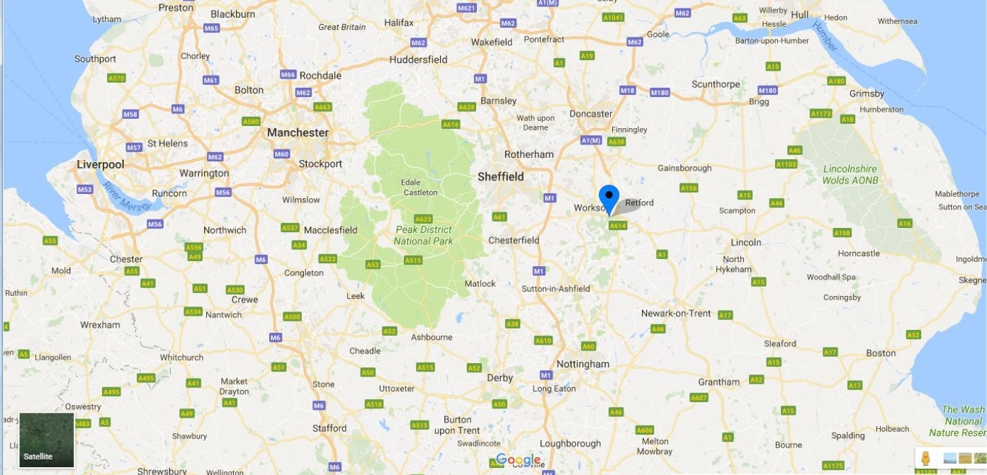



Contact us

01909 537100

careers@wsnl.co.uk

