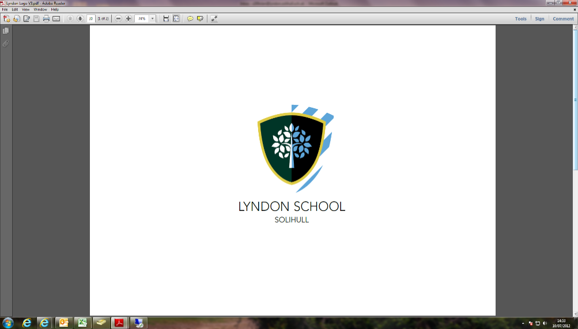

**Ninestiles Academy Trust Mission Statement**Ninestiles Academy Trust will be nationally and internationally acknowledged as a high achieving, innovative and exciting group of schools which recognise and respect the richness and diversity of their communities.  The trust will be structured and resourced to meet the needs of 21st century students and pupils.  Within a caring environment, we will develop and reinforce the values, skills and attributes which promote good citizenship and lifelong learning. Parents, directors and councillors, and the wider community will work in partnership with our committed, appropriately skilled workforce and our students and pupils, to ensure that high quality learning takes place.

 Outcomes will be outstanding.

**Information for applicants**

## Current context

In September 2015 Lyndon School embarked on an exciting new chapter in its history as an academy sponsored by the Ninestiles Academy Trust, a group of 6 schools that share the same vision and values that Lyndon stands for. The school believes this will enable it to build on its current strengths and further improve the provision for its students and their families.

The school has just over 1300 students on roll, from 11-16 years of age and serves an expansive and diverse community, attracting students from over 35 feeder primary schools located in two Local Authorities.

We are situated in the north east of Solihull, half a mile from the Birmingham boundary in a largely residential area. The region’s post-war boom years centred on the motor industry and Elmdon Airport (now Birmingham International Airport). In recent years the area has attracted a variety of large service companies concentrated in the Birmingham Business Park and the National Exhibition Centre. This unique position, serving communities from both Solihull and Birmingham, has influenced and shaped Lyndon’s development.

The location provides a wide range of residential properties varying from city living to quiet rural locations. The school not only provides easy access to Solihull and Birmingham but is also well served by the motorway network giving access to Warwickshire, Leicestershire, Staffordshire and Worcestershire.

Local facilities for leisure activities are excellent. Solihull town centre has an exciting shopping and leisure complex (Touchwood) that has attracted major retail outlets. The surrounding areas provide superb sports facilities, cinemas and restaurants. Birmingham has undergone a dramatic transformation in recent years and is now recognised as the country’s second city offering a world-class cultural centre, excellent shopping and nightlife. The school is in close proximity to Birmingham International Airport / Station catering for those wanting to venture further out.

**Leadership and Standards**

The Principal, Abid Butt leads a Senior Leadership Team consisting of two Vice Principals, four Assistant Principals and an Assistant Principal responsible for Support Services. The school places a huge emphasis and commitment on developing all staff into confident managers and leaders through a comprehensive programme of CPD. The school also benefits from support from the Ninestiles Training Consortium.

The school firmly believes in creating a safe and positive learning environment; one in which every person underpins an ethos of setting and maintaining high standards. We believe readiness for learning is essential; all students are expected to arrive to school sufficiently prepared and dressed in the correct school uniform. At the heart of the school’s drive to raise standards is an expectation that all students will adhere to the student code of conduct which includes the prohibited use of mobile phones and/or electronic devices during the school day. With the support of the Ninestiles Academy Trust the school has recently introduced BfL (Behaviour for Learning) which provides a clear indication of the school’s expectations of behaviour and a simple and clear set of sanctions if these are not followed.

**Trust Partnerships**

The school has established strong links with a number of local businesses that have been carefully chosen to provide a range of experiences in both further education and the world of work so that the school can help raise the aspirations of its students and community. These businesses include:

* + The 6th Form College, Solihull
  + Birmingham City University (BCU)
  + The John Lewis Partnership, Solihull
  + McCann Erickson, Solihull
  + Jaguar Land Rover

Over the past few years the school has embarked upon many projects that have helped to raise the aspirations of all involved. Below are some examples of the activities that have taken place already.

**The Sixth Form College, Solihull**

Working closely with the Sixth Form College enables our students to obtain first-hand bespoke information, advice and guidance on post-16 courses to support progression beyond Lyndon. Working in partnership now for over three years has resulted in a marked increase in the numbers of students embarking upon Level 3 qualifications.

**John Lewis**

Liaison with John Lewis has included students participating in team building workshops, mock assessment days and working closely with professionals to evaluate school based projects. Recently a group of students completed a two day shadowing course; this provided the students with a valuable insight into employment in the retail sector and gave them an awareness of the skills and qualities employers look for in young people.

**Jaguar Land Rover –** Our links with Jaguar Land Rover are broad and diverse. They have provided practical support to help improve the school environment, supported the curriculum with specific projects and conducted mock interviews to name but a few. This year some of our students have embarked upon a new project with JLR based around the themes of recycling and sustainability. This has been an excellent project; our common commitment to protecting our environment has been instrumental in developing our students both socially and morally.

**McCann Erickson**

McCann Erickson is a renowned worldwide organisation, with a large regional office here in Solihull. Lyndon benefits greatly from their expertise and in a very short time they have contributed to transforming learning environments in the school as well as helping to rebrand Lyndon School. Our partnerships quite often have mutual benefits; in the case of McCann, last year they received a prestigious award following a project involving Lyndon.

**Birmingham City University**

At Lyndon we encourage our students to have high aspirations and to view further and higher education as a realistic prospect. Every year we arrange for a significant proportion of our year 7 students to visit Birmingham City University to discover what higher education has to offer and the range of courses students can go onto study. These visits, alongside the provision of Master classes in a range of subject areas and ‘Aim Higher’ style mentoring have resulted in a renewed enthusiasm in students wanting to move on to further education and beyond.

## Accommodation

The original school buildings were opened in 1952 to accommodate a boys’ only school. Afterwards, a separate girls’ school was added a few years later with the two eventually being amalgamated. The result is an extensive site that allows curriculum subjects to be grouped together, and includes a large assembly hall, gym, sports hall, drama studios, dining hall and Design workshops. Considered “state of the art” at conception, the buildings have been upgraded to provide sound accommodation which is carefully maintained on a rolling programme.

New builds in the last ten years have included a two storey Open Learning Centre, housing media and ICT facilities, ‘The Hub’ (multi-media area) and ‘The Pod’ that includes three design classrooms and display space. We consider the environment to be an important factor in teaching and learning for both staff and students and a considerable refurbishment budget has allowed for extensive redecoration with enhanced facilities in Science, ICT, Food Technology, Drama, Art, Reading Room / Library, PE, changing rooms and student toilets.

ICT facilities are located throughout the school and the continued development of ICT remains a priority. As part of our vision for transforming learning we are fully committed to building upon the National ICT Mark to become a “Best Whole-School of Excellence” and transform the teaching and learning environments that we all learn in.

We are also extremely proud of our mature grounds which provide facilities for student and community activities and off road staff and visitor parking.

**Our students**

The Standard Admission Number for September 2015 is 269. We currently have over 1300 students on roll. Like most Solihull schools our students continue their education, post-16, at a number of colleges in both Solihull and Birmingham.

Visitors have described the school as exciting, busy and happy. We provide a caring, secure and orderly environment that promotes purposeful learning.

Awards include:

* Investors in People (2009)
* National Healthy School status (2007)
* Leading From the Middle (with NCSL)
* Most Improved School (2009)
* NAACE ICT award (2005)
* National ICT Mark (BECTA 2006)
* Inclusion Quality Mark (2008)
* Investing in Community Engagement (ICE) 2010

Despite another year of volatility with GCSE results both locally and regionally, we are pleased to say that Lyndon School has improved across many areas. From the equivalent position in 2014 published by the Department for Education our latest results show that we have:

* Increased the percentage of students who achieved 5 A* to C grades including English and Mathematics.
* Increased the percentage of students who achieved the EBACC qualification (English, Mathematics, Science, Languages and a Humanities GCSE.)
* Increased the percentage of students who made “better than expected progress” in English and Mathematics.
* Increased the percentage of students who achieved A* and A grades, across a number of subjects including English and Mathematics.
* Ensured that students now achieve statistically in line with national benchmarks for A* to C in Biology, Chemistry and Physics.
* Continue to raise the aspiration of our students, with over 90% of students leaving having secured a positive destination in further education.

However success is not just about exams and we aim to celebrate and share all achievement and good news.

We value the student voice in our decision making process; students have their own council and are regularly canvassed for their ideas and opinions. The school has retained a prefect system of which we are extremely proud. The senior prefects lead on events such as Open Evenings / Days. Our Head Girl and Head Boy lead and organise the prefects. They attend full Governing Body meetings and regularly perform speeches to a range of audiences.

## Staffing

The school has over 120 full and part-time staff including teachers, teaching assistants, site, pastoral, technical and administrative staff. This team offers a wide range of expertise and experience.

School life is based around three colleges; Warwick, Coventry, Birmingham and students in Years 8 – 11 belong to one of these. Year 7 remains a ‘separate’ college to allow for continuity on transfer from primary.

In September 2008 the school introduced vertical tutoring. Evaluations indicate this has led to improvements in the attitudes of students to each other and improved communications between school and home. Students are able to mentor each other and relationships improve because of smaller group sizes.

## Professional Development

Lyndon has remained fully staffed and we feel that this is in part due to on-going investment in recruitment, induction and retention processes. Professional Development is led by a Vice Principal ensuring access to induction and continued development for all staff. She oversees the initial teacher training programme, applications for the Graduate Teacher Programme, mentoring for NQTs and all new staff, Learning Focus Groups and regular professional development workshops that provide in-house training for all. Opportunities for staff are linked to the School Development Plan and their own Appraisal targets.

## Extra Curricular Activities

Lyndon continues to be a busy place before and after the end of the school day offering a wide range of extra curricular activities as well as breakfast! Sports teams are consistently successful both locally and, at times, at national level; we offer a wide range of activities including football, netball, cross-country and cricket. We are also proud of individual achievements that are regularly recognised and celebrated.

Trips have ranged from Norfolk to Poland to include curriculum-based areas such as French and Geography and also provide wider opportunities including the annual skiing trip. During 2014-2015 the following extra-curricular trips will take place:

The House of Parliament Birmingham City University

Birmingham Hippodrome Italy

France Land Rover, Solihull

Nottingham Skills Show, NEC

Black Country Museum Barcelona

There are opportunities to join the thriving Duke of Edinburgh Award scheme.