Application pack
Special Education Teacher
March 2021
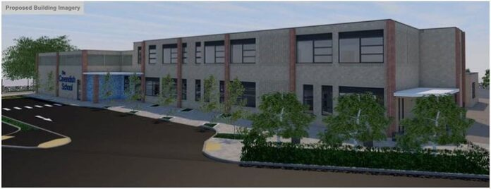
Contents

Welcome from Stephanie Smith 3
Welcome from Ryan Kelsall 4
About The Cavendish School 5
About the Eastern Learning Alliance 6
Job Description 7
Person Specification 9
Interviews and application process 11

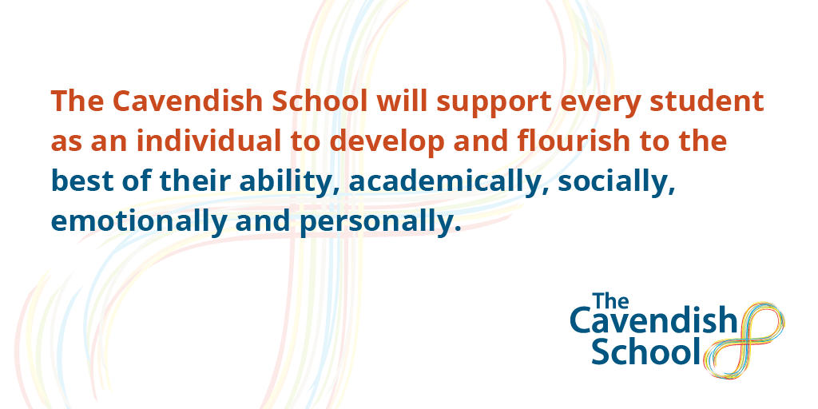

Welcome from Stephanie Smith
Deputy Headteacher of The Cavendish School
I am pleased that you are interested in applying to be part of The Cavendish School. It is an exciting time for us as we look to opening to our first cohort in September ‘21 with a wider opening of years 3 to 7 in our purpose built premises on New road in Impington.

The Cavendish School will be Cambridgeshire’s first state maintained special free school provision for young people with autism and aspires to support students in its mission of ‘enabling the self’; equipping students with the skills, confidence and abilities to take their place in the world.

It is difficult this early in the inception of a new school, to give you a clear idea of the hustle and bustle that school life with us would bring, but what we can offer you is a clear picture of the ethos that we live and breathe. Our core aims are to provide a safe, nurturing space, alongside inclusive and comprehensive support so that all students thrive academically and in their own personal development journeys. We will provide a unique educational environment that young people with autism need to thrive and succeed when their needs cannot be met in a mainstream school. Every pupil at our school deserves our high expectations and support to have equitable access to education and the world, Autism does not mean less.

Our school plans include fully supported therapy rooms, sensory and calming areas, Life skills rooms as well as a full range of areas dedicated to the sciences and arts. Our onsite orchard, outdoor learning areas and the ability to develop a forest school area will ensure that learning goes beyond the classroom.
We are looking for someone who is an outstanding teacher, who is passionate about playing a full role in their pupils education and wants to be part of a strong positive community. Our teachers will play an active role in the EHCP process for each of their allocated pupils, they will be passionate about ensuring that the EHCP truly reflects the views, aspirations, needs and support required for the young person that they represent. We want the child to be at the centre of everything we do no matter how challenging that may be. Autism must be viewed as a different way of thinking and processing the world; one that provides unique insights and skills that we need in an ever-developing climate of society and work.
If you are as passionate about inclusive and whole person education as we are, if you want to make a difference for children and their families and are up for the challenge afforded by this exciting new specialist Autism school, then I very much look forward to receiving your application. We are open to applications from both experienced special education teachers and aspiring new ones.
If you would like more information on the school or the role then please contact me on ssmith@tcs.tela.org.uk

Stephanie Smith
Deputy Headteacher, The Cavendish School

Welcome from Ryan Kelsall
Deputy CEO of Eastern Learning Alliance

Thank you for your interest in the post of teacher at The Cavendish School (or TCS as it tends to be known). I very much hope that from reading all the details, you would like to apply for the role. In return you will be strongly supported by a multi-academy trust that has as its core vision the drive to ‘build a better world through education and to enable all students to achieve their full potential’.

TCS came into existence as an idea in early 2016, when the Cambridge News highlighted the poverty of specialized provision locally for children with autism. It seemed ideal therefore for a trust with a track record in inclusion and special needs to create a new provision via the Free School programme. The Local Authority was delighted with our approach, as was the DfE and Regional Schools Commissioner. We therefore reached out across the local community for support and successfully submitted our plans in September 2016.

With the slowing down of government and delays to the funding, the project has taken time to get to this stage. However, we have our contractors (McAvoy’s who successfully built The Rise School, another excellent school for children with autism in West London) and our designs/plans have now been given approval by South Cambs’ District Council. We are on course to open the new school on part of the site of IVC in autumn 2021 we have appointed a Deputy Headteacher to play the lead role in finalizing plans for the school and are now planning recruitment of our first special education teachers.

I look forward to receiving and reading your application. If you decide not to apply, I wish you every success with the next step in your career.

Ryan Kelsall
Deputy CEO, Eastern Learning Alliance

About The Cavendish School

As a school that is yet to open, we appreciate that there is not as much to see or read about the school as one that is open and bustling. On the one hand that can be unnerving because you are looking for information about the place where you will work. On the other hand, it is very exciting as place of work you will be a part of creating!

We have a website which provides some information: http://www.thecavendishschool.org.uk/. The school was founded to give families of children with autism the opportunity to attend a local state provider where the young person’s needs would be met in a therapeutic and specialised environment. Our vision for the school is encapsulated around the phrase ‘Enabling the self’. We know and recognise that too many children and adults with autism struggle to achieve independence in their lives and often face significant challenges coming to terms with the condition as well as gaining greater acceptance and tolerance. Our ultimate ambition for TCS is for all young people to leave our care walking tall and proud, confident in the knowledge and understanding that there is a real opportunity for them in the world they will inhabit.

Broadly speaking, our school curriculum will follow International Baccalaureate (IB) programmes and accredited qualifications, alongside specific therapies or interventions as appropriate for individuals. Initially the school will admit students in years 3 to 7, who will follow the Primary Years Programme. When students reach year 9 they will chose from a range of accredited qualifications including GCSEs where appropriate. Our sixth form will be small and bespoke, with access for those students for whom this is appropriate to Impington International College or other providers further afield. The IB Primary Years Programme (PYP), an inquiry-based transdisciplinary curriculum model. The PYP is a broad and balanced curriculum model that encourages students to make practical connections between their learning and real-life contexts, to develop the IB characteristics and become global citizens. The PYP curriculum framework emphasises the central principle of agency that is threaded throughout the three pillars of the curriculum: the learner, learning and teaching and the learning community it underlines that everyone connected to the school community has voice, choice and ownership to impact learning and teaching. These holistic components complement and reinforce each other to form a coherent whole. Subjects are studied in relation to transdisciplinary themes (such as “how the world works”) to ensure that learning is contextualised and holistic.

Our design for TCS saw us looking to create a therapeutic environment with plenty of space for individual work and for places where the young people could head during the day for periods of calm. We will place a great accent on staff training and expect to appoint from a wide range of settings. We are looking for practitioners with resilience and a ‘can-do’ mindset and those who believe that people with autism are not inhibited but who have a life condition which needs a supportive and flexible environment in which they can flourish.

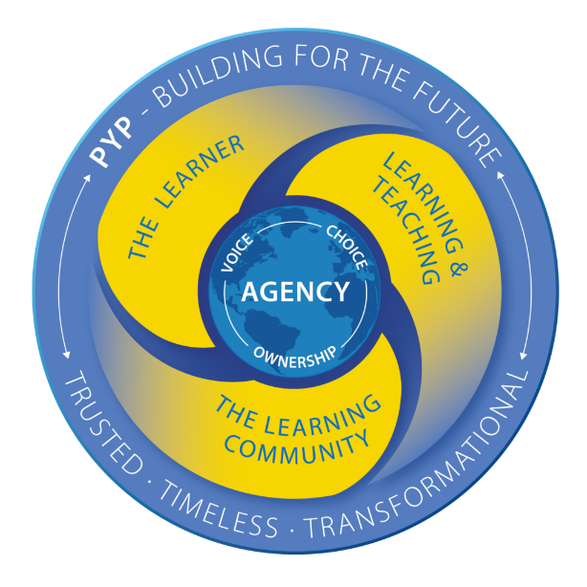
Our community will naturally have close relations with the staff at IVC, but also with colleagues across the whole trust. There will also be a strong partnership with Girton Glebe, our primary school, and with colleagues in the local authority and in Cambridge University, with whom we hope to work on research into autism.

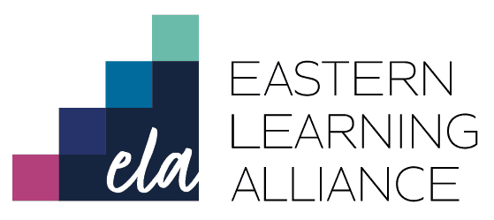

About the Eastern Learning Alliance
The Eastern Learning Alliance (ELA) was formed in 2020 following the merger of Cambridgeshire Educational Trust (CET) and Morris Education Trust (MET), creating a strong local multi-phase/setting MAT rich in our distinctive values.
The ELA Trust is a small purposeful family of schools, each with its own distinct identity which, combined, offer more choice than any other group of schools, enabling every student to pursue their dreams and passions. As our Trust grows, each school will retain that identity but share the same values and standards of academic rigour, excellent extra-curricular opportunities and exceptional arts and performing arts.
What makes ELA so very different is that it is born out of an alliance between two existing trusts, not out of a need for one school to grow. Our joint commitment is to being proudly international and internationally minded, serving a diverse community of families from Cambridge, across the UK and overseas, facilitated by our host family network, with a broad, specialist and inclusive provision.
We are a trust with an excellent track record in inclusion and special needs that has as its core vision the drive to ‘build a better world through education’. We are very excited for the opening of TCS and to be providing new local provision for children with autism.

MET-Living

Our schools are proud of their community work. This includes on-site sports/leisure provision, adult learning and lettings which bring in many varied groups across the year. We recognise that the ‘non-school’ elements of the village college are no less important than the ‘school’ and require their own leadership and management. Therefore the Trustees have created a subsidiary company (which is still part of ELA) called ‘MET-Living’ to oversee and operate the ‘non-school’ elements. To ensure this works well, an agreement is put in place to manage the facilities best for the benefit of both ‘school’ and ‘non-school’.

What we can offer you
You will be joining a relatively new MAT at an exciting stage of its growth and development. We are passionate about the environment we create and how we look after our staff.

As a newly appointed member of staff, we can provide you with:
- The opportunity to contribute to a growing community and take learning beyond the classroom.
- The opportunity to join and engage with the IB world schools and contribute to the IB curriculum and resources.
- A brand new and autism-friendly innovative learning environment
- bespoke professional development linked to your identified needs and forward looking, evidence informed, CPD programme with Trust wide CPD
- Preferential rates for access to the excellent sports/leisure facilities within our Trust

Job Description

Post: Special Education Teacher
Salary: MPS/UPS + Sen Allowance (currently £2,270)
Responsible to: Lower School Assistant Headteacher, Deputy Headteacher

Primary Purpose of the Role
You will be a member of our school teaching team, responsible for a class of 8 – 10 pupils all of whom have a diagnosis of Autistic Spectrum Condition. Teachers at The Cavendish school will be passionate about inclusion and providing high quality environments and provision to allow pupils to thrive with us and beyond. A good sense of humour, resilience and ability to start each day fresh will be an integral part of classroom and school practice. Teachers are deployed as appropriate throughout the school. Each class has a support team usually consisting of a TA and HLTA.

Teaching of the curriculum is in line with the International Baccalaureate Primary Years Programme with a view to creating a collaborative learning community both in and out of the classroom, with all stakeholders. This post will include additional non-contact collaborative IB design and planning time.

As a class teacher at TCS you will be involved in all aspects of the education for the pupils within your class. This will include setting pupil targets, preparing reports for EHCPs and leading and chairing the EHCP review process for your class pupils. Learning in all aspects of the school day is particularly important to pupils at the Cavendish, staff will support pupils during a lunchtime provision.

Post commencement date: January/April 2022
This post will start January or April 2022 contingent on the availability of our new purpose built premises. Confirmation of exact start date will be confirmed no later than October 1st 2021.

Shaping the Future and strengthening the Community
- Ensure that The Cavendish School’s vision is embodied and acted upon effectively within the school.
- Demonstrate TCS’s vision and values in everyday work and practice and motivate and work with others to create a shared collaborative culture and positive climate
- Ensure creativity, innovation and the use of appropriate new technologies to achieve excellence
- Collaborate at operational levels with parents, carers and across multiple agencies for the well-being of allocated children.
- Host students, volunteers and visitors within your class.
- Promote and facilitate family participation in learning and life of the school and in particular your class

Leadership and Management
- Lead, manage and support Teaching Assistants within your class.
- Promote positive standards of conduct from all staff.
- Liaise with families and professionals to support pupil outcomes
- Represent The Cavendish School as an ambassador where required.

Teaching and Learning with continual Monitoring and Evaluation
- Demonstrate high quality teaching and learning (QFT and Autism Strategies), providing inspiration and motivation.
- Support and be an ambassador for the IB programmes and learner profile.
- Ensure every individual child has access to a high quality provision to achieve EHCP targets and that all legal provision is always given.
- Ensure a continuous and consistent focus on students’ achievement and personal development, using relevant data systems to monitor progress
- Maintain and promote the highest standards of student behaviour, discipline and attendance within the school in line with the school’s behaviour and intervention policies
- Manage and organise the school environment efficiently and effectively to ensure that it meets the needs of the pupils, curriculum and all health and safety regulations.
- Contribute to whole school and Class level events
- Collaboratively plan and implement of educational visits and journeys for the pupils in line with their curriculum and needs.
- Chair Education, Health and Care Plan reviews for allocated pupils. Produce educational reports inline with legal timeframes to support these reviews and communication with all stakeholders.
- Provide termly reports on all areas of progress to leaders and parents.
- Participate in parents evening consultations.

Developing Self and Working with Others
- Treat people fairly, equitably and with dignity and respect to create and maintain a positive trusting culture that exhibits ‘Humans first, professional second’ (Myatt, 2016)
- Support a collaborative learning culture within the school
- Develop and maintain a culture of high expectations for self and others
- Regularly review own practice, set personal targets and take responsibility for own personal development by participating positively in arrangements made for the appraisal system.
- Support an inclusive and inspirational ethos within the school (aligned with that of the Trust) that enables everyone to work collaboratively, share knowledge and understanding, celebrate success and accept responsibility for outcomes

Keeping pupils safe
- Ensure the welfare and safeguarding of pupils across the whole school through rigorous application of the school child protection, behaviour management and pupil well-being policies.
- Promote excellent standards of pupil safety and positive behaviour through application of schools behaviour principles.
- Ensure that pupils with health and medical needs have their needs safely met in line with school, local and national policy.

This job description should be seen as enabling rather than restrictive and will be subject to regular review.
These duties and responsibilities should be regarded as neither exhaustive nor exclusive as the post holder may be required to undertake other reasonably determined duties and responsibilities commensurate with the grading of the post.
You will be required to attend meetings outside of school working hours to support school governance and other school functions.

Person Specification

Job Title: | Special Education Teacher – The Cavendish School
Reports to: | Assistant Headteacher, Deputy Headteacher

 | ESSENTIAL | DESIRABLE
Qualifications and Training | Qualified teacher status.  Honours degree or equivalent | A professional qualification in SEND relevant to this post  Relevant training in SEND and autism, specifically
Experience | Some successful experience of teaching and differentiating for pupils with special educational needs and disabilities.  Can demonstrate ability to deploy classroom support staff effectively  An understanding of what best practice looks like for supporting pupils with communication needs and knowing how these needs can impact upon behaviour; planning and providing for the appropriate support and resourcing  Working knowledge of the SEND Code of Practice, to support effective reviews of EHCPs, targets and transition planning  An understanding of the potential health and safety risks within a school environment and the skills to monitor H&S checks including risk benefit analysis | Experience of working with pupils with complex needs as a result of Autism and comorbid conditions  Planning and leading extra curricular education visits and residential trips.
Knowledge  /Skills  (Ability to) | Is able to positively contribute to The Cavendish school team  Has a positive attitude towards inclusion in special schools and mainstream schools  Knowledge of current child protection guidance, safeguarding, and health and safety requirements.  Will respect parents and carers as partners and involve them in the education and learning community of their children  Will seek to develop links with local schools and community groups.  Ability to communicate effectively with all members of the school and wider community to facilitate partnerships between school and home.  Is prepared to work collaboratively with a wide range of professionals in order to provide the best possible education for pupils  Ability to deal with confidential information sensitively and appropriately in line with school and trust policies.  Clear and successful decision making skills and a proven track record of problem solving and conflict resolution.  Is prepared to undertake training appropriate to the role | A working knowledge of specific interventions such as Makaton, Attention Autism, TEACCH, PECS Lego Therapy, Rebound Therapy, colourful semantics, dyslexia interventions such as Toe by Toe and English interventions such as Corrective reading and Switch on reading, be able to share your knowledge with others.  Successful teaching in a special needs class /unit /school
Personal Qualities | Empathy with the ethos and values of ELA and TCS a commitment to working collaboratively with the Trust and embedding the Trust ethos and values in the school.  Is enthusiastic about teaching children and young people with special educational needs and disabilities and has a high level of commitment.  Commitment to young people’s wellbeing, safeguarding and development  A positive ‘can do’ attitude, shared with pupils and colleagues to build and sustain a great team ethos  High levels of resilience and determination Demonstrable experience of highly effective communication skills, both orally and in writing and as an active listener  Role model of best practice, with a professional manner that motivates others and inspires confidence, trust and respect.  Be highly organised and able to plan and prioritise work within timeframes and to meet deadlines.  Creative approach to problem solving  Flexibility and willingness to adapt quickly and effectively to changing situations/circumstances.  Open minded and good sense of humour | Minibus driver, or the willingness to complete minibus training (MIDAS)  Full UK Driving license and business insurance  Confident swimmer and pool side spotter

The post holder will have a shared responsibility for the safeguarding of all children and young people. The post holder has an implicit duty to promote the welfare of all children and young people and to be committed to promote diversity and equality for all.

Interviews and application process

The interviews will take place at Impington Village College during the week commencing April 26th 2021 and will include a range of activities and interviews. The interview day will consist of

- a tour of the site
- data and written tasks
- observing a lesson and giving feedback
- interview with IVC students
- Interview Panel of Deputy CEO, Deputy Headteacher and Local Governing Body Chair

If you would like to apply, please complete the application form and a letter (no more than 2 sides of A4) outlining:

- your reasons for applying
- what you will bring to the role
- why you believe you might be suited to this particular challenge/opportunity.

Applications close at 12noon on Monday April 19th 2021.

Please ensure your form and letter is returned to HR@TCS.tela.org.uk

