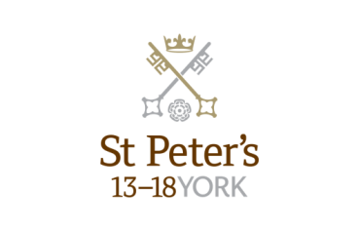

Information for Applicants

Head of Hockey (13 – 18) and Teacher of PE
February 2019

Department: Sport
Responsible to: Director of Sport
Grade/Salary: The starting salary will be at a point on the St Peter’s salary scale, related to, but above, the National Scale.
Start Date: September 2019

The Role
We are seeking to appoint an outstanding individual with appropriate experience to the joint roles of Head of Hockey and Teacher of PE. The role will encompass leading and developing our strong Hockey programme for boys and girls both at St Peter’s 13-18 in addition to teaching and coaching across the whole foundation which includes St Olave’s 8-13 and Clifton 3-8.. The teaching of PE will encompass curricular PE from 13-16 and, for the right person, may include some A level PE teaching. The successful applicant will also contribute to the wider games programme at St Olave’s 8-13 and St Peter’s 13-18 as appropriate to his or her expertise.
The Department
There are five full time members of the senior school P.E. department and three full time PE teachers at St Olave’s. Curriculum PE is delivered to Years 9-11 within the timetable. Athletics, Gymnastics, Health Related Fitness, Basketball, Tennis and Badminton make up the major blocks of work and there is a swimming lesson throughout the Christmas and Easter Terms.
The school has excellent facilities including two sports halls, a gymnasium, a fitness suite, swimming pool, all-weather pitch, netball/tennis courts, a number of rugby and cricket pitches and a new boathouse to service the School’s thriving rowing club.
Hockey
Hockey is the major team game played by girls at St Peter’s in the Christmas term and by boys in the Easter term. There are two training sessions in the Third and Fourth Form and three to four in the Fifth and Sixth Form and a fixture every Saturday of the term. The School plays on a competitive Northern circuit, competing against most of the major Hockey playing schools in the North of England.
The School runs four senior teams with A and B teams at U15 and U14 age groups for boys and girls. We enter the National Schools’ competition at U18, U16 and U14 age groups. All teams are coached by experienced and knowledgeable coaching staff. Specialist external coaches are also employed on the programme and there is also a full-time graduate hockey coach who is regularly involved in coaching sessions and matches.
The senior girls’ teams tour every 2 years, visiting locations such as South Africa and the boys recently enjoyed a successful tour of Germany and Holland. Last season saw the girls achieve their greatest success by reaching the National Schools’ finals placing them in the top eight in the country.
The School has produced many pupils who have gone on to receive representative honours the most recently in the National U18 Girls’ Squad and National Boys’ U16 & U18 squads.
Overall Purpose of the Post:

To oversee all aspects of Hockey, ensuring high standards of associated coaching and teaching are delivered.

To contribute to the mission and the strategic objectives of the School through the effective and appropriate delivery of high quality teaching, learning and support to pupils.

Key Responsibilities:

1. Plan, prepare and deliver high quality teaching on a range of sports in PE ensuring effective learning for pupils.

2. Managing the Hockey coaching team to ensure they have clear expectations of their roles including identifying training needs for both yourself and others within the department.

3. Promoting interest in Hockey and keeping up to date with developments in the sport ensuring best practice is maintained across the School and that delivery meets the needs of the curriculum.

4. Organising all fixtures and ensuring all appropriate match day arrangements are in place.

5. Identifying current and future resourcing needs, ensuring all resources are fit for purpose.

Teaching and Learning

1 Planning and preparing courses, lessons and activities that ensure appropriate challenge and high expectation for all learners.

2 Teaching lessons according to the educational needs of the pupils and as required by the timetable.

3 Setting, marking and recording work carried out by pupils in accordance with the School policy.

4 Liaising with other teachers, as necessary, to ensure consistency across the curriculum.

5 Periodically reviewing programmes of work and methods of teaching.

6 Maintaining good order and discipline amongst pupils.

Assessment and Reporting

1 Assessing and reporting upon the progress of pupils in line with School policy including producing written reports as required and those on request.

2 Maintaining and updating appropriate and accurate records of pupils’ marks and progress.

3 Attending and contributing to parents’ evenings to discuss pupils’ progress with parents.

Co-Curricular Duties

1. Contribute to the broader life of the School by supporting and/or leading co-curricular activities.

Pastoral Duties

1 Taking responsibility for the academic and pastoral oversight of pupils as a tutor within a day house and having full involvement in the life of the House.

Other Professional Duties

1 Sharing in the overall responsibility for the academic progress, personal development and well-being of all pupils.

2 Participating in meetings to discuss curriculum, pastoral and other issues including staff meetings, departmental and whole school meetings as required.

3 Attending school events and activities as necessary.

4 Making an appropriate contribution to the planning and management of the subject area and to share departmental responsibilities as required.

5 Providing supervision or cover for classes / absent colleagues as necessary.

6 Participate fully in the school Performance Review and Support process and engage in appropriate continuing professional development.

The School is committed to safeguarding and promoting the welfare of children and young people and expects all staff and volunteers to share this commitment. The successful applicant will be required to undergo checks with the Disclosure and Barring Service.
All staff at St Peter’s School are required to observe all relevant Health and Safety, Equality and Data Protection legislation and procedures.
Note: This job description is not a comprehensive definition of the post and the post holder will be expected to undertake any other tasks commensurate with the duties and responsibilities of the post. The job description will be reviewed as part of the cycle of appraisal, and it may be subject to modification or amendment at any time after consultation with the post holder.

Person Specification

KEY CRITERIA | ESSENTIAL | DESIRABLE | Assessment
Experience | Relevant PE teaching experience. | Experience of working in a boarding school environment and/or an understanding of the independent school sector.  Coaching Hockey to a high level.  Managing people.  Teaching a second subject. | Application  Interview  References
Qualifications | A degree or equivalent qualification in a relevant subject area.  Professional coaching qualifications e.g. Level 2 Hockey Coach. | Evidence of continuing professional development.  Qualified teacher status.  Driving licence appropriate for driving of minibuses. | Application
Specialist Knowledge | Up to date knowledge of a range of teaching, learning and behaviour management strategies.  A passion for PE coupled with a thorough understanding of the national curriculum.  Legislative requirements and best practice relating to equal opportunities, health and safety and the safeguarding of children.  Knowledge and understanding of digital technology and its ability to enhance classroom learning. | . | Interview  References
Skills, Abilities and Competencies | Ability to effectively prepare, plan and organise lessons to encourage a positive learning environment.  Excellent communication skills with the ability to develop and maintain good relationships with colleagues, pupils and parents.  Ability to organise and/or support a range of co-curricular activities.  A commitment to organise and/or support events and trips.  A commitment to safeguarding and protecting children and young people.  To be a role model with a passion for teaching and the ability to motivate, inspire and challenge pupils.  A willingness to fully embrace the ethos and values of the School, and to engage fully with the life of the School. |  | Application  Interview  References

Other Opportunities

The school works a busy six day week and the person appointed will be expected to play an active part in the school’s tutorial system and in its co-curricular life. The average teaching load is around 28 x 40 minute lessons in a 40 period week. The School’s co-curricular programme is broad and is well-supported by the teaching staff. Opportunities exist to choose to become involved with the School’s active Music Department, the Community Action programme, the extensive sport programme and the various dramatic productions staged annually. Because of the breadth of activity on offer, there is scope for the interests and expertise of the successful candidate within the framework of co-curricular activity provision. There is also a broad range of School trips each year, from expeditions to Morocco and India, major sports tours, Choir tours to Europe, numerous cultural visits as well as Ski trips. The School runs an active and well-supported CCF and a large number of children complete Duke of Edinburgh awards each year.

All teachers at St Peter’s take on pastoral roles as tutors in either a day house or a boarding house. This gives some responsibility under guidance from a Housemaster or Housemistress for the personal, social and academic development of around twelve children. Tutors are an important point of contact with parents who value the overview which the tutor can take on their child’s progress.

Applications

To apply for this post, please submit a school application form, completed in full, with a covering letter. Please do not send CVs, either in place of or as an attachment to the application. Completed applications should be returned to:

Mr Paul Hewitt
Human Resources Manager
St Peter’s School
York, YO30 6AB

Or by e-mail to p.hewitt@stpetersyork.org

The closing date for applications is 10.00am on Wednesday 20th February 2019. Interviews will be held w/c 4th March.

About St Peter’s
Background

St Peter’s School, York comprises three schools: St Peter’s School (pupils aged 13 – 18), St Olave’s School (pupils aged 8 – 13) and Clifton School and Nursery (pupils aged 3 – 8 years). The school is fully co-educational with 1,150 pupils, of whom 120 are full time boarders and 250 are in the Sixth Form. There are over 300 teaching and support staff. It is one of very few schools in the North of England to offer three distinct phases of education, each sharply identified and focused towards the needs of its pupils at each age group and set within an overall context of trust, confidence-building, inspiration and opportunity.

St Peter’s is the fourth oldest school in the world, founded in 627AD, and is ranked in the top 100 schools in the country for its academic results. The school is located within a short walk of York city centre, with its thriving cultural, educational and commercial life. Many of St Peter’s facilities are modern and spacious, with playing fields adjacent to the main building that stretch down to the River Ouse.

An Independent Schools Inspectorate Report in 2017 found the school to be ‘excellent’ in all areas. The School has been awarded The Sunday Times North Independent School of the Year 2018.The school’s website can be visited at www.stpetersyork.org.uk. The most recent inspection report is available on the ISI website.

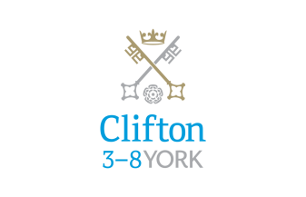

Clifton School and Nursery

Clifton School and Nursery, for day girls and boys aged rising 3 to 8 years, has its own building with use of extensive play areas, sports hall and swimming pool. Under the leadership of the Head, teachers use the attractive buildings and play areas to maximum advantage, teaching a broad and balanced curriculum which gives a wide variety of experiences, and emphasises the importance of basic skills. The curriculum is based on the National Curriculum and Primary Strategy, but goes far beyond this, both within the school day and during the wide range of co-curricular activities and visits outside of School.

Clifton enjoys separateness, a clear identity and its own House system. It allows smooth academic progression and provides tailor-made approaches and facilities for each age group.

Clifton School and Nursery was named by the TES Awards as the Prep/Pre-Prep School of the Year in February 2018.

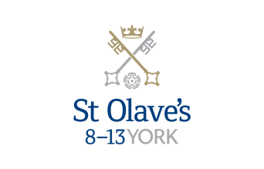

St Olave’s School

St Olave’s School (pronounced ‘olives’), for girls and boys aged 8 to 13 years, is adjacent to the main campus of St Peter’s and introduces boarding as an element of the School. Under the leadership of the Master, the teaching staff provide expertise in the 8 to 13 range, guaranteeing subject specialism to challenge and support every pupil.

The curriculum is wide and challenging with expert teaching from the earliest age. There are many opportunities for recreational and competitive sport with girls’ and boys’ teams enjoying success both regionally and nationally. There are numerous co-curricular activities to choose from on a weekly basis. Music plays a central role in school life, involving the full range of orchestral instruments.

Boarding is an integral element of the School and is accommodated in Wentworth, a boarding house on the main school campus.

St Olave’s has retained its own identity – a school within a school – giving all pupils a sense of pride and identity. It is recognised as a school in its own right, playing a vital role in the success of Clifton and St Peter’s.

St Peter’s School

St Peter’s School, for children aged 13 to 18 years, is underpinned by academic rigour and challenge. Through outstanding teaching, first rate facilities, high expectations and pupils’ hard work and enthusiasm, St Peter’s achieves considerable success across a broad curriculum.

The four vibrant and successful boarding houses for boys and girls lend vitality to the pastoral life of the School. Inspiration from living in close proximity to a cultured and historic city adds further richness to the pupils’ lives.

The School Chapel stands at the centre of the campus and regular services (three mornings a week) give pupils and staff the opportunity to reflect together on the spiritual values of the community and on the meaning and significance of what is happening locally, nationally and globally.

Music, Art and Drama are central to the cultural and academic depth of the School. The Sports programme is extensive, providing a wide range of choice for both girls and boys. Results are excellent, and St Peter’s pupils’ co-curricular achievements are considerable. The excellence of the teaching and facilities allows pupils to thrive.

About York

St Peter’s School is situated five minutes’ walk away from York’s compact city centre. York is one of the oldest and most beautiful cities in Europe, famous for its gothic Minster and winding medieval streets. York has won a number of tourist awards and further details are available on the Visit York website. York is regularly voted as one of the best places to live in the UK. Such is the size and layout of York, walking and cycling are ideal ways to get around, including taking in the famous sights of this historic city; an ancient Roman and Viking capital.

York is a central rail hub between Edinburgh, London and Manchester. The main railway station is only a 15 minute walk from the School. In addition it has a large variety of restaurants, pubs, theatres, cinemas, parks, museums and galleries, and life in York is always interesting, by day or by night.

Finding somewhere to live is also comparatively easy. York’s rental sector is in good health, though demand remains high. If you are trying to buy you will find York prices are around the national average.

York is a family friendly city. Attractions such as the Jorvik Viking Centre, the Barley Hall, the York Dungeons, the National Railway Museum and the York Chocolate Story are immensely popular with people of all ages.

The city lies in the Vale of York, a valley that runs north to south between the heathery North Yorkshire Moors to the east and the famous Yorkshire Dales to the west. Both areas offer an excellent escape for walkers, cyclists, climbers – indeed anyone with a love of fresh air and rolling countryside.

A guide to the City of York can be found at http://www.visityork.org/

Employee benefits

Our vision is to be a happy, thriving 3-18 co-educational day and boarding school community that combines a classical, high quality, all-round education with a forward-looking and exciting approach to learning.

Our staff are the key to our success. It is their expertise, enthusiasm and commitment that is reflected in our high standards and continued success. In return, we offer all our colleagues a competitive reward package from day one of their employment with us.

Annual Leave

Teachers will normally be entitled to take as annual leave all school holidays except for such time as may be reasonably required to carry out additional duties during the school holidays. This includes staff INSET training. Public holidays occurring when the School is in session are working days.

Cycle to Work Scheme

Eligible employees can join our Cycle to Work Scheme (also a salary sacrifice arrangement) that allows tax and National Insurance savings on the purchase of a bicycle (and related equipment).

Discounted school fees

A discount on school fees is offered to eligible staff for a maximum of two children at a time, if a place is available and entry requirements are met. The discount is offered for children at St Peter’s and St Olave’s Schools only.

For part-time staff the discount would be pro-rata based on the employee’s working hours.

Free School Lunches

Staff can enjoy a free meal during the lunch period in the School Dining Room. Lunch is provided on normal working days during term time. A selection of hot and cold food, beverages and sandwiches are available.

Parking
There is extensive free parking available to staff on the school site.

Pension

Teacher’s employment with the School is pensionable under the Teacher's Pension Scheme. Teachers are automatically enrolled when required by law. Both the teacher and the School will make the appropriate contributions based upon the teacher’s pensionable salary.

School Chapel

School Chapel is available to former pupils, staff and people connected the school for weddings, christenings and other appropriate events. Extensive grounds and gentle green lawns provide an excellent location for a marquee or champagne reception. The School is licensed for regulated entertainment and the Memorial Hall is ideal for evening functions.
Sick Pay

Where employees are unable to attend work due to sickness, there is a provision for sick pay. The amount of sick pay increases according to the employee’s length of service and current contract.
Enhanced Maternity Pay
After one year’s continuous service with the School by the 11th week before the EWC, you will be entitled to receive enhanced maternity benefits as well as Statutory Maternity Pay (SMP).
Sports Facilities

All staff can use the school sports facilities free of charge when they are not in use by the pupils. This includes a modern gym and swimming pool.

Training and Development

Our employees are encouraged to continually develop their skills and knowledge. Training and development opportunities may include gaining a professional qualification and other learning opportunities.

How to find us

You can find St Peter’s School, York, at YO30 6AB. The School is less than fifteen minutes on foot from York Railway Station.

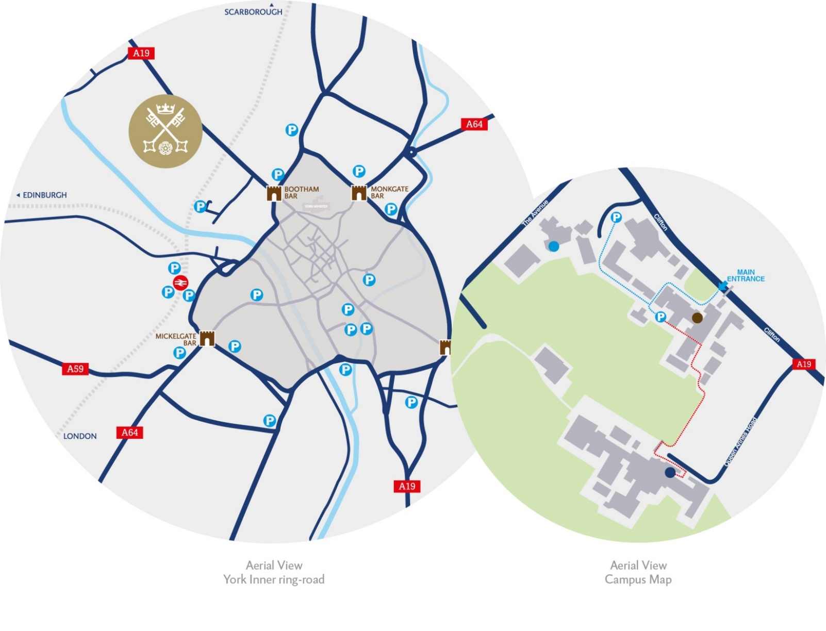
By car:

From York City Centre: Take the Thirsk Road (A19) at the Bootham Bar traffic lights. The school is 700m on the left, immediately after the footbridge.

From the A64: Take the Northern Ring Road (A1237). At the A19 roundabout turn towards the city centre. The school is two miles on the right, 300m after Clifton Green. Turn right into the school immediately before the footbridge that crosses the road.

Parking is available on site.

