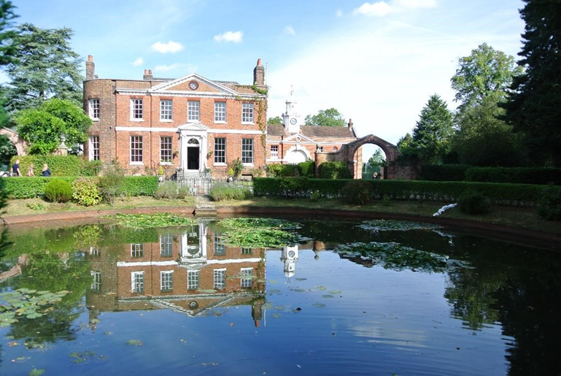
Teaching Assistant
Full or Part Time (Fixed Term in the first instance)

Required as soon as possible
April 2021
About Mount House School
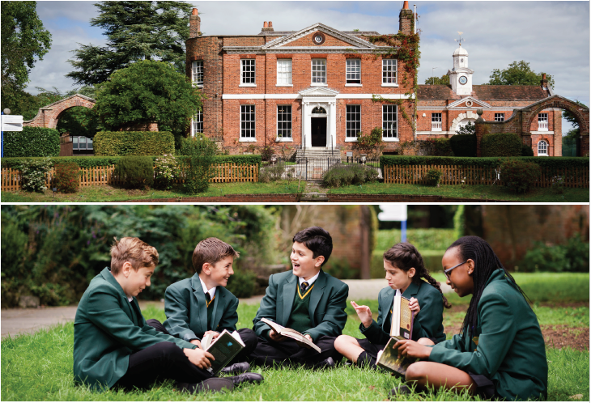
Co-educational excellence, where everyone is known, cherished and challenged.
Mount House is a small school with a highly nurturing environment in Barnet, North London. With a maximum of sixty students in each year group, it gives every student a chance to participate and shine in a whole range of academic and co-curricular areas.
In September 2020 our new Head Sarah Richardson joined Mount House and from her previous role as Deputy Head of the Perse School in Cambridge. As well as making enhancements to the academic curriculum and co-curricular programmes, Mrs Richardson is soon due to announce exciting plans for the development of the school site including some elements of which we hope will be ready for the start of the academic year in September 2021.
The Mount House school building is a stunning Georgian house set in a green and leafy corner of London opposite Hadley Common. Offering a countryside feel whilst still being close to train and tube stations is a really beneficial aspect of the school’s location. The rare combination of being a small school in an idyllic location close to central London allows our students to gain confidence whilst realising all the incredible opportunities the city has to offer.
Education has been the main purpose of this beautiful building and its grounds since 1940 when Mount House became the Architectural Association School during the war and subsequently St Martha’s Catholic Girls School. In 2018 the transition to co-education was implemented and Mount House School was established. From September 2022 Mount House will be fully co-educational.

Mount House focus on the whole child: academic, extra-curricular and pastoral. We encourage students to work hard, and to develop their intellectual and creative curiosity. We encourage students to ask for help and to be kind in all their interactions with others. We also place great emphasis on the ‘all-round’ education of our students, and the creative arts, music and sport all play an important part role in school life. Pastoral care is truly exceptional at Mount House, and central in delivering that care are tutors working with small groups of students, enhanced by a supportive and enjoyably competitive House system in which all students participate.
A ‘small is beautiful’ ethos is the magic ingredient at Mount House, where every student is well known and supported to reach their true potential and where among the staff there is a close community feel and a supportive, collegiate atmosphere.

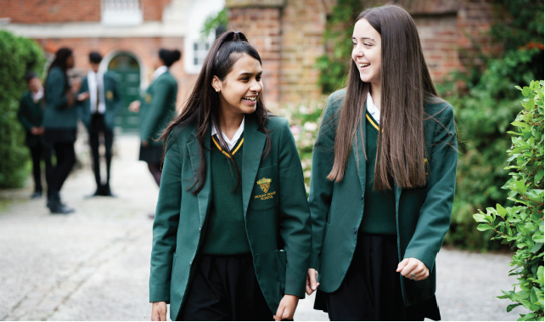
Our Values. At Mount House we A S P I R E to be:

Adaptable: prepared for life and in our future careers.

Supportive: a community with a strong sense of belonging in a safe, caring, inclusive and happy environment, in which everyone feels valued.

Principled: the importance of being a responsible citizen, developing an awareness of, and contributing to, both the local and broader community.

Inquisitive: developing a high degree of intellectual curiosity, beyond subject knowledge and high academic achievement, fostering a life-long love of learning.

Resilient: developing a growth mindset, being capable of taking knocks with a can-do attitude.

Excellent: aiming for excellence and to make the best even better.

Mount House Characteristics
- A SMALL CO-EDUCATIONAL day school. Mount House is committed to maintaining small class sizes.

- Strong ACADEMIC PERFORMANCE. All the teachers at Mount House are experienced, highly qualified professionals with a strong track record of success. Mount House has produced excellent, and rapidly improving, public examination results in recent years.

- A school to MAXIMISE POTENTIAL. At Mount House every child is motivated, enthused and supported to maximise their highest academic potential.

- A school that is serious about ART, DRAMA, MUSIC & SPORT. Art, drama and music promote individuality, personality, self-confidence, self-discipline and team work.

- A school that fosters INDIVIDUALITY AND SELF-CONFIDENCE. At Mount House we recognise that each student is unique and our aim is to encourage and develop this individuality, whilst nurturing any talents and building upon them.

- A school that prepares students for the WORLD OF WORK. A Mount House education extends beyond the confines of the classroom. Our ‘skills for the future’ programme begin as students join us in Form 1 and continues until they leave us.

- A school with OUTSTANDING PASTORAL CARE. Mount House caters for those of all faiths and none. Its environment fosters mutual respect and tolerance. Mount House instils a sense of right and wrong and promotes excellent behaviour in all areas of school life.

Position: Teaching Assistant

Reports to: | Deputy Head (Academic)
Starting Salary: | Competitive dependant on qualifications and experience
Hours: | Full or Part time  Fixed Term in the first instance but with the possibility of becoming permanent.
Starting Date: | As soon as possible

Due to an increase in EHCP students we looking to appoint a Teaching Assistant to support the specific needs of students at our school.

We welcome professionals from a special or mainstream background with experience of working with children with learning difficulties and emotional issues. We are looking for an outstanding Teaching Assistant with excellent interpersonal skills in supporting us to work towards our vision

The Governing Body is committed to safeguarding and promoting the welfare of children and young people and expects all staff to share in the commitment. This appointment is subject to an enhanced DBS check and positive references Further details about this post and an Application Form are available by visiting our School website at https://www.mounthouse.org.uk/vacancies/

Early applications are encouraged as we will review applications as we receive them; and applicants may be contacted before the closing date

We would like to have:
- strong inter-personal skills, team working and a sense of humour
- good understanding of National Curriculum
- a special or mainstream background who is passionate about teaching and learning
- a passion for working with others and will go the extra mile
- Commitment to their own professional development

General Duties:
Support the pupil by:

Undertaking activities with individuals, groups, or a class of children to facilitate their physical, emotional and educational development within a safe environment usually under the supervision of a teacher.
- Working to establish a supportive relationship with the children and parents concerned to facilitate effective communication and partnership between school and home.
- Carrying out pre-determined educational activities and work programmes ensuring that specific guidelines are followed whilst promoting independent learning to support the children’s understanding.
- Encouraging acceptance and inclusion of the child with special needs to support achievement and development.
- Promoting and reinforcing the child’s self-esteem and encourage the child to maximise their achievement and development.

Support the school by:
- Taking responsibility for securing the maintenance of specific equipment in school and to have responsibility for specific aspects of health and safety.
- To have skills which can be utilised in class such as gardening, drama, craft etc.
- Being aware of the school’s policies and procedures.
- Being aware of confidential issues linked to home/pupil/teacher/schoolwork and to keep confidences as appropriate.
- Assisting with out of school activities such as open days, school performances etc. Carrying out the duties of classroom assistants and teaching assistants detailed below (general key tasks) as required or directed.
- Contributing to behaviour management of pupils in accordance with the school policy and guidance.
- Work within the framework of the school’s agreed policies and procedures.

General Key Tasks
- Having specialist knowledge of equipment in the school and provide instruction on the proper use of that equipment.
- Attend staff meetings and school inset days as required by the Head Teacher.
- Provide general care and welfare for children.

Generic Tasks
The following list of tasks is indicative of the generic tasks which Teaching Assistants may be routinely expected to do. This is not intended to be an exclusive or exhaustive list.

• Monitoring and recording absences
• Photocopying
• Classroom display
• Processing exam results
• Collating pupil reports
• Administering work experience
• Administering examinations
• Invigilating examinations
• Administering teaching cover
• ICT trouble shooting and minor repairs
• Ordering supplies and equipment
• Stock taking
• Cataloguing, preparing, issuing and maintaining equipment and materials
• Managing pupil data
• Inputting pupil data

Pension:
Subject to meeting the qualifying conditions all Admin Staff are automatically enrolled in our work place pension scheme, currently provided by Scottish Widows. Mount House matches the employee contribution up to a maximum of 7.5% of your salary.

School fee remission:
Staff fee remission is granted in accordance with the provision at the time of commencing employment at Mount House School

Meals:
In term time Staff are provided with lunch in the School Dining Room.

Pre-Employment Vetting Checks:
It is a condition of employment at Mount House School that every applicant who accepts the offer of a job will be subject to criminal background checks through the DBS and will be required to provide documentary evidence to confirm their identity and right to work in the UK. The checks will be carried out at the School’s expense. References will be taken up, including those from previous employers.

Safeguarding Children:
The post-holder’s responsibility for promoting and safe-guarding the welfare of children and young persons for whom he/she is responsible or with whom he/she comes into contact will be to adhere to and ensure compliance with the Safeguarding Policy Statement at all times. If, in the course of carrying out the duties of the post the post holder becomes aware of any actual or potential risks to the safety or welfare of children in the school he/she must report any concerns to the Head and / or DSL.

