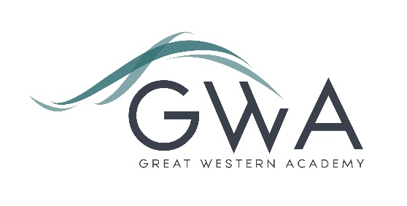

Information for Applicants

Teacher of PE (Full-time)
Great Western Academy opened in September 2018 in North Swindon with a full cohort in year 7 (PAN 150). Years 7 to 9 are heavily over-subscribed and our first cohort of Sixth Form students started in September 2019. PE is available at both GCSE and A-level, as well as Core PE lessons for all.
This role is available as our team of three (two female, one male) needs to expand to accommodate the growth of the school.
During the first year, at least, the successful applicant will need to offer a second teaching subject. The subject offered, and the qualifications or experience you have to teach it, must be clearly stated in your application. The balance of subject teaching can move further towards PE in the second year and beyond, though this will be discussed with the successful candidate.
An applicant’s briefing pack with full information about Great Western Academy and the role is available on the GWA website at www.gwacademy.co.uk/school-information/vacancies . If you have any questions prior to application you are very welcome to contact us.
Application process

Please complete the application form supplied and enclose a supporting letter, either in the space provided on the application form or as a separate document. The application form should be completed in full in black ink or type. A CV is not required and should not be submitted as part of the application.

Your supporting letter should be no more than 2 sides of A4 (with a font size no smaller than 11) and should enhance your application by providing further information, matched to the person specification, about your suitability for the post. This should include evidence of the impact on student outcomes you have made in your career to date, and a clear description of the second teaching subject you can offer and the qualifications and experience you can bring to that part of the role.

Electronic applications should be returned via email to recruitment@gwacademy.co.uk . Postal applications can be returned to:

Graham Davis (Principal)
Great Western Academy, William Morris Way, Swindon SN25 2PP

Closing Date: 9am Wednesday 27th January 2021
Interviews: Week beginning Monday 1st February 2021 (remote)

The interview process will be carried out remotely and will include a way of establishing the quality of your teaching, plus a variety of other tasks and activities.
Great Western Academy is committed to safeguarding and promoting the welfare of children, young people and vulnerable adults and we expect all staff to share this commitment and undergo appropriate checks. All posts within the Trust are therefore subject to an Enhanced DBS and barred list check.

References: References will be taken up prior to interview.

