Church Lane
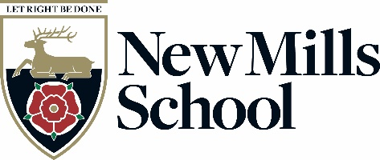
New Mills
High Peak
Derbyshire
SK22 4NR

Tel: 01663 743284
Fax: 01663 745134
email: head@newmillsschool.co.uk
web: www.newmillsschool.co.uk
Headteacher:
Mrs H Watts

Cover Supervisor
G7 PP8-11 (£26,248-£28,161 pa, pro rata)
Full Time (35 hours per week), Term Time only
To start as soon as possible

New Mills School is a rapidly improving 11-16 secondary school, set in the stunning High Peak close to the Peak District National Park, yet within easy reach of Stockport, Manchester and East Cheshire. Our recent strong results reflect the dedication of our team and our commitment to providing an ambitious and inclusive education.
You will find New Mills School a warm and welcoming place, where positive relationships underpin everything we do. Our core values—Think Big, Do the Right Thing, and Team Spirit—drive our relentless focus on student success.
This is an exciting opportunity for a dedicated Cover Supervisor to join our committed team. The successful candidate will play a key role in supporting students with their learning, ensuring all learners are challenged and encouraged to achieve their full potential. You will be working alongside passionate staff who are determined to remove barriers and provide exceptional opportunities for every student.
We are looking to appoint a Cover Supervisor who will provide cover for planned and unplanned teacher absence to ensure the continuity of learning for our students.

The role involves:
- Supervising classes of students in the absence of the teacher and delivering pre-prepared lessons in line with the relevant curriculum medium term plans.
- Assisting in the administration of cover arrangements.
- Taking on tasks as directed by your line manager when lesson cover is not required.

We are looking for an individual who is able to prioritise workload and resolve issues that arise independently. The successful candidate will be confident, have a good general education and be able to build relationships quickly.

If you share our values, have a passion for supporting young people, and want to be part of a forward-thinking and ambitious school, we would love to hear from you.

Application packs may be obtained from, and should be returned to Pete Eckersley, Office Manager, New Mills School, Church Lane, New Mills High Peak, SK22 4NR, or via email to jobs@newmillsschool.co.uk or from the school website www.newmillsschool.co.uk.
If you would like to discuss the post further, or arrange a visit to the school, please contact jobs@newmillsschool.co.uk and this can be arranged.

New Mills School is committed to safeguarding and promoting the welfare of children and young people and expects all staff and volunteers to share this commitment.

New Mills School is committed to creating a diverse workforce. We will consider all qualified applicants for employment without regard to sex, race, religion, belief, sexual orientation, gender reassignment, pregnancy, maternity, age, disability, marriage or civil partnership.

The successful applicant's appointment will be subject to satisfactory pre-employment clearances including references and a Disclosure and Barring check.

Closing date is 2nd March 2025, no later than 23:59

Interviews TBC.

Kind Regards

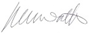

Haether Watts
Headteacher

