Learning Supervisor
INFORMATION FOR CANDIDATES

Contents

3 ……………… Letter from the Headteacher

4 ……………… Advertisement

5 ……………… Welcome to Street

6-7 …………… Job Description

8-9 …………… Person Specification
Letter from the headteacher

Thank you for your interest in the important post of Learning Supervisor at Crispin. Crispin has high expectations of all members of our community and we believe in challenging and supporting students to achieve their very best. It is also important to state that Crispin has a very strong safeguarding culture which we would expect potential colleagues to wholeheartedly support. You will find a range of details about this post in this information booklet. Should you require any further information, would like to discuss the post with me or would like to visit Crispin before an application, do not hesitate to contact Caroline Spurway, by email (CSpurway@educ.somerset.gov.uk).

The post is a really exciting one and would be a great opportunity for the right candidate. We would genuinely welcome applications from colleagues whatever their previous experience. We realise that candidates will have a range of skills and experience and we would fully support the successful candidate to develop professionally.

Crispin has a strong reputation, a sharp focus on learning and colleagues are really positive about the students they teach from the surrounding community.

To apply for this role simply click on the quick apply button on TES.com and complete the online application form. Your supporting statement / letter (of no more than two sides) should outline your skills and experience and how you meet the person specification.

I look forward to receiving your application.
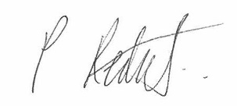

Paul Reddick
Headteacher

Advert
Learning Supervisor

To start as soon as possible. Monday to Friday from 08:30-13:15 and 13:55-15:10. 30 hours per week. Term time plus three paid training days. The salary is within an annual salary range of £12718 and £14240.

This is a fantastic opportunity to work as a Learning Supervisor. Are you potentially an excellent Learning Supervisor with the highest expectations for students and colleagues? Are you driven by sharing your passion and ensuring students reach their potential? If so then we would love to hear from you.

Please read on to find out more information about Crispin and how to apply for the role. In addition, for a more comprehensive insight into Crispin and the role itself, including Job Description, Personal Specification and a letter from the Headteacher, please download the Applicant Information Pack below.

Crispin is a friendly, inclusive and highly successful school of 1030 students. It is rated as ‘good’ in all areas and many strengths were highlighted in our recent Ofsted report (October 2017). Students at Crispin achieve excellent examination results and the school has a strong reputation. We are committed to educating the whole child to ensure they enter adulthood as happy, supported young people with a love for learning. We are looking for a committed Learning Supervisor to join our highly successful team. You will have the opportunity to benefit from a detailed induction process.

Closing date for this post: 12 noon 21 January 2019.

To apply for this role simply click on the quick apply button on TES.com and complete the online application form. Your supporting statement / letter (of no more than two sides) should outline your skills and experience and how you meet the person specification.

Crispin is committed to safeguarding and promoting the welfare of children and young people. This post requires a criminal background check via the disclosure procedure. The successful applicant will therefore be subject to an Enhanced DBS.

This post is covered by Part 7 of the Immigration Act (2016) and therefore the ability to speak fluent spoken English is an essential requirement of the role.

Welcome to street
Crispin School is a secondary school on the eastern edge of Street, a large village in Somerset with a population of around 12,000. It is situated on the Somerset Levels close to Glastonbury, Wells and the Mendips. The village has an interesting history with evidence of Roman occupation. Street is home to Clarks, the world famous footwear retailer. Clarks still has its headquarters in Street but shoes are no longer manufactured in the town. Much of the Street site now houses the popular and thriving designer outlet shopping complex of ‘Clarks Village’.

Somerset generally is a warm and friendly county and Street is no exception. The village itself contains a good range of leisure facilities including a theatre which hosts live performances and a wide range of films, sports facilities and an open air swimming pool. The Glastonbury Festival also takes place very near to the village. There are also a good range of local shops. As one resident of Street said ‘if you choose you can walk to pretty much everything you need’. There is easy access to the coast and there are a number of National Trust properties in the area as well as nature reserves and areas of outstanding natural beauty.

As well as being located in a beautiful part of Somerset, Street is well connected by road being near to the M5, A303 and on a number of bus routes. There are also nearby rail links to London, Bath, Bristol and Devon and Cornwall. Bristol Airport is also close with a wide range of destinations from Iceland to Egypt! There are a number of interesting towns and cities nearby including Glastonbury, Wells and Frome. A little further afield one can easily reach the likes of Bath and Bristol which are both major European cities and home to a very wide cultural and sporting life including excellent music venues, theatres, cinemas, restaurants and professional sports clubs including football and rugby.

Housing is still relatively affordable in Street and many of the surrounding towns and villages. Many colleagues talk of how the area is a safe, yet vibrant area to bring up families with a range of good schools and a college which shares its site with Crispin. Yet at the same time there are a myriad of excellent leisure opportunities and major cities within an hour’s travel.

Job description

Post Title: Learning Supervisor
Purpose: To maintain and make available the appropriate equipment and resources to support student learning in a safe working environment
Reporting to: Associate Assistant Headteacher
Liaising with: Headteacher, Deputy Headteacher, Assistant Headteachers, Heads of House, Teaching Assistants and relevant non-teaching support staff
Working Time: Monday to Friday from 08:30 to 15:10
Salary/Grade: Salary Scale Point 17-21 (£12718-£14240)
Disclosure level: Enhanced
Main (Core) Duties:

Relationships

The post holder:
- Is responsible to the Associate Assistant Headteacher in respect of their overall duties.
- Interacts on a professional level with other colleagues and seeks to establish and maintain productive relationships with them.

Purpose of the Position

To supervise the learning of whole classes during the short term absence of the class teacher as students undertake the work set. To carry out other supervisory roles including accompanying educational visits and the invigilation of examinations and to support teaching and learning across the school. To work in other areas of the school on educational and administrative tasks at times when not required to supervise classes.

Core Responsibilities

- Liaison with teaching staff before and after cover lessons to ensure effective preparation of the cover lesson and comprehensive feedback of progress made
- Register and record student attendance in lessons
- Supervise the work of whole classes set by their subject teacher in accordance with school policies and assist students in achieving the learning objectives of the lesson
- Answer student queries about processes and procedures relating to the lesson and the work set
- Manage the behaviour of students to ensure a positive learning environment, including setting high expectations of conduct and behaviour
- Deal with any immediate problems or emergencies according to school policies and procedures
- Collect completed work after the lesson and return it to the appropriate teacher
- To fulfil your role in line with Crispin’s Behaviour Policy
- Assist with other activities relating to the supervision of students e.g. general supervision during break periods, support in classes, on educational visits, examination invigilation. Support the delivery of learning through personal assistance to teachers, supporting teachers in the classroom
- Carry out administrative tasks to support teachers in the delivery of high quality teaching and learning
- Be aware of and comply with all policies relating to child protection, equal opportunities, health and safety, security, confidentiality, data protection, reporting all concerns to the appropriate authorised person
- Make use of all relevant data and information pertaining to individuals and groups of students when delivering lessons
- Evaluate effectiveness of provision regularly with the Associate Assistant Headteacher
- Carry out any other reasonable activities at the request of your Line Manager or Headteacher

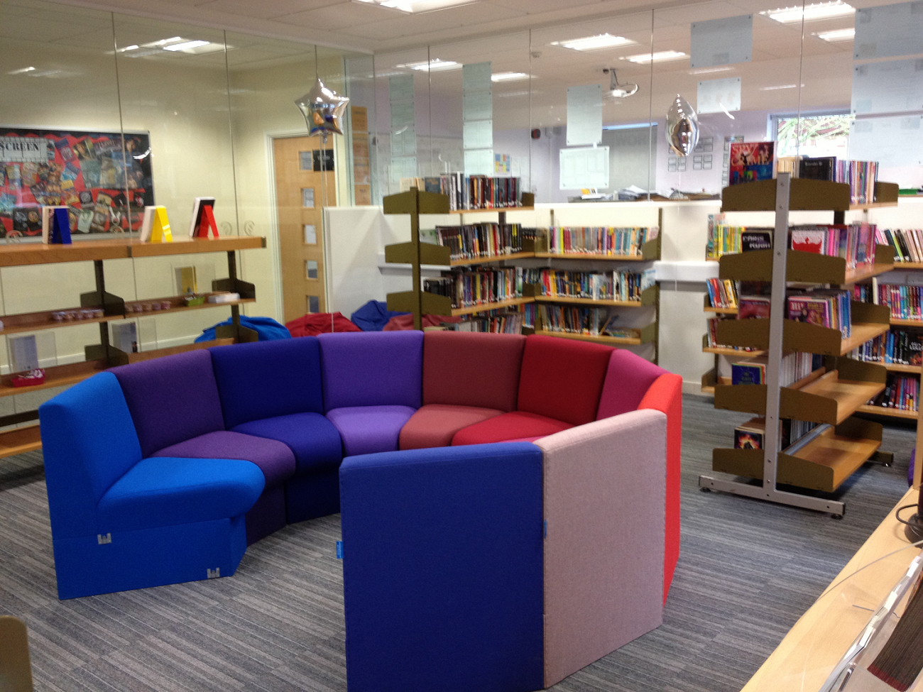

Description  Person specification | Method of Assessment
Qualifications and Training  Essential  - Good English, Mathematics, ICT and communication skills  Desirable  - Experience of working with children / young people | Letter of application
Experience  Desirable  - Knowledge of working with secondary school aged students.  - Good communication skills and the ability to work as part of a team.  - Ability to be reliable, resourceful and take the initiative  - Ability to balance priorities and changing demands under pressure  - Ability to work independently within agreed boundaries  - Some experience of working with children and young people | Letter of application  Application form  Interview
Knowledge, Skills and Understanding  Essential  - A commitment to promoting equal opportunities and meeting individual needs.  - Competent personal skills in dealing with young people.  - Commitment to helping every student achieve his/her potential.  - Ability to work as part of a team.  - Ability to be flexible to the needs of the children.  - Effective communication, interpersonal and organisational skills.  - Ability to use ICT to support students’ learning. | Letter of application  Application form  Interview  References
Crispin’s Values and Ethos  Essential  - Value the contribution that each individual brings to the school community  - Respect and value diversity and promote equality  - Promote and model mutual respect  - Commitment to inclusive education  - Understand responsibilities related to children’s safety and welfare | Interview
Personal Qualities  Essential  - Patience, empathy and compassion.  - A genuine interest in children and young people and a willingness to support and assist them towards independence.  - Good communication skills, flexibility, accuracy, ability to prioritise workload, strong organisational ability.  - Ability to develop and maintain positive relationships with colleagues, staff, students, parents and carers.  - Ability to remain calm under pressure.  - Willingness to constructively challenge the work of self and others to continually improve own and team performance  - Seek to work collaboratively to resolve conflict  - Enthusiasm to support young people to develop intellectually and personally  - Strong commitment to CPD  - Resilience  - Emotional intelligence  - The ability to speak fluent English  Desirable  - Possess an excellent sense of humour | Interview  References

Crispin School, Church Road, Street, Somerset, BA16 0AD
Tel: 01458 442714 Email: office@crispin.somerset.sch.uk Web: www.crispinschool.co.uk

Headteacher: Paul Reddick BA (Hons), MA, MA Ed

