

**A Brief History of Newstead Wood School**

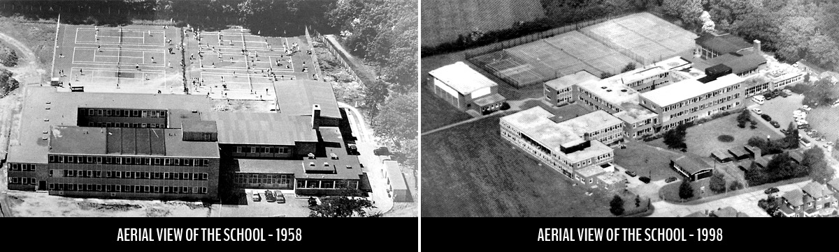

Newstead Wood School (previously Newstead Wood School for Girls) is a long established, highly successful girls’ selective school that also admits boys into the 6th Form. It is in the [Crofton](https://en.wikipedia.org/wiki/Crofton,_London) area of Orpington, not far from the A21, about 15 minutes walk from Orpington station. The school's motto is Fortitudine Crescamus (*'May we grow in strength'*).

Newstead Wood converted to an academy on 1st April 2011. The Newstead Wood Academy Trust has overall responsibility for the running of the school and the Governing Body reports to it. The current acting head teacher is Nick Webb.

The original school opened in September 1954 as Orpington Grammar School, both in response to the needs generated by the rapid growth of Orpington and Petts Wood over the previous years and in the light of local campaigning for a girls’ grammar school in Orpington. The first single form entry was housed temporarily at Midfield Girls’ School.

The present site was purchased in 1954 and building began in 1955. The school moved into those premises on 23rd September 1957. The first head teacher was Miss H.M. Pipe, who served from 1957 until December 1978. The official opening was held on 18th July 1958 by Mrs. Mary Stocks, former Principal of Westfield College, University of London. Since then, at the request of the original students, the anniversary has been marked by the annual Commemoration Day Service.

The school became part of the London Borough of Bromley in 1965 and the name was changed to Newstead Wood School for Girls in September 1968 with the first four-form entry.

An extension was built in 1970, including a block to house the Sixth Form. Later, the Music Centre and Technology Block were added. The building programme continued; the Sixth Form block was further extended with four new classrooms, an office for the Head of Sixth Form and two new physics laboratories for use by the whole school. At the end of the 1998 summer term, work commenced on building a new drama studio, five classrooms, an additional study area and much-needed changing rooms and showers. A new, purpose built Sixth Form Study Centre opened in 2011, housing 11 classrooms and a Computer Suite for Sixth Form students’ use.

In January 1979, Newstead Wood became a ‘super’ selective girls’ school drawing students from a nine mile radius. At this time all other secondary schools in the area, with the exception of St. Olave’s, the boys’ equivalent to Newstead, became comprehensive.

Ofsted has inspected twice in the last 5 years (2010 and 2014) and on both occasions has assessed the school as “Outstanding.” In January 2016, Newstead was awarded a Lifetime Achievement Award by the national body ‘Investor in Careers’, to mark their 20 years of operating the scheme. The Award is in recognition of the school's exceptional programme of support, advice and guidance for its students

The school is proud of its students’ academic achievements, and in 2015 was ranked by the Sunday Times as 31st in the country for its A level results. The school is heavily oversubscribed with over 1000 applicants for year 7 entry for the 160 places available.

The students and staff enjoy and recognise the benefits of a strong extra-curricular programme; evidenced through a variety of drama and musical events. Sport, foreign exchange visits, lunchtime clubs (e.g. debating society) are equally prevalent. The annual Enrichment Week, in which the timetable is suspended so that students can explore topics in depth and across the curriculum, is testament to this philosophy.

The five Headteachers of Newstead Wood School have been:

* Miss Hilda Pipe 1957-1979
* Mrs Valerie Smith 1979-1994
* Mrs Barbara Gibbs 1994-2001
* Mrs Elizabeth Allen 2001-2013
* Mrs Alison Ross 2014 – 2015

Newstead Wood School is now entering a new and exciting chapter in its continued growth and development and is looking forward to welcoming a new Headteacher in 2016.