

**The International School of Ahafo** - **School Profile**

ISA is a not-for-profit, English speaking international, co-educational day school which uses the Early Years Foundation Stage (EYFS) and Cambridge Primary and Secondary 1 programmes. The school currently provides a Reception – Year 8 programme for students whose families work for [Newmont Ghana Gold Limited](http://www.newmont.com/operations-and-projects/africa/ahafo-ghana/overview/default.aspx), a subsidiary of [Newmont Mining Corporation](http://www.newmont.com/home/default.aspx) in the USA. However, to improve long-term sustainability, the school hopes to begin offering places to students who are not part of Newmont in the near future. Currently, students come from: Ghana, Peru, UK, Chile, Indonesia and South Africa, although English language proficiency is very good.

Students are taught in three mixed aged class groups as follows:

* Reception – Year 2 (Sankofa Class)
* Years 3 – 4 (Nkyinkyim Class)
* Years 5, 6 and 7 (Gye Nyame Class)

Class sizes are typically around 12 students.

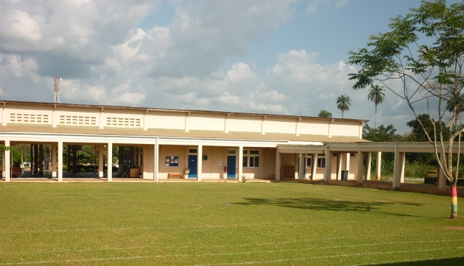

*School playing field*

**Location**

Sunyani, the capital of the Brong Ahafo Region, is 30km north of the school and is where the local airport is situated. There is a flight to and from Accra four times each week. Kumasi, the second city and seat of the Ashanti people, is 60 km away from the school, which is about a three-hour drive.

**Premises and Facilities**

The school is housed in a purpose-built complex, with an open courtyard design. The classrooms on the West and East wings are connected by covered walkways. All rooms are air-conditioned. The spacious classrooms, a well stocked library, Art room, Music room, ICT room and Science Laboratory provide an excellent learning environment. The school also has access to sports facilities, including a swimming pool, through its location within the Newmont Mines residential compound (Mensah Kumta Village). The current premises are adequate for growing the school to its full capacity of 100 students.

**Curriculum**

Students in Reception follow the Early Years Foundation Stage curriculum and move to the Cambridge Primary Curriculum for Years 1 - 6. For the first three years of Secondary school (Years 7 - 9), the Cambridge Secondary 1 Curriculum is followed. The full programmes offered at ISA provide broad and balanced study across a wide range of subjects, using enquiry-based approaches to learning.

Extra-curricular activities offered are dependent upon the interest of individual staff members and community support. Currently, the following are offered: computer, football, yoga, art and crafts, science and technology, music and dance clubs.

**IT facilities**

All classrooms have data projectors and screens, and PCs and tablets are available for whole-class use. A separate ICT room is available for whole-class teaching.

**School Year**

The school year is typical of northern hemisphere schools and is divided into three terms so the academic year begins at the end of August and finishes at the end of June/early July.

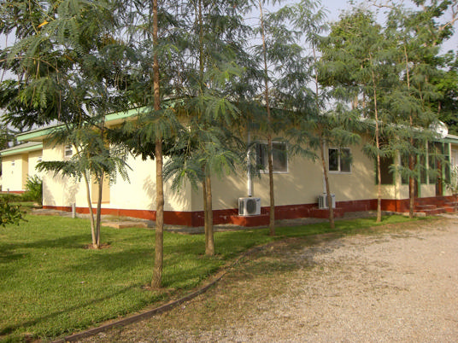

*Mensah Kumta Village*

**Accommodation**

Teachers live in the Mensah Kumta Village (MKV) which houses all expatriate and senior Ghanaian staff of Newmont. It is spread over 30 acres and includes 92 homes, the School, the Clubhouse, the shop and recreation facilities, all within a secure environment. All tap water in the houses is treated and drinkable. The MKV Clubhouse is open seven days a week and dinner is à la cartemenu. Friday nights are a BBQ or theme evening and on Sundays there is a Sunday Brunch.

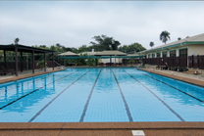

*Swimming Pool*

The bungalows at Mensah Kumta Village were built in 2005 and are quite spacious. In addition to the living room there is a sun room, laundry area, dining room and kitchen. Each bungalow is furnished and equipped with comfortable basics. There is uninterrupted power and water supply, the houses are all air-conditioned, fitted with cable TV (DSTV) and bills are paid by Newmont. A/C power is 220/240v and outlets use the three-pronged UK style plug. There is absolutely peace and quiet here; a sharp contrast from the hustle and bustle of city life. The cycle or walk to school is about 5-10 minutes.

**Banking**

There is a Barclays ATM on site, located next to the shop, which accepts a VISA network ATM card.

**House Staff**

The teachers, in common with other expatriates, are able to employ local people to assist with household chores. Some employ a cleaner, but others employ a cook and/or a nanny. A full time cook/cleaner would expect to earn $100 a month.

**Shopping**

The commissary in the MKV village has a reasonable stock of basic foodstuffs and toiletries which covers necessities. Other options available are a bike ride away at the local markets.

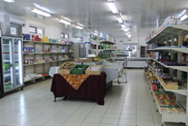

*MKV Commissary*

**Medical facilities**

Teachers from ISA are able to use the fully-staffed clinic run by [International SOS (ISOS)](https://www.internationalsos.com/) at the Newmont Mine plant site for routine medical care. ISOS is a leader in international health care and medical assistance and works with multi-national organizations across the world. The clinic has daytime opening hours - 7:30am to 5:00pm but is staffed 24/7 to handle emergencies.

Private hospitals in Sunyani and Kumasi are able to cope with more serious illness and emergency medical care is covered by the [BUPA Vital Africa Insurance Plan](http://www.bupa-intl.com/for-business/vital-africa-emergency-health-insurance).

**GHANA**

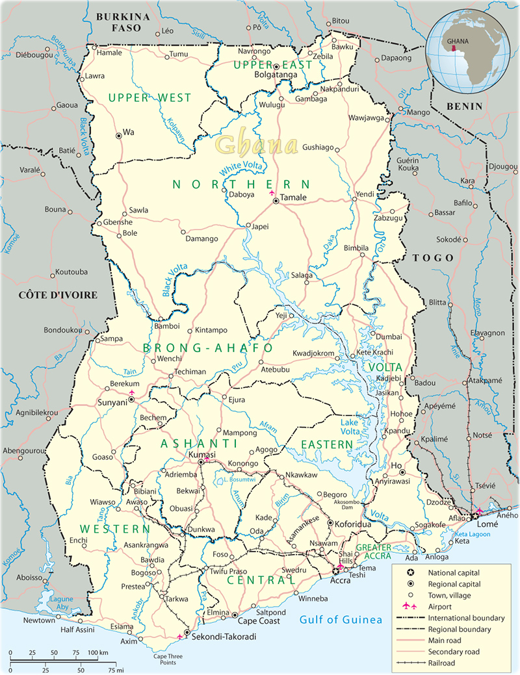Ghana (previously known as the Gold Coast) is a very safe country – among the safest and most politically stable in Africa. It has a rich history dating back to the 15th century, through to Independence from the British in 1957.   The Ghana coast is studded with 32 castles, built by the Portuguese as trading posts in which a range of European goods such as cloth, beads guns and ammunition were sold in exchange for gold.  It was only later that the warehouses which were built to store normal trading items found a new use as dungeons in which to imprison Africans prior to their transportation to slavery. Ghana’s coast is incredibly beautiful; warm winds gently blowing over the palm fringed beaches on which there are often an assortment of picturesque, dug out fishing boats.

**People**

Ghanaians are considered to be some of the friendliest people in the world, with family and religion playing a very important role in the life of a Ghanaian. The population is estimated at 23 million.

**Languages**

The official language is English. Local Ghanaian languages are widely spoken, including Akan, Moshi-Dagomba, Ewe, Twi, and Ga.

**Religion**

Christian, Muslim and traditional beliefs. All forms of religion have a strong influence on Ghanaian life.

**Economy**

[Ghana](http://en.wikipedia.org/wiki/Ghana) has a diverse and rich resource base economy which includes manufacturing and exportation of digital technology goods, automotive and ship construction. The exportation of diverse and rich hydrocarbons and [industrial minerals](http://en.wikipedia.org/wiki/Industrial_mineral) gives Ghana one of the highest GDP per capita in Africa. Ghana is the fastest growing economy in Africa and one of the top-ten fastest growing economies in the world.

**Climate**

The climate is tropical - hot and humid in most areas throughout the year. There are two rainy seasons in Ghana: from March to July and from September to October. Temperatures average between 25°C and 30°C.

**Time Zone -** GMT (no daylight savings)

**Clothing**

Most of the year the temperatures are over 25°C so light cotton provides comfortable clothing. However, during January the temperature can drop to as low as 15°C in the early hours of the morning so a sweater of jacket may be required. Be prepared for heavy rain. The dress code for school is smart but comfortable: shirts, ties and trousers for men and modest professional clothes for women. Out of school, dress is very informal, although Ghanaians expect expatriates to be respectful and modest in their attire.

**Visa**

Most nationalities require a visa to enter Ghana. Please check with the Ghanaian Consulate in your country for more information on visa requirements and procedures.