

Abbey College

**Teacher of Computing**

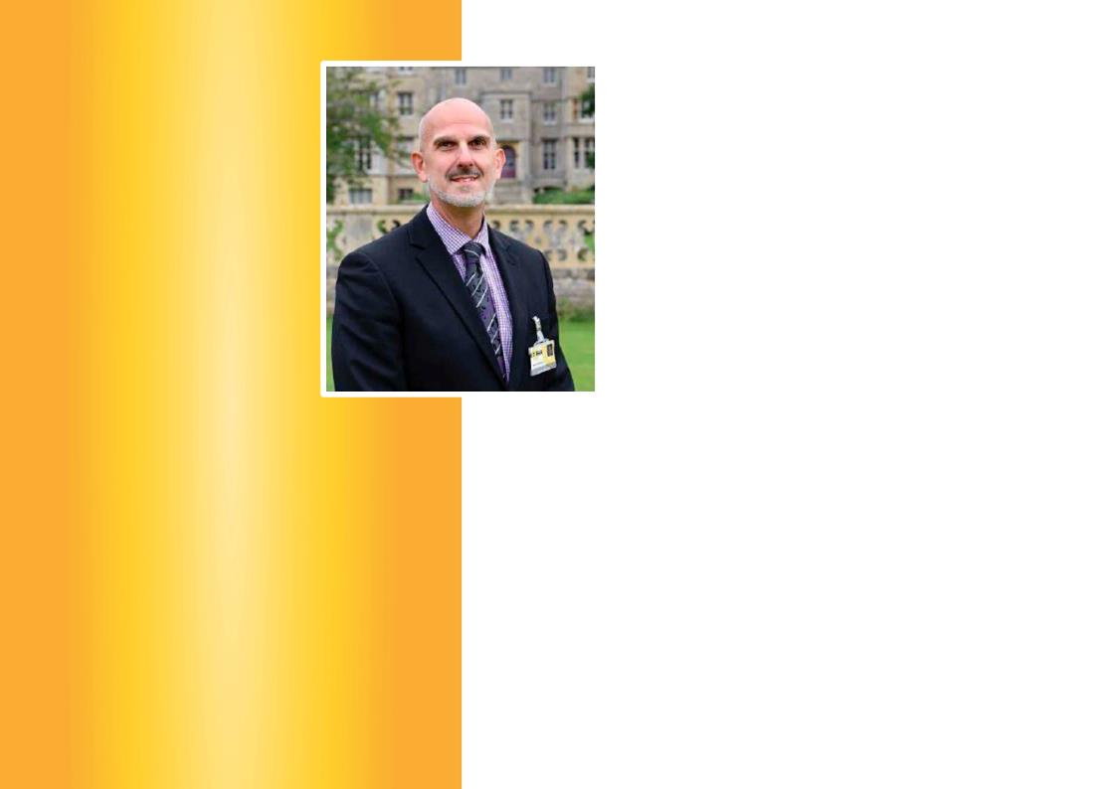

**Recruitment Schedule:**

Application Deadline: 9am Friday 30th June 2017

Interviews: To be arranged

**Teacher of Computing**

***For this role, the Academy offers a recruitment incentive of £8,000* or a relocation expenses package of up to £8,000\****

***\*Conditions apply – available on request***

Start: 1st January 2018

Salary: MPS

Dear Applicant,

Thank you for your interest in our Computing post at Abbey College. We are seeking to appoint a fantastic, enthusiastic and ambitious teacher of Computing to join our team of brilliant staff.

For this role, the Academy offers a recruitment incentive of £8,000* or a relocation expenses package of up to £8,000*

*Conditions apply and are available on request.

Our 2016 results were our best yet. Our A level and BTEC results placed us the sixth best in Cambridgeshire, outdoing many private schools, and in our GCSE results were our highest ever, with a progress 8 figure of 0.21. We are also oversubscribed for the second year in a row this year by over 40% and our attendance is 2% higher than the national averages.

I believe that high quality teaching, learning, engagement and assessment is at the heart of every good school and our consistent success. After all a student’s education is not a dress rehearsal; they only get one chance.

We are on a journey to reach Good and Outstanding and we require a Computing teacher to help drive this vision. The successful applicant will have the opportunity to teach Key Stage 5. The successful candidate will be enthusiastic about giving our students the high-quality education they deserve.

I look forward to receiving your application on the enclosed application form, together with your covering letter. If you would like to visit the College please ring the office to arrange a convenient time.



Mr Andy Christoforou – Headteacher, Abbey College

**About Abbey College**

Abbey College, Ramsey is located in a small market town almost half way between Huntingdon and Peterborough and within easy reach of Cambridge and London. The College is set within extensive, historic and beautiful grounds close to the Parish Church of St Thomas A Becket.

The College is a large 11-18 school with a catchment which extends over a wide rural area. There are approximately 1090 students on role, including a sixth form of 120. We currently have around 70 teaching staff with an additional support team of over 75 members of staff.



Our College ethos is ‘**Aspire and Challenge**’, which means that the College strives to provide strong equal learning opportunities within a broad and balanced curriculum for all students regardless of ability, background or culture. Our values include **B**eing polite, Being **E**quipped for learning, **S**ticking and completing the most challenging task and being **T**olerant, which we remember as **BEST**. Our motto is to: ‘*challenge mind-sets and raising aspirations*’.

**Peterborough**

Must visit: Peterborough Cathedral, Queensgate Shopping Centre, Ferry Meadows Country Park

**Huntingdon**

Must visit: Huntingdon Racecourse, Houghton Mill,   
Grafham Water Centre

**Cambridge**

Must visit: University Colleges, Punting on the River Cam, Cambridge Junction and Corn Exchange

**London**

Must visit: London Eye, Buckingham Palace, Museums and Art Galleries

At Abbey College we regard staff well-being as a top priority and we are committed to ensuring our staff are always developing and growing. We have a full and extensive programme of CPD activities throughout the year and regularly share good practice. We have also recently introduced an employee of the month scheme to recognise members of staff who go above and beyond.

For more information about the day to day life and the successes happening at the College, visit our Facebook page: [www.facebook.com/RamseyAbbeyCollege](http://www.facebook.com/RamseyAbbeyCollege).

**About Ramsey**

Ramsey is a historic English market-town in the district of Huntingdonshire and the county of Cambridgeshire, which was established around the Ramsey Abbey, a Benedictine monastery. Subsequently the town is brimming with history and has retained a quaint, rural feel.

However, do not be fooled, Ramsey is just 20-25 minutes from bustling cities Peterborough and Huntingdon, and its close proximity to the A1 motorway also means it is just 40 minutes from Cambridge and 45 minutes from London from Peterborough train station. Therefore its positioning grants it a perfect combination of both rural charm and city comforts.

**Nearby**

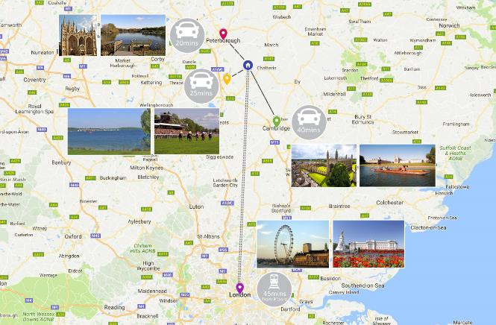

**Job Description: Teacher of Computing**



**Teacher of Computing**

Start: 1st January 2018

Salary: MPS

Application: Deadline: 9am Friday 30th June 2017

Interviews: To be arranged

Please complete the attached application form and return with a covering letter of no more than one side of A4 to Brenda Mustill

Brenda.mustill@abbeycollege.cambs.sch.uk

Abbey College is committed to safeguarding and promoting the welfare of children and young people and expects all staff to share this commitment.

The responsibilities of the post will be in accordance with the Teacher’s standards, latest School teachers’ pay and conditions, school’s policies and under the direction of the Headteacher.

**Job Role and Purpose:**

* Teacher of Computing
* Opportunity to teach Key Stage 5

**Responsibilities:**

* Good or outstanding classroom skills
* Ability to create effective lesson plans
* Ability to use assessment to inform planning for good teaching and learning
* Experience or desire to be involved in a curriculum initiative
* Ability to differentiate materials to meet the needs of learners
* Experience or desire to raise standards of achievements
* Willingness to continue to develop own expertise
* Ability to build good relationships with students and colleagues
* Be well organized and able to obtain accurate records
* Ability to use ICT effectively to engage students

The duties and responsibilities of the subject element of the post may vary from time to time according to the changing needs of the school. Any section of the job description may be reviewed at the discretion of the Headteacher in the light of those changing requirements and in consultation with the post holder and governing body.

A job description and person specification can be found below



Abbey College, Abbey Road, Ramsey, Huntingdon, PE26 1DG

T: 01487 812 352

W: www.abbeycollege.cambs.sch.uk



*ABBEY COLLEGE – MATHEMATICS, COMPUTING, ICT AND BUSINESS STUDIES LEARNING AREA*

**DETAILS FOR APPLICANTS**

**Who are we?**

Computer Science is part of the BITE department which consists of Business Studies, Computing, Information Technology and Economics. The BITE department is staffed by a strong, small committed team.

**What are the accommodation and facilities?**

The BITE department is housed in the Cromwell building. There are three dedicated class sized rooms with the latest software and hardware. There are also additional ICT suites across campus. The rooms have access to printers and are serviced regularly by the committed IT support staff. All rooms have projectors and a whiteboard plus access to the whole school network including provision to share resources via a number of network drives.

**How we deliver the curriculum**

At KS3, currently, we have a single year 7 and year 8 group. The two groups will have four lessons a fortnight. They are currently doing the ECDL qualification over the two years alongside some bespoke Computer Science topics.

The GCSE starts in year 9, the students have five lessons a fortnight. The students are currently doing the OCR Computer Science J276 specification. The same specification is used with year 10 and year 11 groups.

The students cover topics such as:

|  |  |  |
| --- | --- | --- |
| **Systems Architecture** | **Computational thinking, algorithms and programming** | **Programming project** |
| Systems Architecture  • Memory  • Storage  • Wired and wireless networks  • Network topologies, protocols  and layers  • System security  • System software  • Ethical, legal, cultural and environmental concerns | Algorithms *  • Programming techniques  • Producing robust programs  • Computational logic  • Translators and facilities of languages  • Data representation | Programming techniques  • Analysis  • Design  • Development  • Testing and evaluation and conclusions |

Abbey College runs two KS5 courses. The new Edexcel BTEC Level 3 Diploma in IT (2016 NQF) started in September 2016. Students complete an exam on the computer in June, complete a 10 hour database controlled assessment and 2 optional units such as Website Development as well as using IT

We also offer A level Computing with AQA. Students studying this course are using Python as well as VB.NET for the programming aspects of the course. For the AS, they are using the Console mode of Python and Vb.NET. They use the Forms based part of Vb.NET for their project in A2 and this will be started in Year 13. The results for Computing A2 2015 were 75% A*-C and 100% A*-D.

The successful candidate will need to either hold the OSCA qualification for moderating Level 3 BTEC work qualification or be ready to work towards it in the autumn term under the guidance of the school’s Vocational Quality Nominee. In addition the successful candidate will need to have experience of teaching computing to A level standard, preferably using VB.NET or Python and will have given some thought to the delivery of GCSE Computing.

**What do I do if I want to know more before applying?**

Please get in touch by e-mail using [julie.mccrory@abbeycollege.cambs.sch.uk](mailto:julie.mccrory@abbeycollege.cambs.sch.uk) . We are happy to deal with all enquiries and answer your questions. You will find more information on our website [www.abbeycollege.cambs.sch.uk](http://www.abbeycollege.cambs.sch.uk)

Miss Julie McCrory

April 2017



# 

# *Abbey College – Subject Teacher, Specification*

|  |  |  |  |
| --- | --- | --- | --- |
|  |  | Met | To be addressed by |
| Education and Qualifications | * Qualified Teacher Status * First/Second Class Degree * Willingness to continue to develop own expertise (evidenced through continuing professional development) * Appropriate qualifications, experience and any other requirements needed to perform the role in relation to safeguarding and promoting the welfare of children and young people |  | Application |
| Teaching Experience | * Evidence of consistently good or outstanding teaching and learning * Evidence of good or outstanding classroom management skills * The ability to use ICT effectively to engage students * The ability to create effective lesson plans * An understanding of how to use assessment to inform planning for good teaching and learning. * The ability to differentiate materials to meet the needs of learners * Experience or desire to be involved in a curriculum initiative * Experience or desire to raise standards of achievement |  | Application/Interview |
| Skills, Knowledge and Aptitude | * Excellent subject knowledge. * Good ICT skills and their application to teaching with subject specialism * Good/outstanding classroom practitioner able to motivate students * Able to build good relationships with students and colleagues * Ability to communicate effectively with different audiences, orally and in writing * Well organised and able to maintain accurate records and track students performance * Awareness of current educational developments * Ability to reflect on practice |  | Application/Interview |
| Personal Qualities | * Hardworking and committed to inclusive education * A belief in the value of individuals and that every child genuinely matters * A commitment to excellence and working in partnership * A willingness to learn and develop new skills * Commitment to continuing professional development * To work proactively within the ethos of the school * Capacity for working under pressure. * Resilience and a sense of humour. * Reliable with excellent attendance and punctuality * Problem solving and loyal to organisation * The ability to converse at ease with members of the public and provide advice and information in accurate spoken English is essential for the post |  | Application/Interview |

**Safeguarding**

* To have the ability to safeguard and promote the welfare of children and young people.
* Appreciate the significance of safeguarding and interprets this accurately for all individual children and young people whatever their life circumstances.
* To have a good understanding of the safeguarding agenda and can demonstrate an ability to contribute towards a safe environment.



Internal use only­­­­­­­­­­­­­­

Reference no:

Date received: ­­­­­­­­­­­­­­­­­­­­­­­­­­­­

**Employment Application Form: Teacher**

**We are committed to safeguarding and promoting the welfare of children and young people and expect all staff and volunteers to share this commitment.**

Please ensure that you complete **all** sections of Part 1 and Part 2 of the application. Please note that providing false information will result in the application being rejected, withdrawal of any offer of employment, summary dismissal if you are in post or possible referral to the police. Please note that checks may be carried out to verify the contents of your application form. Please complete the form in black ink or type. CVs are not accepted.

|  |  |
| --- | --- |
| **Vacancy Job Title** |  |

PLEASE STATE WHERE YOU SAW THIS ADVERT _________________________________________

Part 1: Information for Shortlisting and Interviewing

**Initials Surname or Family name**

**Letter of Application – Please note, we do not accept CVs**

Please enclose a letter of application. Please refer to the applicant information pack which may include instructions on how to complete the letter of application.

**Current/Most Recent Employment: If Teaching**

|  |  |
| --- | --- |
| **Name, address and telephone number of school** |  |
| 1. **Type of school** | Boys Girls Mixed Age range Number on Roll |
| 1. **Type of school** e.g. Community, Aided, Academy, Foundation, Free School, Independent, etc. |  |
| **Job title** Please enclose a copy of the job description |  |
| **Subjects/age groups taught** |  |
| **Date appointed to this post** |  |
| **Salary** |  |
| **Date available to begin new job** |  |

**Current/Most Recent Employment: If Non-Teaching**

|  |  |
| --- | --- |
| **Name, address and telephone number of employer** |  |
| **Job title** Please enclose a copy of the job description |  |
| **Date appointed to this post** |  |
| **Salary** |  |
| **Date available to begin new job** |  |

**F**ull **C**hronological History

Please provide a full history in date order, most recent first, since leaving secondary education, including periods of any post-secondary education/training, and part-time and voluntary work as well as full time employment, with start and end dates, explanations for periods not in employment or education/training, and reasons for leaving employment.

|  |  |  |  |  |  |  |
| --- | --- | --- | --- | --- | --- | --- |
| **Job title** | **Name and address of school,** | **Number on** | **F/T** | **Dates** | **(DD/MM/YYYY)** | **Reason** |
| **or position** | **other employer, or** | **roll and** | **or** | **From** | **To** | **for** |
|  | **description of activity** | **type of** | **P/T** |  |  | **leaving** |
|  |  | **school, if** |  |  |  |  |
|  |  | **applicable** |  |  |  |  |
|  |  |  |  |  |  |  |
|  |  |  |  |  |  |  |
|  |  |  |  |  |  |  |
|  |  |  |  |  |  |  |
|  |  |  |  |  |  |  |
|  |  |  |  |  |  |  |
|  |  |  |  |  |  |  |
|  |  |  |  |  |  |  |

Please enclose a continuation sheet if necessary.

**Secondary Education and Qualifications**

|  |  |  |  |
| --- | --- | --- | --- |
| **Name of school/college** | **From** | **To** | **Qualifications gained with date** |
|  |  |  |  |

**Higher Education**

|  |  |  |  |  |  |
| --- | --- | --- | --- | --- | --- |
| **Name and address of university, college and/or university education department** | **Dates**  **From To** | **Full or**  **part-time** | **Courses/subjects taken and passed** | **Date of examination and**  **qualifications obtained** | **Age groups for which trained** |
|  |  |  |  |  |  |

**Professional Courses Attended as a Teacher**

Please list relevant courses attended in the past 3 years.

|  |  |  |  |
| --- | --- | --- | --- |
| **Subject** | **Organising body** | **Date(s)** | **Duration** |
|  |  |  |  |

**Other Relevant Experience, Interests and Skills**

|  |
| --- |
|  |

**Referees**

Please provide details of two people to whom reference may be made. The first referee should normally be your present or most recent Headteacher or equivalent person. If you are not currently working with children please provide a referee from your most recent employment involving children. Referees will be asked about disciplinary offences relating to children, which may include any in which the penalty is “time expired” and whether you have been the subject of any child protection concerns, and if so, the outcome of any enquiry or disciplinary procedure. References will not be accepted from relatives or from people writing solely in the capacity of friends.

**First Referee**

|  |  |
| --- | --- |
| **Title and name** |  |
| **Address and post code** |  |
|  |  |
|  |  |
| **Telephone number** |  |
| **Email address** |  |
| **Job title** |  |
| **Relationship to applicant** |  |

**Second Referee**

|  |  |
| --- | --- |
| **Title and name** |  |
| **Address and post code** |  |
|  |  |
|  |  |
| **Telephone number** |  |
| **Email address** |  |
| **Job title** |  |
| **Relationship to applicant** |  |

**It is normal practice to take up references on shortlisted candidates prior to interview.** This is in line with the most recent version of Keeping Children Safe in Education statutory guidance.

Please indicate whether you give your consent for references to be requested before interview, by ticking the appropriate boxes below.

**Reference 1:** Yes No

**Reference 2:** Yes No

Part 2 Internal Ref. No.

This section will be separated from Part 1 on receipt. Relevant responses may be verified prior to shortlisting and/or used for administration purposes but will not then be used for selection purposes. If you are called to interview you may be asked about the answers you have given to questions 14 to 19 if relevant to the job.

**Personal Information**

|  |  |
| --- | --- |
| 1. **Surname or family name** |  |
| 1. **All previous surnames** |  |
| 1. **All forenames** |  |
| 1. **Title** |  |
| 1. **Current address** |  |
| 1. **Postcode** |  |
| 1. **Resident at this address since** |  |
| 1. **Home telephone number** |  |
| 1. **Mobile telephone number** |  |
| 1. **Date of birth** |  |
| 1. **Email address** |  |
| 1. **DfE reference number** |  |
| 1. **National Insurance Number** |  |
| 1. **Do you have a current full driving licence?** | Yes No |
| 1. **Did you qualify as a teacher after May 1999?** | Yes No  If Yes, in which school was induction completed? |
| 1. **Have you ever been subject to a child protection investigation by your employer or any other organisation?** | Yes No  If YES please state separately under confidential cover the circumstances and the outcome including any orders or conditions. This will not be opened unless you are called to interview. |
| 1. **Do you require sponsorship (previously a work permit)?** | Yes No  If YES please provide details under separate cover. |
| 1. **Are you related to or have a close personal relationship with any pupil, employee, or governor?** | Yes No  If YES give details separately under confidential cover. This will not be opened unless you are called to interview. |
| 1. **Are there any special arrangements which we can make for you if you are called for an interview and/or work based assessment?** | Yes No  If Yes please specify, (e.g. ground floor venue, sign language, interpreter, audiotape etc). |

**Compulsory Declaration of any Convictions, Cautions or Reprimands, Warnings or Bind-overs**

If you are shortlisted you will be required to complete a “Disclosure of Criminal Record” form and bring the completed form to interview. If the job involves contact with children up to age 8 you will also be required to make a Disqualification Declaration. The information you give will be treated as strictly confidential. Disclosure of a conviction, caution, bind-over order, warning or reprimand will not automatically disqualify you from consideration. Any offence will only be taken into consideration if it is one which would make you unsuitable for the type of work you are applying for. However, offences relating to children may make you unsuitable since this is a “regulated position” under the Under the Criminal Justice & Courts Services Act 2000.

**Prohibition from Teaching**

In accordance with the requirements of The School Staffing (England) (Amendment) Regulations 2013, any future appointment is subject to a check with the Department for Education to ensure that you are not subject to a prohibition order or an interim prohibition order.

**Data Protection Act 1998**

The information collected on this form will be used in compliance with the Data Protection Act 1998. By supplying information, you are giving your consent to the information being processed for all employment purposes as defined in the Data Protection Act 1998. The information may be disclosed, as appropriate, to the governors, to Occupational Health, to the Teachers Pensions Agency, to the Department for Education, to pension, payroll and personnel providers and relevant statutory bodies. This form will be kept strictly confidential but may be photocopied and may be transmitted electronically for use by those entitled to see the information as part of the recruitment process. When the recruitment process is completed, the form will be stored for a maximum of six months then destroyed. If you are employed as a result of this recruitment process then this application form will be retained as part of your personnel record.

**Notes**

(a) Under the Criminal Justice & Courts Services Act 2000 it is an offence for an individual who has been disqualified from working with children to knowingly apply for, offer to do, accept, or do any work in a ‘regulated position’. The position you are applying for is a “regulated position”.

(b) Canvassing, directly or indirectly, an employee or governor will disqualify the application.

(c) Candidates recommended for appointment will be required to provide a satisfactory Enhanced DBS certificate and complete a pre-employment medical questionnaire and may be required to undergo a medical examination.

(d) This organisation is under a duty to protect the public funds it administers, and to this end may use the information you have provided on this form for the prevention and detection of fraud. It may also share this information with other bodies responsible for auditing or administering public funds for these purposes.

**Declaration**

I certify that, to the best of my knowledge and belief, all particulars included in my application are correct. I understand and accept that providing false information will result in my application being rejected or withdrawal of any offer of employment, or summary dismissal if I am in post, and possible referral to the police. I understand and accept that the information I have provided may be used in accordance with paragraph 13 above, and in particular that checks may be carried out to verify the contents of my application form.

Signature of Applicant**:**

Print Name:

Date:

**Part 3: Equality and Diversity Monitoring**

This section will be separated from part 1 and part 2. Collection of equality information is solely for monitoring purposes to ensure that our policies and procedures are effective. We also collect this data in accordance with the general and specific public sector equality duties under the Equality Act 2010. Any data you enter onto this monitoring form will only be used for monitoring purposes and will not be used in assessing and or scoring your application or during the interview process. This information is kept fully confidential and access is strictly limited in accordance with the Data Protection Act.

|  |  |  |  |
| --- | --- | --- | --- |
| **Ethnic group** | **Workforce**  **census code** |  | **Please tick** |
| White | WBRI | British English Welsh Northern Irish Scottish |  |
|  | WIRI | Irish |  |
|  | OOTH | Irish Traveller |  |
|  | OOTH | Gypsy |  |
|  | WOTH | Other White background |  |
| Mixed | MWBC | White and Black Caribbean |  |
|  | MWBA | White and Black African |  |
|  | MWAS | White and Asian |  |
|  | MOTH | Other Mixed background |  |
| Asian or Asian British | AIND | Indian |  |
|  | APKN | Pakistani |  |
|  | ABAN | Bangladeshi |  |
|  | CHNE | Chinese |  |
|  | AOTH | Other Asian background |  |
| Black or Black British | BCRB | Caribbean |  |
|  | BAFR | African |  |
|  | BOTH | Other Black background |  |
| Other ethnic group | OOTH | Arab |  |
|  |  | Write in: |  |
| Prefer not to say | REFU |  |  |

|  |  |
| --- | --- |
| **Sexual orientation** | **Please**  **tick** |
| Bi-sexual |  |
| Gay |  |
| Lesbian |  |
| Heterosexual |  |
| Other |  |
| Prefer not to say |  |

|  |  |
| --- | --- |
| **Gender** | **Please**  **tick** |
| Female |  |
| Male |  |
| Transgender |  |
| Prefer not to say |  |

|  |  |
| --- | --- |
| **Personal relationship** | **Please**  **tick** |
| Single |  |
| Living together |  |
| Married |  |
| Civil Partnership |  |
| Prefer not to say |  |

|  |  |
| --- | --- |
| **Religion** | **Please tick** |
| No religion |  |
| Christian (including Church of England, Catholic, Protestant and all other Christian denominations) |  |
| Buddhist |  |
| Hindu |  |
| Jewish |  |
| Muslim |  |
| Sikh |  |
| Any other religion (Write in) |  |
| Prefer not to say |  |

|  |  |
| --- | --- |
| **Disability**  Do you consider that you have a disability? | **Please tick** |
| Yes - Please complete the grid below |  |
| No |  |
| Prefer not to say |  |
|  |  |
| My disability is: |  |
| Physical Impairment |  |
| Sensory Impairment |  |
| Mental Health Condition |  |
| Learning Disability/ Difficulty |  |
| Long standing illness |  |
| Other |  |
| Prefer not to say |  |