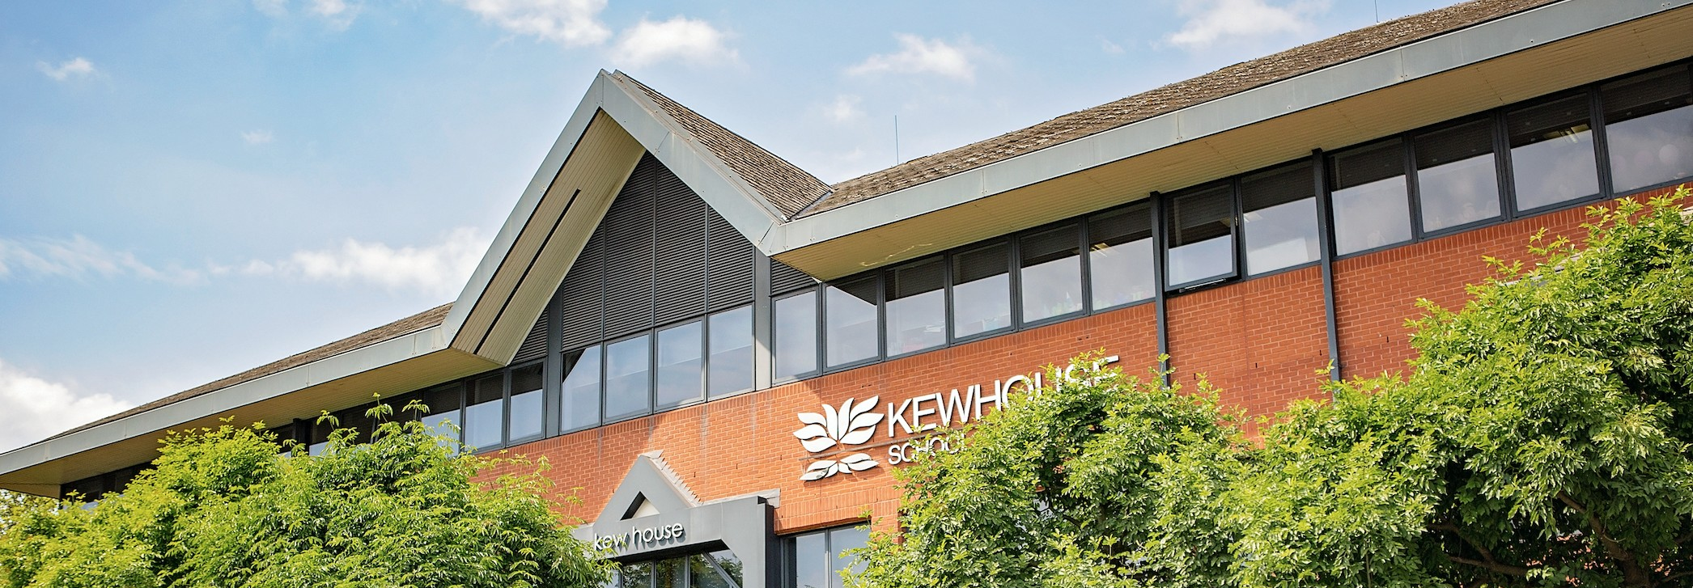


Learning Support Assistant
Location: Kew House School
Job Type: Full-time, Part-time – Term Time only
Salary: TBD
Start Date: September 2025
Reports to: SENCO

Job Description:

We are seeking a flexible and dedicated Learning Support Assistant to provide in-class support for students with additional needs. The role involves helping students access the curriculum and succeed academically and socially, with a particular focus on supporting those with dyslexia, autism, and ADHD.

Would suit a graduate with an interest in pursuing a career in teaching.

Key Responsibilities:
- Provide targeted support to Year 10 students within the classroom setting, under the guidance of the class teacher and SENCO.
- Adapt and differentiate resources to support students with learning difficulties, particularly those with dyslexia, autism, or ADHD.
- Assist students in staying focused, completing tasks, and building independence.
- Encourage positive social interaction and emotional regulation among students.
- Support the implementation of individual support plans, including Education, Health and Care Plans (EHCPs).
- Maintain a flexible approach to support students across different subjects as needed.
- Record observations and provide feedback to teaching staff and SENCO on student progress and engagement.
- Promote a positive, inclusive, and respectful learning environment.
- Attend relevant training and staff development sessions as required.

Essential Requirements:
- Experience working with secondary-age students or in an educational setting.
- Patience, empathy, and excellent communication skills.
- Ability to work effectively as part of a team and independently.
- Flexibility to respond to changing needs and priorities throughout the school day.

Desirable:
- Knowledge or experience of supporting young people with dyslexia, autism, and ADHD.
- Understanding of safeguarding and child protection procedures.
- Relevant qualification in Supporting Teaching & Learning

If you are passionate about education and want to make a meaningful impact, we would love to hear from you!

