Teacher of Maths
Start date: 01 September 2019

Closing date: Friday 22 March 2019 at midday

This school is committed to safeguarding and promoting the welfare of children and young people and expects all staff and volunteers to share this commitment. We will carry out a Disclosure Check by the Criminal Records Bureau before making an appointment.

Headteacher: Kerry Oakley
The Warwick School,
Noke Drive, Redhill, Surrey, RH1 4AD
Tel: 01737 378444 (HR)
Fax: 01737 770007

Website: www.warwick.surrey.sch.uk

Teacher of Maths in Mainstream and Alternative Provision
TMS/UPS + London Fringe Allowance

This is an exciting opportunity for a skilled, enthusiastic and ambitious teacher to join our dynamic and committed Faculty of Maths. The successful candidate will work within this supportive environment to contribute to the success of our students and the development of the curriculum area up to Key stage 4. This post offers an opportunity to work with a range of young people including those at Route 4, which is an Alternative Provision in place to support young people who cannot access mainstream.
The Warwick School is a vibrant 11 to 16 school, serving the Redhill area; judged by Ofsted to be ’Good’ with Outstanding Behaviour and Safeguarding. We have excellent transport links being equally located between London and Brighton; Redhill mainline station is 5 minutes’ walk away and we are close to the M25/M23 motorways.
The school is a member of the South East Surrey Schools Education Trust which is a partnership of The Ashcombe, Therfield and The Warwick Schools; each being successful, inclusive schools committed to work in collaboration for the benefit of their distinctive communities and those children and young people whom they serve. The school offers outstanding continuing professional development for its staff and the Trust will offer a range of opportunities for the right candidate to develop their practice and demonstrate their potential for promotion.
The Warwick School is committed to safeguarding and promoting the welfare of children and young people and expects all staff and volunteers to share this commitment. We will ensure that all our recruitment and selection practices reflect this commitment. All successful candidates will be subject to Disclosure and Barring checks along with other relevant employment checks.

Visits to the school are welcome – please contact the HR officer 01737 378444 or visit the school website www.warwick.surrey.sch.uk for further details.

Therfield School, The Ashcombe School and The Warwick School have formed, and are part of, South East Surrey Schools Educational Trust (SESSET), a charitable company limited by guarantee and registered in England and Wales with company number 10479401. The registered address is The Ashcombe School, Ashcombe Road, Dorking Surrey, RH4 1LY

General Information for Applicants

The School
The Warwick School is a vibrant 11-16 school serving the Redhill area, judged Good with Outstanding Behaviour and Safety in its Ofsted inspection of February 2013. The school works in closely with the Ashcombe School, Dorking and Therfield School, Leatherhead; our partners in the South East Surrey Educations Trust

Currently we have approximately 900 students on roll. Some 98% of our student’s progress to Further Education or Training, in particular to Reigate College and East Surrey College in Redhill, with which we have very close links. We are proud of our school’s strong links with the local community and employers which assist us in fully serving the needs of all the young people who live in the Redhill area.

Continuing Professional Development lies at the heart of our people first values in relation to staff, and we are proud that many colleagues have been promoted as a consequence.

Location
The School is situated at the end of a quiet cul-de-sac on a green site within 4 minutes’ walk of Redhill town centre and rail and bus stations. The M25 and M23 are only a few minutes’ drive away and rail links to London, the South Coast and Gatwick Airport are excellent.

Accommodation
Our current facilities are very good and our buildings are well maintained; although we look forward to our new £13.5 million rebuild scheduled for completion by 2021. Each sector has its own dedicated suite of rooms and an office. The ICT network provides fast, school-wide access to the internet via broadband and a ratio of 1 computer to 3 students. All students and staff have their own e-mail address and area on the network accessible from home. All teachers are provided with a laptop and most departments have their own cluster of computers (desktops or laptops) and interactive whiteboards. We also have bookable ICT rooms for whole class teaching and a cluster of computers in the library. Our duty of care extends to a robust CCTV system that constantly monitors our site.

Our school grounds include playing fields, a floodlit all-weather sports pitch, tennis/netball courts and an ecology area. In keeping with Surrey County Council policy, the School is a no smoking site.

Our students
The Warwick serves the main towns of Redhill, Merstham and Reigate and the surrounding villages as well as students who choose to travel from further afield. Close relationships with our main feeder primary schools are well established. We are a truly comprehensive school in terms of ability, social, additional and educational needs, as well as our religious and cultural mix.

The student voice is a key feature in the life of our school and we encourage our students to take responsibilities in school. Representatives are elected to vigorous Year and School Councils, which meet each half term to discuss issues based on a student-initiated agenda. Prefects, Head Boy and Head Girl are appointed towards the end of Year 10 to offer service to the School including supervision duties and mentoring Year 7 students. The student body runs its own Community Action team, which liaises with the local community and arranges events to benefit local, national and international Charities in association with our student run Rotary Interact Club. Other students help to maintain our ICT facilities, our library and serve as Captains to various subject departments and Clubs.

Curriculum and Organisation
At KS3 all students study the National Curriculum. Students are grouped for learning in most subjects.

At KS4 students study a core consisting of English Language, English Literature, Mathematics, Science, ICT, PE and Philosophy and Ethics. They are encouraged to take an English Baccalaureate subject as at least one of their four option choices. Our close relationships with local colleges enable us to offer a range of vocational qualifications. In addition, we run a small near to site programme for students for whom the traditional school or college route is not appropriate.

All subjects are expected to differentiate learning to meet the needs of the whole ability range and to provide extension activities for the gifted and talented. Additionally, the Learning Support Faculty provides excellent in-class support for students with a range of additional educational needs. Teachers are provided with detailed information on prior attainment, target grades, gifted and talented students, the Pupil Premium, Maths as an Additional Language and SEN requirements. We are rigorous in applying our Assessment for Learning policy to ensure that all students make progress, which is at least in line with expectation.

Students’ welfare and educational progress are supervised by Form Tutors who each have a mixed ability group of about 28 students. Tutors and the Head of Year remain with the students as they progress through the school. We have a dedicated Support Centre to support the development of identified and selected students.

Route 4
Is an Alternative Learning Provision that was first established in 2007. It runs from a separate unit which is situated in Bletchingly. It caters for students at KS4 who are unable to access their education in a mainstream setting. Inititally this was used solely for Warwick students but local schools do also access it when required. Students study a limited set of GCSE options and spend part of their week in work experience, preparing them for courses post 16. Route 4 is very successful with students who may have many complex emotional / behavioural needs. Its small setting supports and nutures these young people and gives them a chance of meeting their potential, which they may not otherwise have the opportunity of.

Extra-Curricular Activities
We offer an extensive range of extra-curricular activities, including sports teams, drama productions, concerts, foreign exchanges, overseas trips, Duke of Edinburgh Awards Scheme and public speaking. Any teacher wishing to offer a new activity will be well supported.

The Staff
The School working environment is stimulating and very busy but we do try to ensure there is opportunity for staff to meet together regularly; we hold briefings three times a week and a weekly top up teaching session to share ideas. Teams meet after school on a scheduled basis. There are opportunities for staff to be part of trips, Duke of Edinburgh expeditions, form quiz teams, join the yoga class and socialise as well. We are also members of the Schools Advisory Service (SAS) who offer a range of free services to staff to support their well-being, including physiotherapy, lifestyle screening and counselling. www.schooladvice.co.uk

We seek to appoint hard working and self-motivated people, who strive for excellence and who are personable and flexible. In short, we want people who are passionate about improving life chances of our students ‘Every Lesson; Every Day’

Successful applicants for posts at The Warwick School will join a friendly, cohesive and supportive team, dedicated to providing a quality education for the young people in our care.

The Warwick Partnership
Our School Direct programme is where we recruit trainees directly so that you can gain a PGCE. We work with a number of other local schools as well as University of Brighton and University of Sussex.

Safeguarding Statement
This school is committed to safeguarding and promoting the welfare of children and young people and expects all staff and volunteers to share this commitment. We will carry out a Disclosure Check by the Criminal Records Bureau before making an appointment.

Department Information

The Warwick has a stable and successful Maths department, consisting of 9 teaching staff (all subject specialists), an HLTA and a T.A. Excellent stability of staff within the department has enabled us to create a strong and vibrant team, well able to meet the challenges of changes at both KS3 and KS4. Experience within our friendly department is wide-ranging, and we have worked hard to foster a supportive and collegiate atmosphere. The department prides itself on delivering a stimulating and wide-ranging course, from which all students can benefit.

The department is housed in eight subject-specific rooms, with a communal office and stock cupboard. All classrooms have interactive whiteboards. Staff are encouraged to share resources and best practice. We work closely with our Librarian and Learning Resource Centre, as well as arranging a variety of extra-curricular activities, from theatre visits to creative writing workshops; from local democracy events to public speaking.

Route 4 is based at:

Bletchingley Skills Centre
Stychens Lane
Bletchingley
Surrey RH14LL
Telephone: 01883 818008

Students attend part time and study Maths, English, Citizenship, ICT and PE. They are also involved in regularly work experience. The aim is to develop a curriculum and an environment where these young people can achieve more from their educational experience. The maximum capacity for Route 4 is 16 in each year group. The centre is led by an experienced your worker and she is supported by Higher Level Teaching Assistants / Teaching Assistants who have specifically trained or shown a passion for working with students with complex needs.

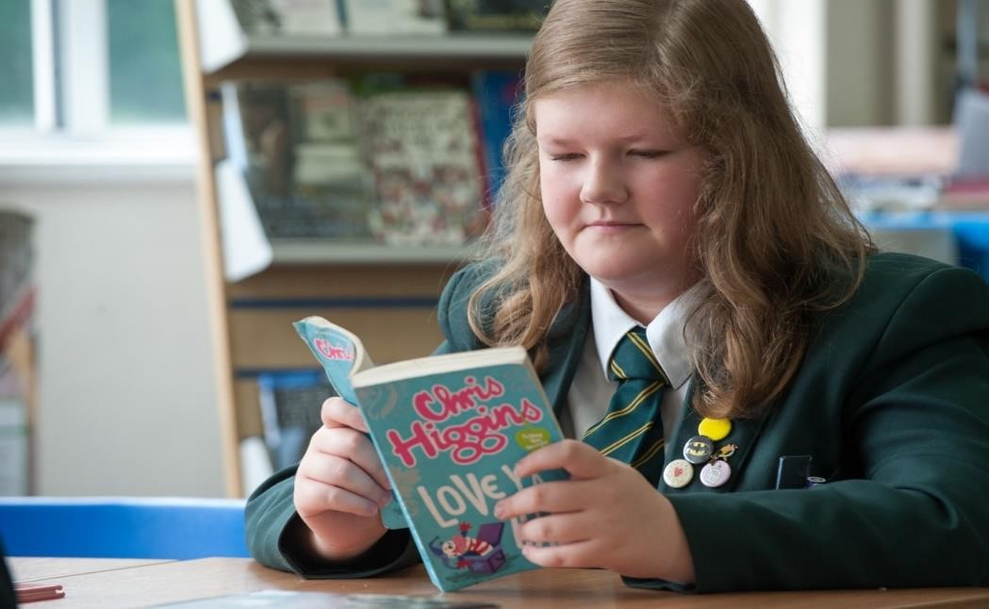

Job Profile

POST TITLE Subject Teacher
LINE MANAGER Head of Maths Faculty
SUPERVISORY RESPONSIBILITY Responsible for directing the work of teaching assistants within the classroom.
JOB PURPOSE To teach pupils within the main school and Route 4. To carry out
such other associated duties as are reasonably assigned by the head teacher.

KEY ACCOUNTABILITIES
These accountabilities are based on the professional responsibilities of teachers outlined in the School Teachers’ Pay and Conditions Document (STPCD). They are supplemented as relevant by reference to the DfE Teachers’ Standards (2012).

1. Teaching

PROFESSIONAL RESPONSIBILITIES
- To plan and teach lessons and sequences of lessons to the classes you are assigned to teach, within the context of the school’s plans, curriculum and schemes of work.
- To assess, monitor, record and report on the learning needs, progress and achievements of assigned pupils.
- To participate in arrangements for preparing pupils for external examinations.
Set high expectations which inspire, motivate and challenge pupils:
- establish a safe and stimulating environment for pupils, rooted in mutual respect
- set goals that stretch and challenge pupils of all backgrounds, abilities and dispositions
- demonstrate consistently the positive attitudes, values and behaviour which are expected of pupils.
Promote good progress and outcomes by pupils:
- be accountable for pupils’ attainment, progress and outcomes
- be aware of pupils’ capabilities and their prior knowledge, and plan teaching to build on these
- guide pupils to reflect on the progress they have made and their emerging needs
- demonstrate knowledge and understanding of how pupils learn and how this impacts on teaching • encourage pupils to take a responsible and conscientious attitude to their own work and study.
Demonstrate good subject and curriculum knowledge:
- have a secure knowledge of the relevant subject(s) and curriculum areas, foster and maintain pupils’ interest in the subject, and address misunderstandings
- demonstrate a critical understanding of developments in the subject and curriculum areas, and
- promote the value of scholarship
- demonstrate an understanding of and take responsibility for promoting high standards of literacy, articulacy and the correct use of standard Maths, whatever the teacher’s specialist subject
- if teaching early reading, demonstrate a clear understanding of systematic synthetic phonics
- if teaching early mathematics, demonstrate a clear understanding of appropriate teaching strategies.

Plan and teach well structured lessons:
- impart knowledge and develop understanding through effective use of lesson time
- promote a love of learning and children’s intellectual curiosity
- set homework and plan other out-of-class activities to consolidate and extend the knowledge and understanding pupils have acquired
- reflect systematically on the effectiveness of lessons and approaches to teaching
- contribute to the design and provision of an engaging curriculum within the relevant subject area(s).
Adapt teaching to respond to the strengths and needs of all pupils:
- know when and how to differentiate appropriately, using approaches which enable pupils to be taught effectively
- have a secure understanding of how a range of factors can inhibit pupils’ ability to learn, and how best to overcome these
- demonstrate an awareness of the physical, social and intellectual development of children, and know how to adapt teaching to support pupils’ education at different stages of development
- have a clear understanding of the needs of all pupils, including those with special educational needs; those of high ability; those with English as an additional language; those with disabilities; and be able to use and evaluate distinctive teaching approaches to engage and support them.
Make accurate and productive use of assessment:
- know and understand how to assess the relevant subject and curriculum areas, including statutory assessment requirements
- make use of formative and summative assessment to secure pupils’ progress
- use relevant data to monitor progress, set targets, and plan subsequent lessons
- give pupils regular feedback, both orally and through accurate marking, and encourage pupils to respond to the feedback.

2. Whole school organisation, strategy and development

PROFESSIONAL RESPONSIBILITIES
- To contribute to the development, implementation and evaluation of the school’s policies, practices and procedures in such a way as to support the school’s values and vision.
- To work with others on curriculum and/or pupil development to secure co-ordinated outcomes.
- To supervise and, so far as practical, teach any pupils where the person timetabled to take the class is not available to do so, subject to the provision that teachers are required to cover only rarely.
Fulfil wider professional responsibilities:
- make a positive contribution to the wider life and ethos of the school

3. Health, safety and discipline

PROFESSIONAL RESPONSIBILITIES
- To promote the safety and well-being of pupils.
- To maintain good order and discipline among pupils.

Manage behaviour effectively to ensure a good and safe learning environment
- have clear rules and routines for behaviour in classrooms, and take responsibility for promoting good and courteous behaviour both in classrooms and around the school, in accordance with the school’s behaviour policy
- have high expectations of behaviour, and establish a framework for discipline with a range of strategies, using praise, sanctions and rewards consistently and fairly
- manage classes effectively, using approaches which are appropriate to pupils’ needs in order to involve and motivate them
- maintain good relationships with pupils, exercise appropriate authority, and act decisively when necessary.

4. Management of staff and resources

PROFESSIONAL RESPONSIBILITIES
- To direct and supervise support staff assigned to you and, where appropriate, other teachers, in an effective way.
- To contribute to the recruitment, selection, appointment and professional development of other teachers and support staff.
- To deploy resources delegated to you.
Fulfil wider professional responsibilities
- deploy support staff effectively

5. Professional development

PROFESSIONAL RESPONSIBILITIES
- To participate in arrangements for the appraisal and review of your performance and, where appropriate, that of other teachers and support staff.
- To participate in arrangements for your further training and professional development and, where appropriate, that of other teachers and support staff, including induction.

Fulfil wider professional responsibilities
• take responsibility for improving teaching through appropriate professional development, responding to advice and feedback from colleagues.

- Communication

PROFESSIONAL RESPONSIBILITIES
  - To communicate with pupils, parents and carers.
Fulfil wider professional responsibilities
  - communicate effectively with parents with regard to pupils’ achievements and well-being.

- Working with colleagues and other relevant professionals

PROFESSIONAL RESPONSIBILITIES
• To collaborate and work with colleagues and other relevant professionals within and beyond the school.

Fulfil wider professional responsibilities
• develop effective professional relationships with colleagues, knowing how and when to draw on advice and specialist support.

Person Specification: Subject Teacher

 | Selection Criteria | Assessment Method
Qualifications | Essential:  - Qualified Teacher Status  - Evidence of further professional development  Desirable:  - Post Graduate Qualification | Application form  Certificates
Experience | Essential:  - Successful teaching and curriculum experience  - Recent experience of teaching within KS3 and KS4 | Written statement  Lesson observation  Interview
Professional  Knowledge and  Understanding | Essential:  - Sound understanding of Maths curriculum  - Knowledge of best practice and procedures for safeguarding children and young people  - Other key areas for the school/phase, early years, extended services etc. | Written statement  Lesson observation  Interview
Professional Qualities | Essential:  - Committed to the development and maintenance of good relationships with staff, parents, students, governors and the community.  - Committed to the continuing professional development of self and others within the school.  - Demonstrates flexibility appropriate to circumstances  - Communicates enthusiasm and energy. | Interview  Group exercise  Presentation
Skills and Aptitudes | Essential:  - Able to plan and organise effectively  - Well developed oral and written communication skills  - Communicates at a level and in a manner appropriate to the situation | Application form  Written statement  Interview  In-tray exercise  Group exercise

How to Apply

We hope that you would like to apply; please complete our application form for teaching posts on the vacancy page and send it to us with a supporting statement explaining what attracts you to the post and details the skills and experience you would bring to it.

Your completed application can be emailed to Karen Ehren HR Officer: ehr@warwick.surrey.sch.uk

or post to:
Mrs Karen Ehren
HR Officer
The Warwick School
Noke Drive
Redhill
Surrey
RH1 4AD

If you would like any further information please telephone Karen Ehren on 01737 378444 or email ehr@warwick.surrey.sch.uk

The deadline for receipt of completed applications is Friday 22 March 2019 at midday.

