Presdales School

Science Technician
Term time, plus 2 weeks
37 hours per week
Salary H4, 17,531-18,603 + fringe allowance

We are seeking a dynamic individual to provide technical and administrative support to teaching staff and to ensure the safe and proper use and maintenance of resources and equipment within the Chemistry department.

The successful candidate must be a team player who is passionate about the role practical work plays in Science education. They will need to be well-organised and flexible. Experience within a school setting and practical Science experience at A level standard in any Science is ideal, but training will also be available for a suitable candidate. You must also be willing to support teachers within the classroom environment by supporting students when time permits.

This is a permanent position, term-time plus 2 weeks, consisting of 37 hours per week, 8.30am-4.30pm (Monday-Thursday) and 8.30am-4.00pm (Friday) or 8.00am-4.00pm (Monday-Thursday) and 8.00am-3.30pm (Friday). Flexibility may be required at busy times of the year.

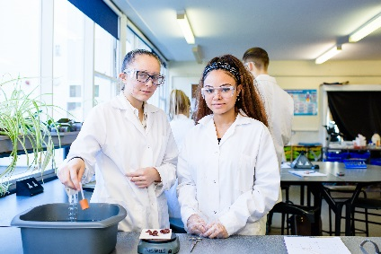
Presdales is an outstanding all-girls 11-18 school, with boys in the sixth form. We are a school which values all students, irrespective of their age and ability and helps them to exceed expectations through high quality teaching and learning and the opportunity to take part in a wide variety of activities which will enrich their educational and personal development beyond the classroom.

We provide a caring environment where all students are supported, as well as challenged, to ensure that there is no limit to their potential. We prepare our students for a world that is constantly changing by encouraging them to be independent learners who are determined, confident and who never give up. Alongside academic excellence there is a strong focus on enjoyment, excellent behaviour and respect for all.

The school is committed to safeguarding and promoting the welfare of young people and expect staff to share this commitment. Applicants must be willing to undergo an Enhanced DBS disclosure and approved references will be required for the post

Closing date for applications: 9.00 am Monday 12th April 2020

Please submit:

- A letter of application
- A completed application form (available on the school website)

You can post your application to the school, or send by email to recruitment@presdales.herts.sch.uk
Please note that CVs will not be accepted

