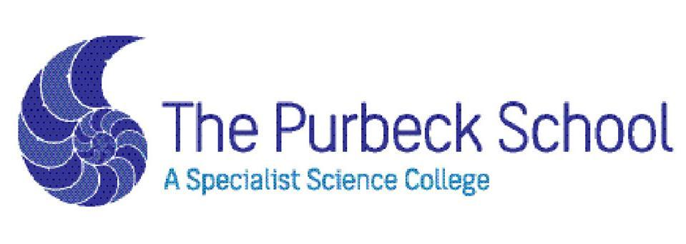

TEACHER OF SCIENCE (BIOLOGY SPECIALISM)
PART TIME 0.6 FTE FIXED TERM CONTRACT TO COVER MATERNITY LEAVE
FROM SEPTEMBER 2019 OR EARLIER START IF POSSIBLE

We are looking for an enthusiastic and passionate Biology teacher who wishes to work within a successful, supportive faculty keen to implement innovative teaching ideas to further the success of Science across the school. This job would suit either an NQT or a more experienced teacher. The Purbeck School is currently thriving in the top 20% of schools nationally for Progress 8 and has recently had a very successful OFSTED.

This is a fantastic time to join the Science faculty at the Purbeck School. The faculty consistently posts excellent results at both GCSE and A level. Science, and particularly Chemistry and Biology are our most popular subjects at A-Level with multiple classes in both year 12 and 13. Science is taught through a dynamic mastery based curriculum, rigorously preparing students by developing the science skills and knowledge necessary for success at GCSE from year 7.

We are looking for a teacher who wants to work in a strong team, within a caring and compassionate school, in a beautiful area of the country. We would welcome visits from any prospective candidates.

Please visit our school website for more information and an application form.
Closing date: Noon Tuesday 23rd April, 2019

The Purbeck School values the diversity of our workforce and welcomes applications from all members of the community. We are committed to safeguarding and promoting the welfare of children and young people and this is a commitment we expect all staff and volunteers to share. The successful candidate will be required to have a Disclosure and Barring Service check in line with the Government safer recruitment guidelines.

Further details and application forms are available via the school website

Website: www.purbeck.dorset.sch.uk

Email: spenney@purbeck.dorset.sch.uk Telephone: 01929 550077

