Dear Candidate,

Thank you for your interest in a position at Northwood School.

Northwood is a high performing school and in recent years we’ve secured genuinely impressive academic outcomes for our students. This has been recognised by Ofsted in our two most recent reports. Most recently our achievements have been recognised by The Real Schools Guide who have rated us as a 5* school for the exceptional progress our students make. In summer 2016, 76% of students gained GCSEs A*-C in English and maths.

Northwood is a happy, vibrant school with a caring ethos. As a relatively small secondary school, we are uniquely placed to work with and develop our staff. We treat our students as individuals ensuring that they feel safe and happy, that they achieve well and are well-prepared to lead a fulfilling adult life. The key to our success as a school are the excellent partnerships we establish with our staff, students and parents.

In October 2016 we moved into our new £35 million building which means that Northwood School now provides the most up to date, state-of the-art teaching and learning environment, not just in Hillingdon, but beyond.

I hope that you will consider applying for a position with us. If you would like to visit us, please contact my PA, Mrs Swan on 01923 836363 to arrange an appointment.

Yours faithfully,

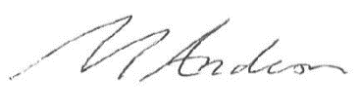

Mark Anderson
Headteacher

