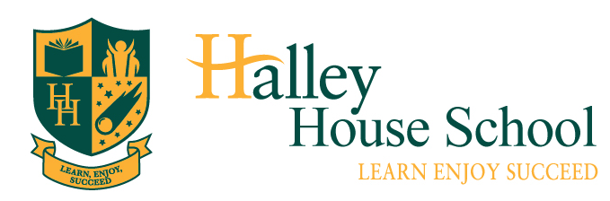
Role | Teaching Assistant | Closing Date: | 26th June 2019
Location | Dalston, Hackney | Interview Date: | w/c 1st July 2019
Salary | Scale 2-4, scp 11-21 (£20,616 – £24,082 FTE) | Job Start: | 1st September 2019

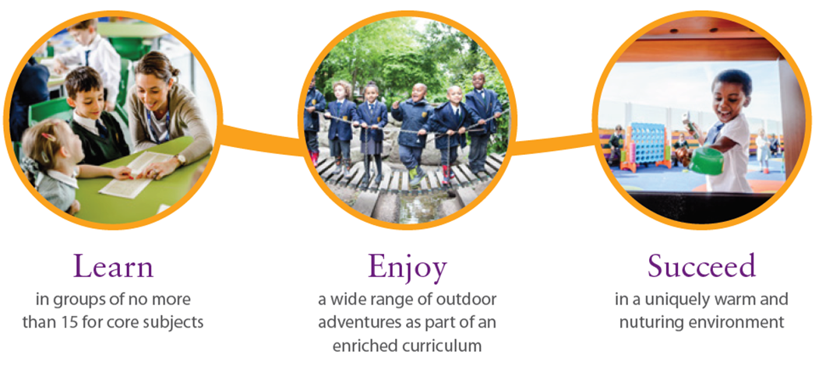
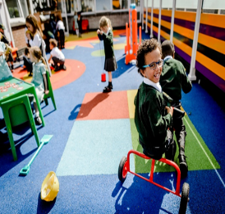
in groups of no more
than 15 for core subjects

in a uniquely warm and nurturing environment
a wide range of outdoor adventures as part of an enriched curriculum

We are looking for an enthusiastic and committed teaching assistant to join our growing team, provisionally in a Year 1 class.
Our school:
Halley House School is a one-form entry Free School that opened in Arcola Street, Dalston in September 2015. The school is one of seven free schools established by Bellevue Place Education Trust. We believe in having rightfully high expectations and standards for every pupil, and by working actively in partnership with our children, staff, parents and local community, we will support and guide our pupils to reach their full potential academically, socially and emotionally. Halley House is a school that enables its pupils to take confidence from, and enjoyment in, everything they do, and places them at the heart of a vibrant, thriving school community.
Why not visit us and see for yourself?

Our candidate:
You have experience and passion for working in primary schools. You are able to deliver inspirational learning experiences in a stimulating environment and are committed to excellence, inclusion and challenge. You enjoy supporting children using creative and innovative approaches to teaching and learning and respond to the individual strengths and needs of the children in your care. You display relentless enthusiasm for striving for the very best. You are excited and motivated by the rewards and challenges working in a growing school affords and welcome the opportunity to really make your mark!

Our offer:
As well as an attractive starting salary, we offer excellent, wide-ranging and bespoke professional development and training opportunities. This position would be ideal for someone looking to build on their early career experiences. We are committed to supporting and developing both our staff and children, and have created a warm and welcoming environment.

Role | Teaching Assistant | Closing Date: | 26th June 2019
Location | Dalston, Hackney | Interview Date: | Week beginning 1st July 2019
Salary | Scale 2-4, scp 11-21 (£20,616 – £24,082 FTE) | Job Start: | 1st September 2019
How to apply:
Visits to the school are warmly encouraged. Please contact the school office to arrange a tour and visit with the Headteacher, Claire Syms.

For more information please take a look at the school website.

If you have the skills and drive to be successful in this role, please download the attached documents and submit the application form to us at office@halleyhouseschool.org.uk

The school is committed to safeguarding and promoting the welfare of children and expects all staff and volunteers to share this commitment. All appointments are subject to satisfactory references, pre-employment and DBS checks. Halley House School welcomes a diverse population of both children and staff and is committed to promoting and developing equality of opportunity in all its functions.
Thank you for your interest in our school!

