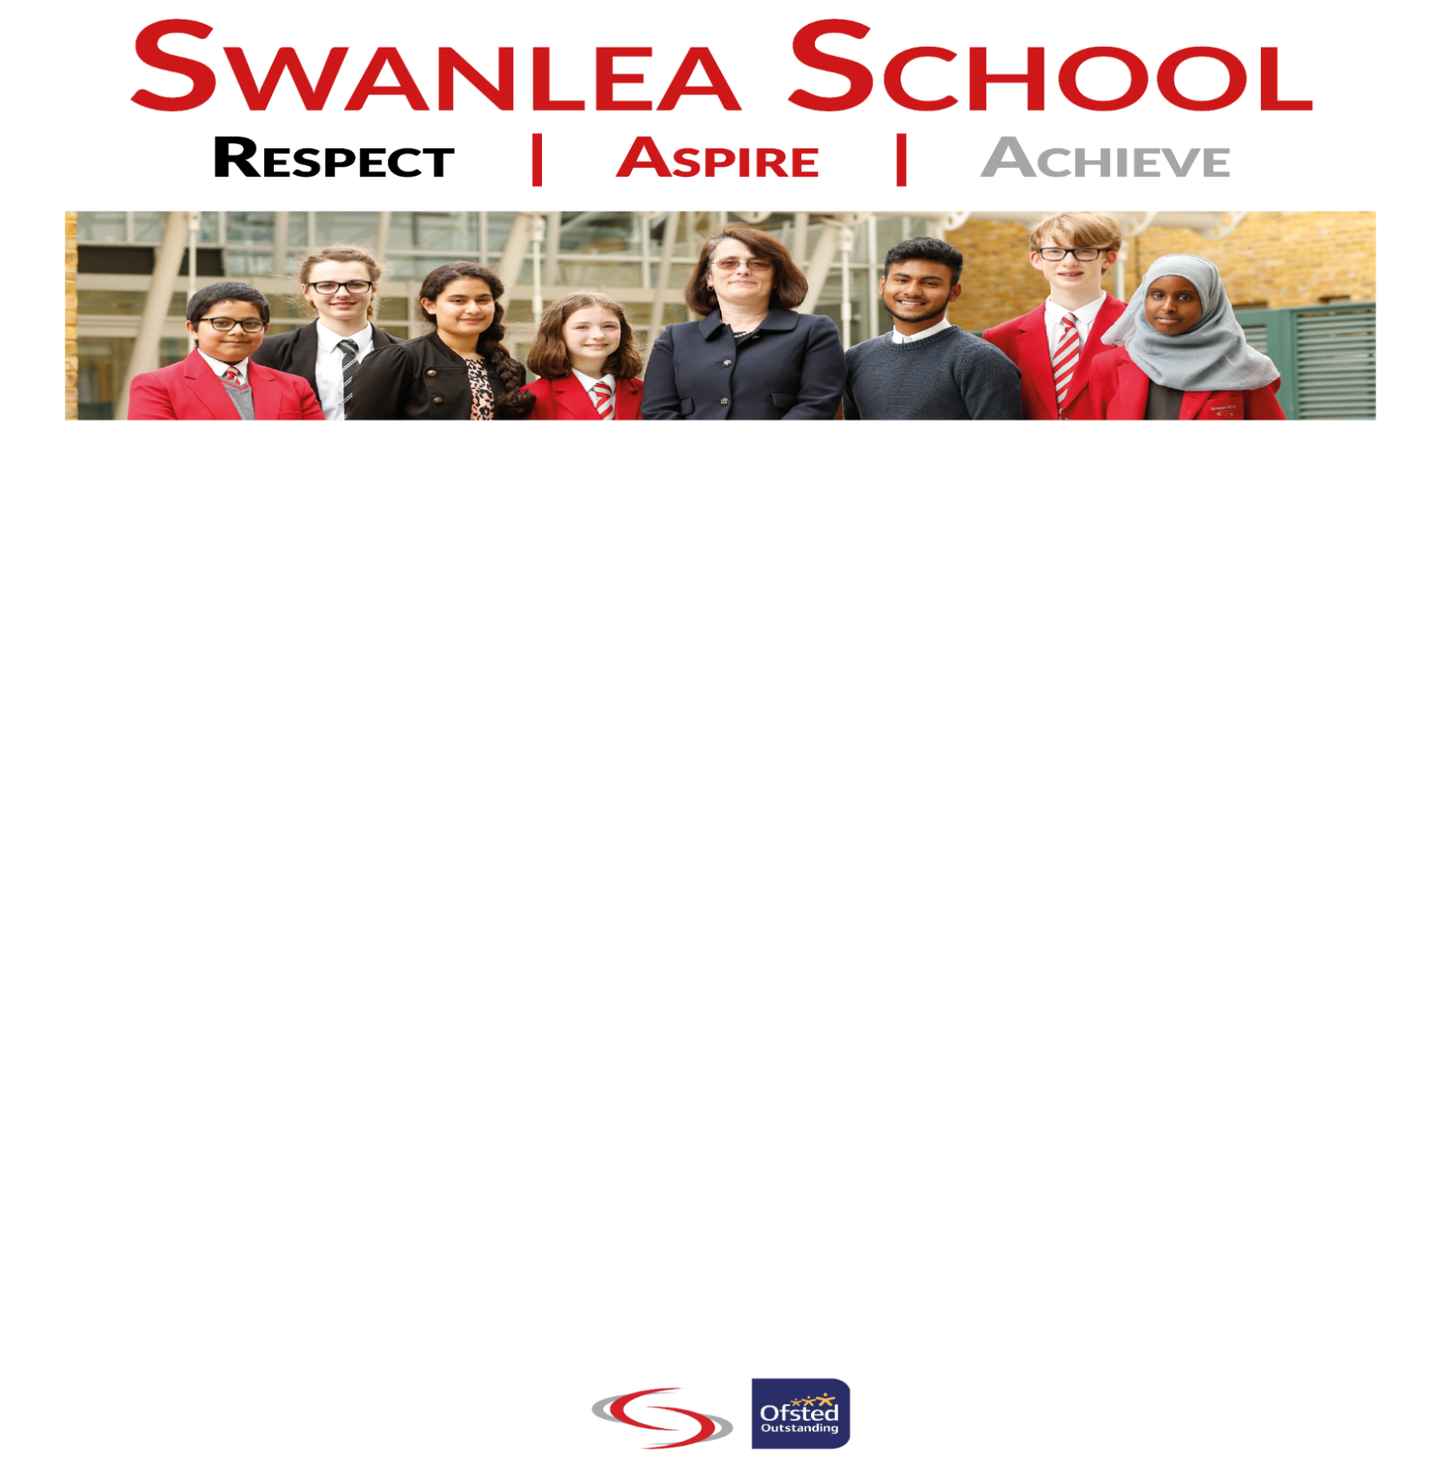

School Business Manager
Start Date: January 2024
Salary: Scale LP08 (£67,770 - £71,058), rising to LP09 (£75,375 - £84,024) as more
responsibilities are taken over. 2023 pay award still pending.
Contract Type/Term: Full Time/Permanent (4 days per week may be negotiable)
Four or five days per week, all year round working with 32 paid days’ holiday plus bank holidays (pro-rata), rising to an extra 5 paid days’ holiday after completion of 5 years’ local government service. 0.8FTE may be possible (4 days per week).
Salary: LP08 (£67,770-£71,058), rising to LP09 (£75,375-£88,024) as more responsibilities are taken over. (Payment award for 2023 still pending). For 0.8 FTE, salary is pro-rata. Terms are negotiable for a candidate with exceptional experience.
A unique opportunity for a School Business Manager
We are an OFSTED outstanding school with a culture of high expectations based on our Swanlea Values. In Tower Hamlets, we are the top performing mixed school for progress at KS4, for all students’ progress at KS5 and have the best attendance and punctuality. Most of our students’ progress on to top universities including Oxford and Cambridge. Despite our successes, we are not complacent, and we believe that we have the capacity to further improve.
Swanlea students are proud of their school, and we have extremely supportive parents/carers and governors. We are highly committed to the development of all colleagues as evident in our comprehensive CPD programme.
Swanlea School is in one of the most deprived areas in the UK; 45% of our students are Pupil Premium. Our students may come from disadvantaged backgrounds, but they do not lack ambition for their futures, and neither do we as reflected in our no excuses culture. Our highly motivated and hard-working staff are driven by the moral imperative that our young people can achieve highly. We welcome students from all backgrounds. The school is inspired by the diversity and strength of its community, an inclusive approach to learning, excellence in education and varied, innovative approaches to teaching and learning.

We are an over-subscribed school that has around 1300 children from Year 7 through to Year 13. We are entering the next phase of our development and will become a federation from January 2024 incorporating two local feeder primaries into our school family. There is now an opportunity to evaluate our development, reflect on our progress and practice and make any necessary adjustments as we move into the future as a complete school federation community.

We are looking for:
- A proven track record of excellence in school business management and leadership.
- A candidate who sees the vision and values of the school as a good fit for their professional work.
- Applicants who want to work as part of a collaborative team, building an exceptional school.
- An individual looking for a challenge and professional growth.
- Someone who enjoys working hard and shows great resilience in a busy school environment
- Someone open to new ideas and initiatives.
- A highly professional, positive person who will strive for excellence and work to a high standard securing the best possible outcomes for the children and for the school.
In return we can offer the following:
- Working with a forward thinking, driven and experienced leadership team
- A competitive salary with inner London weighting and pension scheme;
- A vibrant, warm and engaged community of children, parents, staff and governors.
- The opportunity to work in a creative and thoughtful environment with a strong and committed team.
- Great CPD and work/life balance
- Working with a forward thinking, driven and experienced leadership team
- A central location within a vibrant, diverse London Borough, with excellent transport links;
- Outstanding facilities and resources to support teaching and learning;
- Supportive & collegiate staff;
- A highly regarded middle & emergent leadership programme;
- A friendly and diverse student and staff community;
- Discount scheme that offers savings on purchases, including grocery, eating out, entertainment, etc;
- Season ticket loan scheme;
- Cycle to work scheme;
- Free eye tests and discounted eye-care scheme;
- Subsidised staff restaurant offering breakfast, break and lunch time hot and cold food.
- Access to confidential emotional and practical advice support services.

Application deadline: 12 noon, 25th September 2023
Interviews: Wednesday 4th October 2023
Application pack available at www.swanlea.co.uk/working-at-swanlea
References will be taken up before interview.
For more information contact Naviya Azmin: recruitment@swanlea.co.uk
Swanlea School is committed to safer recruitment and the protection of children and vulnerable adults. All positions will require a satisfactory DBS & Social Media check. We are committed to promoting equality and challenging discrimination. We welcome applicants from all sections of the community. You can find our safeguarding policy on our school website https://swanlea.co.uk/ .

