# cid:image022.jpg@01CFD347.D2E5AD80

 EXPLORE OUR WORLD

**Purchase Ledger Clerk**

**Required April/May 2019**

**Permanent, Full-time**

**INFORMATION FOR CANDIDATES**

**A Catholic Independent Day School for Girls 2-18 and Boys 2-5**



**The School**

Set in 26 acres of beautiful parkland in Cobham, Notre Dame School nestles in a picturesque 18th century mansion beside the River Mole. Notre Dame is a Catholic School and is a Foundation of the Company of Mary Our Lady with an ethos shaped by the life and work of St Jeanne de Lestonnac. Despite the tranquil setting Notre Dame School is a hive of activity, with over 600 children and teachers working hard in the important business of education. The school has an enviable reputation for the highest academic standards and a progressive, holistic, academic education that is underpinned by over 400 years of international educational tradition in 30 countries. Established in England in 1937, the school has always had the philosophy that the greatest success comes from knowing how to learn and how to ask the right questions; training pupils to take an active role in reaching and exceeding early expectations. From the vibrant Nursery to the exciting Sixth Form, tomorrow's professionals acquire the skills, knowledge and qualifications that give them the best possible start in life. This summer, our A Level students have gained the highest percentage of A* - B grades (84%) in over ten years and girls are going on to study at prestigious Russell Group universities in a wide range of disciplines. At GCSE over half the awarded were A and A*. Twin aims of academic success and ability to strive for social justice in the world create rounded, compassionate, highly qualified and wise young women. Past pupils proliferate the professional sphere, many of whom enthusiastically retain links to Notre Dame.

The school is filled with a strong sense of purpose, offering a wide-ranging and active education with facilities encompassing new Science laboratories, music and drama studios, sports fields, indoor swimming pool, dedicated Sixth Form Centre, a forest school for the youngest pupils, and a fully equipped, West End quality theatre seating over 350. The school has completed its all-weather facilities to complement the existing outdoor and indoor netball and sports facilities. The girls participate in choirs, sports teams, orchestras, language groups, outreach work, craft clubs, swimming squads and debating societies. The school councils for the different age groups and the peer mentoring and 'big sister' system provide pastoral care in a place that values the individual and always stretches a hand to help others, leading to charity initiatives as well as a happy and fulfilled community.

Leadership is prized and all are encouraged to fully engage in the life of the school. In recent years educational research has shown that this type of all-round education adds limitless value to the lives and experiences of our young people, as well as enhancing academic success and personal confidence, so it is a delight to find a world-class school on the doorstep that has promoted this so strongly and so successfully for over three quarters of a century.

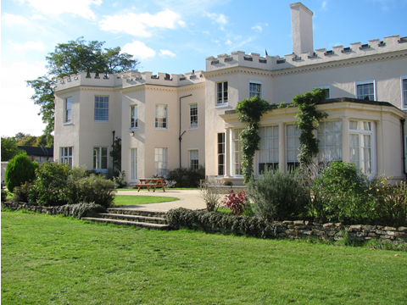

# J:\Buildings\Chapel\stjeanne windows.jpg

**Heritage and ethos**

The School has a long heritage in matters spiritual and philosophical. Notre Dame, Cobham is a Catholic School, but with an ecumenical attitude to those of other faiths. It was established in 1937 by the Sisters of the Order of the Company of Mary Our Lady. The Company of Mary was founded in France in the 17th century by St Jeanne de Lestonnac and has over 300 educational establishments throughout the world. The Sisters of the Company of Mary continue to play a very important role in the pastoral life of the school ensuring that the ethos is maintained. Our values are rooted in our heritage, however, as an inclusive, outward-looking School; we are committed to encouraging a questioning spirit of mutual tolerance and informed dialogue based on openness, reciprocal respect and trust. We welcome girls of all faiths and none.

**The Finance Department**

The Finance Department is responsible for the complete, accurate and timely recording and reporting of all financial transactions for Notre Dame School and to manage financial relationships both within, and outside, the School.

The Finance Team is made up of one full time Sales Ledger and Fees Clerk and one Purchase Ledger Clerk both of whom report to the Finance Manager.

 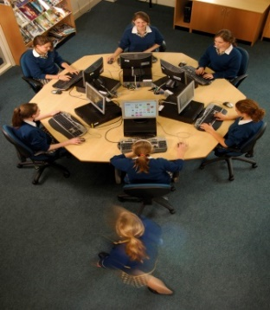

**The Role**

**Function of the Post**

* The Purchase Ledger Clerk will work within the School’s financial procedures to provide an accurate, efficient and timely financial service to support procurement of all goods and serviced purchased by the staff and school to support effective teaching and learning to students.

**Line manager:** Finance Manager

**Areas of Responsibility include but are not limited to:**

* Accurate processing of all purchasing transactions for the School from the initial order to payment
* Follow the School’s financial procedures to keep accurate records of the Schools’ finances.
* Support the Finance Manager to ensure the School financial procedures are robust and followed at all times.
* Prepare regular reports and provide support to staff and budget holders on the School’s financial procedures.
* Process purchase orders accurately and efficiently, matching delivery notes and invoices.
* Responsible for maintaining the Supplier database, including adding new suppliers and maintaining existing supplier details ensuring they are up to date and verify all changes of addresses and bank details.
* Entering all Invoices received by the School onto the financial system accurately and efficiently and post to the correct nominal codes.
* Liaise with Budget Holders for invoice authorisation and settlement.
* Ensure that financial procedures with regard to authorisation and payment of invoices are adhered to.
* Liaise with suppliers to reconcile supplier statements and investigate and resolve queries, quickly and accurately.
* Prepare the School’s payment runs by BACS, ensuring credit terms are maximised and the occasional cheque for authorisation by the Finance Manager and Executive Team.
* Ensure all invoices are scanned and electronically filed correctly.
* Maintain accurate records for all school trips including allocating all payments made to the correct activity code.
* Process Procurement Card transactions and reconcile the monthly statements ensuring each transaction is supported by a purchase order authorised in accordance with the School’s purchasing regulations and process a journal to the correct budget cost codes
* Support other members of the Finance Team as required (e.g. holiday and sickness cover)
* Filing and maintenance of all folders and files relevant to the Purchase Ledger.
* In conjunction with the other members of the Finance Team, assist in maintaining the financial system.
* Deal with day to day enquiries, referring to Finance Manager where necessary
* Open and distribute all post for the Finance office
* Providing financial information when required to staff, governors and auditors.

**Other duties may include:**

Carry out any other duties commensurate to the post as required by the Finance Manager or Executive Team.

*As job descriptions cannot be exhaustive, the post-holder may be required to undertake other duties which are broadly in line with above key responsibilities.*

**General Expectations**

* + Set a good example to pupils they work with, in their appearance and their personal conduct.
  + Consider carefully issues of confidentiality when dealing with school matters.
  + Have high expectations of pupils’ behaviour, academic and social abilities.
  + Encourage all pupils to be part of a school community which affords equal value to all its members, is seen to be just and encourages mutual respect, concern for other and truthfulness.

**Health and Safety**

* All employees have a legal duty to ensure the safety of him/herself and all the pupils and staff within the school as detailed in the Health and Safety at Work Act 1974.

**Data Protection**

* All employees should familiarise themselves with and follow the Data Protection guidelines and practices.

**Safeguarding**

* The school is committed to safeguarding and promoting the welfare of children and young people and expects all staff and volunteers to share this commitment.

**The Person**

**Education/Qualities/Skills**

Essential

* Good standard of education (with a minimum of good GCSE levels or equivalent in English and maths)

Desirable

* Educated up to ‘A’ Level or equivalent
* A qualification in bookkeeping or AAT Foundation level are desirable.

**Experience**

Essential

* Experience of working in a similar financial role
* Experience of working with Financial systems

Desirable

* Experience of working in a school or the education sector
* Experience of working with SAGE

**Skills and Abilities**

Essential

* Good IT skills and confident in the use of Microsoft Office software including Word and Excel and Outlook
* Ability to communicate effectively in person, on the telephone and by email
* Be able to explain financial procedures clearly to non-financial people
* Strong attention to detail and produce work with a high level of accuracy
* Good organisational and workload management skills specifically with the ability to prioritise own work and reprioritise when necessary
* Able to work in an office environment that often demands high levels of concentration, while coping with frequent interruptions
* Integrity and understanding of care needed with sensitive information
* Able to manage high volume workload
* Able to analyse information
* Good problem solving ability
* An understanding of the importance of confidentiality
* Work as part of a team to resolve problems quickly and to support key functions
* Be enthusiastic and motivated to develop new skills while providing help and assistance to all areas of the school
* Knowledge of relevant legislation (e.g. Data Protection)

**Personal Characteristics**

Essential

* Ability to work independently with limited supervision
* Patience and flexibility
* A good sense of humour
* Commitment to the provision of a quality service
* Commitment to continuous professional development of yourself and others
* Ability to relate well to all types of stakeholders for example students, suppliers, staff, contractors and governors
* A commitment to positive and healthy outcomes for young people
* A demonstrable commitment to the safeguarding of students and child protection
* A demonstrable commitment to equal opportunities.

**Benefits of Service**

**Contract:** Permanent, Full-time

Salary: Notre Dame NJC25 to NJC31

£25,068 - £30,612 per annum (dependent on skills and experience)

**Hours of work:** 37.5 hours per week with 30 minutes unpaid lunchbreak

**Benefits**

* The School has high expectations of its staff, and therefore looks to reward them with a competitive salary scale and beneficial conditions of service
* 25 days paid annual leave
* Contributory Pension Scheme
* There is ample opportunity to take on additional responsibility

**Personal**

* The School enjoys a fantastic location: central London is 30 minutes away, the M25 and A3 are 5 minutes away. Heathrow is less than half an hour.
* Fee concessions are available for the pupils of any member of staff who meet the school’s entry requirements
* Longer holidays than the state maintained sector
* Free on-site parking
* School Nurse on site during term-time

**For Recreation**

* Free use of the school’s leisure and sporting facilities, including a heated indoor pool
* Free lunch and refreshments are available throughout the working day

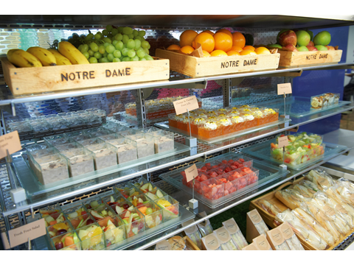

**Selection Process**

Please complete the online application form available on our career site on eTeach:

[notredame.careers.eteach.com](http://www.notredame.careers.eteach.com/)

# Applications to:

Human Resources Department

Notre Dame School

Burwood House

Convent Lane

Cobham

Surrey KT11 1HA

Email: [HR@notredame.co.uk](mailto:HR@notredame.co.uk)

Any questions, please contact HR on 01932 589092.

**Closing Date: 9am on Tuesday 23 April 2019**

**Interviews: Tuesday 30th April 2019**

All applicants will receive an email to confirm receipt of the application form. Applications will be reviewed on a rolling basis.

Shortlisted candidates will be interviewed by senior members of the School, undertake a practical test and take a tour of the school.

The School is committed to safeguarding and promoting the welfare of children and young people and expects all staff and volunteers to share this commitment. Applicantsmust be willing to undergo child protection screening appropriate to the post, including checkswith past employers and the Disclosure and Barring Service.

As an organisation using the Disclosure and Barring Service (DBS) to assess applicants’ ability for positions of trust, Notre Dame School complies fully with the DBS code of practice and undertakes to treat all applicants for positions fairly. It does not discriminate unfairly against any subject of a Disclosure on the basis of conviction or other information revealed.

The School is an equal opportunities employer and is fully committed to a policy of treating all its employees and job applicants equally and does not discriminate on the grounds of race, sex or marital status.



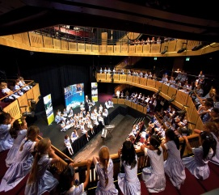

**NOTRE DAME SCHOOL**

**BURWOOD HOUSE**

**CONVENT LANE**

**COBHAM**

**SURREY**

**KT11 1HA**