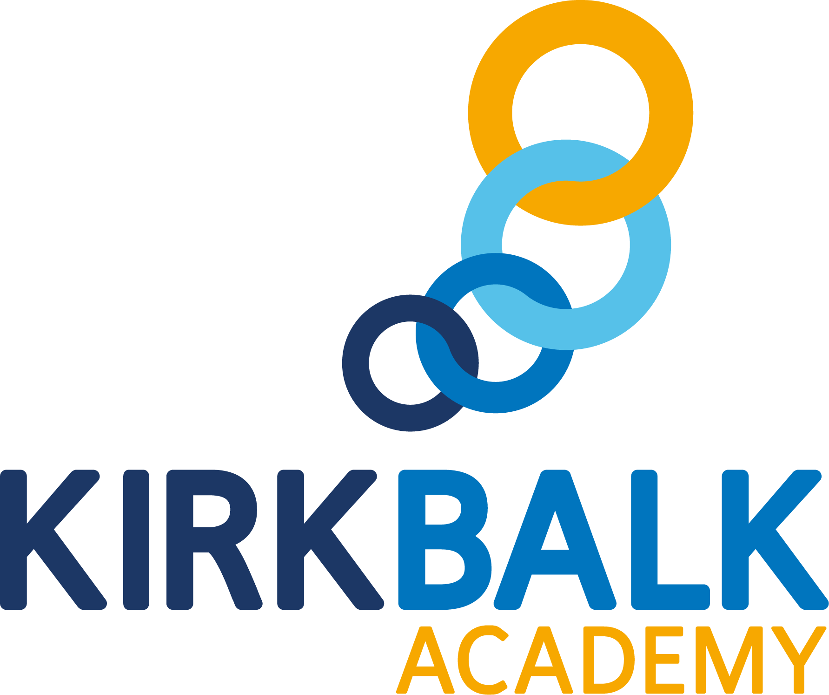

Outcomes Focused, Child Centred

Cover Supervisor
SCP 14-19
(Starting point negotiable for an exceptional candidate)

Contents

Welcome from the Chief Executive | 03
Welcome from the Principal | 04
Introduction to Kirk Balk Academy | 05
Northern Education Trust | 07
Staff and Students | 08
Enrichment | 09
The Application Process | 10
Where to Find Us | 11
Job Advert | 12
Job Description | 13
Person Specification | 15

Welcome from the Chief Executive

On behalf of the Northern Education Trust Board, welcome to the Northern Education Trust.

We are unswerving in our commitment to ensure that the outcomes our young people secure prepare them fully for life beyond school. Our Academies are happy and thriving communities where children both achieve and feel safe and cared for. As an inclusive Trust, we strive to help young people overcome any barrier to learning.

We are a caring employer and invest heavily in professional development, allowing our staff opportunities to take the next steps in their career. We hope you find our website holds all the information you need to believe that whether you are a parent or prospective employee, your next steps should be taken with us.

Welcome from the Principal

I would like to offer a warm welcome and thank you for your interest in the Cover Supervisor position at Northern Education Trust, Kirk Balk Academy.

Our wonderful academy has a strong reputation for high standards of academic achievement as well as high quality pastoral care and commitment to learning in the widest sense. People very quickly understand that we ‘live and breathe’ our vision of being ‘Outcomes Focused, Child Centred’ and this is something of which we are most proud.

I have served here as Principal for a few years now, having been Vice Principal beforehand. Every day, I find work at Kirk Balk exciting, challenging and hugely rewarding. I am delighted that every member of staff here is committed to providing the best opportunities and experiences to enable students to flourish, achieve their full academic potential and develop as confident individuals.

Over recent years, our outcomes have transformed and this has been particularly evident in English and Maths, where we now boast outstanding results that are amongst the best nationally. For example, in 2019, 84% of students achieved a Grade 4 or higher in English, with 71% achieving a Grade 5 or higher. 79% of students achieved a Grade 4 or higher in Maths, with 62% achieving a Grade 5 or higher. In addition, the English Element of Progress 8 was calculated as +0.38 and the Maths Progress 8 was calculated at +0.44.
For the successful candidate, our school will offer a fantastic chance to work with a collaborative and passionate staffing body and senior leadership team. We work hard to foster our collaborative ethos and reward our staff with good career opportunities, a clear focus on ensuring ‘teachers can teach’, numerous benefits, and ultimately the satisfaction of supporting schools like ours in their quest to give every child the opportunity to succeed and reach their full potential.
The best way to get a real flavour of our school is to visit our website at www.kba.northerneducationtrust.org and to visit us in person to talk to the staff and students - we very much welcome and encourage visitors to the school.
After reading the supporting job description and information pack, I hope you will pursue an application for this wonderful and rewarding role.
Please send your completed application to kirkbalkhr@northerneducationtrust.org. The closing date for receipt of application is midday, Friday 21st February 2020; interviews are then scheduled to take place during at some time the following week.
Applicants are encouraged to apply promptly, as we may call candidates for interview at any time and close the advert early.

Dean Buckley
December 2019

Introduction to Kirk Balk Academy

Residing approximately six miles south of Barnsley, Kirk Balk Academy serves the communities of Hoyland, Hoyland Common, Elsecar, Platts Common, Blacker Hill, Jump, Birdwell, Pilley and Tankersley; all of which were traditional mining villages before pit closures. These closures, along with other factors, caused community aspirations to suffer although these are now beginning to rise and we are proud of the part we are playing in regenerating the area.

The Key Stage 2 APS (Average Points Score) for every year groups in line with the national average although this is decreasing each year as the academy grows in population. That said, we are brazenly ambitious for our students and believe determinedly that they are as capable as any other students; anywhere.

We are resolute in our conviction that our curriculum is helping redress the inequality that once existed; to give the young people of Hoyland a better deal and a better chance to break the legacy circles of underachievement and low aspirations in the town to transform the life chances of every young person we serve.

Kirk Balk has good rail and road links, and is within easy reach of Sheffield, Huddersfield, Leeds, and Wakefield, located minutes from J36 of the M1 motorway. There are beautiful country areas and parks within a short distance, the Peak District and other parts of Yorkshire are easily reached. Kirk Balk is proud of our tradition of encouraging young people to succeed not only in the classroom, (where examination results have steadily improved over the last decade), but also in other spheres including Sport and the Arts.

Nine years ago, Barnsley initiated a re-organisation of its secondary stock, with some schools merging and all becoming new builds. Kirk Balk has stayed within its locality and simply moved into a new building in April 2011. The building took the staff, head teacher, local officers and architects over three years to plan, and a further 20 months to complete.

With every room and facility purpose built, Kirk Balk is a great environment in which to teach and work. Over £30 million has been invested in making a bright building that gives the local community every chance for success. The spaces in the building provide opportunities to teach in rooms that are larger than the average classroom, with Interactive Whiteboards providing scope for multi-user kinaesthetic learning at a touch.

There are several specialist areas in the building including a four-court sports hall, a super lab, ICT suites, 2 drama studios, a lecture theatre, a construction centre, an industrial engineering room, a catering kitchen and spaces to allow students to study independently.

Our intent is to make all lessons outstanding.

Teachers plan and prepare effectively and make lessons as engaging as possible using the very best practice. Our departments work collegiately with subject directors and colleagues across the trust to ensure the best ideas and practices are consistently applied in all lessons.
Our entire pedagogical approach is based upon collaborative learning as we truly believe in the power of working collaboratively to promote the inclusion and progress of all.
We have developed a wide range of well-understood ‘Collaborative Learning Structures’, underpinned by some key structures that we believe enable our lessons to be consistently effective, engaging and exciting. Students react positively to the consistency of the learning structures and embrace the collaborative approach to learning.

We believe a teachers’ time outside of the classroom should be focused on planning exciting and effective lessons. We also believe students respond best to feedback that is immediate and meaningful. Therefore, at Kirk Balk Academy, staff do not mark students’ books outside of lessons. Apart from formal assessments, all marking is live during a lesson and students’ respond immediately.

There is a strong culture of praise and celebration at Kirk Balk Academy. Students are regularly applauded for contributing to lessons and each member of the senior leadership team makes six calls home a week to praise students. Student praise is further enhanced by our 'Proud Thursday' initiative, by which students nominate work of which they are especially proud. Teachers encourage students to recognise and value their own success by using live feedback and PROUD stickers to celebrate achievement and therefore building students’ self-esteem. This work is publicly rewarded by members of SLT on a weekly basis and participating students receive certificates celebrating their effort.

We understand that personal development is important to our dedicated team. Therefore, time is dedicated to staff development on a weekly basis through L&P. A detailed calendar is shared with staff and includes topics requested by teachers and department leaders. We also understand that staff development should be personalised and reflect the career stage and experiences of staff. Therefore, different staff development packages, routes and support strategies are in place to meet the different needs of our teaching team. Time to work together as a team is also important. Therefore, time is provided for departments to work together on issues relevant to their subject area.

At Kirk Balk Academy, we believe appraisal should be developmental. Therefore, there are no numerical targets or formal lesson observations. Instead, teachers are invited to select a personal development goal and have opportunities to discuss their practice with colleagues in a supportive and reflective environment. This removes unnecessary stress and time consuming administrative tasks from teaching staff.

Northern Education Trust offers a range of staff benefits to employees. For example, the Tusker car scheme is available to all staff as is a range of health benefits such as free flu vaccinations.

Staff views are also important to us and we are keen to listen to staff opinions. For example, two extra holiday days per year was voted for by staff through disaggregating INSET. Staff also voted for where the extended holiday should take place.

We are proud of our talented staff and believe they should be given opportunities to flourish within the academy. We provide leadership opportunities through the DEEPs system every year. All staff, including NQTs and support staff, are welcome to apply for a range of leadership roles allowing staff to grow as leaders and develop projects they are passionate about.

Northern Education Trust

Our Vision

We constantly focus on standards as we understand outcomes are paramount. Our decision making is driven entirely by what is best for children. By doing this we enhance the life chances of the children and young people in our care.

The 10 values which underpin our vision:

- We care passionately about the education and welfare of young people

- We believe that all young people, irrespective of background or ability will be successful in our Trust

- We are not and will never be selective. We believe that local schools are for all children

- We are always inclusive. Our mechanisms to support the most vulnerable child to succeed and overcome barriers to learning are a key aspect of our work

- Our approach to education recognises that outcomes are paramount and also allows children to gain experiences and values which prepare them fully for life in modern Britain. This includes workplace skills and appropriate advice for future progression

- We have high expectations of behaviour

- We adopt the local authority admissions protocol and work closely with them

- We would always wish to act in such a way that has a positive effect on a neighbouring school or community. We care passionately about children in all schools, not just our own

- That all employees act with integrity and embrace the value that ‘we are the Trust’

- We work regionally and nationally to develop approaches to MAT improvement that influence the wider school-led system

Staff and Students

The leadership of Northern Education Trust Kirk Balk Academy is undertaken by the Principal, Mr Dean Buckley who is supported by Mr Richard Whitfield (Vice Principal), Mr Martin Davies (Vice Principal), three Assistant Principals (Mr Same Moore, Mrs Hayley Craddock, Mr Jordan Gates) and three Associate Assistant Principals (Miss Jade Halliday, Mr James Dransfield and Mrs Laura Allen). These colleagues, alongside the Business Manager – Mrs Erica Jackson, complete the Senior Leadership Team.

The staffing structure and curriculum are constantly being reviewed but departments are primarily suited in faculties, with TLR holders supporting the Heads of Department. Currently, non-teaching ‘Learning Managers’ leaders help support the well-being and pastoral development of all students.

We believe teachers’ work best when they are focused on the progress of their students and not on dealing with distractions. Therefore, we have a no office rule during the academy day for all senior leaders to ensure they are on hand to support teaching staff. Senior leaders, alongside support staff, visit lessons to support behaviour management (with a particular focus on praise), live marking and assist teaching. In addition, our detailed and well managed behaviour policy supports teachers in establishing an excellent climate for learning.

Senior leaders are also on duty every morning, break, lunch and after school. This enables the academy to reduce staff duties to a minimal again free staff to focus on teaching and learning.

There are currently 1249 students on roll. The admission number for each year group is 270. The clear majority of our students live in the local villages, come from a wide range of backgrounds and cover the full range of ability – a truly comprehensive intake. The students are well behaved and attendance is very good.

In addition to being ‘’Outcomes Focused, as an academy we are also ‘child centred’. As such we have a vibrant Student Voice programme which ensures that all students are represented in decisions which affect their education.
Dedicated Student Voice teams are chosen to represent different areas of school life, these include; Teaching and Learning, Safeguarding and Hospitality. Students apply to represent their chosen area and meet regularly with a dedicated staff facilitator. Student Voice representatives regularly present to the Senior Leadership Team and have played an important role in developing school policies on rewards and praise, as well as representing the academy with distinction at social events and academy events.

Enrichment

Our intent is to deliver a student learning experience which is appropriately challenging and meets the needs of individual students. We are proud of our wider enrichment offer, open to all students, which allow students to access a range of activities designed to broaden horizons and to equip our students with the confidence to face the future.

We offer students across all year groups the opportunity to develop their knowledge, skills and interests through an extensive provision of extended learning and diverse enrichment. A multitude of subject specific and special interest enrichment groups are held during after school enrichment time. These range from Sporting and Drama Clubs to Coding, Creative Writing and STEM club. These also include a raft of bespoke enrichment subject sessions available to students in Year 10 and Year 11.

We offer intensive intervention for identified students to ensure all individual needs are met. Students to join the school in Year 7 who are not at age related expectation for reading are afforded additional reading based library lessons in which they are provided with weekly one-to-one reading opportunities, with their progress being measured through both the testing of reading age as well as through the number and range of books they have read.

Identified students in Year 10 and Year 11 are also afforded a range of intensive interventions, including access to one-to-one Maths and English tutor sessions. These interventions support progress in the core subjects as well as supporting progress across the curriculum by helping students to access topics and develop understanding in all subjects.

We recognise that our staff are committed to supporting the life chances of young people through raising outcomes and dedicate time after school to run enrichment opportunities. We wish to celebrate and reward their commitment. Each term, departments who have ran enrichment programmes for students, are provided money and time to take part in a team building activity of their choice. Staff have enjoyed a range of activities such as: escape room experiences, sport events, meals out, theatre trips and staff quizzes.

The Application Process

All details, including the Application Form, Job Description and Person Specification can be found on our academy website: kba.northerneducationtrust.org

We would expect that all prospective candidates spend some time reviewing our website where a vast array of further information about our college exists. However, should you require any additional information about this post or would like an informal discussion/visit, please contact Michelle Pedler, PA to the Principal, on telephone number 01226 742286 or email kirkbalkhr@northerneducationtrust.org.

Informal visits are welcome before the closing date – please see the specific job advertisement for further details. For further information and an application pack for the post, please contact Michelle Pedler as above.

To apply, please email your completed application and recruitment monitoring form to kirkbalkhr@northerneducationtrust.org or send in the post for the attention of Michelle Pedler, Principal’s PA.

All applications that have been submitted electronically will receive an email from the recruitment team confirming receipt. A letter will be sent to shortlisted candidates with details of the interview process.

If you have not heard from us within 2 weeks of the closing date, please assume your application has been unsuccessful.

Kirk Balk is committed to safeguarding and promoting the welfare of children and young people and expects all staff and volunteers to share this commitment. This position is, therefore, subject to a satisfactory enhanced Disclosure and Barring Service application. We are an Equal Opportunities employer with excellent CPD provision.

If you have any queries on any aspect of the application process, or need additional information, please contact Michelle Pedler (PA to the Principal) on 01226 742286 or by e-mailing kirkbalkhr@northerneducationtrust.org

Where to Find Us
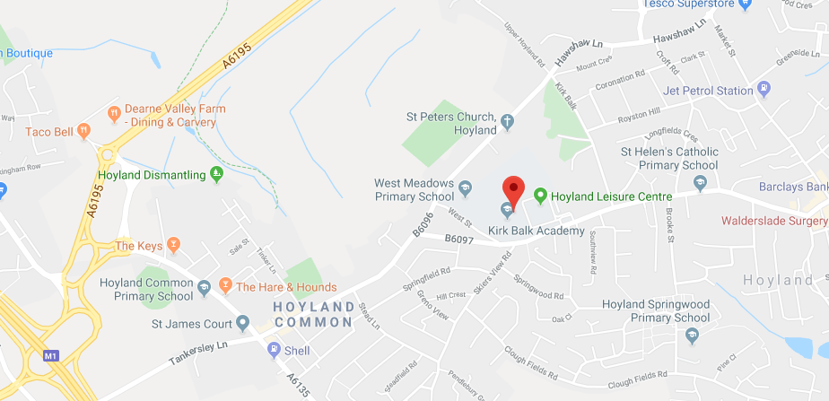

Directions to Kirk Balk Academy

From Junction 36 of the M1 motorway, at the initial roundabout follow signs to Barnsley. At the second roundabout take the turning towards Hoyland [A6135]. You will pass a Jet petrol station on the left and a Primary School on your right. After the pedestrian crossing, turn left at the traffic lights. You will pass the Co-op supermarket on the left. Continue until there is a right-hand turn as the road bends to the left. Take this turn that is again signposted to Hoyland. You are now on West Street. As you approach the College, there is the Hoyland Leisure Centre and a bus stop shelter on the left. Turn left into the car park that we share with the Leisure Centre and then sharp left up the drive to the College and into a further car parking area.

Contact Details

Kirk Balk Academy
West Street
Hoyland
S74 9HX

Phone: 01226 742 286

Email: kirkbalk.enquiries@northerneducationtrust.org

Web: https://kba.northerneducationtrust.org

Cover Supervisor

SCP 14-19
(Starting point negotiable for an exceptional candidate)

An exciting opportunity for an efficient and organised person to join us as a Cover Supervisor has arisen. The key responsibilities include supporting the smooth operation of the academy through delivering planned lessons across a range of subjects.

Responsibilities include delivering lessons based on pre-prepared work to full class groups, managing the classroom environment to promote good behaviour for learning, and liaising with teaching colleagues on their return to promote good continuity for students.

Adaptability, resilience and the ability to think on your feet are essential in this varied and evolving role, as is an ability to communicate effectively with a wide range of people. Strong ICT skills and a good command of English and Maths are necessities.

We welcome applications from people who hold qualified teacher status or are interested in pursuing this. The opportunity to join our sought-after and highly regarded, tailored CPD package is included as part of the role. You will benefit from working alongside a talented staff team and very capable senior leadership team.

We reserve the right to call candidates to interview prior to application deadline, or withdraw this vacancy at any time ahead of the closing date if there is a good level of response. Therefore, we recommend you submit your application as early as possible.

Closing date: Noon Friday 21st February 2020
Appointments can be booked by contacting 01226 742286 or email kirkbalkhr@northerneducationtrust.org Our comprehensive recruitment pack can also be requested by using these details.

To apply, please email your completed application and recruitment monitoring form to kirkbalkhr@northerneducationtrust.org or send in the post for the attention of Michelle Pedler, Principal’s PA.

Northern Education Trust is committed to safeguarding and promoting the welfare of children and expects all staff to share that commitment. The appointment is subject to an enhanced DBS check and references.

Job Description

Northern Education Trust – Job Description

Job Title: | Cover Supervisor
Base: | Academy
Reports to: | Attendance Manager / Cover Manager | Grade: | SCP 14 -19
Service responsibility: |  | Salary: | £22,462 - £24,799  (FTE)
Additional: |  | Term: | 32.5 hours per week,  39 weeks per year (actual salary to be pro-rata in line with hours / weeks worked)

JOB PURPOSE
➢➢ To work under the guidance of teaching staff and within an agreed system of supervision, to implement work programs with individuals/groups in or out of the classroom, managing student behaviour and supervising whole classes during the short term absence of teachers.

RESPONSIBILITIES:
- Supervising the pupils on work left in accordance with the Academy policy
- Assisting in preparing the learning environment and the materials used therein
- Assisting with the management of student behaviour to ensure a constructive working environment and promote positive behaviour
- Responding to pupils about the work that has been set
- Collecting any work completed after the lesson and returning it to an agreed person/place
- Leaving the room in good order at the end of the lesson
- Supervising entry and departure of pupils in accordance with Academy policy
- Recording and reporting attendance at lessons in accordance with Academy policy
- Assisting in exam invigilation under the supervision of the examinations officer
- Reporting back as appropriate using the Academy’s agreed referral procedures on the behaviour of pupils during the class and any other issue arising
- Dealing with any immediate problems or emergencies according to the Academy’s policies and procedures
- Following Academy policies and procedures especially those relating to Child Protection and health; safety, security, confidentiality and data protection, reporting all concerns to an appropriate person
- Respecting confidential issues linked to home/pupils/teacher/Academy work and to keep confidences as appropriate
- Escort and supervise pupils on educational visits and out of Academy activities 15. Use ICT effectively to support pupils learning
- Develop and promote positive relationships with pupils, acting as a role model and setting high expectations
- Promote the inclusion and acceptance of all pupils within the classroom
- Support pupils consistently whilst recognising and responding to their individual needs
- Encourage pupils to interact and work co-operatively with others and engage all pupils in activities
- Promote independence and employ strategies to recognise and reward achievement of self-reliance
- Provide feedback to pupils in relation to progress and achievement
- Be responsible for keeping and updating records as agreed with the teacher, contributing to reviews of systems/ records as requested
- Contribute to the overall ethos/work/aims of the Academy
- Establish constructive relationships and communicate with other agencies/professionals, in liaison with the teacher, to support achievement and progress of the pupils
- Attend and participate in meetings as required
- Participate in training and other learning activities and performance development as required
- Recognise own strengths and areas of expertise and use these to advise and support others
- Provide appropriate guidance and supervision and assist in the training and development of staff as appropriate
- Show a duty of care and take appropriate action to comply with Health & Safety requirements at all time
- Demonstrate and promote commitment to Equal Opportunities and to the
- Elimination of behaviour and practices that could be discriminatory

GENERAL
- To participate in wider Academy meetings and working groups as required.
- All staff of the Northern Education Trust will abide by the one academy rule: ‘All students and adults are expected to behave in a responsible manner both to themselves and others, showing consideration, courtesy and respect for other people at all times’.
NET is committed to safeguarding and promoting the welfare of children and young people. We expect all staff to share this commitment and to undergo appropriate checks, including an enhanced DBS check. Whilst every effort has been made to explain the main duties and responsibilities of the post, each individual task undertaken may not be identified and the post holder may reasonably be expected to undertake other duties commensurate with the level of responsibility that may be allocated from time to time.
Signed: …………………………………… Date: ……………………………….

Person Specification

Post: Cover Supervisor
 |  |  | Assessed by:
No | Categories | Essential / Desirable | App Form | Interview / Task
QUALIFICATIONS
1. | NVQ level 2 or equivalent in a relevant discipline, e.g. Supporting Teaching and Learning OR appropriate experience | E | ✓✓
2. | Willingness to obtain and / or enhance qualifications and training for development in the post | E | ✓✓
3. | NVQ Level 3 or equivalent in a relevant discipline, e.g. Supporting Teaching and Learning OR appropriate experience | D | ✓✓
4. | Training in a particular subject or area, e.g.  Literacy, ICT, Maths, Humanities, Dyslexia, Aspergers | D | ✓✓
5. | First Aid training | D | ✓✓
6. | Child Protection training | D | ✓✓
7. | 5 GCSE’s or equivalent, including English and Maths | E | ✓✓
EXPERIENCE
8. | Experience of working with or caring for children of the relevant age | E | ✓✓ | ✓✓
9. | Experience of school policies relating to Health & Safety, behaviour, attendance, Equal Opportunities, Child Protection. | E | ✓✓ | ✓✓
10. | Experience of supporting teaching staff in the development and education of pupils, including the provision of specialist skills and knowledge. | E | ✓✓ | ✓✓
11. | Experience of behaviour management with children of the relevant age | D | ✓✓ | ✓✓
12. | Be familiar with the full range of school policies | E |  ✓✓ |  ✓✓

 |  |  | Assessed by:
No | Categories | Essential / Desirable | App Form | Interview / Task
ABILITIES, SKILLS AND KNOWLEDGE
12. | Be familiar with the full range of school policies | E | ✓✓ | ✓✓
13. | Have the necessary skills to manage safely classroom activities, the physical learning space and resources | E | ✓✓ | ✓✓
14. | Understand and be able to use a wide range of strategies to deal with classroom behaviour as a whole and individual behavioural needs | E | ✓✓ | ✓✓
15. | Ability to use ICT effectively to support learning | E | ✓✓ | ✓✓
16. | Ability to relate well to children and adults and build and maintain successful relationships | E | ✓✓ | ✓✓
17. | Able to work constructively on your own initiative and as part of a team | E | ✓✓ | ✓✓
18. | Excellent numeracy and literacy skills | E | ✓✓ | ✓✓
19. | Knowledge of First Aid | E | ✓✓ | ✓✓
20. | Able to liaise sensitively and effectively with parents and carers | E | ✓✓ | ✓✓
21. | Working knowledge of national/foundation stage curriculum and other relevant learning programmes/strategies | D | ✓✓ | ✓✓
22. | Ability to use other technology as required. | D | ✓✓ | ✓✓
PERSONAL QUALITIES
23. | Pleasant and friendly manner | E | ✓✓ | ✓✓
24. | Polite and punctual | E | ✓✓ | ✓✓
25. | Reliable | E | ✓✓ | ✓✓
26. | A commitment to working as part of the whole Academy team and supporting the vision and aims of the Academy | E | ✓✓ | ✓✓
27. | Flexibility | E | ✓✓ | ✓✓

NET is committed to safeguarding and promoting the welfare of children and young people. We expect all staff to share this commitment and to undergo appropriate checks, including an enhanced DBS check.
Chief Executive: Mr R Tarn
Northern Education Trust
c/o Thorp Academy
Main Road
Ryton
NE40 3AH

Phone: 0191 406 6383
Email: public.enquiries@northerneducationtrust.org
Web: www.northerneducationtrust.org

