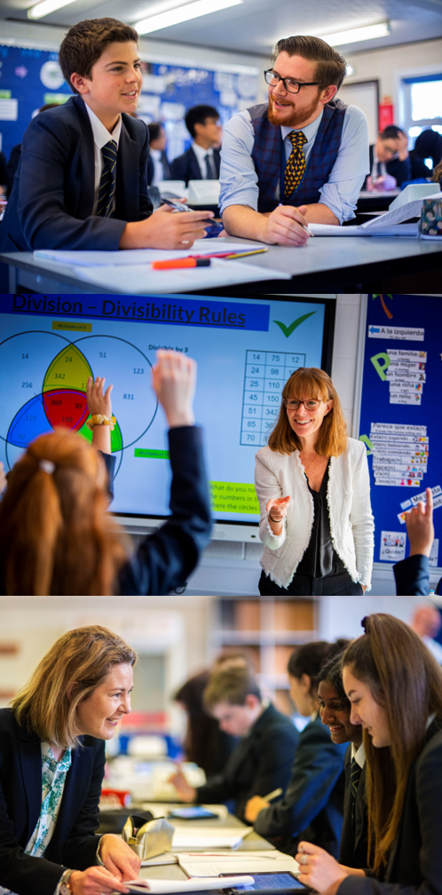

TEACHING ASSISTANT

Starting your Salesian journey
Salesian
Enlightening minds, uplifting hearts


Teaching Assistant

To commence: As Soon As Possible
Salary: £21,269 pro-rated over 39 weeks per year / 36 hours a week
Closing date for applications: Applications will be reviewed on submission
Responsible to: Head of SENCO
Working in partnership with : Head of Centre, Class Teachers,
Leadership Team Higher Level Teaching Assistants, and other
Teaching Assistants

Person Specification
- Basic IT skills
- Able to follow instructions
- Able to plan and prioritise regular and irregular tasks
- Able to clarify and explain instructions to pupils
- Able to communicate effectively with pupils
- Able to motivate pupils to learn
- Able to assist with the organisation of the learning environment
- Able to undertake routine tasks under the direction of a teacher
- Craft skills
- Able to maintain records and pupil files
- Able to work effectively with adult team members
- Maintains Confidentiality inside and outside the workplace
Responsibilities in relation to Mainstream Support
To support teachers with their responsibility for the development and education of children in schools. Uses routine supervision and care skills to support pupils.

To provide Keyworker support to individual pupils, this may be across and extended school day.
To have a flexible and sympathetic approach that takes into consideration the sensory and social communication needs of students with autism.

Under the direction and supervision of the teacher:
- Assists in the delivery of educational work programmes by participating in day-today learning activities
- Discuss with and reports back to the teacher on the planning an assessment of pupil work
- Organises and maintains the learning environment (displays and resources)
- Works as part of a team to ensure that the well being, behaviour and personal development of pupils enhances their learning opportunities and life skills
- Maintains confidentiality inside and outside workplace
- Understands and applies school policies

Responsibilities in relation to Special Needs Support: Level 1
Supports the teacher with their responsibility for the development and education of pupils with special needs.
Uses ASD specific supervision and care skills to support pupils, including those who have physical, emotional or educational needs.
Under the direction and supervision of the teacher:
- Assists in the delivery of individual work programmes for pupils with statements of special educational needs using agreed ASD strategies
- Monitors progress and contributes to future planning
- Works with small groups of pupils as required
- Organises and maintains the learning environment (displays and resources)
- Liaise with parents in keyworker role to support continuity of approach between home and school where possible

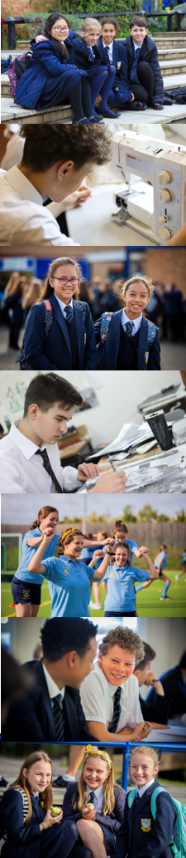
Level 2 post holders should demonstrate the competencies identified for the Level 1 posts listed above, together with additional competencies from the list below:
- Develops and uses specialist skills in, for example, literacy, numeracy or science, to contribute to pupil learning
- Assists with planning, preparation and development of work programmes for individuals and groups of pupils and prepares resources to support learning activities
- Monitors and evaluates pupil progress and reports on this to the class teacher/Head of Learning Support
- Discusses with the teacher/Head of centre and contributes to curriculum and classroom planning
- Works as part of a team to ensure that the wellbeing, social and personal development of pupils enhances learning opportunities and life skills
- Organises and maintains the learning environment and takes responsibility for specific aspects of class organisation and administration
- Works as part of a team to ensure that the wellbeing, behaviour and personal development of the pupil(s) enhances learning opportunities and life skills
- Maintains confidentiality inside and outside the workplace
- Under the guidance of the Head of Centre to plan learning activities to suit pupil ability
- Able to develop specific knowledge and expertise to work with groups of pupils to deliver aspects of the curriculum
- Able to plan and organise learning activities for pupils, in liaison with the Head of Centre
- Able to prepare resources for teaching and learning activities
- Able to contribute to discussion on curriculum delivery and classroom planning
- Able to think through and implement strategies to enhance pupil learning, in liaison with the Head of Learning Support
- Able to plan and organise own work schedule, in liaison with the Head of Centre
- Able to undertake administrative procedures as required by the Head of Centre


Other:
- To undertake any other duties, commensurate with the grade, as reasonably requested by the Headteacher

Supervision Arrangements:
- Yearly formal review of performance with Head of Centre
- Yearly informal review of performance with Head of Centre
- Termly departmental meeting with Head of Learning Support & Head of Centre
- Observation of classroom and individual support work by Head of Centre

Continuing Professional Development:
- To develop SEN and Autism specific knowledge and understanding through the Surrey and NAS CPD programmes. To take responsibility for your broader personal professional development, in conjunction with the line manager, keeping up-to-date with developments related to school efficiency, which may lead to improvements in the day-to-day running of the school


Salesian School is committed to safeguarding and promoting the welfare of children. Enhanced CRB checks will be sought prior to appointment

Appointments at Salesian

Information for Candidates
Thank you for your interest in the positions currently being advertised at Salesian School. I would like to take this opportunity to share some thoughts with you.
Salesian is a co-educational 11-18 Catholic comprehensive school and part of the Xavier Catholic Education Trust which started in 2016. The school ethos is based on the work of Don Bosco, a Salesian priest. Community and great relations are central to our work. As a consequence, both students and staff are happy, positive and enjoy their time at school.
Standards at the school are outstanding and students achieve exceptionally well. In last year’s GCSE examinations 88% of students achieved five standard passes including English & Maths and 40% of all grades awarded 9-7 and the pass rate at A-Level was 100%.
The school has 1680 students and is situated on two sites approximately one mile apart, near to the centre of Chertsey. The main school is situated at Guildford Road and our Sixth Form College has 350 students on its own site at Highfield Road.
A great deal of emphasis is placed on extra-curricular life at Salesian and outside the formal curriculum there are numerous opportunities for students to take part in a wide range of activities - drama, sport, music, exchanges, away days, Duke of Edinburgh, retreats and trips.
We work hard to ensure that staff and students are well looked after but we also set exceedingly high expectations of everyone at the school and underperformance is always challenged. When you get the balance right between challenge and support you get great teaching, when you have great teaching the school becomes heavily-oversubscribed and when this is the case parents believe in what you are trying to do and support you in doing it. All of this results in us having the privilege of working with children who are, on the whole, an absolute delight!
Our last Ofsted Inspection was in September of 2013 when we were judged to be “outstanding” in all categories. We were obviously delighted with this recognition and are all very proud of our achievements which are a great tribute to the staff and students who have worked so hard to enable us to reach this point.
Salesian was designated as a Teaching School in September 2014 in recognition of our track record of success in training teachers and supporting schools in difficulty. The Teaching School offers a range of exciting opportunities for staff to engage in professional development and school-to-school support activities and from 2015 we have been operating as a SCITT accrediting our own trainee teachers.
Regardless of all this, we don’t think we’ve got it cracked; the challenge now is to keep improving on what we do. Are you the person to help us continue on this journey?
Candidates are welcome to contact the school to find out more information about specific departments or pay us a visit. We take recruitment very seriously and want to do all we can to find the best staff for our students.
The ideal candidates will be energetic, enthusiastic, ambitious and excellent practitioners. We would expect at least two years’ hard work and good service. In exchange we will prepare you for the next step in your career.
I believe Salesian is a fantastic place to work and I am excited about the prospect of appointing colleagues with whom we can work closely in order to drive the school forward. There are great opportunities here for the right candidates to provide a high quality service for our community and make a real difference to children’s futures. I very much look forward to meeting you.

Paul Gower
Headteacher



