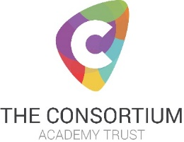
English Teacher 0.6 FTE required from 01 September 2021
Salary: Main Pay Scale – Upper Pay Scale

Cottingham High School has fantastic students, supportive parents, passionate teachers and enormous potential: this is an exciting time to join our well-established school. 100% of our parents would recommend our school to another parent. (Parent View 2020) In the school’s last inspection we were judged to be good in all areas and the upward trajectory of our student outcomes continues to evidence this. One parent commented ‘I cannot thank you and the other staff who've supported my son enough. I will be eternally grateful that you all saw my son’s potential, believed in him and have encouraged him to want to achieve.

This is an excellent opportunity for a highly motivated and talented teacher, who is passionate about helping young people to realise their potential, to join our supportive and successful English team. The successful candidate will have the opportunity to teach students at Key Stage 3 and Key Stage 4.
We invest in all our staff, providing a comprehensive induction programme and outstanding support for NQTs or RQTs and ongoing continuous, personalised, professional development.
We welcome and encourage visits to school, where you will have the opportunity to meet some of our staff, students and the Headteacher to learn a little more about our ethos, vision and journey.
Cottingham High School is committed to safeguarding and promoting the welfare of children and young people and expects all staff to share this commitment. This post is subject to a Disclosure and Barring Service (DBS) check.
Closing date for receipt of applications is 9am Friday 16th April. Interviews and lesson observation are expected to be held week commencing 19th or 26th April
Application forms and further details are available from the school:
telephone: 01482 847498, e mail: vacancies@cottinghamhigh.net, or on the website: www.cottinghamhigh.net

